Assignment – 24

Classes and Objects

1. Write a python program to create a user class with 3 properties : name, age, email.

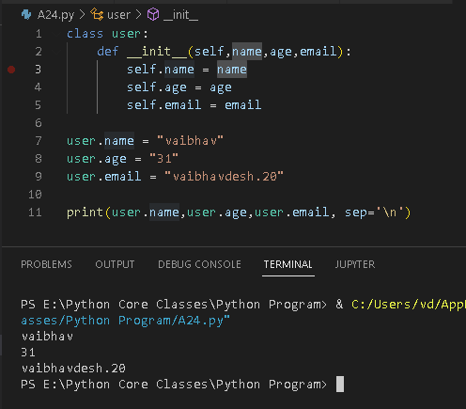

1. Write a python program to create a user class with a method to greet the user.



3. Write a python program to create 2 objects of the user class and assign different

values.



4. Write a python program to init default values for user object using __init__ method.



5. Write a python program to delete the age property of the user.

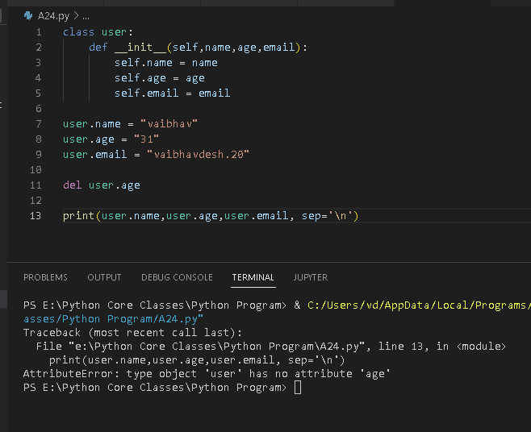

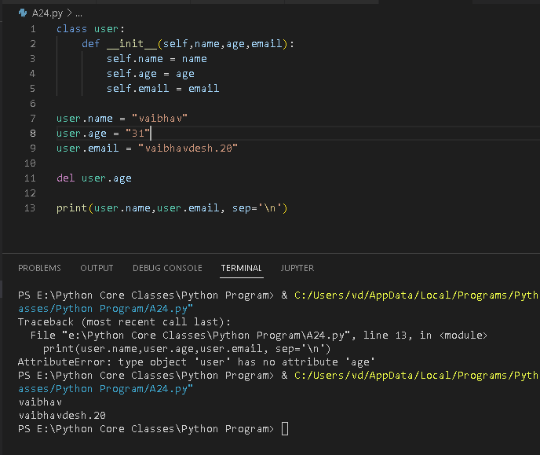

7. Write a python program to create a Laptop class with 4 attributes (brand, ram, cpu,

hdd) and 2 methods (showConfig() to print the values, __init__() to initialize the

values).

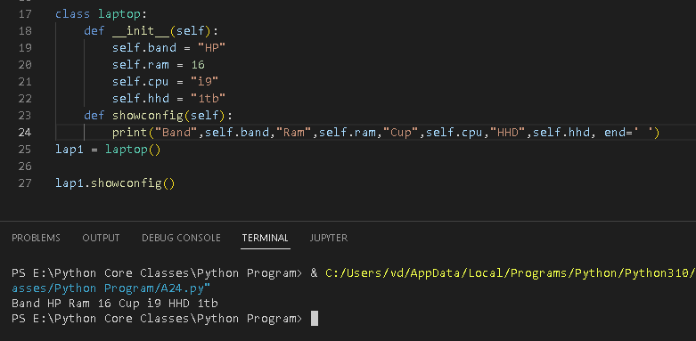

8. WRT 7th Question, create 3 Laptop objects and add them to the list in the sorted

order based on the ram size.

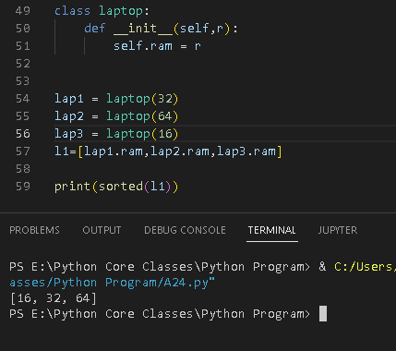

9. Write a python program to create a School class and 3 instance variables and 1 class

variable.

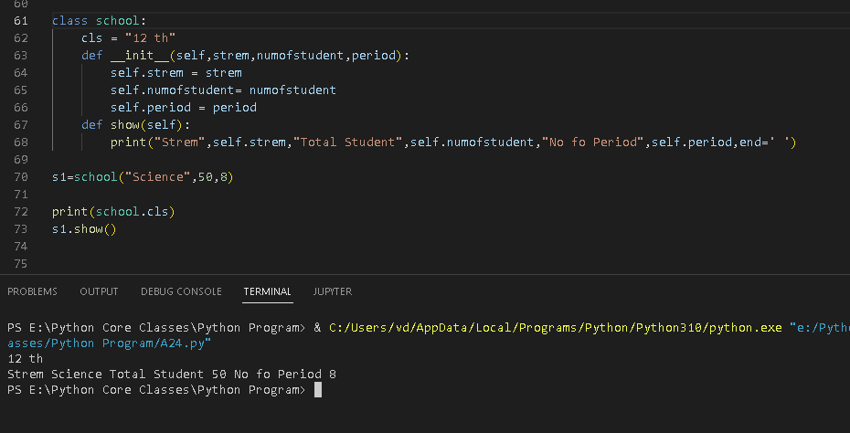

10. Define a class Employee with instance object variables empid, name, salary. Write

__init__() method in the class to initialize instance object variables. Also define

instance methods to input fields and display field values

