Assignment – 25 OOPs and Inheritance

1. Write a python script to create a Profile class with 3 attributes (name, email, age).

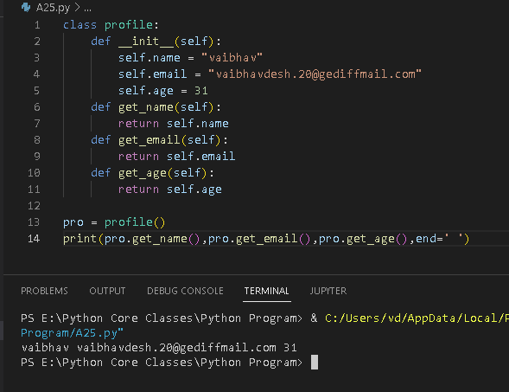

1. Write a python script to update the above Profile class with encapsulation.

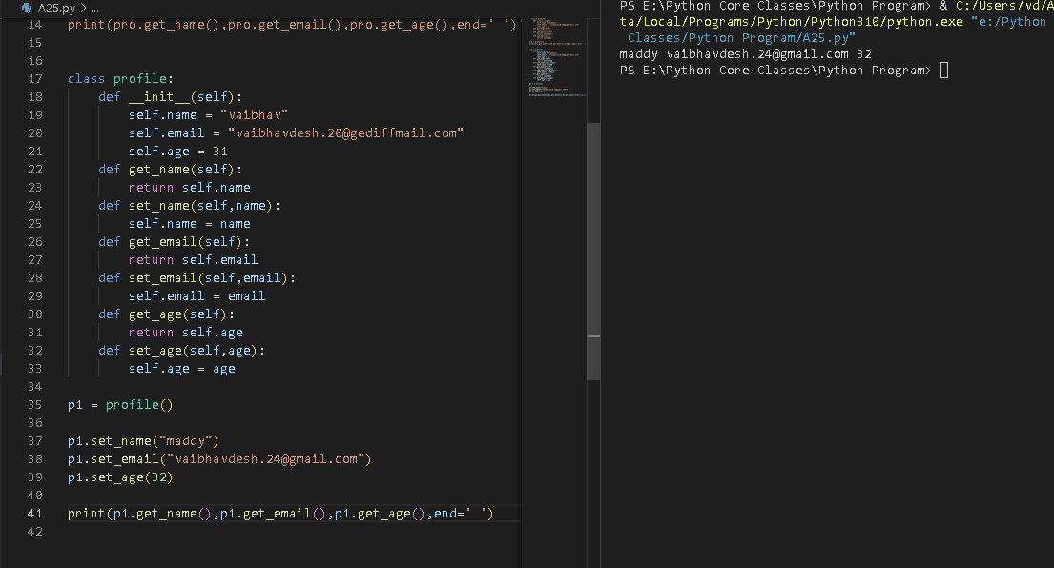

3. Write a python script to update 2nd Question, change email and age to __email and

__age.

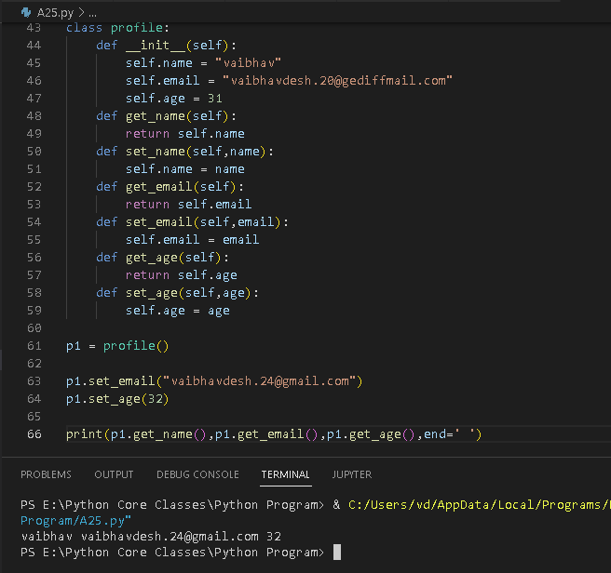

4. Write a python script to update 2nd Question, add a class variable (platform) and

create a classmethod to access it.

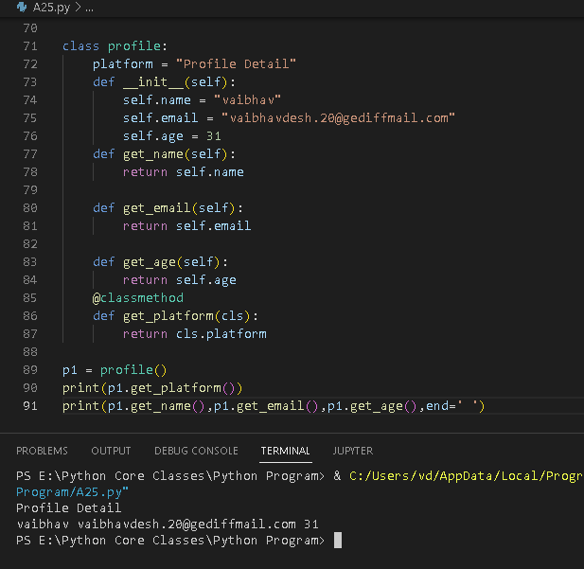

5. Write a python script to create a Calculator class with 2 methods for adding and

subtracting 2 values.

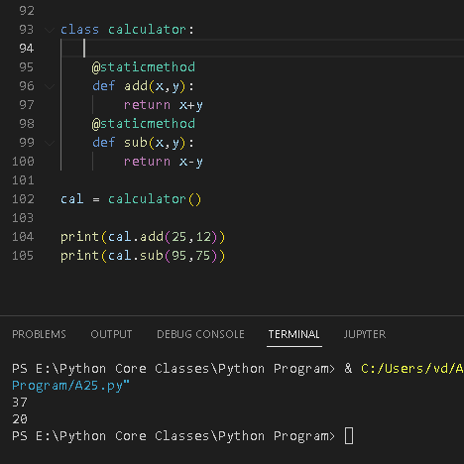

6. Write a python script to create a Calculator 2.0 class with 2 methods for multiplication

and division of 2 values and inherit it from the Calculator class.

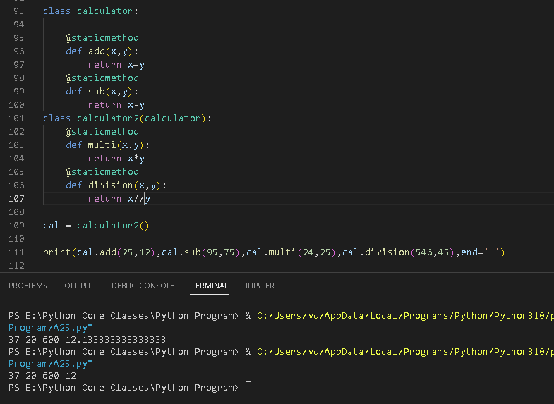

7. Write a python script to create a Phone class with 2 methods to print the features

(calling and sms).

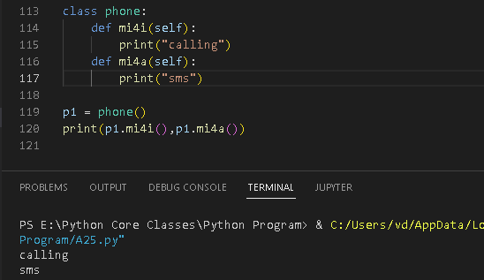

8. Write a python script to create a SmartPhone class by inheriting Calculator 2.0 and

Phone Class.

