Assignment-3: Type Conversion

1. Write a python script to convert a number into str type.

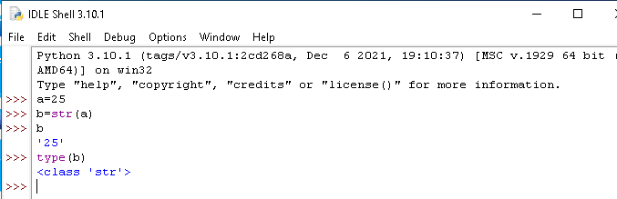

1. Write a python script to print Unicode of the character ‘m’

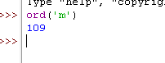

1. Write a python script to print character representation of a given unicode 100.

C:\Users\vd\OneDrive\Desktop\Capture.PNG

1. Write a python script to print any number and its binary equivalent

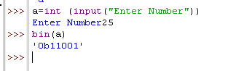

1. Write a python script to print any number and its octal equivalent.

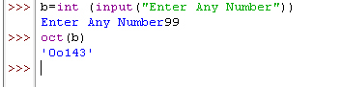

1. Write a python script to print any number and its hexadecimal equivalent.

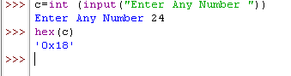

9. Write a python script to store an octal number 125 in a variable and print it in binary format.

