Assignment – 4

1. Write a python script to take your name as input from the user and then print it.

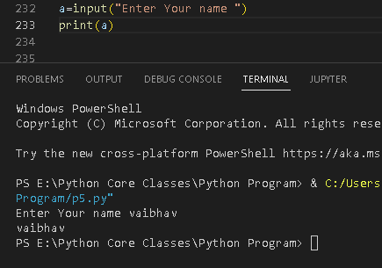

1. Write a python script to take input from the user. Input must be a number.

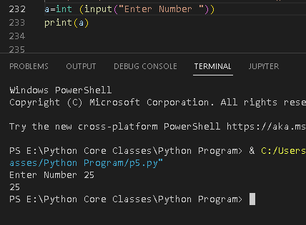

1. Write a python script which takes two numbers from the user, then calculate their sum and display the result.

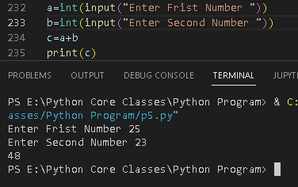

5.Write a python script to calculate the square of a number. Number is entered by the user.

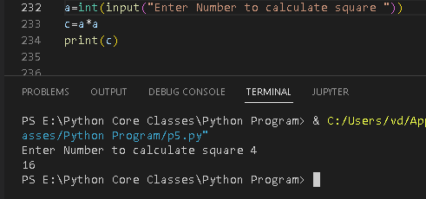

6. Write a python script to calculate the area of Triangle. Number is entered by the user.

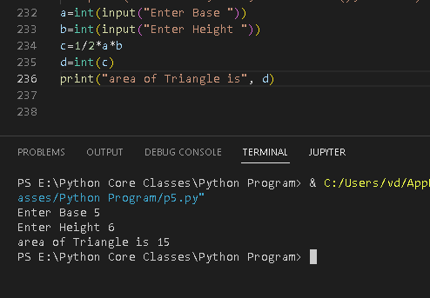

7. Write a python script to calculate average of three numbers, entered by the user

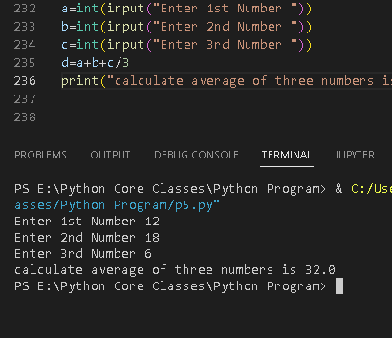

9. Write a python script to calculate the volume of a cuboid.

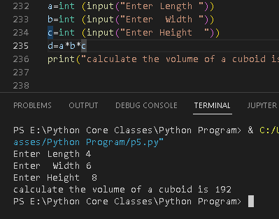

10. Write a python script to calculate area of a rectangle

