Assignment – 6

1. Write a python script to check whether a given number is positive or non-positive.

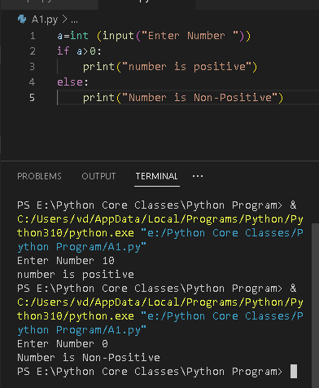

1. Write a python script to check whether a given number is divisible by 5 or not

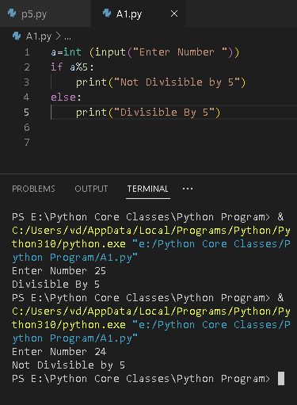

1. Write a python script to check whether a given number is even or odd

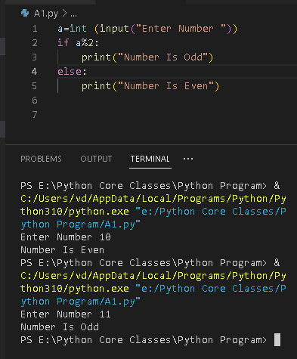

1. Write a python script to print greater between two numbers. Print number only once even if the numbers are the same.

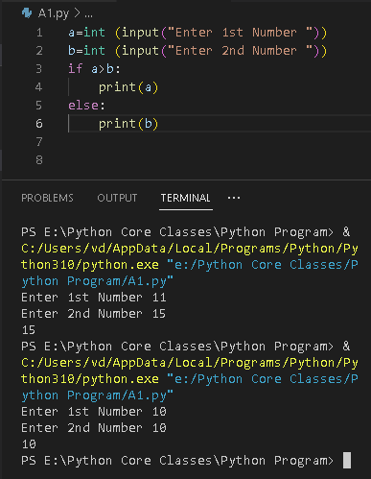

1. Write a python script to print two given words in dictionary order

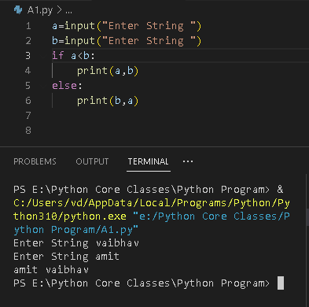

1. Write a python script to check whether a given number is a three digit number or not.

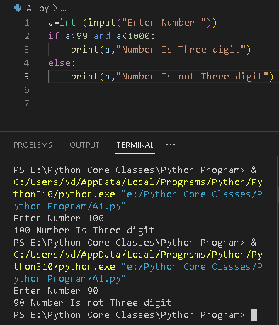

1. Write a python script to check whether a given number is positive, negative or zero.

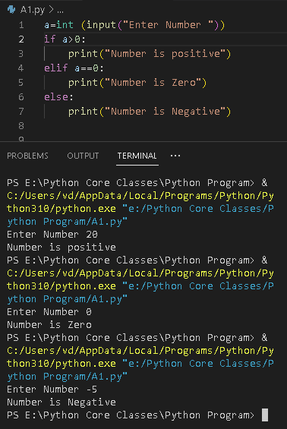

1. Write a python script to check whether a given year is a leap year or not.

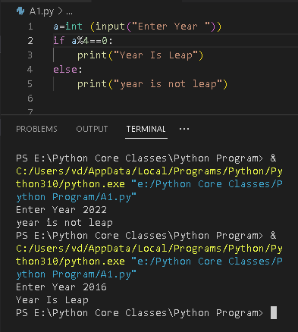

1. Write a python script to print greater among three numbers. Print number only once even if the numbers are the same.

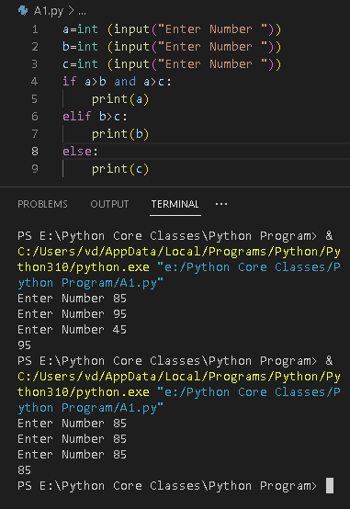

11. Write a python script to take the month value in numeric format and display the

number of days in it.

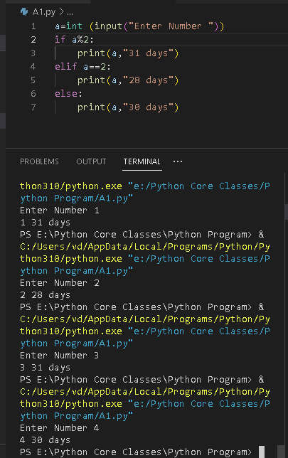

12. Write a python script to accept one complex number from the user and display the

greater number between real part and imaginary part.

