Assignment – 7

1. Write a python script to display the number of days in a given month number.

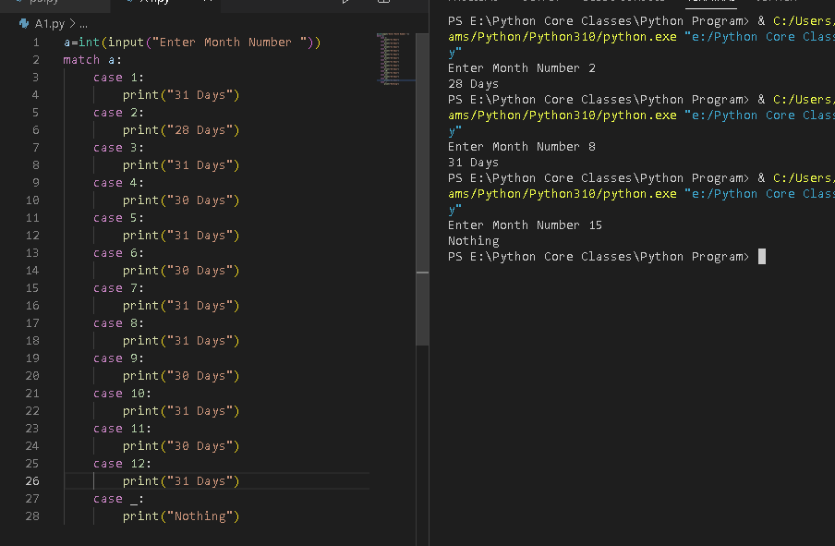

1. Write a menu driven program to perform following operations - Addition, Subtraction,Multiplication, Division

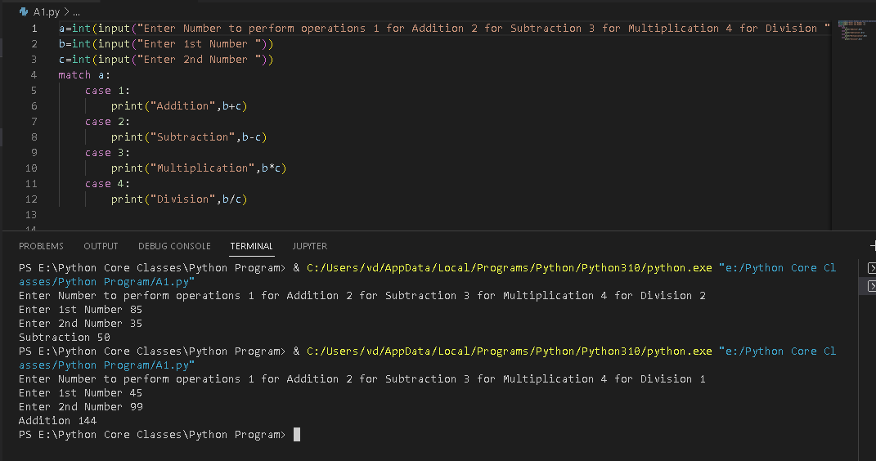

3. Write a menu driven program with the following options:

a. Check whether a given set of three numbers are lengths of an isosceles

triangle or not

b. Check whether a given set of three numbers are lengths of sides of a right

angled triangle or not

c. Check whether a given set of three numbers are equilateral triangle or not

d. Exit.

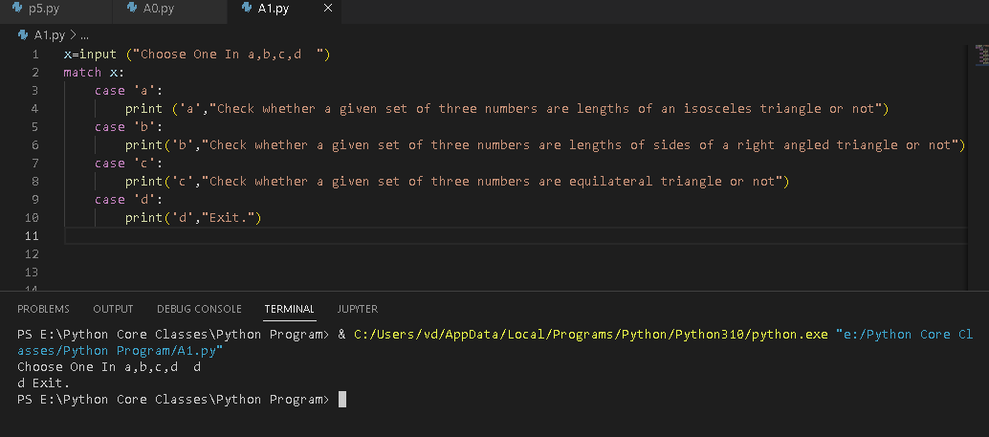

4. Write a program which takes user’s age and display the category of person. Age

below 10 years- Kid, Age below 20 - Teen, Age below 40 - young, Age below 60 -

Experienced, Age above or equal 60 - Senior Citizen.

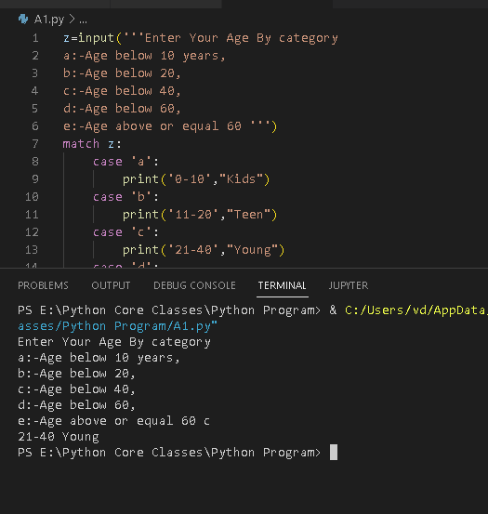

5. Write a program which takes a number from user. Print Saurabh Shukla if the number

is even, print Prateek Jain if the number is negative odd number and print Aditya

Choudhary if number is positive odd number.

a=int (input("Enter Number "))

if a%2:

    print("Aditya Choudhary")

elif a:

    print("Saurabh Shukla")

else:

    print("Prateek Jain")

6. Write a python program to check whether a given string is a multiword string or single

word string using match case statement

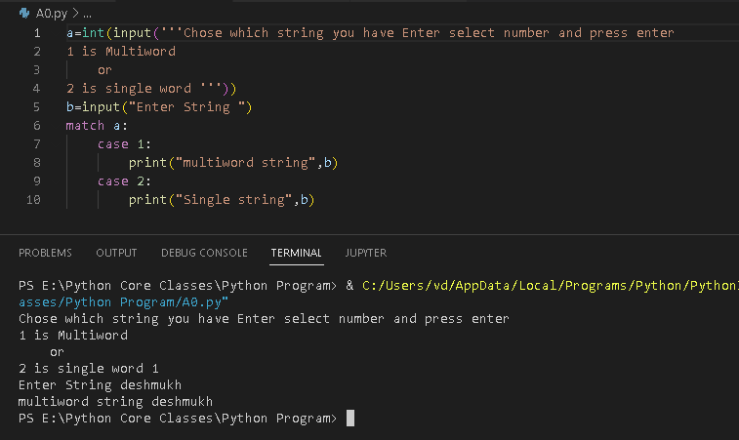

7. Write a python program to check whether a given number is positive, negative or

zero using match case statement

