Assignment – 8

1. Write a python script to print MySirG 5 times on the screen

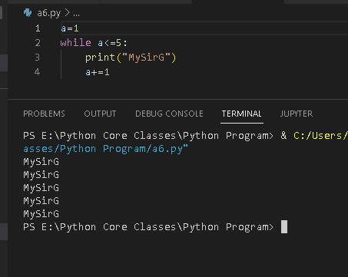

1. Write a python script to print first 10 natural numbers

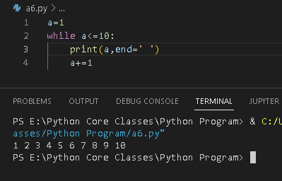

1. Write a python script to print first 10 natural numbers in reverse order

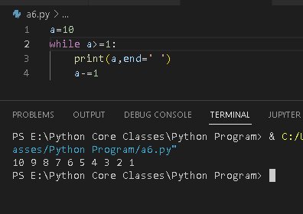

1. Write a python script to print first 10 odd natural numbers

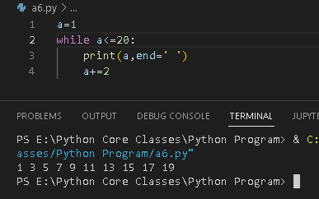

1. Write a python script to print first 10 odd natural numbers in reverse order

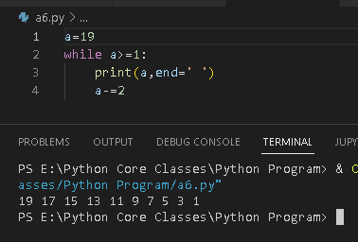

1. Write a python script to print first 10 even natural numbers

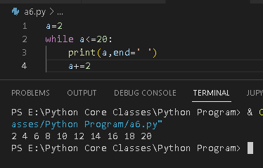

1. Write a python script to print first 10 even natural numbers in reverse order

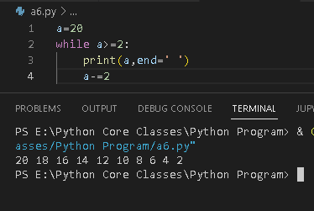

1. Write a python script to print squares of first 10 natural numbers

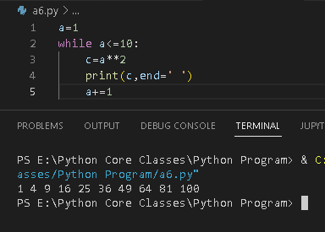

1. Write a python script to print cubes of first 10 natural numbers

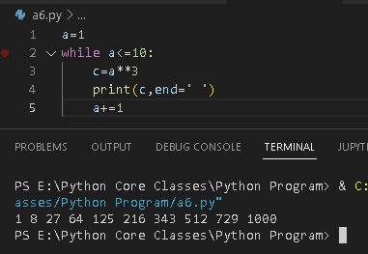

1. Write a python script to print first 10 multiples of 5

