Project – 1 Word Puzzle Game

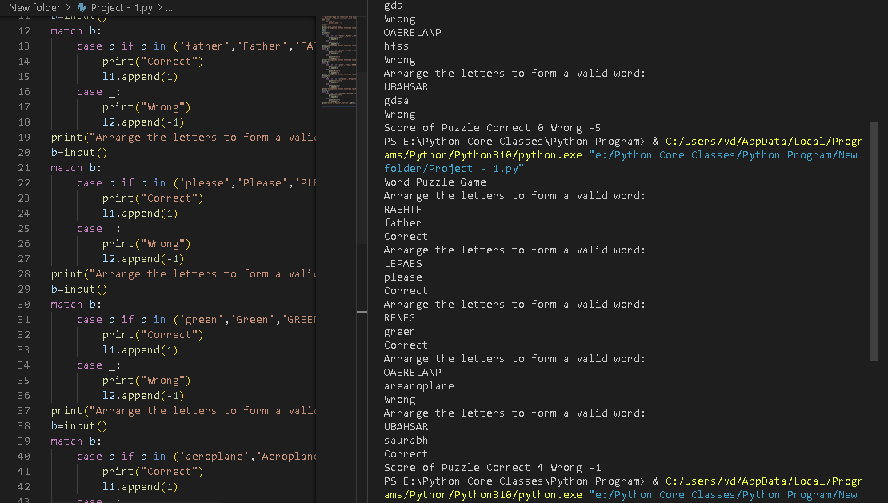

print("Word Puzzle Game")

print("Arrange the letters to form a valid word: \nRAEHTF")

l1=[]

l2=[]

b=input()

match b:

    case b if b in ('father','Father','FATHER'):

        print("Correct")

        l1.append(1)

    case _:

        print("Wrong")

        l2.append(-1)

print("Arrange the letters to form a valid word: \nLEPAES")

b=input()

match b:

    case b if b in ('please','Please','PLEASE'):

        print("Correct")

        l1.append(1)

    case _:

        print("Wrong")

        l2.append(-1)

print("Arrange the letters to form a valid word: \nRENEG")

b=input()

match b:

    case b if b in ('green','Green','GREEN'):

        print("Correct")

        l1.append(1)

    case _:

        print("Wrong")

        l2.append(-1)

print("Arrange the letters to form a valid word: \nOAERELANP")

b=input()

match b:

    case b if b in ('aeroplane','Aeroplane','AEROPLANE'):

        print("Correct")

        l1.append(1)

    case _:

        print("Wrong")

        l2.append(-1)

print("Arrange the letters to form a valid word: \nUBAHSAR")

b=input()

match b:

    case b if b in ('saurabh','Saurabh','SAURABH'):

        print("Correct")

        l1.append(1)

    case _:

        print("Wrong")

        l2.append(-1)

print("Score of Puzzle",'Correct',sum(l1),'Wrong',sum(l2),end=' ')