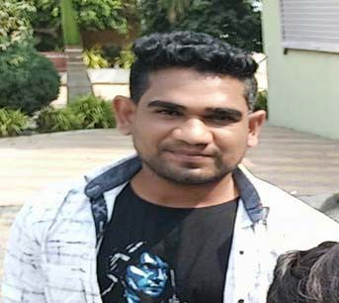


Vaibhav Damodhar Deshmukh
Personal Details
Caste :- Wandekar Kunbi

DOB :- 24-08-1990
Height :- 5.8" Education :- MBA-(IT) Occupation :- Sr.IT Engg.
Hinganghat Integrated Textile Park
(I’M Learning Full Stack Data Science on iNeuron (Batch Nov 22))

Family Background
Father :-Damodhar Deshmukh Occupation :-Retired (Employee) Mother :- Kalpana D. Deshmukh Occupation :- House Wife
Sister :- 1) Vaishali Pravin Kubade
2) Sonali Rupesh Dhoke

Maternal :- 1)Lashman Nathuji Lohakare
2)Gajanan Nathuji Lohkare

Others
Address :- Sant Tukdoji Ward,Near Mahatma Fule
School,Hinganghat Dist-Wardha
Contact :- 7058630440,9730609117,8421582340
Linkedin: - https://www.linkedin.com/in/vaibhav-deshmukh-87b58a15b/

