**IT Practical File**

Practical -1

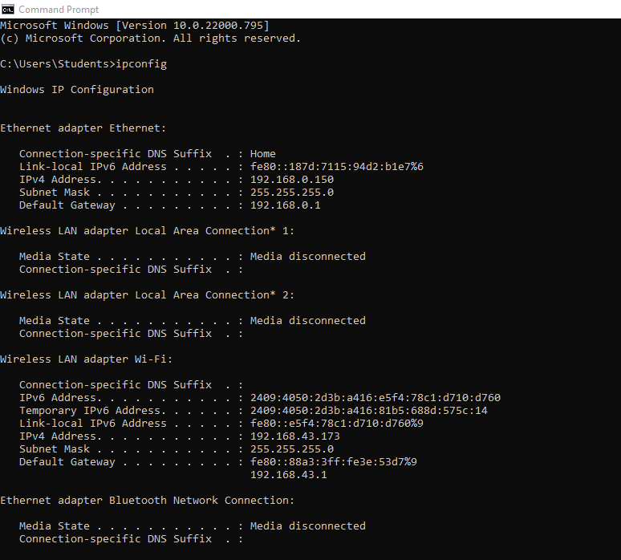

System IPV4 address -> 192.168.43.173

Subnet mask-> 255.255.255.0

Subnet number -> 192.168.43.0

Broadcast Address 192.168.43.255

Range of usable IP Address -> 192.168.43.1 to 192.168.43.254

Or 28 -2 = 254 IP addresses

Practical -2

