Jaypee University of Engineering & Technology, Guna

Python Project

Name: Vaibhav Goel

Batch: B9(BZ)

Enrollment Number: 161B259

Project Name: JUET Management System

Branch: CSE

Submitted To: Dr. Mahesh Kumar

1. **What is this project about?**

JUET Management System is programmed in python version 2.7.13. It is programmed to manage the management system of JUET College, which does all max. operation in JUET like Adding Any Student or Teacher, Searching, Salary Process, Removing any teacher or student.

1. **Splash Screen?**

The splash screen which is the first screen of the project, which jumps to the login window whenever you hover the mouse on the text MOVE.

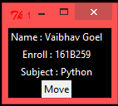

1. **The Login Window!!**

This is the second window which enables the user to enter into the main program. In Login window there is a username as well as a password and a Login Button which will perform the rest calculation like checking password.

Username=Admin Password=161B259 this is the correct combination to get entry to the program through login windows

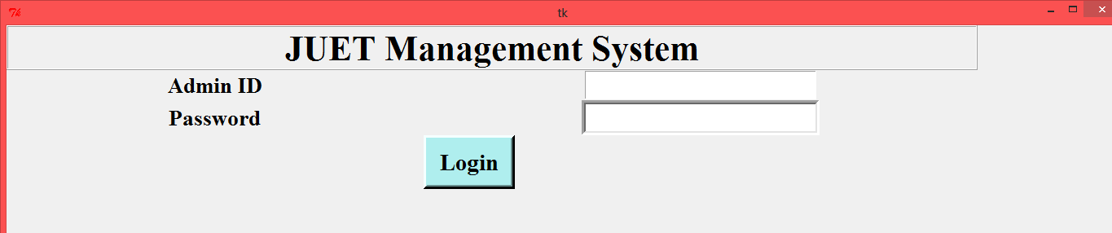

1. When everything is right and you click on Login button then it will jump to the program windows, which is the third screen and manage all the function in the program

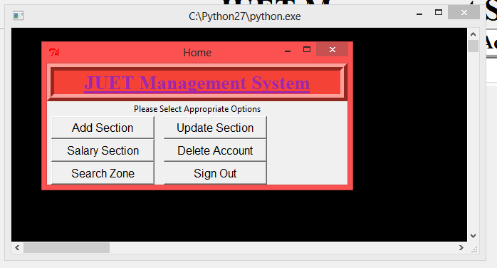

This is the master window of the main project that consist of 6 Button

Button 1 : The Add Section

When you click on Add section it will jump to next window and it consist of 3 buttons i.e. Student, Teacher, Exit

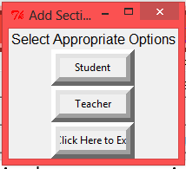

Student: Windows->

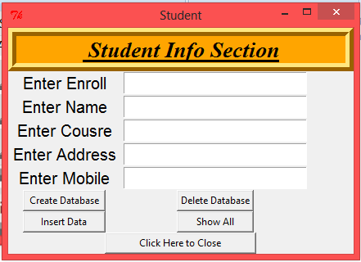

This section will consist 5 Entries about the new student i.e. Name,Enroll,Course,Address,Mobile and 5 Buttons.

Create DB Button : This button will create Student database

Delete DB Button : When you want to delete the whole database in one go.

Insert Data : This button will add the student information to the database.

Show all : This button will show all the students enroll in your database.

Click Here to Close Button : This Button will jump to your previous window.

Teacher: Button->

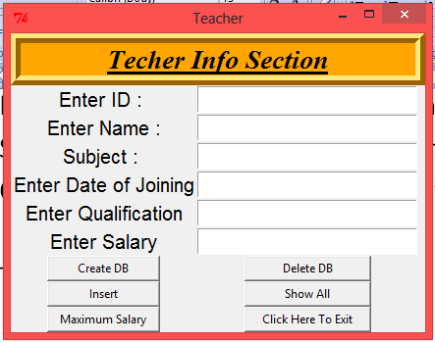

This section will consist 6 Entries about the new student i.e. Name,Enroll,Course,Address,Mobile and 6 Buttons.

Create DB Button: This button will create Teacher database

Delete DB Button : When you want to delete the whole database in one go.

Insert Data : This button will add the Teacher information to the database.

Show all : This button will show all the students enroll in your database.

Max Sal : This button will show you the maximum salary in the database.

Click Here to Close Button : This Button will jump to your previous window.

Update Section: Windows

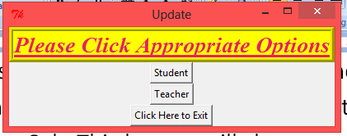

This windows consist of 3 Buttons i.e. Student, Teacher, Exit

Student – Button

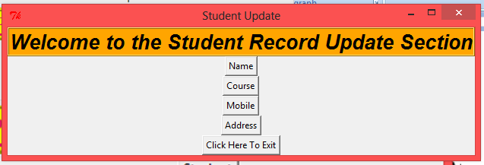

This button consist of 5 Button: Name,Course,Mobile,Address,Exit

Name Button will update The Name of Student by providing its Enroll ID.

Course Button will update the Course of Student by providing its Enroll ID.

Mobile Button will update the Mobile of Student by providing its Enroll ID.

Address Button will update the Address of Student by providing its Enroll ID.

Exit Button will jump to the previous windows.

Teacher – Button

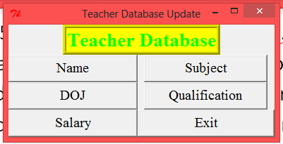

This Windows consist of 6 Button i.e. Name, Subject, DOJ, Qualification, Salary, Exit

Name Button will update the Name of Teacher in the main Database

Subject Button will update the Subject of Teacher in the main Database

DOJ Button will update the DOJ of the Teacher in the main Database

Qualification Button will update the Qualification in the main Database

Salary Button will update the salary of the teacher in the main Database

Exit – Button

This button will jump to the main menu

Salary Section:

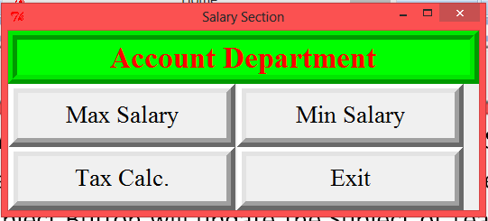

This window consist of 4 Button Max, Min, Tax, Exit

Max Salary Button: This button will show the maximum salary of a teacher.

Min Salary Button: This button will show the minimum salary of a teacher.

Tax Calc. Button : This will calculate the tax of each teacher.

Delete Zone:

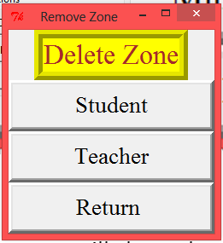

This window consist of 3 buttons Student, Teacher, Return

Student Button will delete the student from the database

Teacher Button will delete the teacher from the database

Return Button will jump you the main windows.

Search Zone:

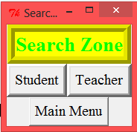

This window will consist of 3 Buttons i.e. Student, Teacher, Main Menu.

Student Button: This will help you to find any student from the database by providing it’s enroll id.

Teacher Button: This will help you to find any Teacher from the database by providing its enroll ID.

Main Menu: This button will jump to the Main Windows

SignOut Button : This button will exit you from all the windows and gives you message : Successfully Logged Off