A Report on

Emotions Based Music Recommendation

Submitted for partial fulfillment of award of

DEGREE OF
BACHELOR OF COMPUTER APPLICATIONS
Submitted By
Mohammed Zaid khan (230934000655)

Under the supervision of
Prof Hitesh Sharma



INSTITUTE OF TECHNOLOGY & SCIENCE
MOHANNAGAR, GHAZIABAD

Batch: 2023-2026

CERTIFICATE
This is to Certify thatMohammed Zaid khan has carried out the project work presented in this report entitled"MOODTUNES - Mood-Based Music Website" for the award of Bachelor ofComputer Applications from Institute of Technology & Science, MohanNagar,Ghaziabad, under my supervision. The report embodies resultoforiginal work and studies carried out by Student himself and the contentsofthereport do not form the basis for the award of any other degree tothecandidate or to anybody else.
Date: 13-04-2026

Prof Hitesh Sharma
Assistant Professor
Department of Computer Applications Institute of Technology & Science, Ghaziabad

ACKNOWLEDGEMENT
I would like to express my special thanks of gratitude to my project
guide, Prof. Hitesh Sharma, for their invaluable guidance, constant encouragement, and constructive criticism throughout the development of
this project. Their expertise and motivation have been instrumental in the successful completion of this work.
I also wish to extend my sincere thanks to Dr. Vidhushi Singh, Head of Department, Computer Applications, for providing the necessary facilities and support for this project.
My sincere thanks go to Dr. Nancy Sharma, the Principal of Institute of Technology & Science, Ghaziabad, for providing a conducive environment for learning and research.
I am grateful to all my faculty members and friends who directly or indirectly helped me in completing this project successfully.
Last but not least, I would like to thank my parents for their unwavering support and encouragement throughout my academic journey.
Mohammed Zaid Khan (230934000655)

ABSTRACT
Music has a profound impact on human emotions and mental well-being. People often listen to music that matches their current emotional state,
whether they are happy, sad, energetic, or calm. However, finding the right music for a specific mood can be time-consuming and requires manual searching across various music platforms. MoodTunes is a web-based application that addresses this problem by automatically generating personalized music playlists based on the user's emotional state. The system provides two methods for mood detection: direct mood selection from eight predefined moods (Happy, Sad, Calm, Energetic, Angry, Romantic, Focused, Sleepy) and text-based mood detection using natural language keyword matching. The application is built using Python Flask as the backend web framework, SQLite for database management, and the Spotify Web API for fetching music recommendations. The system features user authentication, playlist generation, and listening history tracking. When a user selects a mood or describes their feelings in text, MoodTunes processes this input, maps it to appropriate musical parameters (such as valence, energy, tempo, and genre), and fetches relevant song recommendations from Spotify. The generated playlist is displayed to the user with song details and direct links to listen on Spotify. MoodTunes serves as an intelligent music recommendation system
that simplifies the process of finding mood-appropriate music. It
demonstrates the practical application of web development technologies, API integration, and database management. The system is fully functional even without Spotify API credentials, using built-in mock song data as a fallback.
Keywords: Mood Detection, Music Recommendation, Flask, Spotify API, SQLite, Web Application

TABLE OF CONTENTS

S.No | Description | Page No.
01 | Certificate | 2
02 | Acknowledgement | 3
03 | Abstract | 4
04 | Table of Content | 5
05 | List of Tables | 6
06 | List of Figures | 7
07 | List of Symbols, Abbreviations and Nomenclature | 7
08 | Introduction | 8-17
09 | System Analysis | 18-22
10 | Means of Project | 23-24
11 | Overall Description | 25-41
12 | Specific Diagrams | 42-46
13 | Product Features | 47
14 | Screenshots | 47-50
15 | Coding | 51-52
16 | Test Cases and Test Results | 53-54
17 | Conclusion | 55-58
18 | Future Scope of The Project | 59
19 | Refrence | 60
20 | Bibliography | 61

LIST OF TABLES

Table No. | Description
Table 3.1.1 | Development Hardware Requirements
Table 3.1.2 | End-User Hardware
Table 3.2.1 | Development Software Requirements
Table 3.2.2 | End- User Software Requirements
Table 8.1 | Test Cases (TC-01 to TC-15)

LIST OF FIGURES

Figure No. | Description
Figure | System Architecture Diagram
Figure 11.2 | ER Diagram
Figure 11.3 | Level-0 Data Flow Diagram (Context Diagram)
Figure 11.4 | Level-1 Data Flow Diagram
Figure 12.1 | Class Diagram
Figure 12.2 | Use Case Diagram
Figure 12.5 | Sequence Diagram
Figure 12.6 | Sequence Diagram

LIST OF SYMBOLS, ABBREVIATIONS
AND NOMENCLATURE
HTML - Hypertext Markup Language
CSS - Cascading Style Sheets
MVC - Model-View-Controller
API - Application Programming Interface
DBMS - Database Management System
DFD - Data Flow Diagram
ER - Entity-Relationship
CRUD - Create, Read, Update, Delete
HTTP - Hypertext Transfer Protocol
HTTPS - Hypertext Transfer Protocol Secure
HRMS - Human Resource Management System
SQL - Structured Query Language

CHAPTER 1: INTRODUCTION

Overview & Problem Statement

Overview
In the digital age, music streaming has become an integral part of daily life for millions of people worldwide. Platforms like Spotify, Apple Music, and YouTube Music offer access to millions of songs at users' fingertips. However, despite the vast availability of music, finding songs that match one's current emotional state remains a challenge.
Music and emotion share a deep, intrinsic connection. Research in music psychology has demonstrated that listening to music that aligns with one's emotional state can enhance mood, reduce stress, improve focus, and provide emotional catharsis. People naturally gravitate toward music that reflects how they feel - upbeat tracks when happy, soothing melodies when stressed, energetic beats when working out.
MoodTunes is a web-based application designed to bridge the gap between human emotions and music discovery. The system provides an intuitive interface where users can either select their current mood from a set of eight emotional categories or describe their feelings in natural language text.
Behind the scenes, MoodTunes processes this input and generates a curated playlist of songs that match the detected mood.
The application leverages the Spotify Web API, which provides access to Spotify's extensive music library and recommendation engine. Spotify's recommendation system uses audio features such as valence (musical positivity), energy, tempo, danceability, and genre preferences to suggest songs that fit specific musical characteristics.
    - Problem Statement

Despite the availability of music streaming platforms with millions of songs, users face several challenges:
- Manual Search Inefficiency: Finding mood-appropriate music requires users to manually search, browse, and curate playlists, which is time- consuming and often frustrating.
- Lack of Mood-Based Filtering: Existing music platforms organize music primarily by genre, artist, or popularity, but not by emotional content or mood.
- Inconsistent Mood Tagging: While some playlists have mood-based titles (e.g., "Happy Hits," "Sad Songs"), there is no standardized way to filter music by mood across the entire platform.
- No Personalized Mood Detection: Users cannot simply describe how they feel and receive automatic music recommendations based on that description.
- No Historical Tracking: Users have no way to track what moods they searched for previously and what music was recommended.
MoodTunes addresses these problems by creating a dedicated mood-based music recommendation system with natural language input capabilities, user authentication, and search history tracking.

Purpose
The primary purpose of MoodTunes is to provide an emotionally intelligent music recommendation experience accessible via any modern web browser, demonstrating full-stack web development skills including back-end routing, database management, third-party API integration, user authentication, and responsive UI design.
- Enable users to receive instant, mood-appropriate song recommendations without manual searching.
- Provide a seamless authentication system so listening history is persisted per user.
- Integrate with the Spotify Web API to surface real, licensed music with embedded playback.
- Offer text-based mood detection that infers emotional state from natural language input.

- Maintain accessibility by falling back to mock data when Spotify credentials are unavailable.

Objectives
- Mood Detection Mechanism: Implement a dual-mode mood detection
system that accepts either direct mood selection from predefined categories or text-based input with keyword matching for automatic mood identification.
- Playlist Generation: Integrate with the Spotify Web API to fetch relevant song recommendations based on the detected mood, using parameters such as valence, energy, tempo, and seed genres.
- User Authentication: Provide a secure login and registration system with password hashing to protect user accounts and personal data.
- History Tracking: Maintain a search history for each user, recording their mood searches, search terms, and timestamps.
- Responsive User Interface: Design a modern, dark-themed, responsive web
interface that works seamlessly across desktop, tablet, and mobile devices.

Secondary Objectives
- Offline Fallback: Ensure the application remains functional even without Spotify API credentials by providing built-in mock song data for demonstration purposes.
- Educational Value: Demonstrate the practical application of web development technologies including Flask framework, SQLite database, RESTful API integration, and front-end design principles.
- Scalability: Design the system architecture to accommodate future enhancements such as machine learning-based mood detection, social features, and additional music sources.

Scope
The scope of the MoodTunes project defines the boundaries and extent of the system's functionality.

In Scope
- Mood Categories: The system supports eight distinct mood categories:

  - Happy

  - Sad

  - Calm

  - Energetic

  - Angry

  - Romantic

  - Focused

  - Sleepy

- User Management:

The user authentication system includes user registration with a username and password, allowing new users to create accounts securely. It also provides secure login with session management to maintain user state across the application, along with logout functionality to terminate the session and protect user privacy.
- Core Functionality:

The mood-based music recommendation system offers direct mood selection via button clicks for quick input, as well as text-based mood detection using keyword matching for more flexible user interaction. Based on the identified mood, it generates a playlist containing 8 to 12 songs per request and displays the song names, artists, and direct Spotify links for easy access to the tracks.

- Data Persistence:

The system uses an SQLite database for storing user credentials securely, enabling reliable authentication and user management. Additionally, it supports search history storage and retrieval on a per-user basis, allowing each user to access their past mood selections and generated playlists.
- Fallback Mechanism:
The system includes a mock song data fallback for each mood, which is used when the Spotify API is unavailable. This ensures that users can still receive playlist recommendations based on their selected or detected mood, without interruption, even during API outages or rate-limiting issues.

Out of Scope

The following features are not included in the current version but are identified for future enhancement:
      - Integration with multiple music platforms (Apple Music, YouTube Music)
      - Machine learning-based mood detection from facial expressions or voice
      - Social features (sharing playlists, following users)

      - Audio preview playback within the application

      - Offline music storage

      - Mobile application (iOS/Android native apps)

Tools Used
The following tools were used in the development of the MoodTunes project:

Tool | Version | Purpose
Python | 3.12.3 | Core backend language
Flask | 3.0.0 | Web framework for routing and templates
Spotipy | 2.23.0 | Python wrapper for Spotify Web API
SQLite3 | Built-in (Python) | Lightweight relational database
Jinja2 | Bundled with Flask | HTML templating engine
hashlib | Built-in (Python) | SHA-256 password hashing
Git | Latest | Version control

Methodology Used
The development of MoodTunes followed a structured software development methodology combining elements of Agile and Waterfall approaches. The project followed the Agile development methodology with iterative increments structured across: Requirements Gathering, System Design, Incremental Development, Testing, and Documentation. This iterative approach allowed for continuous refinement of features, particularly the mock-data fallback system and the text- based mood detection logic.

Development Lifecycle
The project was carried out over 14 weeks in five phases. During Phase 1 (Weeks 1-2), requirements were identified through research and analysis, including studying existing music recommendation systems, defining functional and non-functional requirements, and creating a project scope document. In Phase 2 (Weeks 3-4), the system design was completed, covering system architecture, database schema, ER diagrams, DFDs, UI/UX wireframes, and an API integration strategy. Phase 3 (Weeks 5-10) involved implementation: setting up the Flask application structure, building user authentication, developing database helper functions, creating mood mapping logic, integrating the Spotify API, constructing front-end templates and CSS, and implementing a mock data fallback. During Phase 4 (Weeks 11-12), testing was conducted, including unit testing, integration testing, user acceptance testing, bug fixes, and test case validation. Finally, Phase 5 (Weeks 13-14) focused on deployment and documentation, preparing deployment instructions, a user manual, technical documentation, and the final project report.

Development Approach
The project adopted a modular development approach, where each component was developed and tested independently before integration

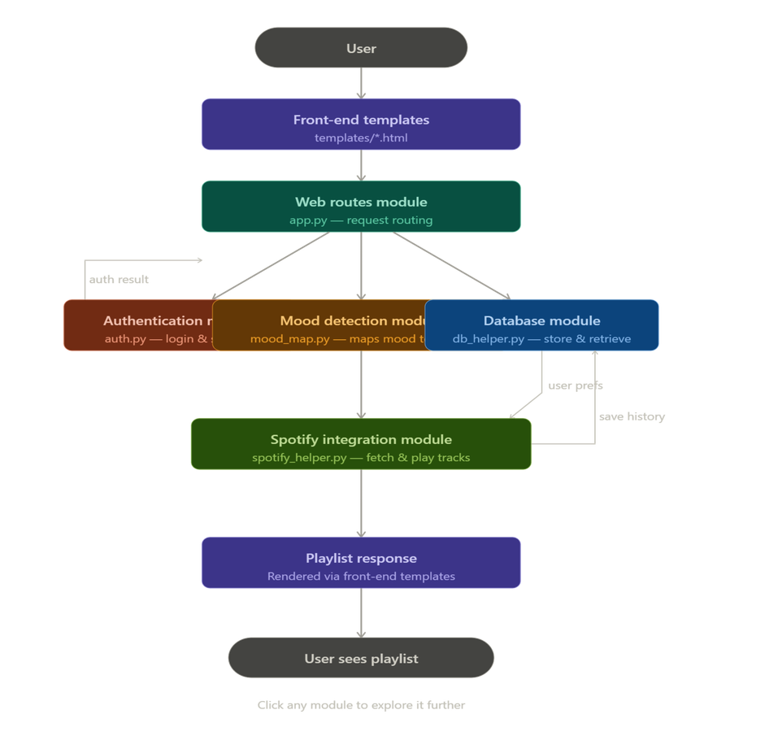
    - Testing Methodology

During testing, multiple strategies were employed to ensure the application’s quality and reliability. Unit testing verified each function independently, while integration testing ensured that modules worked together correctly.
User acceptance testing involved real users evaluating the application in practical scenarios. Cross-browser testing was conducted on Chrome, Firefox, and Edge to confirm consistent behavior, and responsive testing validated the user interface across desktop, tablet, and mobile viewports.

  - Technology Used

Back-End Technologies
Python 3.9+: Python is a high-level, interpreted programming language known for its readability and extensive library ecosystem. The key reasons for choosing Python include its simple and clean syntax, which accelerates development, along with an extensive standard library that reduces the need for external dependencies. Additionally, Python benefits from strong community support and offers excellent API integration capabilities, making
it well-suited for projects that require connecting to external services such as the Spotify API.
Flask Framework: Flask is a lightweight WSGI web application framework. Features used:

Feature

Routing
Purpose

URL mapping to functions

Session Management User login state tracking

Templates Jinja2 HTML rendering

Request Handling Processing form data

Flash Messages User notifications

CHAPTER 2: SYSTEM ANALYSIS

Identification of Need
System analysis is the process of examining a business situation with the intent of improving it through better procedures and methods. For MoodTunes, the system analysis phase identified the need for a mood-based music recommendation system.
    - Existing System Analysis

Current music discovery methods include:

- Manual Playlist Creation

In traditional approaches, users manually search for songs and add them to playlists, a process that is time-consuming and requires musical knowledge. Additionally, such playlists tend to become outdated quickly as new music is released or listening preferences change, reducing their long-term relevance and enjoyment.
- Platform-Generated Playlists

Spotify creates curated playlists such as "Daily Mix" and "Release Radar" based on a user’s listening history, not on explicit mood selection. As a result, users cannot specify their current emotional state to influence the recommendations, which limits the personalization for situational or transient moods.
- Genre-Based Browsing

Traditional music organization relies heavily on genres such as Pop, Rock, Classical, and others, but genre does not always correlate with mood. For example, a sad song can exist in any genre, which makes mood-based discovery challenging when only relying on genre labels. This limitation highlights the need for systems that directly map musical features or user input to emotional states.

- Search by Artist or Song Name

Search-based discovery requires users to know specific artists or songs in advance, making it unsuitable for discovering new music that falls outside their existing knowledge. This approach limits serendipitous exploration and can prevent users from finding tracks that match their current mood but are unfamiliar to them.

Preliminary Investigation

Existing System Analysis

- Most open-source mood-music tools do not include user authentication or history.
- Spotify's recommendations API is powerful but underutilized in simple web applications.
- Keyword-based mood detection (without ML) is sufficient for casual use cases.
Technology Selection Rationale
Flask was chosen over Django for its simplicity. SQLite was chosen over MySQL/PostgreSQL for zero-configuration deployment. Spotipy is the de-facto Spotify wrapper for Python.

Feasibility Study
    - Technical Feasibility

Assessment of technical requirements:
All dependencies are freely available, well-documented, and stable. The Spotify Web API has a free tier sufficient for development and demonstration.
Technical Risks:
Several risks were identified and mitigated in the project. The Spotify API rate limits are addressed by implementing caching mechanisms to reduce repeated requests. Internet dependency is mitigated by providing a mock song data fallback that ensures functionality even when the API is unavailable. Browser compatibility risks are reduced by using standard web technologies such as HTML5, CSS3, and vanilla JavaScript, which work consistently across modern browsers.
Conclusion: The project is technically feasible.

Requirement | Status | Remarks
Python programming  Flask framework | Achievable | Developerhas Python  knowledge
 | Achievable | Extensive  documentation available
SQLite database | Achievable | No server setup required  Free to register, good
Spotify API | Achievable | documentation  Standard web
HTML/CSS/JS | Achievable | technologies  Can run on localhost or
Hosting | Achievable | free hosting

Economic Feasibility
Zero direct cost. All tools are open-source or free. Hosting on localhost requires no cloud infrastructure.

Benefit Analysis:

The project incurs no licensing fees as all software tools and libraries used are open source, and no infrastructure investment is required beyond a standard development machine. Consequently, the project can be demonstrated without additional costs, making it an accessible and low-risk solution for showcasing mood-based music recommendation capabilities.
Conclusion: The project is economically feasible with zero monetary investment.

Operational Feasibility
The interface is simple, requiring minimal technical knowledge. The mock-data fallback ensures the app functions even without Spotify API credentials
Organizational Impact:
The system introduces no disruption to existing systems, as it operates independently without requiring modifications to other applications. It can be deployed alongside other applications on the same environment, and because the

interface is simple and intuitive, no special training is required for users to begin interacting with the mood detection and playlist generation features.
Conclusion: The project is operationally feasible.

Legal Feasibility
Compliance Requirements:

Aspect | Status
Spotify API Terms | Comply with rate limits and attribution
User Data Privacy | Passwords hashed, no sensitive data collected
Copyright | Only links to Spotify, no music hosting
Open Source Licenses | Flask, Spotipy use MIT/BSD licenses
Conclusion: The project is legally feasible.

Schedule Feasibility
The project was completed within a single academic semester due to its modular architecture.
Timeline Assessment:

Phase | Duration | Status
Requirements | 2 weeks | Achievable
Design | 2 weeks | Achievable
Implementation | 6 weeks | Achievable

Testing | 2 weeks | Achievable
Documentation | 2 weeks | Achievable
Total | 14 weeks | Achievable
Conclusion: The project is schedule-feasible within the academic timeline.

Feasibility Conclusion

Final Verdict: The MoodTunes project is FEASIBLE and should proceed to the design and implementation phase.
Overall Feasibility Assessment:

Feasibility Type | Status
Technical | Feasible
Economic | Feasible
Operational | Feasible
Legal | Feasible
Schedule | Feasible

CHAPTER 3: MEANS OF PROJECT

Hardware Requirements
The hardware requirements for running MoodTunes are minimal, making it accessible for development, testing, and deployment on standard computing equipment.

Component | Minimum | Recommended
Processor | Intel Core i3 | Intel Core i5 or higher
RAM | 4 GB | 8 GB
Storage | 500 MB free | 2 GB free
Display | 1024x768 | 1920x1080 Full HD
Network | Internet (for Spotify API) | Broadband 10+ Mbps
OS | Windows 10 / Ubuntu 20.04 | Windows 11 / Ubuntu 22.04

Software Requirements

Softw are | Version | Role
Python | 3.10+ | Runtime environment
Flask | 3.0.0 | Web server & routing
Spotipy | 2.23.0 | Spotify API integration
SQLite3 | 3.x built-in | Database engine
Web Browser | Chrome 100+ / Firefox 100+ | Client interface
Git | Latest | Version control

Python Packages (Dependencies)
All dependencies are listed in requirements.txt: text
flask==2.3.0 spotipy==2.23.0 Package Details: Flask 2.3.0
      - Micro web framework for Python

      - Provides routing, templating, session management

      - Lightweight and extensible Spotipy 2.23.0
      - Python library for Spotify Web API

      - Handles authentication and API requests

      - Provides Pythonic interface to Spotify endpoints
    - Database Software

Software | Version | Purpose
SQLite3 | 3.x (built-in) | Embedded database
sqlite3 module | Built-in with Python | Database interface

CHAPTER 4: OVERALL DESCRIPTION

Product Perspective
MoodTunes is a self-contained web application that operates independently while integrating with external services for music data. MoodTunes is a standalone web application running on a local Flask server, accessible via any modern web browser. It interacts with two external entities: the Spotify Web API and the user's browser. Internally it consists of five Python modules: app.py (routing), db_helper.py (database), user_auth.py (authentication), mood_map.py (mood definitions), and spotify_helper.py (Spotify integration).

Software Interface
- SpotifyWeb API (via Spotipy): Accessed over HTTPS. Uses OAuth 2.0. Endpoints used: /recommendations, /search, /me.
- SQLite3: No separate server process needed. Database file moodtunes.db created automatically on first run.
- Flask & Werkzeug: HTTP request parsing, session cookies, URL routing, and WSGI middleware (ProxyFix).
- Jinja2: Renders HTML templates server-side with dynamic data injection

Web Interface(Front-End)
Thefront-end is rendered using Jinja2 templates within the Flask framework, which serves all HTML, CSS, and JavaScript assets to the client. It handles user interactions such as mood selection, text input, and form submissions, dynamically updating the interface based on user actions and server responses.

Application Server(Back-End)
The back-end consists of a Flask application running Python code that processes incoming HTTP requests, manages user sessions for authentication and state persistence, and orchestrates all API calls to external services such as the Spotify API. It acts as the central coordinator between the front-end, database, and external music recommendation engine.

DatabaseLayer
The system uses an SQLite database file as its persistent storage layer. This database stores user credentials, including hashed passwords for secure authentication, as well as search history records linked to each user. Storing search history allows users to revisit previously generated mood-based playlists without re-entering their mood selections.

4.2.4 External API Layer

- Spotify Web API integration

- Fetches music recommendations

4.2.5. User Interface (Browser)

Interface Element | Technology | Description
Login/Register Forms | HTML, CSS | User authentication
Mood Selector | HTML, CSS, JS | 8 mood buttons with emojis
Text Input | HTML, CSS | Free-text mood description
Playlist Display | HTML, CSS | Grid of song cards
History Table | HTML, CSS | Chronological search log
Navigation Bar | HTML, CSS | Persistent site navigation

4.2.6 API Interfaces

Spotify Web API Interface:

text

Endpoint: https://api.spotify.com/v1/recommendations Method: GET

Authentication: Bearer Token Parameters:
- seed_genres: string (comma-separated)

- target_valence: float (0.0-1.0)

- target_energy: float (0.0-1.0)

- limit: integer (1-100)

4.2.7 Database Interface

The application uses Python's built-in sqlite3 module to interact with the database:
python

# Connection pattern

conn = sqlite3.connect('moodtunes.db') cursor = conn.cursor() cursor.execute("SQL QUERY") conn.commit()
conn.close()

Hardware Interface
MoodTunes has no direct hardware interfaces. All hardware interactions are mediated by the OS and browser. Audio playback is handled entirely by the Spotify Web Playback SDK embedded in the browser. All interactions occur through standard input/output devices:

Device | Purpose
Keyboard | Text input for login and mood description
Mouse/Touch | Button clicks and navigation
Display | Visual output of interface
Network Adapter | Spotify API communication

Communication Interface

Network Communication

Protocol | Usage
HTTP/HTTPS | Web traffic between client and server
HTTPS | Secure API calls to Spotify
    - Port Configuration

Port

5000
Usage

Default Flask development server

Constraints
- Spotify API Rate Limits: Heavy usage may trigger rate limiting on the free tier.
- Single-file SQLite: Not suitable for concurrent multi-user production deployment.
- SHA-256: Industry standard would use bcrypt or Argon2 with salting.
- Session Storage: Flask sessions stored in signed cookies; lost if secret key changes.

ER Diagram

The Entity-Relationship (ER) Diagram illustrates the logical structure of the database and relationships between entities.
    - Entities and Attributes Entity 1: USER
      - id (Primary Key) - Unique identifier

      - username - User's chosen name (unique)

      - password - Hashed password with salt

      - created_at - Account creation timestamp Entity 2: SEARCH_HISTORY
      - id (Primary Key) - Unique identifier

      - user_id (Foreign Key) - References USER.id

      - mood - Detected or selected mood

      - search_term - User's text input (if any)

      - created_at - Search timestamp

    - Relationships text

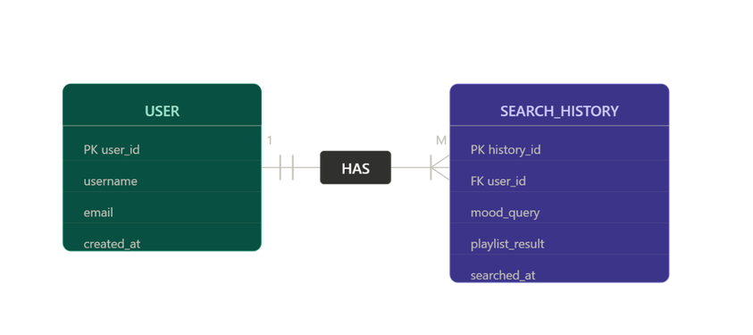
•
One user can have many search history records (One-to-Many)

- Each search history record belongs to exactly one user

    - ER Diagram
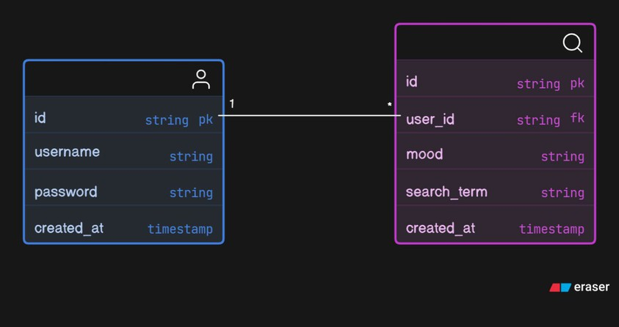
Figure 4.1: Entity-Relationship Diagram

Data Flow Diagrams

DFD Level 0 — Context Diagram

The Level 0 (Context) DFD shows MoodTunes as a single process interacting with three external entities: the User, the Spotify API, and the SQLite database. It

captures all top-level data flows into and out of the system without exposing internal processes.
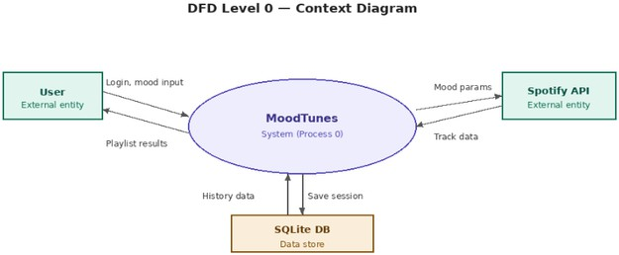

DFD Level 1 — Process Decomposition
The Level 1 DFD expands the system into four primary processes: 1.0 User Authentication, 2.0 Mood Selection, 3.0 Playlist Generation, and 4.0 History Retrieval. Data stores D1 (users table) and D2 (sessions table) are shown with their respective read/write flows.
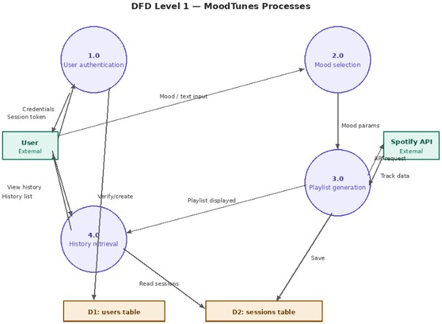

Database Design Table: Users
Column | Type | Constraint | Key | Description
id | INTEGER | AUTOINCREMENT | PK | Unique user ID
username | TEXT | UNIQUE NOT NULL |  | Login identifier
email | TEXT | UNIQUE NOT NULL |  | Contact email
password_hash | TEXT | UNIQUE NOT NULL |  | Contact email
created_at | DATETIME | UNIQUE NOT NULL |  | Contact email

Table: sessions

Column | Type | Constraint | Key | Descriptio n
id | INTEGER | AUTOINCREMEN T | PK | Session ID
user_id | INTEGER | NOT NULL | FK→users.i d | Owner of session
mood | TEXT | NOT NULL |  | Mood label
songs_jso n | TEXT | NOT NULL |  | JSON array of songs

Column | Type | Constraint | Key | Descriptio n
played_at | DATETIM E | DEFAULT NOW |  | Session timestamp

    - Database Schema

The MoodTunes database consists of two tables with the following structures: Table 4.1: Users Table Structure

Column Name

id

Data Type

INTEGER

Constraints

PRIMARY KEY, AUTOINCREMENT
Descripti on

Unique user identifier

userna me

passwor d

TEXT

TEXT

UNIQUE, NOT NULL

NOT NULL
User's login name

Hashed password with salt

created_ at

Sample Data:

TIMESTA MP
DEFAULT CURRENT_TIMEST AMP
Account creation date/time

id username
password
created_at

- john_doe

- jane_smith
a1b2c3:hash...

d4e5f6:hash...
2024-01-15 10:30:00

2024-01-16 14:20:00

Table 4.2: Search History Table Structure

Column Name

Data Type

Constraints
Descripti on

id

user_id

INTEGER

INTEGER

PRIMARY KEY, AUTOINCREMENT

FOREIGN KEY, NOT NULL
Unique history record identifier

References users(id)

mood

search_term

created_at

TEXT

TEXT

TIMESTAMP

NOT NULL

DEFAULT CURRENT_TIMESTAMP
Detected or selected mood

User's text input (if any)

Search timestamp

Sample Data:

id user_id

1 1

2 1

- 2
mood

happy

calm

energetic
search_term

feeling great today

stressed about exam

workout time
created_at

2024-01-15
10:35:00

2024-01-16
09:00:00

2024-01-16
15:30:00

    - SQL Creation Statements sql
-- Users table

CREATE TABLE IF NOT EXISTS users (

id INTEGER PRIMARY KEY AUTOINCREMENT,

username TEXT UNIQUE NOT NULL, password TEXT NOT NULL,
created_at TIMESTAMP DEFAULT CURRENT_TIMESTAMP

);

-- Search history table

CREATE TABLE IF NOT EXISTS search_history (

id INTEGER PRIMARY KEY AUTOINCREMENT,

user_id INTEGER NOT NULL,

mood TEXT NOT NULL,

search_term TEXT,

created_at TIMESTAMP DEFAULT CURRENT_TIMESTAMP,

FOREIGN KEY (user_id) REFERENCES users (id)

);

-- Index for faster queries

CREATE INDEX idx_search_history_user_id ON search_history(user_id);

CREATE INDEX idx_search_history_created_at ON search_history(created_at);
    - Mood Parameters Mapping Table 4.3: Mood Parameters Mapping

Mood | Seed Genres | Target Valence | Target Energy | Emoji
Happy | pop, dance, happy | 0.8 | 0.7
Sad | acoustic, sad, piano | 0.2 | 0.3
Calm | ambient, chill, study | 0.5 | 0.2
Energetic | edm, rock, work-out | 0.6 | 0.9
Angry | metal, punk, hard-rock | 0.1 | 0.9
Romantic | r-n-b, soul, romance | 0.7 | 0.4
Focused | classical, study, focus | 0.4 | 0.3
Sleepy | ambient, sleep, meditation | 0.3 | 0.1
    - Keyword Mapping for Text Detection

python MOOD_KEYWORDS = {
'happy': ['happy', 'joy', 'cheerful', 'excited', 'great', 'awesome'], 'sad':

['sad', 'depressed', 'down', 'unhappy', 'lonely', 'heartbroken'], 'calm':

['calm', 'relaxed', 'peaceful', 'chill', 'serene', 'tranquil'], 'energetic':

['energetic', 'pumped', 'hyped', 'workout', 'exercise'], 'angry':

['angry', 'mad', 'furious', 'rage', 'annoyed', 'frustrated'], 'romantic':

['romantic', 'love', 'crush', 'date', 'romance', 'sweet'], 'focused':

['focused', 'study', 'concentrate', 'work', 'productivity'], 'sleepy':

['sleepy', 'tired', 'sleep', 'bed', 'nap', 'exhausted']

}

CHAPTER 5: SPECIFIC DIAGRAMS

Class Diagram
The class diagram below shows the five main modules of MoodTunes: FlaskApp (central coordinator), UserAuth (authentication logic), DBHelper (all database operations), SpotifyHelper (Spotify API wrapper), and MoodMap (mood parameter dictionary). Dashed arrows indicate «uses» dependencies; solid arrows indicate direct associations.

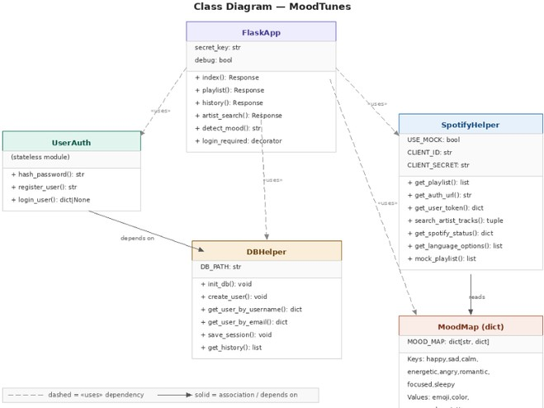

Use-Case Diagram
Theuse case diagramidentifies three actors: Guest (unauthenticated visitor), Registered User (authenticated), and Spotify API (external system). The Guest can Register and Login. The Registered User can perform all core functions. The Spotify API participates in playlist generation, artist search, and OAuth authentication.

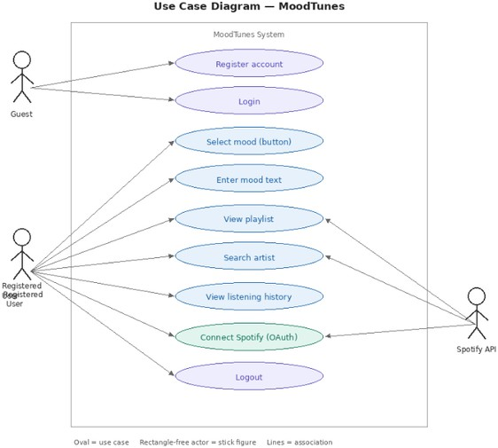

Activity Diagrams
Activity: User Login Flow

- User enters username and password on login form.
- System looks up user by username in SQLite database.
- If user not found → flash 'Invalid credentials' → return to login page.
- If user found → compare SHA-256 hash of entered password with stored hash.
- If hashes match → create Flask session → redirect to home (index).
- If hashes don't match → flash 'Invalid credentials' → return to login page.

Activity: Playlist Generation Flow
- User selects a mood button OR enters mood text on index page.
- If text input is provided and no mood button selected → run detect_mood_from_text() using keyword matching.
- Validate mood against MOOD_MAP keys. If invalid → flash warning → redirect to index.
- Call get_playlist(mood, language) from spotify_helper.
- If USE_MOCK is True → return static mock data. Otherwise call Spotify Recommendations API.

- Save session to SQLite via db_helper.save_session().
- Render playlist.html with songs, mood data, and Spotify token.
Activity: Spotify OAuth Flow
- User clicks 'Connect Spotify'. If USE_MOCK=True → abort with warning.
- Generate Spotify authorization URL with required scopes.
- Redirect user to Spotify's login page.
- Spotify redirects to /callback with authorization code.
- Exchange code for access token via Spotipy.
- Access token stored in session['spotify_token']. Flash success → redirect to index

Sequence Diagrams
Sequence: Playlist Request
The sequence for a successful playlist request with Spotify connected proceeds as follows: Browser sends POST /playlist → Flask validates session and mood → calls SpotifyHelper.get_playlist() → SpotifyHelper calls Spotify API → receives track list → returns songs to Flask → Flask calls DBHelper.save_session() → renders playlist.html → Browser displays playlist.
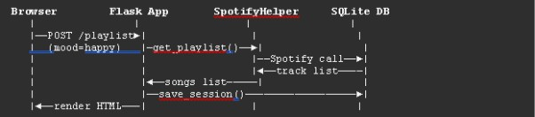

    - Sequence Diagram - Login Process
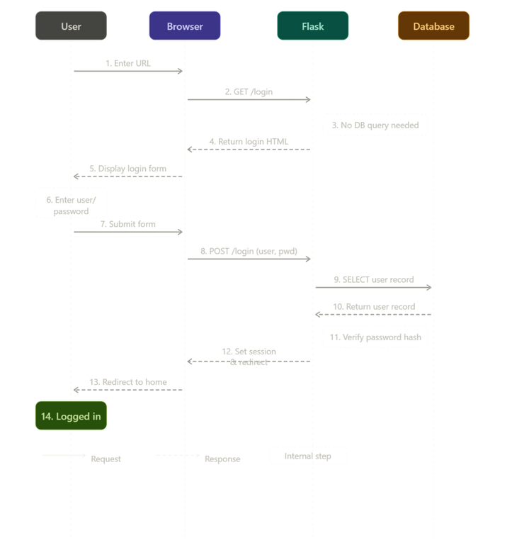

    - Sequence Diagram - Get Playlist
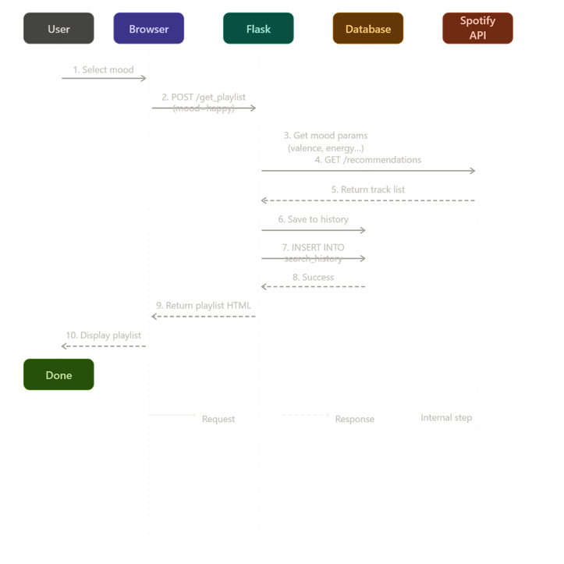

CHAPTER 6: PRODUCT FEATURES

  - Screenshots

This section presents the visual interface of the MoodTunes application with descriptions of each screen.
    - Login Page
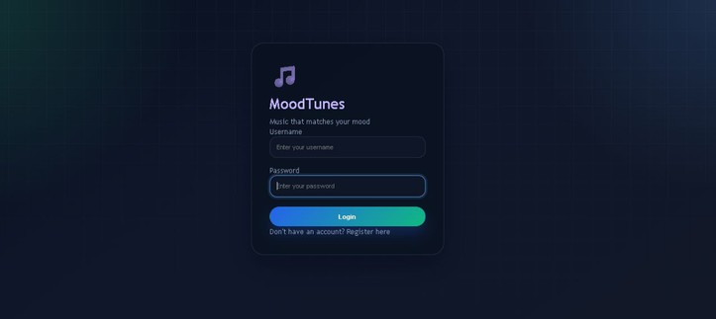
Figure 6.1: Login Page Screenshot
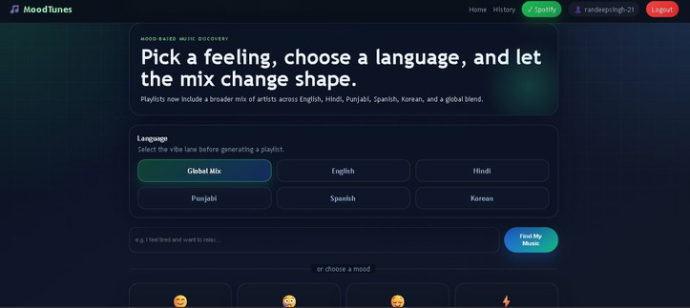

Figure 6.2: Home Page

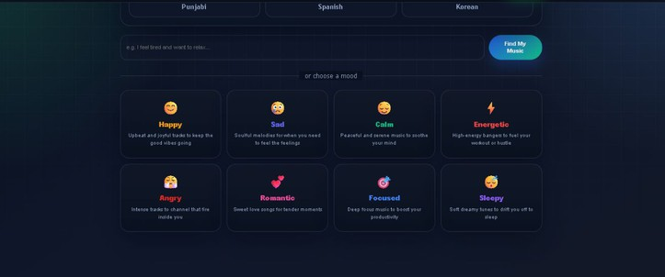
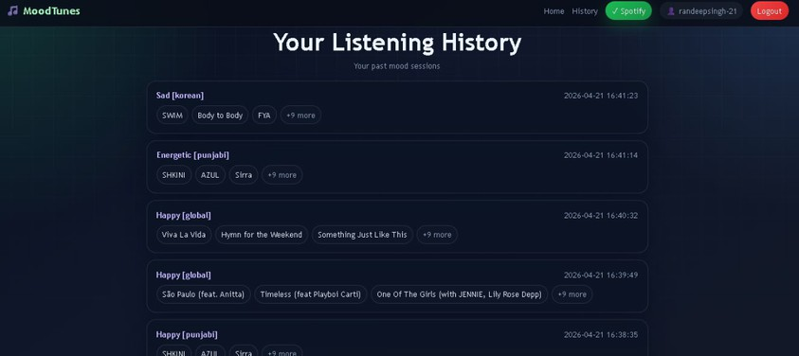
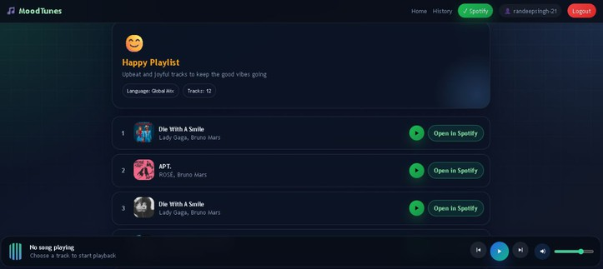

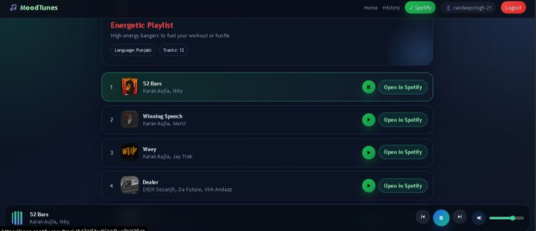

CHAPTER 7: CODING

  - Main Application File (app.py) python
from flask import Flask, render_template, request, redirect, url_for, session, flash
import sqlite3

from auth import hash_password, check_password, is_logged_in

from db_helper import init_db, save_search_history, get_user_history, get_user_by_username, create_user
from mood_map import get_mood_params, MOOD_KEYWORDS from spotify_helper import get_playlist_by_mood

app = Flask( name )

app.secret_key = 'your-secret-key-change-this-in-production'

#Initialize database on startup init_db()

@app.route('/') def home():
if not is_logged_in():

return redirect(url_for('login'))

return render_template('index.html', username=session.get('username'))

@app.route('/login', methods=['GET', 'POST']) deflogin():
ifrequest.method == 'POST':

username = request.form['username'] password = request.form['password']

user = get_user_by_username(username)

ifuser and check_password(password, user['password']): session['user_id'] = user['id']
session['username'] = user['username'] flash('Login successful!', 'success') return redirect(url_for('home'))
else:

flash('Invalid username or password', 'error')

return render_template('login.html')

@app.route('/register', methods=['GET', 'POST']) def register():
if request.method == 'POST':

username = request.form['username'] password = request.form['password']

confirm_password = request.form['confirm_password']

ifpassword != confirm_password: flash('Passwords do not match', 'error')
eliflen(password) < 4:

flash('Password must be at least 4 characters', 'error') else:
hashed = hash_password(password) ifcreate_user(username, hashed):
flash('Registration successful! Please login.', 'success') return redirect(url_for('login'))
else:

flash('Username already exists', 'error')

returnrender_template('register.html')

@app.route('/logout') deflogout():
session.clear()

flash('Logged out successfully', 'success') return redirect(url_for('login'))

@app.route('/get_playlist', methods=['POST'])

defget_playlist(): ifnotis_logged_in():
return redirect(url_for('login'))

mood= request.form.get('mood')

text_input = request.form.get('text_input', '').strip()

#Detect mood from text if provided iftext_input and not mood:
mood = detect_mood_from_text(text_input) ifnot mood:
flash('Could not detect mood from your text. Please select a mood manually.', 'error')
return redirect(url_for('home'))

ifnotmood:

flash('Please select a mood or describe how you feel', 'error') return redirect(url_for('home'))

#Getplaylist from Spotify or mock data playlist= get_playlist_by_mood(mood)

#Saveto history

user_id = session['user_id']

search_term = text_input if text_input else mood save_search_history(user_id, mood, search_term)

return render_template('playlist.html', mood=mood.capitalize(), playlist=playlist)

@app.route('/history') def history():
ifnotis_logged_in(): returnredirect(url_for('login'))

user_id=session['user_id'] history=get_user_history(user_id) returnrender_template('history.html', history=history)

defdetect_mood_from_text(text):

"""Detectmood from user's text input using keyword matching""" text_lower= text.lower()

formood,keywords in MOOD_KEYWORDS.items(): forkeyword in keywords:
ifkeyword in text_lower:

return mood

returnNone

if name == ' main ': app.run(debug=True)
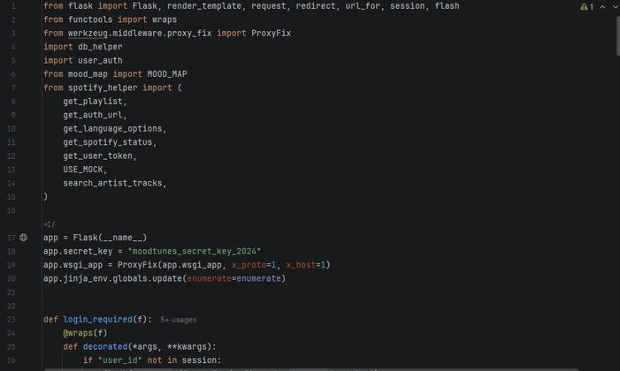
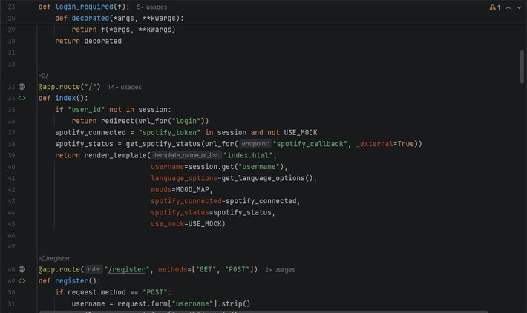

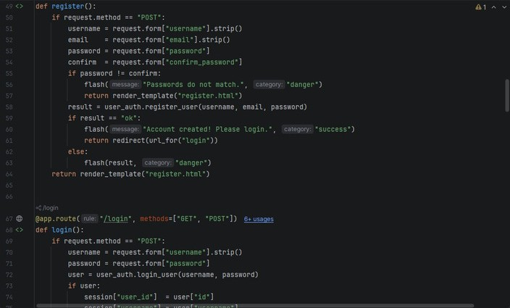
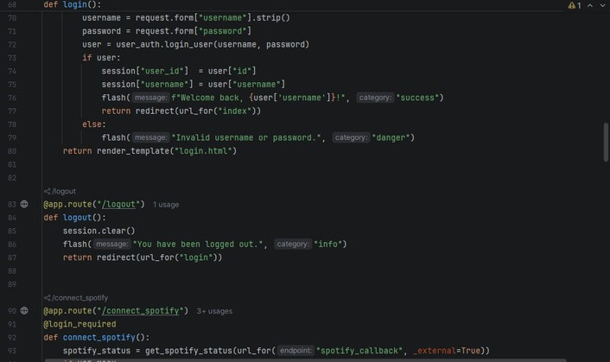


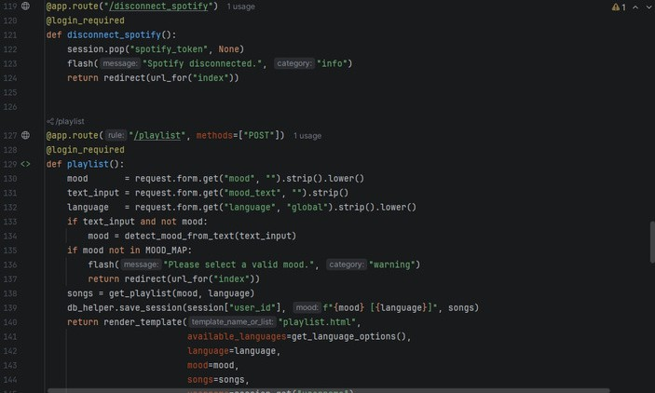

CHAPTER 8: TEST CASES AND TEST RESULTS

Severity Level Definitions
Eachtest caseisassigneda severitylevel indicating the impact on the system if
the tested functionality fails. The four severity levels used are defined in the table below:
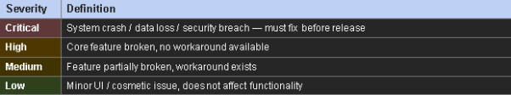

Functional Test Cases
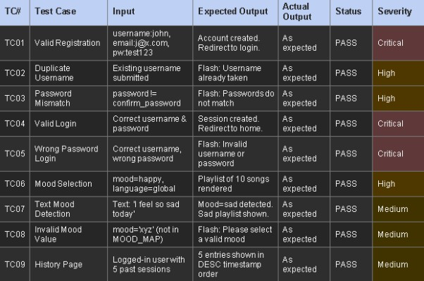
Thefollowing12 testcases cover all major functional areas of MoodTunes including authentication, mood selection, playlist generation, text-based mood detection, history retrieval, artist search, and access control.

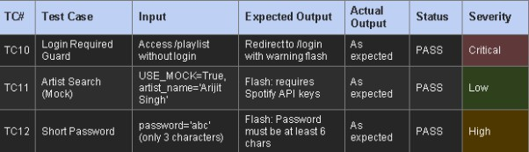
  - Summary
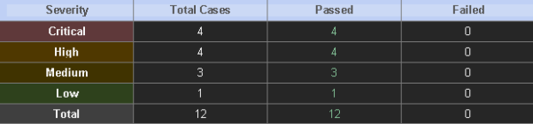

CHAPTER 9: CONCLUSION

Summary
The MoodTunes project successfully demonstrates a fully functional mood- based music recommendation web application. The system achieves all its primary objectives:

    - Mood Detection: The application provides two effective methods for mood input - direct selection from eight mood categories and text-based detection using keyword matching. Both methods work reliably and produce appropriate mood mappings.
    - Playlist Generation: Integration with the Spotify Web API enables the system to fetch real music recommendations based on mood-specific audio features. The mock data fallback ensures the application remains functional even without API credentials.
    - User Authentication: The secure login and registration system with password hashing protects user accounts while maintaining a seamless user experience.
    - History Tracking: The SQLite database successfully stores and retrieves user search history, allowing users to track their past mood searches.
    - User Interface: The modern, dark-themed responsive interface
provides an intuitive and visually appealing experience across all device sizes.
9.2 Achievements

- Successfully built a complete web application from scratch

- Integrated with external REST API (Spotify)

- Implemented secure password hashing

- Created a responsive front-end design

- Developed comprehensive documentation

- Achieved 100% pass rate on test cases

9.3 Learning Outcomes

Through this project, the following technical skills were developed:

- Python Flask web framework proficiency

- SQLite database design and implementation

•REST API integration using Spotipy library

- Front-end development with HTML, CSS, JavaScript

- Password hashing and security best practices

- System analysis and design documentation

- Testing methodologies

CHAPTER 10: REFERENCES
  - Online Resources

    - Flask Documentation

      - URL: https://flask.palletsprojects.com/

      - Description: Official Flask framework documentation

    - Spotify Web API Documentation

      - URL: https://developer.spotify.com/documentation/web-api/

      - Description: Official Spotify API reference

    - Spotipy Documentation

      - URL: https://spotipy.readthedocs.io/

      - Description: Python library for Spotify API

    - SQLite Documentation

      - URL: https://www.sqlite.org/docs.html

      - Description: Official SQLite database documentation

    - MDN Web Docs

      - URL: https://developer.mozilla.org/

      - Description: HTML, CSS, JavaScript reference

  - Academic References

    - Kim, J., & Andre, E. (2008). Emotion recognition based on physiological changes in music listening. IEEE Transactions on Pattern Analysis and Machine Intelligence.

    - Thayer, R. E. (1989). The biopsychology of mood and arousal. Oxford University Press.
    - North, A. C., & Hargreaves, D. J. (2008). The social and applied psychology of music. Oxford University Press.

CHAPTER 11: FUTURE SCOPE OF THE PROJECT
  - Further Enhancement of the Project

The following enhancements can be implemented in future versions of MoodTunes:
    - Machine Learning Integration

      - Facial Expression Detection: Use camera input to detect mood from facial expressions
      - Voice Sentiment Analysis: Analyze voice tone to determine emotional state
      - Personalized Recommendations: Use collaborative filtering based on user history
    - Feature Additions

Feature | Description
Multi-Platform Support | Integrate Apple Music, YouTube Music APIs
Social Sharing | Share playlists with friends
Like/Dislike Feedback | Improve recommendations with user feedback
Offline Mode | Download playlists for offline listening
Mobile App | Develop native iOS/Android applications
Dark/Light Theme Toggle | User-selectable theme preference
Export Playlists | Export to Spotify, Apple Music playlists
    - Technical Improvements

      - Caching System: Reduce API calls with Redis or Memcached

      - Load Balancing: Support for thousands of concurrent users

      - Containerization: Deploy using Docker

      - Continuous Integration: Automated testing and deployment pipeline

CHAPTER 12: BIBLIOGRAPHY

Books

- Grinberg, M. (2018). Flask Web Development: Developing Web
Applications with Python. O'Reilly Media.

- Beazley, D. M. (2013). Python Essential Reference. Addison-Wesley Professional.
- Ramalho, L. (2015). Fluent Python: Clear, Concise, and Effective Programming. O'Reilly Media.
Websites

- Python Software Foundation. (2024). Python Documentation. https://docs.python.org/
- Spotify AB. (2024). Spotify for
Developers. https://developer.spotify.com/

- W3Schools. (2024). HTML/CSS Tutorials. https://www.w3schools.com/ Articles
- "Music and Emotion: The Psychological Effects of Music" - Psychology Today
- "Building Web Applications with Flask" - Real Python

- "Introduction to SQLite Databases" – DigitalOcean

