 **Centre of Excellence in Artificial Intelligence**

**AI42001:Machine Learning Foundations and Applications**

**Name**-Vaibhav Gupta **Roll Number**-20IE10041

**Date:**15-01-2024 **Assignment -**1

**a. Experiment 1: A table containing the first 8 rows to get an overview of the data.**

OrderID Product Quantity Price Date

0 1 Product_A 10 20.0 01-01-2023

1 2 Product_B 5 15.0 02-01-2023

2 3 Product_A 8 20.0 03-01-2023

3 4 Product_C 12 25.0 05-01-2023

4 5 Product_B 6 15.0 01-02-2023

5 6 Product_A 15 20.0 02-02-2023

6 7 Product_C 10 25.0 03-02-2023

7 8 Product_A 7 NaN 01-03-2023

**b. Experiment 2: A table containing each group name and corresponding number of**

**missing values.**

Column names Count of Missing Values

0 OrderID 0

1 Product 0

2 Quantity 0

3 Price 2

4 Date 0

**c. Experiment 3: A line plot of the revenue trend over date. Proper labeling on the**

**plot should be there (X-label, Y-label, Title, and legend).**

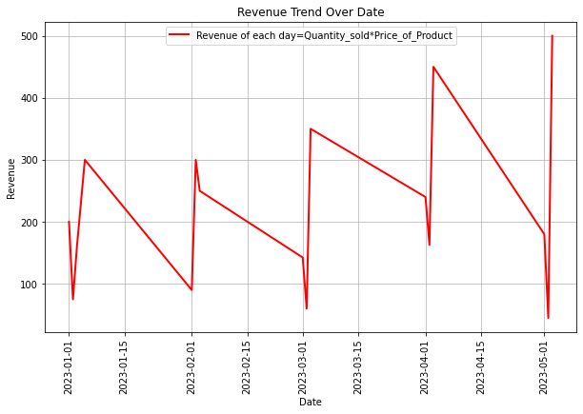

**d. Experiment 4: Mention total number of orders and total revenue.**

Total Number of Orders: 16

Total Revenue Generated: 3505.36

**e. Experiment 5: A table containing three individual products and corresponding**

**average price. A bar plot which plots the average price for each product. Mention**

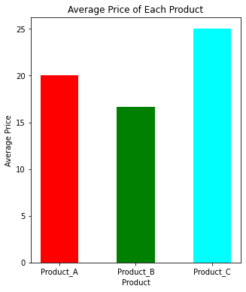**the most sold product.**

Average Price of Each Product:

Product Average_Price

0 Product_A 20.040984

1 Product_B 16.648352

2 Product_C 25.000000

Top Most Sold Products:

Product Quantity

2 Product_C 74

0 Product_A 61

1 Product_B 26

As we can see the most sold product is

Product_C .