 **Centre of Excellence in Artificial Intelligence**

**AI42001:Machine Learning Foundations and Applications**

**Name**-Vaibhav Gupta **Roll Number**-20IE10041

**Date:**22-03-2024 **Assignment -**5

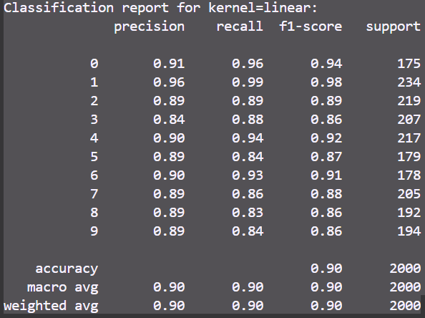Support Vector Classifier (SVC)

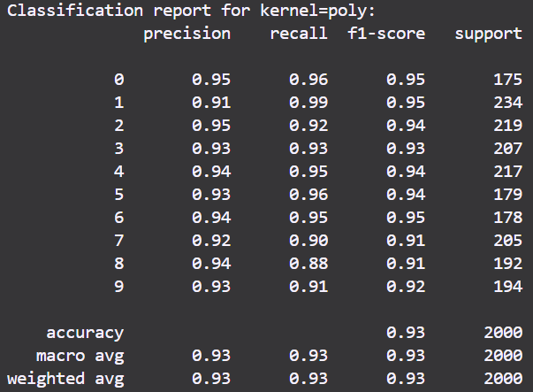

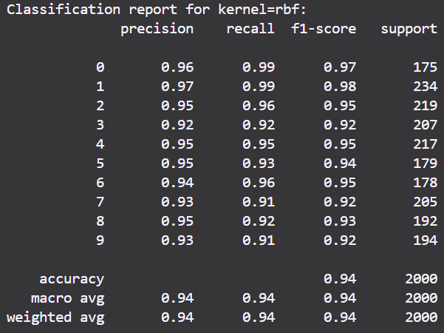

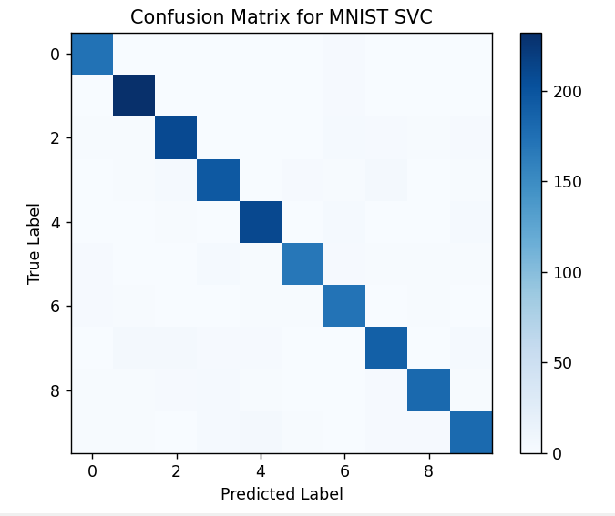

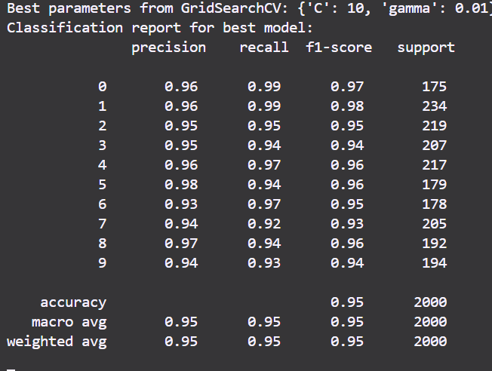

Support Vector Regressor

MSE with default parameter: 1.3922086000291185

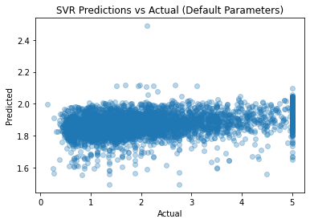

Best epsilon from GridSearchCV: 1.0

MSE with best epsilon: 1.3558710340977345

