 **Centre of Excellence in Artificial Intelligence**

**AI42001:Machine Learning Foundations and Applications**

**Name**-Vaibhav Gupta **Roll Number**-20IE10041

**Date:**04-04-2024 **Lab Test-** 2

**­Experiment -1**

Seed value is  **2020**

Device is set to cpu

**­Experiment -2**

Batch size : 64

Overall dataset size: 9778

Training dataset size: 6844

Validation dataset size: 1467

Testing dataset size: 1467

**­Experiment -3**

Number of convolutions kernels used=2

Their sizes =3 each

Stride and padding =1 each for both convolutions

Number of neurons in fully connected layer(in-features)

32*8*8*4 =8192 in fully connected layer 1

128 in fully connected layer 2

64 in fully connected layer 3

**­Experiment -4**

Epoch 1, Train Loss: 550.9565, Val Loss: 394.6166

Epoch 2, Train Loss: 264.5594, Val Loss: 257.9753

Epoch 3, Train Loss: 210.8244, Val Loss: 206.5028

Epoch 4, Train Loss: 171.0928, Val Loss: 178.6010

Epoch 5, Train Loss: 144.1420, Val Loss: 157.2039

Epoch 6, Train Loss: 124.3910, Val Loss: 141.5390

Epoch 7, Train Loss: 109.0830, Val Loss: 149.9724

Epoch 8, Train Loss: 101.8264, Val Loss: 133.5369

Epoch 9, Train Loss: 86.4322, Val Loss: 123.9142

Epoch 10, Train Loss: 78.9618, Val Loss: 118.1720

Epoch 11, Train Loss: 70.1299, Val Loss: 117.4720

Epoch 12, Train Loss: 61.3971, Val Loss: 109.9009

Epoch 13, Train Loss: 57.3601, Val Loss: 111.8619

Epoch 14, Train Loss: 51.9370, Val Loss: 111.3211

Epoch 15, Train Loss: 46.3610, Val Loss: 108.3390

Epoch 16, Train Loss: 41.5984, Val Loss: 108.6124

Epoch 17, Train Loss: 40.2870, Val Loss: 109.6553

Epoch 18, Train Loss: 35.3477, Val Loss: 114.9221

Epoch 19, Train Loss: 31.0518, Val Loss: 106.3665

Epoch 20, Train Loss: 28.0818, Val Loss: 111.5027

Epoch 21, Train Loss: 25.4106, Val Loss: 110.0603

Epoch 22, Train Loss: 22.4692, Val Loss: 109.3164

Epoch 23, Train Loss: 20.9518, Val Loss: 110.1736

Epoch 24, Train Loss: 18.4323, Val Loss: 123.6956

Epoch 25, Train Loss: 16.4685, Val Loss: 128.6486

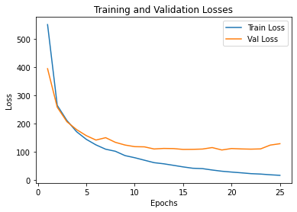

**Experiment-5**

Test Loss: 118.6217 (MSE)

