Sentinel-4337
Project title:
Sentinel-4337: Zero-Trust Threat Detection in ERC-4337 Alt-Mempools via ZK-Gated Account Abstraction
Team: Vaibhavi Kalluri • Shreya Sinha • Shambhavi Kumar • Pallavi P
Important scope statement: The implemented prototype includes Solidity policy components, saved Random Forest inference, controlled benchmark evidence, and a local Flask demo. The browser does not submit UserOperations; genuine cryptographic ZK verification and ML-to-on-chain gating are future work.

1. Introduction
Sentinel-4337 investigates security beyond basic authorization for ERC-4337 smart accounts. It combines deterministic policy rules, a trace-derived Random Forest monitoring model and an interactive research-prototype interface. A correctly signed UserOperation may still invoke risky contracts, approvals or multi-call sequences. The project addresses this distinction through layered checks and explainable local decisions. [1]

Team contributions and work-package responsibilities
The following is a balanced work-package presentation for the four-member project. Confirm it against the team’s actual work records before submitting as a historical account of individual contributions.
Team member | Primary work package | Deliverables / responsibility
Vaibhavi Kalluri | System architecture and core integration (lead) | ERC-4337 policy architecture; integration of ML, Solidity and Flask; validation of end-to-end prototype narrative
Shreya Sinha | Literature review and research methodology | ERC-4337 security background; DiT-SGCR and FAAN-GBM analysis; comparative study and research gap
Shambhavi Kumar | Data pipeline and ML evaluation | Feature definitions, preprocessing methodology, benchmark protocol, metrics and error analysis
Pallavi P | Testing, UI and documentation | Smart-wallet demonstration scenarios, testing strategy, diagrams, report preparation and demonstration workflow

1.1 Problem statement and need
Problem statement: Existing authorization checks cannot by themselves determine whether an ERC-4337 UserOperation is safe. Risky approvals, target substitution, malicious delegation and batched actions may be validly signed. A research prototype is needed that combines explicit policy restrictions with behavior-based risk signals, while making outcomes interpretable. The prototype does not claim to prevent all attacks or enforce ML decisions on-chain.

2. Current status of the problem, sites/APIs used and references
Related work primarily studies Ethereum malicious/phishing accounts through graph and neighbor representations. DiT-SGCR uses directed temporal graph embeddings and clustering; FAAN-GBM uses attention-enhanced node features, autoencoder learning and GBM. These are not direct ERC-4337 UserOperation policy systems. [2,3]

Literature review: methods, tables and research gap

Study A — DiT-SGCR (Tian et al., 2025)
Research question: How can Ethereum malicious accounts be detected by representing directed, time-evolving transaction relationships and global account clusters? The paper proposes a graph representation encoder using directional temporal aggregation, differentiable clustering and graph Laplacian regularization. A downstream Random Forest performs account classification. It evaluates account-level graph datasets, not ERC-4337 UserOperation safety decisions. [2]
Dataset (Table II) | Precision | Recall | F1 | Weighted F1
MulDiGraph | 0.8922 | 0.9403 | 0.9156 | 0.9461
B4E | 0.7872 | 0.8780 | 0.8301 | 0.8837
Transactions Network | 0.8763 | 0.9341 | 0.9043 | 0.9282

Interpretation: Direction, temporal order and clustering can improve representation of suspicious account relationships. Transfer to Sentinel would require constructing transaction-level graphs and evaluating real labels; the current Sentinel RF does not consume these graph embeddings.

Study B — FAAN-GBM (Liu et al., 2024)
Research question: How can phishing-account detection improve by enhancing basic, transaction and neighbor-interaction features? FAAN-GBM combines feature importance, attention-based neighbor aggregation, autoencoder-based nonlinear feature learning and gradient boosting. It evaluates labeled Ethereum phishing nodes. [3]
Dataset (Tables 3–4) | Accuracy | Precision | Recall | F1 | ROC-AUC | PR-AUC
EthereumData1 | 0.9954 | 0.9988 | 0.9920 | 0.9954 | 0.9997 | 0.9997
EthereumData2 | 0.9925 | 0.9958 | 0.9892 | 0.9924 | 0.9994 | 0.9995

How the papers differ from Sentinel-4337
Dimension | DiT-SGCR | FAAN-GBM | Sentinel-4337
Target | Malicious Ethereum accounts | Phishing Ethereum nodes | UserOperation-derived feature perturbations + smart-wallet policy
Representation | Directed temporal graphs, global clusters | Node/neighbor features and attention | 17 tabular trace count/flag/log features
Learning | Graph encoder + RF | Attention, autoencoder + GBM | Random Forest
Ground truth | Paper account datasets | Paper phishing datasets | Unmodified background vs controlled synthetic perturbation
Decision point | Account classification | Account classification | Local advisory + independent deterministic policy
ZK | Not core to paper | Not core to paper | Proposed, not cryptographically implemented

Critical comparison rule: These F1 values are not a head-to-head benchmark. The datasets, labels, unit of prediction and experimental objectives differ; Sentinel cannot claim superiority from cross-paper numbers.

Websites, APIs and development resources
Source / site | Purpose | Observed status or limitation
ERC-4337 EIP: eips.ethereum.org/EIPS/eip-4337 | Protocol specification | Technical reference for UserOperation, bundlers, EntryPoint [1]
JiffyScan: jiffyscan.xyz | Attempted UserOperation/bundle data retrieval | Project recorded HTTP 502 for getUserOp and empty latest-bundle responses in tested attempts; not a universal service claim [7]
Foundry: book.getfoundry.sh | Local contract testing and Anvil | Used as development/test framework [8]
arXiv:2506.20123 | DiT-SGCR literature | Uploaded paper, Table II [2]
doi.org/10.3390/electronics13245060 | FAAN-GBM literature | Uploaded paper, Tables 3–4 [3]

Research gap
The cited papers classify account-level maliciousness or phishing on their respective labeled datasets. Sentinel studies ERC-4337 operation-derived aggregates and explicit smart-account policy checks. However, a verified malicious UserOperation dataset was not obtained; the experimental positive label is a controlled perturbation. Thus the prototype provides a reproducible methodological step, not deployment-grade threat-detection evidence.

3. Proposed solution

Proposed and implemented system architecture
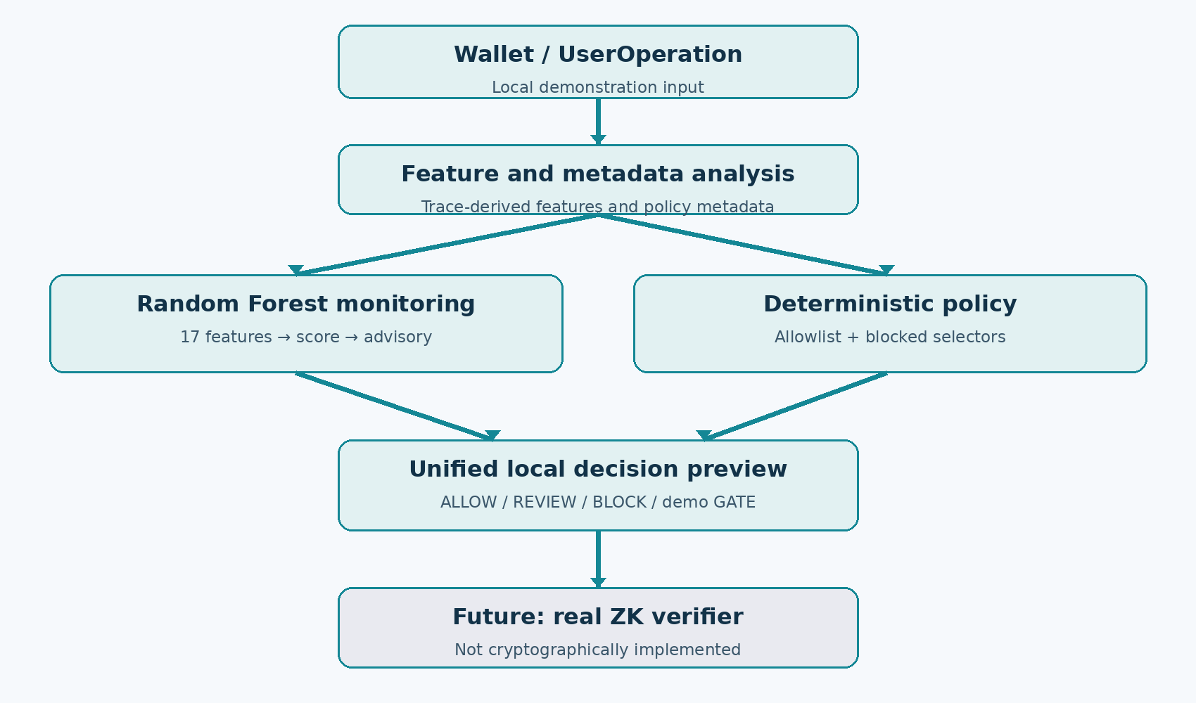
Figure 1. Architecture and implementation boundaries; the ZK verifier is explicitly future work.
Zero-trust principle: a valid signature is authorization, not a guarantee of safe behavior. Sentinel combines explicit policy restrictions with a separate behavioral signal. The original PPT proposes execution graphs, wallet-habit baselines, temporal context, GNN modeling and ZK gating. The implemented benchmark instead uses tabular trace-derived features and a Random Forest.

Components and source files
Layer | Repository location | Role and limitation
Smart account | src/SentinelAccount.sol | ERC-4337 account execution and policy integration
Factory | src/SentinelAccountFactory.sol | Deterministic smart-account deployment
Policy | src/SentinelPolicy.sol | Owner-managed target allowlist and selector blocklist
Local tests | test/, script/ | Foundry unit/integration scripts; rerun for final live verification
Metadata rules | monitoring/evaluate_operation.py | ALLOW/FLAG local advisory; not on-chain
ML inference | monitoring/ml_evaluator.py | Loads saved RF; 0.5 REVIEW threshold
Model artifact | models/sentinel_real_background_injected_rf.joblib | Trained Random Forest model
Benchmark | reports/real_background_benchmark/report.json | Saved test metrics and selected validation threshold
Web | server.py, templates/, static/ | Local Flask simulator; no live UserOperation submission
Unified demo | monitoring/prototype_decision.py | Local ALLOW/REVIEW/BLOCK/GATE; GATE simulated

End-to-end demo logic
- Select wallet action, destination, amount, paymaster and optional trace-feature counts.
- Metadata rules examine the supplied operation; the policy preview blocks an unapproved destination.
- The ML evaluator validates six counts and five flags, constructs six log1p features, and loads the saved Random Forest.
- The original evaluator labels REVIEW at score ≥ 0.5, otherwise NO_ML_ALERT.
- The unified prototype separately uses validation-selected review threshold ≈0.44663 and a demo high tier ≈0.8; an unapproved destination takes priority as BLOCK.
- The GATE button is simulated user confirmation; it does not produce a ZK proof or authorize an on-chain operation.

Smart-contract policy details
SentinelPolicy stores owner, allowedTargets and blockedSelectors. Only the owner can change permissions. checkOperation() rejects unapproved destinations, calldata shorter than four bytes, and blocked function selectors. The protected smart-account execution path consults policy and can revert. Batch tests are intended to verify that disallowed actions do not execute through the protected path. The Flask preview is separate from the Solidity transaction path.

Scope boundary and future work
The original proposed system includes full execution-graph reconstruction, temporal/wallet-habit features, graph models, risk-adaptive ZK proof gating and automatic on-chain enforcement. The current working research prototype implements RF scoring, policy logic, a local unified decision and separate Foundry components. Cryptographic ZK verification, live alt-mempool monitoring and ML-to-chain coupling remain future work.

4. Execution section

4.1 Environment and procedure
- Environment: Python virtual environment, Flask UI, scikit-learn/pandas/NumPy/joblib, Solidity, Foundry/Forge and local Anvil.
- Contracts: compile and test src/SentinelPolicy.sol, SentinelAccount.sol and factory/target using forge test; local execution script exercises ERC-4337 separately.
- ML: load the saved Random Forest; validate counts/flags; compute log1p features; score the supplied feature vector.
- Web: start python server.py, open localhost:5050, choose wallet action, recipient and advanced security signals.
- Decision: compare independent metadata, ML and policy preview outputs; for an unapproved destination, BLOCK takes priority in local prototype.
- Safety: local simulator does not submit ETH, deploy ZK proofs or trigger a live chain transaction.

4.2 Example observed demonstration
In the user-supplied October 2026 screenshots, Send ETH with an unapproved destination and 1.2 ETH produced policy preview BLOCK and original ML recommendation NO_ML_ALERT with a score of about 48.7/100. The unified prototype displayed HIGH · BLOCK because policy rejection took priority; HIGH here describes policy severity, not a high ML score. This demonstrates independence of rule enforcement and ML advice, not an actual blockchain rejection.

4.3 Results (numerical)

Data collection, preprocessing, training and numerical results
Collection challenge: the project records describe JiffyScan API attempts, including getUserOp returning HTTP 502 and latest-bundle requests yielding empty results in tested cases. Public account-phishing datasets used in the literature are not labeled harmful ERC-4337 UserOperations. Therefore the experiment used real-background operation-derived aggregates plus controlled synthetic feature perturbations; it did not assert real malicious labels. [4,7]
Partition | Rows | Share
Train | 50,400 | 60%
Validation | 16,800 | 20%
Test | 16,800 | 20%
Total | 84,000 | 100%

All 17 model features
Counts (6) | Binary flags (5) | Transforms (6)
trace_count | has_approval | log1p_trace_count
unique_destinations | has_transfer_from | log1p_unique_destinations
approve_trace_count | has_value_transfer | log1p_approve_trace_count
transfer_from_trace_count | has_trace_errors | log1p_transfer_from_trace_count
value_transfer_trace_count | has_paymaster | log1p_value_transfer_trace_count
errored_trace_count | — | log1p_errored_trace_count

Preprocessing: count features are validated as nonnegative integers, flags as booleans/0–1, and related count/flag pairs for consistency. Log features are computed as ln(1 + count). These are aggregate trace-derived features, not full reconstructed EVM execution graphs.
Test metric | Saved result | Meaning
Accuracy | 94.23% | All correctly classified test rows
Precision (class 1) | 95.02% | Share of predicted perturbations that are perturbed
Recall (class 1) | 93.35% | Share of perturbations detected
F1 (class 1) | 94.17% | Precision/recall harmonic mean
ROC-AUC | 98.67% | Class-ranking discrimination
PR-AUC | 98.75% | Precision–recall area
False-positive rate | 4.89% | Background rows incorrectly flagged

Test confusion matrix (16,800 rows)
Actual / predicted | Background (0) | Perturbed (1)
Background (0) | 7,989 TN | 411 FP
Perturbed (1) | 559 FN | 7,841 TP

Validation-selected threshold: 0.4466300357; validation F1: 0.9411623. Original inference evaluator threshold: 0.5. Do not claim the saved test metrics were computed using the 0.5 UI threshold. Benchmark timing reports ≈3.75 seconds model fitting and ≈0.0209 ms test inference per row in its recorded environment; this is not a network latency or full blockchain execution measurement.

Experimental validity and limitations
- Class 1 = controlled synthetic feature perturbation, NOT verified maliciousness.
- Class 0 = unmodified real-background record, NOT confirmed benign behavior.
- Perturbations modify aggregate features without reconstructing full transaction traces.
- Model scores are not calibrated probabilities of theft or compromise.
- No direct performance comparison to the two literature datasets is valid.
- The browser preview is not proof of on-chain blocking or zero-knowledge verification.

4.4 Findings and discussion
The held-out experiment shows high separability between unmodified background records and designed aggregate perturbations (class-1 F1 94.17%, false-positive rate 4.89%). This is evidence of the chosen benchmark’s internal performance, not proof of real-world malicious-operation detection. The deterministic policy offers a separate explainable guardrail, and the web interface makes its decision visible without falsely claiming on-chain submission.

5. Conclusion and future scope
Sentinel-4337 demonstrates the feasibility of combining programmable ERC-4337 security policies, machine-learning advisory signals and an explainable user-facing prototype. Future work includes trace-reconstructed and verified attack datasets, wallet-temporal/graph features, deployment evaluation, a genuine zero-knowledge circuit and verifier, and integration of risk decisions with on-chain account validation.

References and source traceability
[1] Ethereum Improvement Proposal 4337, “Account Abstraction Using Alt Mempool,” https://eips.ethereum.org/EIPS/eip-4337 (technical standard; accessed October 2026).
[2] Ye Tian et al., “DiT-SGCR: Directed Temporal Structural Representation with Global-Cluster Awareness for Ethereum Malicious Account Detection,” arXiv:2506.20123v1, 2025, https://arxiv.org/abs/2506.20123 (uploaded PDF; Table II).
[3] Sheng-Zheng Liu et al., “Detection of Ethereum Phishing Fraud Nodes Based on Feature Enhancement Strategy and GBM,” Electronics 13(24), 5060, 2024, https://doi.org/10.3390/electronics13245060 (uploaded PDF; Tables 3–4).
[4] Project repository: reports/real_background_benchmark/report.json (saved benchmark, confusion matrix, thresholds and limitations).
[5] Project repository: monitoring/ml_evaluator.py; monitoring/evaluate_operation.py; src/SentinelPolicy.sol; src/SentinelAccount.sol; src/SentinelAccountFactory.sol; test/; script/ (implementation evidence).
[6] Project presentation: sentinel-4337-presentation (1).pptx (research motivation, proposed execution-graph/ZK architecture; vision not proof of implementation).
[7] JiffyScan, https://jiffyscan.xyz/ (public ERC-4337 explorer/API ecosystem; the project’s recorded API attempts included HTTP 502 and empty bundle responses; this is not a general service-availability claim).
[8] Foundry documentation, https://book.getfoundry.sh/ (Forge, Anvil and scripting environment).

