1.1. **Store & Display Values in Different Variables:**Create and display variables of different data types, including Integer, Double, Float, Long, Short, Byte, Char, Boolean, and String

fun main(){  
 val a:Int = 5  
 *println*("Integer value = $a")  
 val b:Float = 30.00F  
 *println*("Floating value = $b")  
 val c:Char = 'v'  
 *println*("Character value = $c")  
 val d:String = "vaibhavi"  
 *println*("String value = $d")  
 val e:Double = 30.56  
 *println*("Double value = $e")  
 val f:Long = 15000000000L  
 *println*("Long value = $f")  
 val g:Short = 5000  
 *println*("Short value = $g")  
 val h:Boolean = false  
 *println*("Boolean value = $h")  
 val i:Byte = 127  
 *println*("Byte value = $i")  
}

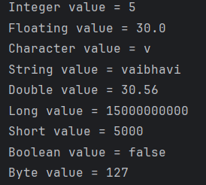

1.2. **Type Conversion:**Perform type conversions such as Integer to Double, String to Integer, and String to Double.

fun main(){  
 var a : Int = 3  
 var b: Double = a.toDouble()  
 *println*("Integer =$a")  
 *println*("Integer to Double = $b")  
 var s1 : String = "100"  
 var c : Int = Integer.valueOf(s1)  
 *println*("String = $s1")  
 *println*("String to Integer = $c")  
 var s2 : String = "10.89"  
 var d :Double =s2.*toDouble*()  
 *println*("String=$s2")  
 *println*("String to Double = $d")  
}

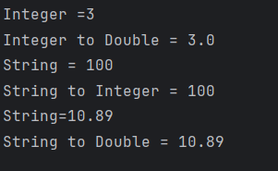

1.3. **Scan student’s information and display all the data:**Input and display data of students, including their name, enrolment no, branch,etc.

fun main(){  
 *println*("Enter Student Enrollment no:")  
 val eno = *readLine*()  
 *println*("Enter Student Name:")  
 val name = *readLine*()  
 *println*("Enter Branch:")  
 val branch = *readLine*()  
 *println*("Enter Class:")  
 val classname = *readLine*()  
 *println*("Enter Batch:")  
 val batch = *readLine*()  
 *println*("Enter CollegeName:")  
 val college = *readLine*()  
 *println*("Enter University:")  
 val uni = *readLine*()  
 *println*("Enter Age:")  
 val age = *readLine*()  
 *println*()  
 *println*("**********************")  
 *println*()  
 *println*("Student Information")  
 *println*("Student Enrollment no: $eno")  
 *println*("Student Name: $name")  
 *println*("Student Branch: $branch")  
 *println*("Student Class: $classname")  
 *println*("Student Batch: $batch")  
 *println*("Student College: $college")  
 *println*("Student University: $uni")  
 *println*("Student Age: $age")  
}

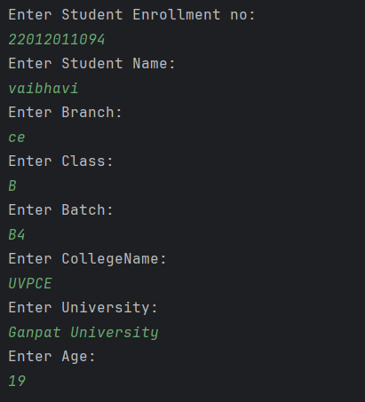

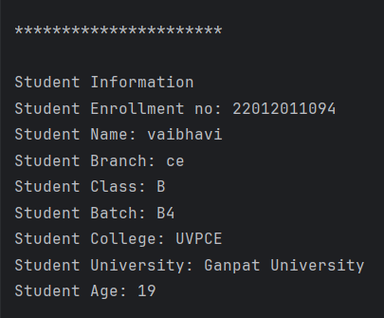

1.4. **Check Odd or Even Numbers:** Determine whether a number is odd or even using control flow within println() method.

fun main(){  
 *println*("Enter Number")  
 val num = *readLine*()!!.*toInt*()  
 *println*(  
 if (num % 2 == 0)  
 {  
 "Even"  
 }  
 else  
 {  
 "Odd"  
 }  
 )  
}

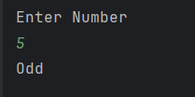

1.5. **Display Month Name:** Use a when expression to display the month name based on user input.

fun main() {  
 *println*("Enter the MonthNumber")  
 val MonthNumber = *readLine*()!!.*toInt*()  
  
 val MonthName = when(MonthNumber) {  
 1 -> "January"  
 2 -> "February"  
 3 -> "March"  
 4 -> "April"  
 5 -> "May"  
 6 -> "June"  
 7 -> "July"  
 8 -> "August"  
 9 -> "September"  
 10 -> "October"  
 11 -> "November"  
 12 -> "December"  
 else -> "Invalid"  
 }  
 *println*(MonthName)  
}

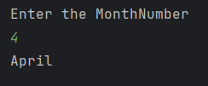

1.6. **User-Defined Function:**Create a user-defined function to perform arithmetic operations (addition, subtraction, multiplication, division) on two numbers

fun main() {  
 *println*("Enter the first number")  
 val a = *readLine*()!!.*toInt*()  
 *println*("Enter the second number")  
 val b = *readLine*()!!.*toInt*()  
  
 *println*("Addition of $a and $b = ${*add*(a,b)}")  
 *println*("Subtraction of $a and $b = ${*sub*(a,b)}")  
 *println*("Multiplication of $a and $b = ${*mul*(a,b)}")  
 *println*("Division of $a and $b = ${*div*(a,b)}")  
  
}

fun add(a:Int,b:Int):Int{  
 return a+b  
}  
fun sub(a:Int,b:Int):Int{  
 return a-b  
}  
fun mul(a:Int,b:Int):Int{  
 return a*b  
}  
fun div(a:Int,b:Int):Int{  
 return a/b  
}

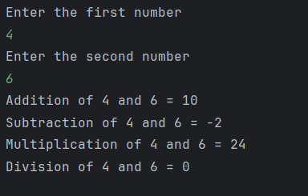

1.7. **Factorial Calculation with Recursion:**Calculate the factorial of a number using recursion.

fun main() {  
 *println*("Enter the number")  
 val num = *readLine*()!!.*toInt*()  
  
 *println*("factorial of $num = ${*fact*(num)}")  
}  
fun fact(num:Int):Int{  
 if(num == 0 || num == 1)  
 {  
 return 1  
 }  
 else  
 {  
 return num\**fact*(num-1)  
 }  
  
}

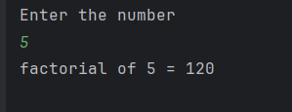

1.8. **Working with Arrays:** Explore array operations such as Arrays.deepToString(), contentDeepToString(), IntArray.joinToString(), and use them to print arrays. Utilize various loop types like range, downTo, until, etc., to manipulate arrays. Sort an array of integers both without using built-in functions and with built-in functions.

import java.util.*  
  
fun main(){  
 val Array_1 = *arrayOf*(1,2,3,4,5)  
 *println*(Array_1.*joinToString*())  
  
 val Array_2 = Array(5)**{**0**}** *println*(Array_2.*joinToString*())  
  
 val Array_3 = Array(7) **{** i **->** i**}** *println*(Array_3.*joinToString*())  
   
 val Array_4 = IntArray(5)**{**0**}** *println*(Array_4.*joinToString*())  
  
 val Array_5 = *intArrayOf*(5, 2, 8, 3, 9)  
 for (i in 0..Array_5.*lastIndex*) {  
 *println*(Array_5[i])  
 }  
  
 val array2D_1 = *arrayOf*(  
 *arrayOf*(1, 2, 3),  
 *arrayOf*(4, 5, 6),  
 *arrayOf*(7, 8, 9)  
 )  
 *println*(java.util.Arrays.deepToString(array2D_1))  
  
 val array2D_2 = *arrayOf*(  
 *intArrayOf*(1, 2, 3),  
 *intArrayOf*(4, 5, 6),  
 *intArrayOf*(7, 8, 9)  
 )  
 *println*(array2D_2.*contentDeepToString*())  
  
 val numbers = IntArray(5)  
 *println*("please enter the values:")  
 for (i in 0 *until* 5) {  
 *print*("Enter value ${i + 1}: ")  
 numbers[i] = *readLine*()!!.*toInt*()  
 }  
 *println*("Values using 'until' statement:")  
 for (i in 0 *until* 5) {  
 *print*("${numbers[i]} ")  
 }  
 *println*()  
 *println*("Values using 'downTo' statement:")  
 for (i in 4 *downTo* 0) {  
 *print*("${numbers[i]} ")  
 }  
  
  
 *println*("**********Shorting with built in function***********")  
 val num = *intArrayOf*(3, 1, 4, 2, 5)  
 numbers.*sort*()  
 *println*(numbers.*joinToString*(", "))  
  
 *println*("**********Shorting without built in function********")  
 val num1 = *intArrayOf*(3, 1, 4, 2, 5)  
 for (i in 0 *until* num1.size - 1) {  
 for (j in 0 *until* num1.size - i - 1) {  
 if (num1[j] > num1[j + 1]) {  
 // Swap elements  
 val temp = num1[j]  
 num1[j] = num1[j + 1]  
 num1[j + 1] = temp  
 }  
 }  
 }  
 *println*(num1.*joinToString*(", "))  
  
  
  
}

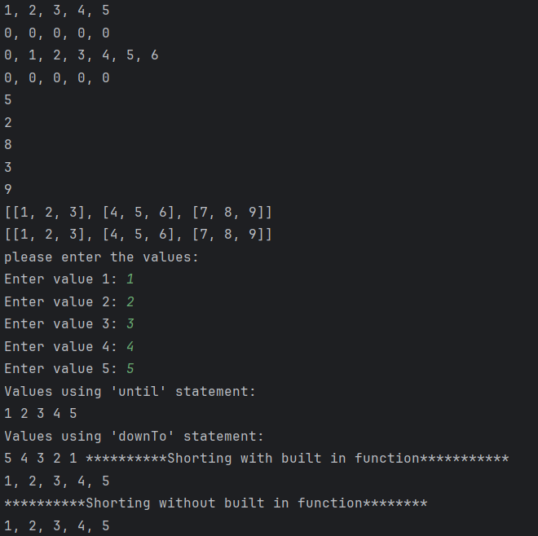

1.9. **Find Maximum Number from ArrayList:** Write a program to find the maximum number from an ArrayList of integers.

fun main(){  
 val Array_1 = *arrayListOf*<Int>()  
 *print*("enter how many numbers do you want to enter?")  
 val size = *readLine*()!!.*toInt*()  
  
 if(size>0){  
 for(i in 1..size){  
 *print*("enter $i number:")  
 val number = *readLine*()!!.*toInt*()  
 Array_1.add(number)  
 }  
 val maxnumber = Array_1.*max*()  
 *println*("maxnumber = $maxnumber")  
 }  
  
}

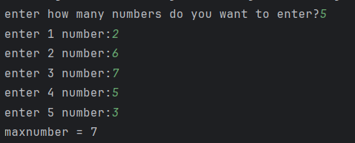

1.10. **Class and Constructor Creation:** Define different classes and constructors. Create a "Car" class with properties like type, model, price, owner, and miles driven. Implement functions to get car information, original car price, current car price, and display car information

class Car(type: String, model:String, price:Double, currentPrice:Double, owner: String,milesDriven:Double){  
 val type:String  
 val model:String  
 val price:Double  
 val currentPrice:Double  
 val owner:String  
 val milesDriven:Double  
  
 init {  
 this.type = type  
 this.model = model  
 this.price = price  
 this.currentPrice= currentPrice  
 this.owner = owner  
 this.milesDriven = milesDriven  
  
 }  
 fun showInfo(){  
 *println*("Car Information: $type,$model")  
 *println*("Car Owner: $owner")  
 *println*("Miles Driven: $milesDriven")  
 *println*("Original Car Price: $price")  
 *println*("Current Car Price: $currentPrice")  
 }  
}  
  
fun main(){  
  
 val car1 = Car("BMW","2018",400000.0,399800.0,"vaibhavi",20.0)  
 val car2 = Car("Toyota","2019",1080000.0,1079000.0,"Krish",100.0)  
  
 car1.showInfo()  
 car2.showInfo()  
   
}

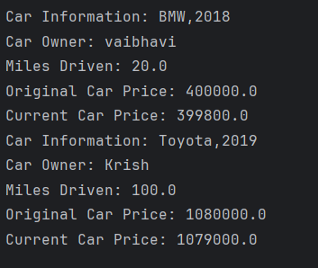

1.11. **Operator Overloading and Matrix Operations:**Explain operator overloading and implement matrix addition, subtraction, and multiplication using a "Matrix" class. Overload the toString() function in the "Matrix" class for customized output.

class Matrix(val data:Array<IntArray>,val rows:Int,val cols:Int){  
  
 // Operator overloading for Matrix addition  
 operator fun plus(other: Matrix): Matrix {  
 if (this.rows != other.rows || this.cols != other.cols) {  
 throw IllegalArgumentException("Matrices must have the same dimensions for addition")  
 }  
  
 val result = Array(rows) **{** IntArray(cols) **}** for (i in 0 *until* rows) {  
 for (j in 0 *until* cols) {  
 result[i][j] = this.data[i][j] + other.data[i][j]  
 }  
 }  
 return Matrix(result, rows, cols)  
 }  
  
 // Operator overloading for Matrix subtraction  
 operator fun minus(other: Matrix): Matrix {  
 if (this.rows != other.rows || this.cols != other.cols) {  
 throw IllegalArgumentException("Matrices must have the same dimensions for subtraction")  
 }  
  
 val result = Array(rows) **{** IntArray(cols) **}** for (i in 0 *until* rows) {  
 for (j in 0 *until* cols) {  
 result[i][j] = this.data[i][j] - other.data[i][j]  
 }  
 }  
 return Matrix(result, rows, cols)  
 }  
  
 // Operator overloading for Matrix multiplication  
 operator fun times(other: Matrix): Matrix {  
 if (this.cols != other.rows) {  
 throw IllegalArgumentException("Number of columns in the first matrix must equal the number of rows in the second matrix for multiplication")  
 }  
  
 val result = Array(this.rows) **{** IntArray(other.cols) **}** for (i in 0 *until* this.rows) {  
 for (j in 0 *until* other.cols) {  
 for (k in 0 *until* this.cols) {  
 result[i][j] += this.data[i][k] * other.data[k][j]  
 }  
 }  
 }  
 return Matrix(result, this.rows, other.cols)  
 }  
  
 override fun toString(): String {  
 val matrixStr = data.*joinToString*("\n") **{** row **->** row.*joinToString*(" ") **}** return "($rows x $cols Matrix):\n$matrixStr"  
 }  
}  
  
  
fun main(){  
  
 val firstMatrix = Matrix(*arrayOf*(*intArrayOf*(3,2,-5), *intArrayOf*(3,0,4)),2,3)  
 val secondMatrix = Matrix(*arrayOf*(*intArrayOf*(2,3), *intArrayOf*(-9,0), *intArrayOf*(0,4)),3,2)  
 val secondMatrix1 = Matrix(*arrayOf*(*intArrayOf*(6,3), *intArrayOf*(9,0), *intArrayOf*(5,4)),3,2)  
  
 *println*("**************Addition*****************")  
 *println*("Matrix1:")  
 *println*("$secondMatrix1")  
 *println*("Matrix2:")  
 *println*("$secondMatrix")  
 val AddMatrix = secondMatrix1 + secondMatrix  
 *println*("Addition = $AddMatrix")  
  
 *println*("**************Subtraction*****************")  
 *println*("Matrix1:")  
 *println*("$secondMatrix1")  
 *println*("Matrix2:")  
 *println*("$secondMatrix")  
 val SubtractMatrix = secondMatrix1 - secondMatrix  
 *println*("Subtraction = $SubtractMatrix")  
  
 *println*("**************Multiplication*****************")  
 *println*("Matrix1:")  
 *println*("$firstMatrix")  
 *println*("Matrix2:")  
 *println*("$secondMatrix")  
 val MulMatrix = firstMatrix * secondMatrix  
 *println*("Multiplication = $MulMatrix")  
  
}

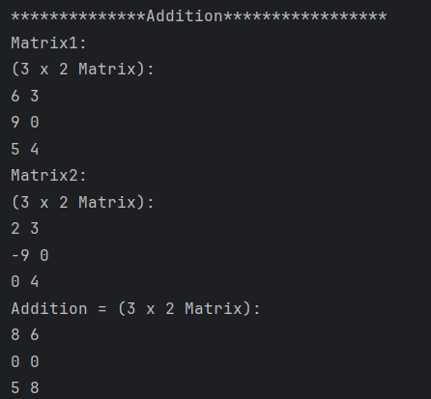

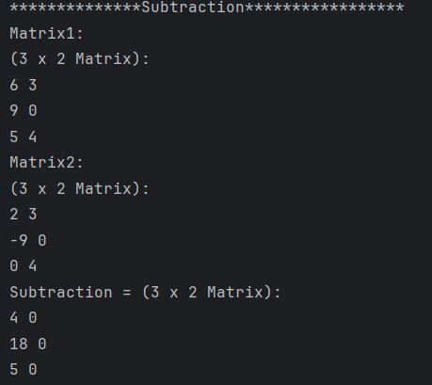

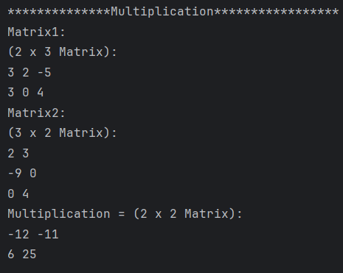

Exercises: KOTLIN PROGRAMS

Swap Value of two variables without using third variable and with using third variable.

2. Create two class named as Product and Laptop. Inherit with this information: Product class should be parent and child class should be Laptop class.

Add Product Name, Quantity, Amount per Quantity in Product class. In Laptop class add CPU name, RAM size, HDD Size, etc. of Laptop configuration.

Create primary and secondary Constructor of both class.

If Primary constructor is there then can we create secondary constructor in inheritance?

If we can create secondary and primary constructor both in child class then what is restriction if parent have more than two different secondary constructor?

Create List of 5 laptops in ArrayList and display all objects information.

3. Create two class named as Person and Student. Inherit with this information: Person class should be parent and child class should be Student class.

Add first name, last name, age in Person class. In Student class add enrollment no, branch, class, lab batch, etc.

Create primary and secondary Constructor of both class.

Create List of 5 students in ArrayList and display all objects information.