**MARKETING ANALYTICS**

**CASE STUDY REPORT (INTEL)**

**Navigating Customer Diversity: A Case Study on Intel's Entry into the Smartwatch**

As Intel ventures into the burgeoning smartwatch market, it faces a fundamental challenge inherent in all industries: **customer heterogeneity**. This phenomenon underscores the reality that consumers are not monolithic in their preferences and behaviors but rather comprise a diverse array of individuals with unique needs, experiences, and influences. Recognizing this, Intel must navigate the intricate landscape of customer diversity to craft an effective marketing strategy.

This report explores Intel's journey into the smartwatch market, emphasizing the critical importance of understanding and leveraging customer heterogeneity. By dissecting the various factors that shape customer preferences, including individual differences, life experiences, functional needs, self- identity/image, and marketing influences, the report aims to equip Intel with actionable insights for success.

As Intel seeks to develop a customer survey to guide its strategy, it is essential to grasp the

underlying sources of customer heterogeneity. This report serves as a roadmap, illuminating the complexities of the market and providing Intel with the tools to tailor its marketing efforts to the diverse needs and preferences of smartwatch consumers.

Intel surveyed university alumni, receiving responses from 1,000 individuals, constituting a 2% response rate. The data is analyzed using R programming language from an Excel sheet.

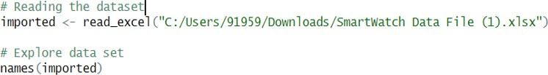

The dataset, as depicted in the provided image, comprises columns detailing smartwatch features like Constant communication, Timely information, Device sturdiness, Task management, Athlete, well-being, and Style. Additionally, demographic information such as age, gender, income, and

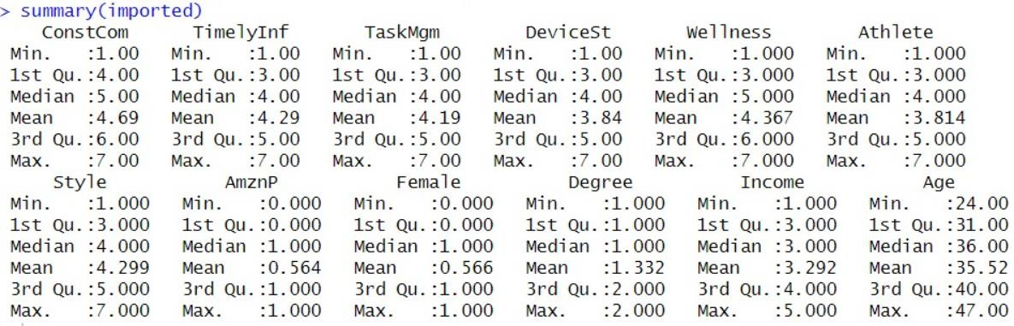Amazon Prime membership status is included.

The summary data obtained illustrates the distinctive traits of each group, serving as a basis for in- depth analysis of each group's unique profile.

**QUESTION 1:** How many distinct and meaningful segments are present in the market? Please determine the number of distinct segments present in the market as represented in the current respondent sample.

The **cluster analysis** aimed to categorize customers based on feature homogeneity, utilizing the

**Euclidean distance** metric. Initially, each customers formed an individual cluster, resulting in 1,000 segments. Subsequently, merging commenced from two clusters, progressing until an optimal number was reached, balancing segmentation with acceptable information loss.

For determining the appropriate number of clusters, the **Elbow method** was employed. This method involves plotting cluster count against the dispersion of data points within each cluster.

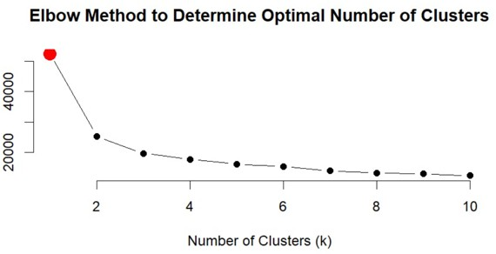

The Elbow graph exhibited a distinct bend, indicating an optimal point with four clusters. This suggests that creating additional clusters may not yield significant differentiation.

Additionally, confirmation can be obtained through Euclidean distance calculation and Dendrogram plotting, providing further insights into the cluster distinctiveness.

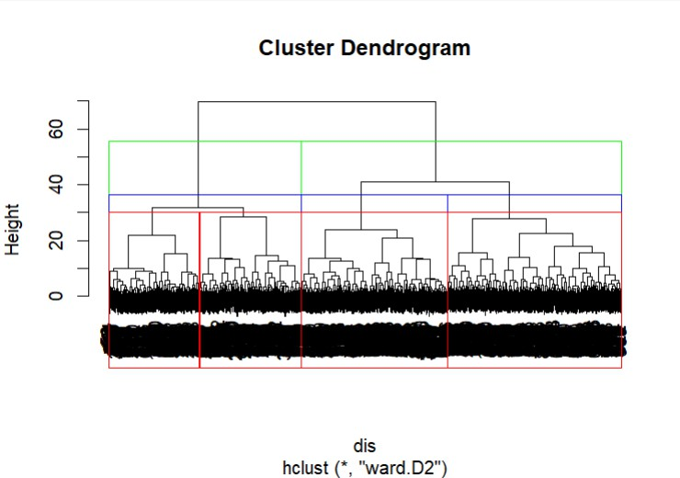

The presented dendrogram visually represents the trade-off between information loss and cluster count. Clusters of 2, 3, and 4 are distinctly coloured, showing that surpassing the 4-cluster threshold may lead to undesirable information loss. Therefore, the segmentation is judiciously halted at 4 clusters to maintain optimal information retention.

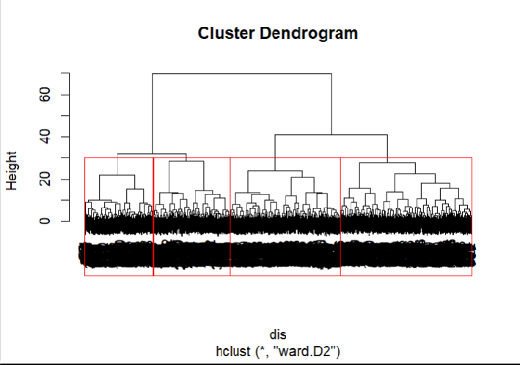

Furthermore, examining the composition of each cluster provides insights into the number of customers within each cluster and their respective percentage representation in the dataset.

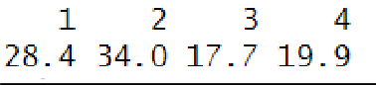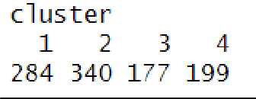

**QUESTION 2:** How would you describe each identified segment? Please provide a detailed

description of each identified segment using the variables in the data set (e.g., their mean values). Based on the segment characteristics, create a name for each segment that captures the essence of what makes it unique.

**SOLUTION:** After the segmentation process, the dataset undergoes grouping by clusters to derive a comprehensive summary. This step provides a clear overview of the unique characteristics and tendencies exhibited by customers in each identified cluster.

And the mean values for clusters can be represented in a table as below:

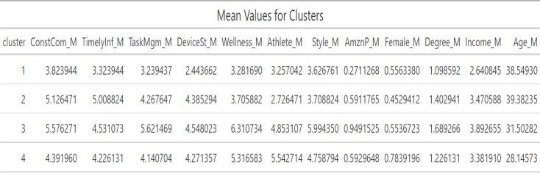

We can describe each cluster based on its mean values as follows:

# CLUSTER 1:

* It comprising **284** individuals out of the **1000** surveyed, exhibits a slightly female-majority composition (**55**%).
* With an average age of around **39**, the majority holds undergraduate degrees (degree mean:

**1.09**).

* This cluster is characterized by notably lower income (**2.64**), indicating potential budget constraints.
* A mere **0.27** of this cluster opts for an Amazon Prime account, reflecting a financial consciousness that may impact smartwatch affordability.
* The population assigns similar importance to features like Constant communication (**3.82**),

timely information (**3.32**), wellness (**3.28**), athlete (**3.25**), and task management (**3.23**), albeit lower than other clusters.

* Device sturdiness is the least favoured attribute, receiving an average score of **2.44**.
* Cluster 1 demonstrates relatively **modest** interest compared to other clusters. Based on the above observations, this segment could be named as **Minimal Engagers. CLUSTER 2:**
* This is largest segment with **340** customers out of **1000**, represents a substantial portion of the surveyed population.
* Comprising **45%** females, the average age of this cluster falls between 39 and 40.
* the mean income is relatively higher, and over **50%** of customers in this cluster have opted for an Amazon Prime account, indicating a higher economic status and online shopping preferences (Amazon Prime adoption: **0.59**).
* Cluster 2 expresses significant interest in constant communication and timely information, with mean ratings of **5.12** and **5.01**, respectively. This suggests a strong emphasis on staying connected and well-informed.
* Device sturdiness and task management are deemed fairly important, receiving mean ratings of **4.38** and **4.26**, respectively. This indicates a preference for reliable and efficient devices, reflecting a practical orientation.
* The least interest is shown in wellness and athlete-related features, suggesting a lower priority on health and fitness aspects.

Based on the above observations, this segment could be named as **Productive Engagers. CLUSTER 3:**

* It comprises of **177** individuals out of **1000**, is characterized by a notable **55%** female composition.
* This cluster stands out as the highest income group, with a mean income of approximately

**3.9**.

* **95%** of these members are Amazon Prime account holders, indicating a high level of engagement in online services.
* Additional characteristics include an average age of **31** and a relatively high education level, with a mean degree value of **1.69**.
* This cluster demonstrates a significant interest in wellbeing, indicating a keen awareness and prioritization of health-related features on smartwatches.
* The members of Cluster 3 are fashion-oriented, with a high emphasis on style (mean rating:

**5.99**), showcasing a desire for aesthetically pleasing smartwatches.

* This cluster prefers sturdier devices (mean rating: **4.54**) and values task efficiency (mean rating: **5.62**), highlighting a preference for high-performance devices suitable for active use.

Based on the above observations, this segment could be named as **Tech–Wellness Enthusiasts. CLUSTER 4:**

* It comprises of 199 individuals out of 1000, is predominantly female, constituting 78% of the cluster.
* This segment stands out as the youngest, with a mean age of 28.
* Despite their youth, Cluster 4 members assign similar importance to features like constant communication (4.71), timely information (4.22), and task management (4.14).
* Cluster 4 assigns the highest importance to wellbeing (mean 5.31) and athlete-related features, showcasing a strong emphasis on health and fitness aspects.
* They exhibit high importance on style (mean 4.75), indicating a preference for chic and aesthetically pleasing devices that complement their youthful taste.
* There is a fairly high level of Amazon Prime membership within this cluster (mean 0.59), suggesting a propensity for online engagement and shopping.

Based on the above observations, this segment could be named as **Female Fit Influencers.**

**QUESTION 3**: Which segment should be targeted by Intel? How should Intel position themselves to compete strongly in the targeted segment(s)? Please provide a detailed discussion of each identified segment, based on the attractiveness of the segment for Intel and the strength of competitors’ offerings (e.g., Samsung, Apple, etc.). Explain the factors that you used to rate the attractiveness of each segment and Intel’s competitive strength.

**SOLUTION:** Post-segmentation, Intel confronts the pivotal task of selecting a **target** market, a decision influenced by both market attractiveness and competitive strength. The segment known as "Minimal Engagers" appears less favourable due to its modest size and moderate interest across features, presenting limited influence on the market. "Female Fit Influencers," while showing a

slightly better market segmentation, remains niche with a predominant focus on wellness and athletics.

In contrast, "Productive Engagers" emerge as a robust option, boasting the largest strength and exhibiting interest across various features. This segment presents a substantial and well-defined market share. Although "Tech Wellness Enthusiasts" display keen interest in every feature, their smaller size compared to "Productive Engagers" makes the latter a more strategic choice.

Considering both market segmentation and size, targeting "Productive Engagers" stands out as the optimal strategy for Intel. This segment not only represents a substantial consumer base but also

demonstrates a comprehensive interest in smartwatch features, aligning well with Intel's capabilities and market dynamics.

To establish its market **position** effectively, Intel needs to assess both its internal strengths and weaknesses and the strengths of its competitors (2 C’s Company and Competitor). A comprehensive SWOT analysis is instrumental in understanding Intel's current standing and comparing it with competitors. This analysis provides insights into areas of advantage and vulnerability, guiding Intel in strategic planning to navigate future challenges successfully. By evaluating internal factors and competitor landscapes, Intel can develop informed strategies to capitalize on its strengths, address weaknesses, and stay ahead in the dynamic market environment.

# SWOT Analysis of Intel Company:

**Strengths:**

Intel holds a commanding position, providing top-notch processor chips.

Alongside Microsoft, Intel has secured a significant share of profits in the modern computer revolution.

# Weaknesses:

Despite success in PCs, Intel missed the rise of smartphones, impacting market share.

Compared to competitors like Nvidia, Intel's stock has shown modest growth, especially amid AI and GPU advancements.

# Opportunities:

Exploring the modern smartwatch sector presents opportunities for companionship, fitness tracking, and medical health reporting devices.

# Threats:

Entry of tech giants like Samsung and Apple in 2014 and 2015, along with numerous other competitors, heightens market rivalry.

Diverse Competitors: Google, Microsoft, Sony, and Toshiba, among others, contribute to a crowded smartwatch market with over 30 companies.

# Summary:

Intel's established dominance in processors and profitable collaborations are key strengths. However, missed opportunities in emerging technologies and intensified competition in the smartwatch

market pose challenges. To capitalize on the growing smartwatch sector, Intel must leverage its core strengths and address weaknesses for sustained market leadership.

# SWOT Analysis of Competitors:

**Strengths:**

Competitors possess a strong and recognized brand, contributing to customer trust. The availability of various features enhances the competitiveness of their products. A loyal customer following strengthens the market position of competitors.

# Weaknesses:

Safety Concerns: Instances like Basis Peak battery causing burns due to overheating pose safety challenges.

# Opportunities:

Competitors can explore opportunities in expanding their presence within a growing market. Forming alliances with top companies provides avenues for collaborative growth.

Creating additional features adds value to products, meeting evolving customer expectations.

# Threats:

The market is characterized by high competition, posing challenges for sustained differentiation. Evolving customer preferences and needs require constant adaptation to remain competitive.

# Summary:

Competitors benefit from a strong brand, diverse features, and a loyal customer base. However, safety concerns highlight potential vulnerabilities. Opportunities lie in market expansion, strategic partnerships, and continuous product improvement. The threat landscape includes intense competition and the dynamic nature of customer preferences, emphasizing the need for agility and innovation in a rapidly changing market.

**Manage INTEL Customer Heterogeneity - Marketing Decision Framework**

**Tar**

.

**Competitors:**

Strengths: Brand Value, Loyal Customers

Weaknesses: Battery Life Opportunities: Expansion in growth market, Partnerships Threats: sustainability

challenge, competition

Positioning Statement: Productive Engagers are largest segment.

Great market segmentation. Partnership with Amazon

Target Segment Productive Engagers

-Practical oriented

-need to stay Connected and well informed

- need reliable and efficient devices

**INTEL** Company

**Strengths**: Dominance in Computer Chip Industry, Profitable Collaboration **Weaknesses:** Missed on smartphones, Stock Price **Opportunities:**

Smartwatches, fitness tracker

**Threats:** Huge Competition

Approaches taken: Customer Centricity Segmentation,

Targeting, Positioning STP method

Analysis: Cluster Analysis,

GE Matrix

**Managing Customer Heterigenity**

All Potential Customers:

1. Smartwatch Features
2. Demographic Features (Age,Income,Gender,Degree, PrimeUser)

Industry Segmentation

1. Minimal Engagers
2. Productive Engagers
3. Tech Wellness Enthusiasts
4. Female Fit Influencers

**INPUT 3C’s**

Following the analysis, Intel faces the critical decision of selecting a strategic partner, and among the options - **Health insurer Aetna, Google, and Amazon** - a thoughtful choice is imperative. Aetna may not align with Intel's current focus on communication and app accessibility, given its predominant role in health care and wellness. In weighing the remaining contenders, Google and Amazon, the latter emerges as the more favourable choice. **Amazon** offers a comprehensive package

encompassing communication, app access, and the added advantage of Alexa. This aligns seamlessly with the preferences of the target segment, **Productive Engagers**, especially considering their inclination towards being Amazon Prime users. Given the significant size of this segment, partnering with Amazon presents an opportune avenue. While initially targeting Productive Engagers, Intel maintains flexibility for future enhancements, potentially addressing wellness features and appealing to the **Tech Wellness Enthusiast** segment. This strategic alignment positions Intel for sustained success and adaptability in the evolving smartwatch market.

**REFERENCES:**

* Palmatier, R. W., & Sridhar, S. (2020). Marketing strategy: Based on first principles and data analytics. Bloomsbury Publishing.
* Huang, M. H., & Rust, R. T. (2021). A strategic framework for artificial intelligence in marketing. Journal of the Academy of Marketing Science, 49, 30-50.