Final Project Report
Data Analytics with Tableau
Agricultural Insights: Analysis of India’s Agriculture Data (1997–2021)
Submitted by: Vaibhavi Ghutukade
SmartBridge | October 2026

1. Introduction

1.1 Project Overview
Agriculture is the backbone of the Indian economy, and understanding how production, cultivated area and yield vary across states, crops, seasons and years is essential for informed decision-making. This project analyses India’s agriculture dataset using Tableau Public. Eight worksheets were built to explore state-wise production, crop-wise cultivated area, year-wise trends, production units and seasonal distribution. These were combined into an interactive dashboard (Agriculture Production Insights) and an eight-point Tableau story (Agricultural Insights_Story) that walks the audience from the geographic overview to the finer details.

1.2 Objectives
- Visualize state-wise agricultural production across India using a geographic map.
- Identify the leading states by total production and by cultivated area.
- Compare the crops that occupy the largest cultivated area.
- Analyse the trend of agricultural yield and production over the years 1997–2021.
- Understand how production is distributed by unit type (Tonnes, Nuts, Bales) and by season.
- Combine all insights into a single interactive dashboard and a data story for stakeholders.

2. Project Initialization and Planning Phase

2.1 Define Problem Statement
. Agricultural data in India is large and spread across many states, districts, crops, seasons and years. In raw tabular form it is difficult for policymakers, researchers and farmers’ organisations to see which regions lead in production, which crops dominate cultivation, and how output has changed over time. There is a need for a clear, interactive visual analytics solution that turns this data into actionable insights

2.2 Project Proposal (Proposed Solution)
The proposed solution is a Tableau-based analytics report. The raw dataset is connected to Tableau Public, cleaned and organised using sets and filters (Crop Set, State Set, Year Set, Season Set), and visualized through a map, bar charts, a line chart, a donut chart and a pie chart. The visuals are assembled into a dashboard for at-a-glance monitoring and into a story that presents the findings sequentially.
Component | Description
Tool | Tableau Public
Data source | India’s Agriculture dataset (Sheet1)
Deliverables | 8 worksheets, 1 dashboard, 1 story (8 story points)
Audience | Policymakers, agricultural analysts, students and researchers

2.3 Initial Project Planning
Phase | Activities | Output
1. Initialization | Define problem statement, objectives and scope | Problem statement, proposal
2. Data collection | Identify and load the agriculture dataset into Tableau | Connected data source
3. Preprocessing | Check data quality, create sets and filters | Clean, analysis-ready data
4. Visualization | Frame business questions and build worksheets | 8 worksheets
5. Dashboard | Arrange worksheets in a single layout | Agriculture Production Insights
6. Story | Sequence insights into story points | Agricultural Insights_Story
7. Testing & report | Test filters and interactions, document results | Final report

3. Data Collection and Preprocessing Phase

3.1 Data Collection Plan and Raw Data Sources Identified
The analysis uses a single dataset on India’s agriculture, loaded in Tableau as Sheet1. It covers crop-level records by state and district for the years 1997–2021. [Add the dataset source and link here, e.g. Kaggle / data.gov.in.]
Field | Type | Description
State | Dimension (geographic) | Indian state / union territory
District | Dimension | District within the state
Crop | Dimension | Name of the crop (e.g. Rice, Wheat, Bajra)
Season | Dimension | Kharif, Rabi, Autumn, Summer, Winter, Whole Year
Year | Dimension | Agricultural year (e.g. 2011-12)
Area / Area Units | Measure / Dimension | Cultivated area and its unit
Production / Production Units | Measure / Dimension | Output and its unit (Tonnes, Nuts, Bales)
Yield | Measure | Production per unit area

3.2 Data Quality Report
Check | Observation | Action
Mixed production units | Production is recorded in Tonnes, Nuts and Bales | Analysed by unit type in a separate donut chart; totals should be read with this in mind
Incomplete final year | Yield falls to almost zero in 2020-21 | Treated as incomplete data rather than a real collapse
Multiple seasons | Includes Whole Year, Kharif, Rabi, Autumn, Summer, Winter | Season Set used to filter and compare
Geographic matching | State names must match Tableau’s geographic roles | State field assigned the State/Province role for the map

3.3 Data Exploration and Preprocessing
The dataset was explored in Tableau’s Data pane. Dimensions and measures were identified, and the State field was given a geographic role, which generated Latitude and Longitude fields for the map. To support focused analysis, the following sets and filters were created and applied across the worksheets:
- Crop Set – limits analysis to selected crops (e.g. Top 5 crops by cultivated area).
- State Set – selects the top states by production or area.
- Year Set – restricts the years displayed (e.g. 2011-12, 2014-15, 2015-16, 2018-19, 2019-20).
- Season Set 2 – filters seasons for the unit-type and production views.
- Action Set – supports interactivity between dashboard views.
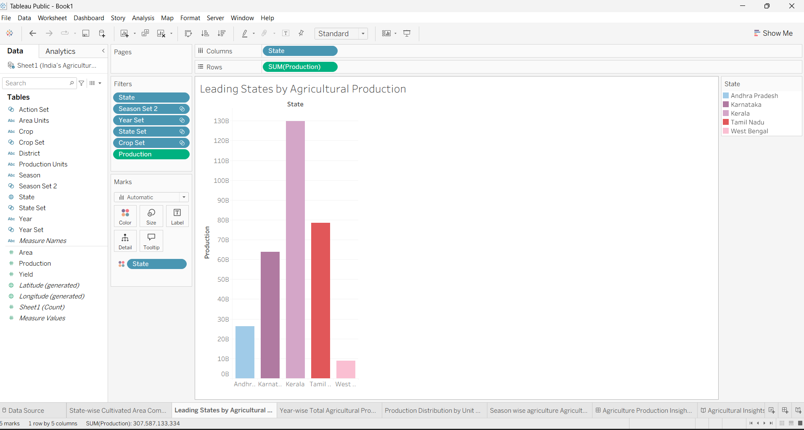
Figure 1: Data pane showing dimensions, measures and sets (Leading States worksheet)

4. Data Visualization

4.1 Framing Business Questions
- Which states contribute the most to India’s agricultural production?
- Which states cultivate the largest area?
- Which crops occupy the largest cultivated area?
- How has agricultural yield changed from 1997 to 2021?
- How does total production vary across selected years?
- In which units is production recorded, and what is the split?
- Which seasons contribute most to total production?

4.2 Developing Visualizations
Eight visualizations were developed to answer these questions.
Visualization 1 – State-wise Cultivated Area Comparison. A bar chart (State vs SUM(Area)) comparing the top five states by cultivated area: Uttar Pradesh, Madhya Pradesh, Rajasthan, Maharashtra and Karnataka.
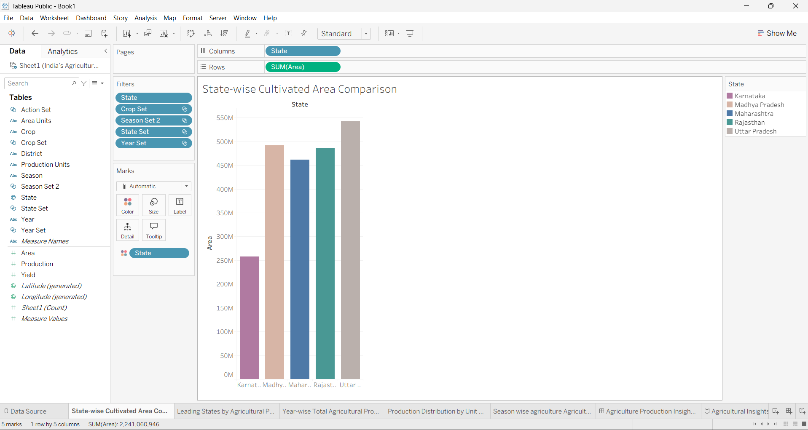
Figure 2: State-wise Cultivated Area Comparison
Visualization 2 – Leading States by Agricultural Production. A bar chart (State vs SUM(Production)) showing Kerala, Tamil Nadu, Karnataka, Andhra Pradesh and West Bengal, with Kerala clearly ahead.
Figure 3: Leading States by Agricultural Production
Visualization 3 – Year-wise Total Agricultural Production. A bar chart (Year vs SUM(Production)) for selected years between 2011-12 and 2019-20.
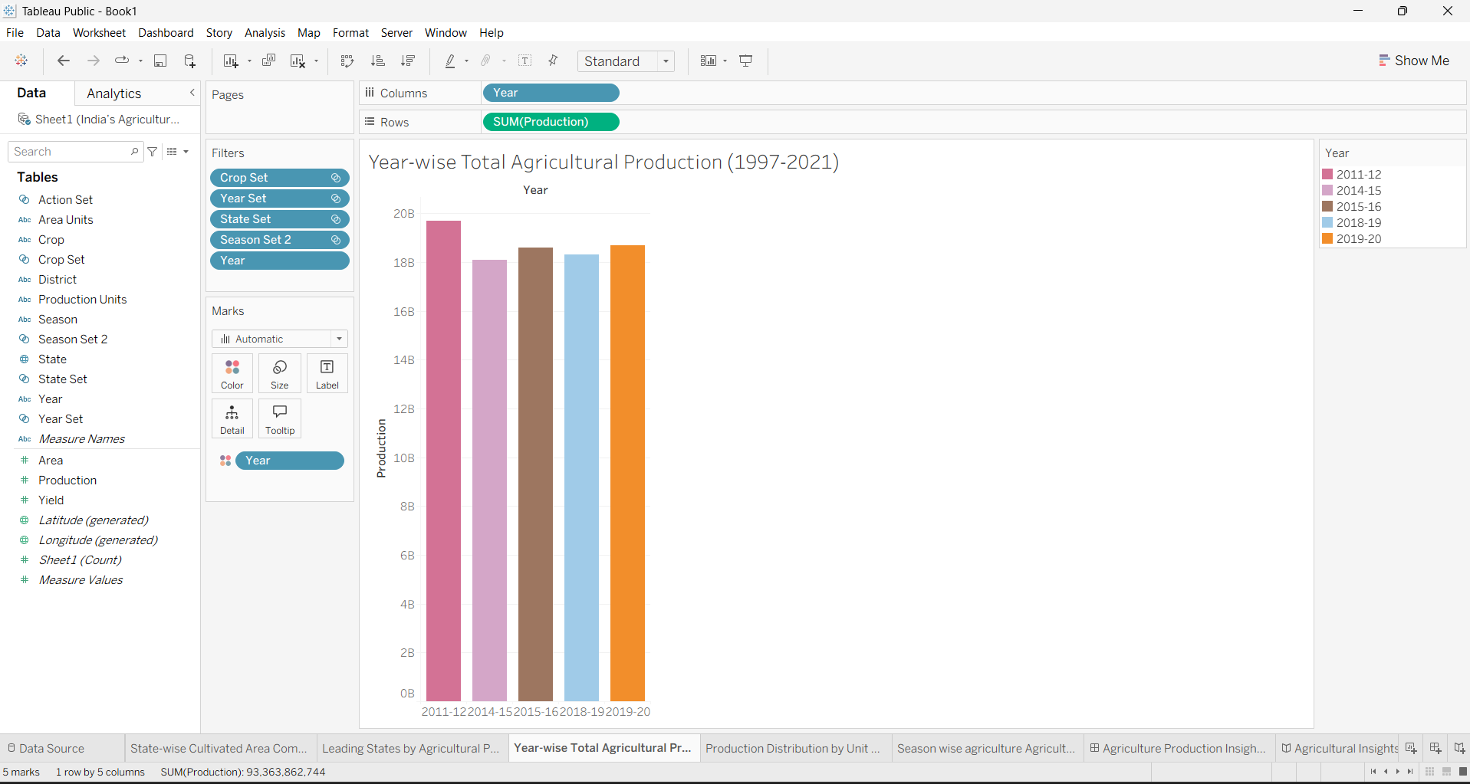
Figure 4: Year-wise Total Agricultural Production (1997–2021)
Visualization 4 – Production Distribution by Unit Type. A radial (donut) chart showing the share of production recorded in Tonnes, Nuts and Bales.
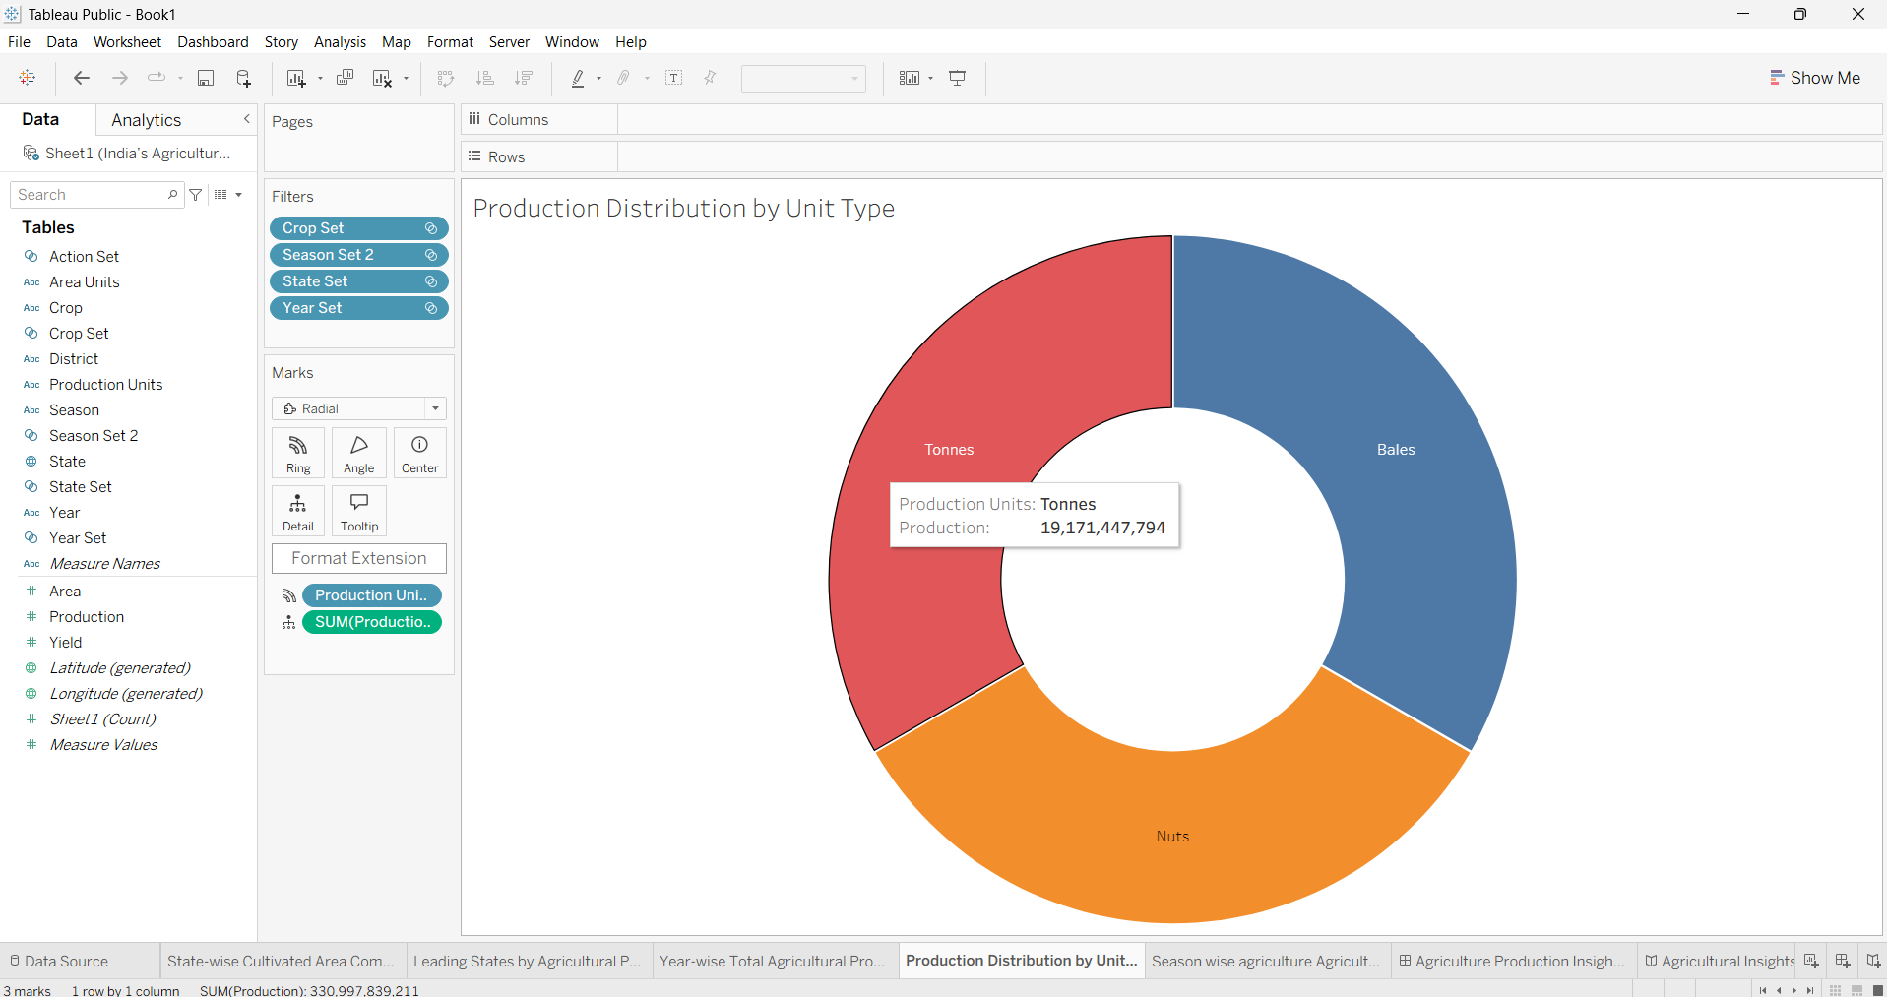
Figure 5: Production Distribution by Unit Type
Visualization 5 – Season-wise Agricultural Production. A pie chart with labels showing production by season; Whole Year dominates, followed by Kharif and Rabi.
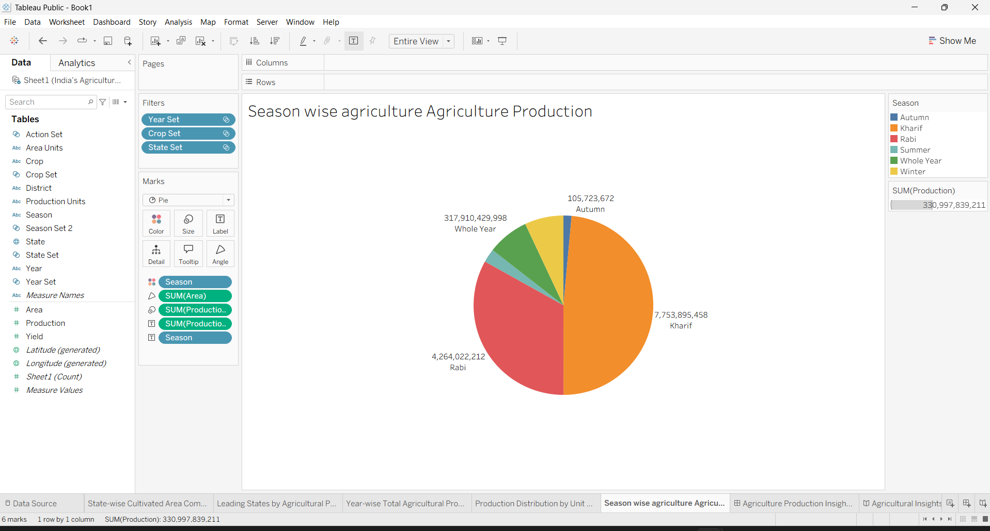
Figure 6: Season-wise Agricultural Production
Visualization 6 – State-wise Agricultural Production (India Map). A filled map colored by production, with Tamil Nadu and the southern states shaded darkest. Visualization 7 – Comparison of Cultivated Crop (bar chart of top 5 crops by area, Rice highest) and Visualization 8 – Trend of Agricultural Yield (line chart over 1997-98 to 2020-21) are shown within the dashboard and story in Sections 5 and 6.

5. Dashboard

5.1 Dashboard Design File
The dashboard “Agriculture Production Insights” brings all visualizations together on a single screen, designed for a desktop layout (1280 x 1024). It contains the India map, crop comparison, state-wise area, leading states, season-wise pie chart, year-wise production, unit-type donut and yield trend. Each worksheet has its own title and a consistent beige header band for a uniform look, and the Action Set allows the views to be explored together.
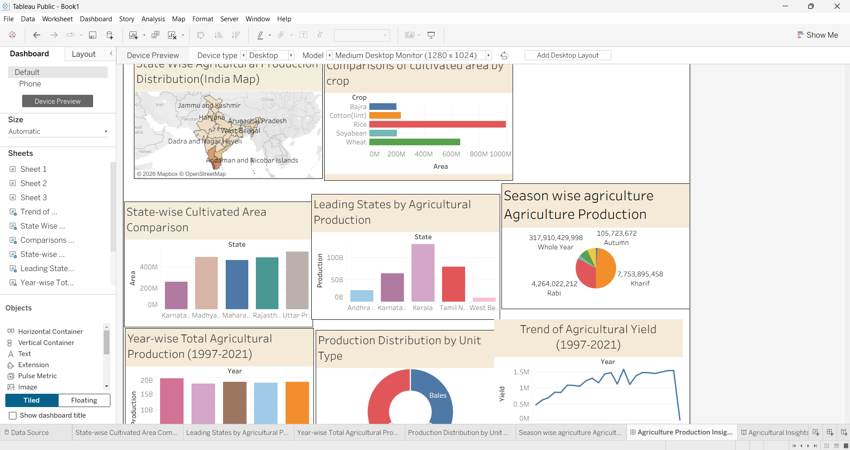
Figure 7: Agriculture Production Insights dashboard

6. Report

6.1 Story Design File
The story “Agricultural Insights_Story” contains eight story points. It starts with the geographic overview, moves to trends and comparisons, and ends with the distribution by unit type and by season.
No. | Story point | Insight conveyed
1 | State-wise agricultural production | Production is concentrated in southern India
2 | Trend of Agricultural Yields | Yield rises steadily from 1997 to 2019
3 | Comparisons of Cultivated Crop | Rice and wheat dominate cultivated area
4 | Leading States by Agricultural Production | Kerala leads, followed by Tamil Nadu
5 | State-wise Cultivated Area Comparison | UP, MP and Rajasthan have the largest area
6 | Year-wise total agricultural production | Production is stable across the selected years
7 | Production Distribution Unit by Type | Tonnes, Nuts and Bales share production
8 | Season-wise total agricultural production | Whole Year production dominates

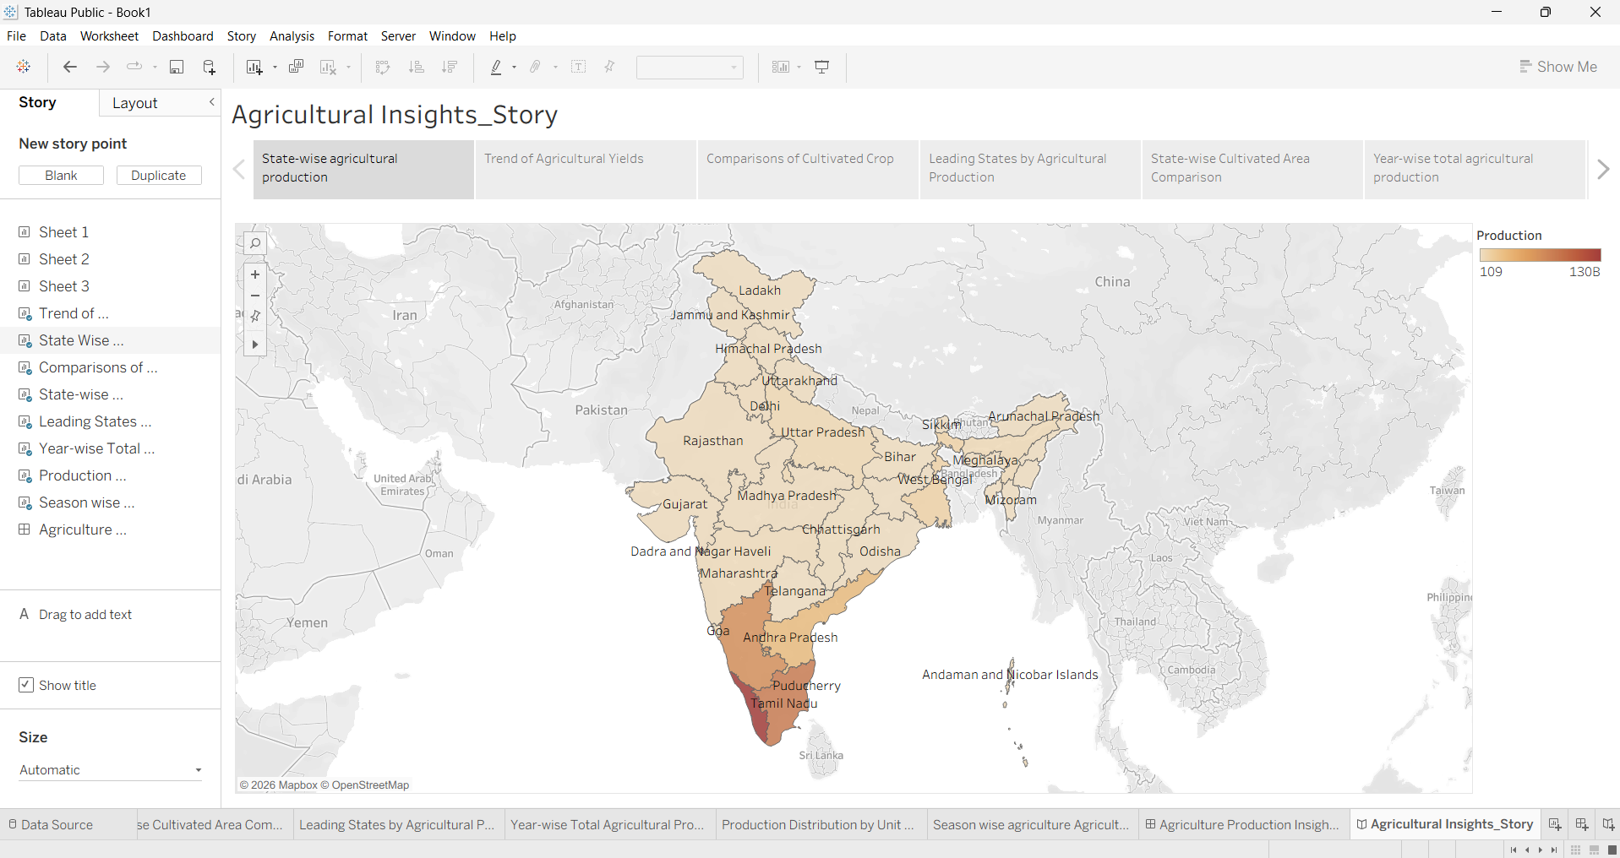
Figure 8: Story point 1 – State-wise agricultural production
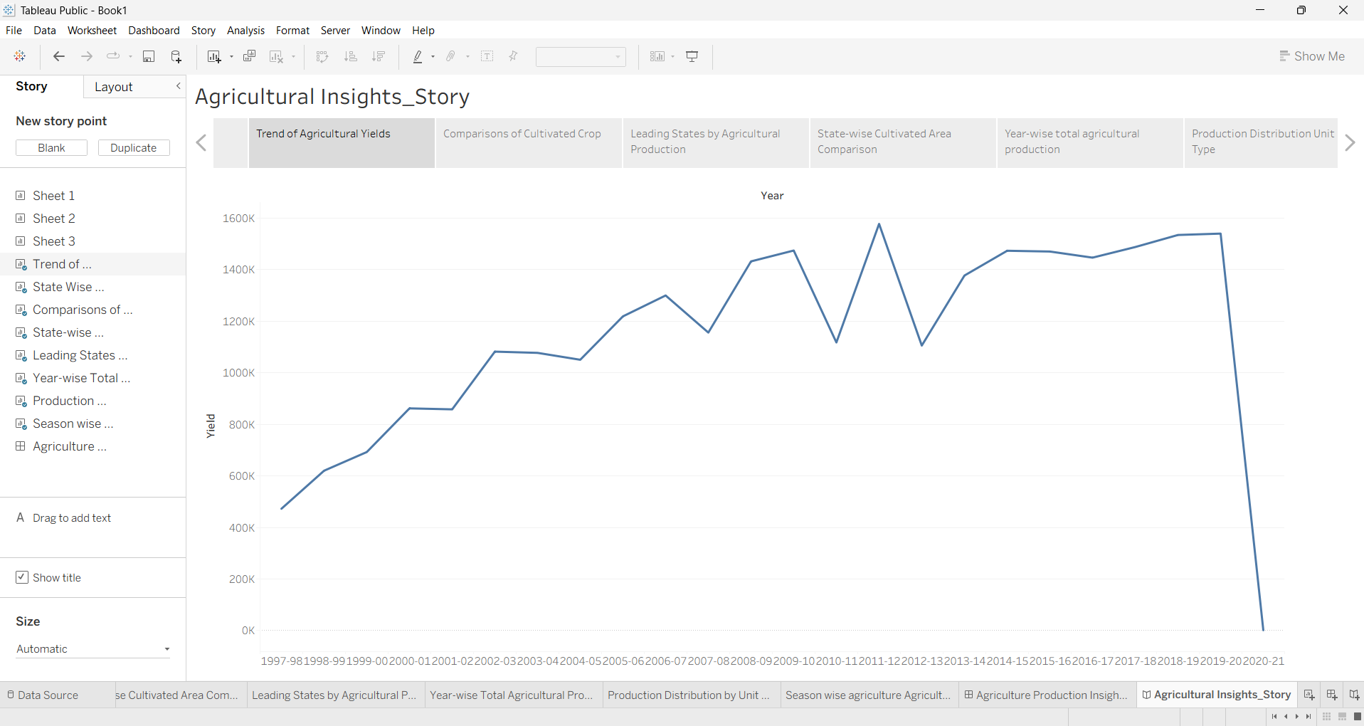
Figure 9: Story point 2 – Trend of Agricultural Yields
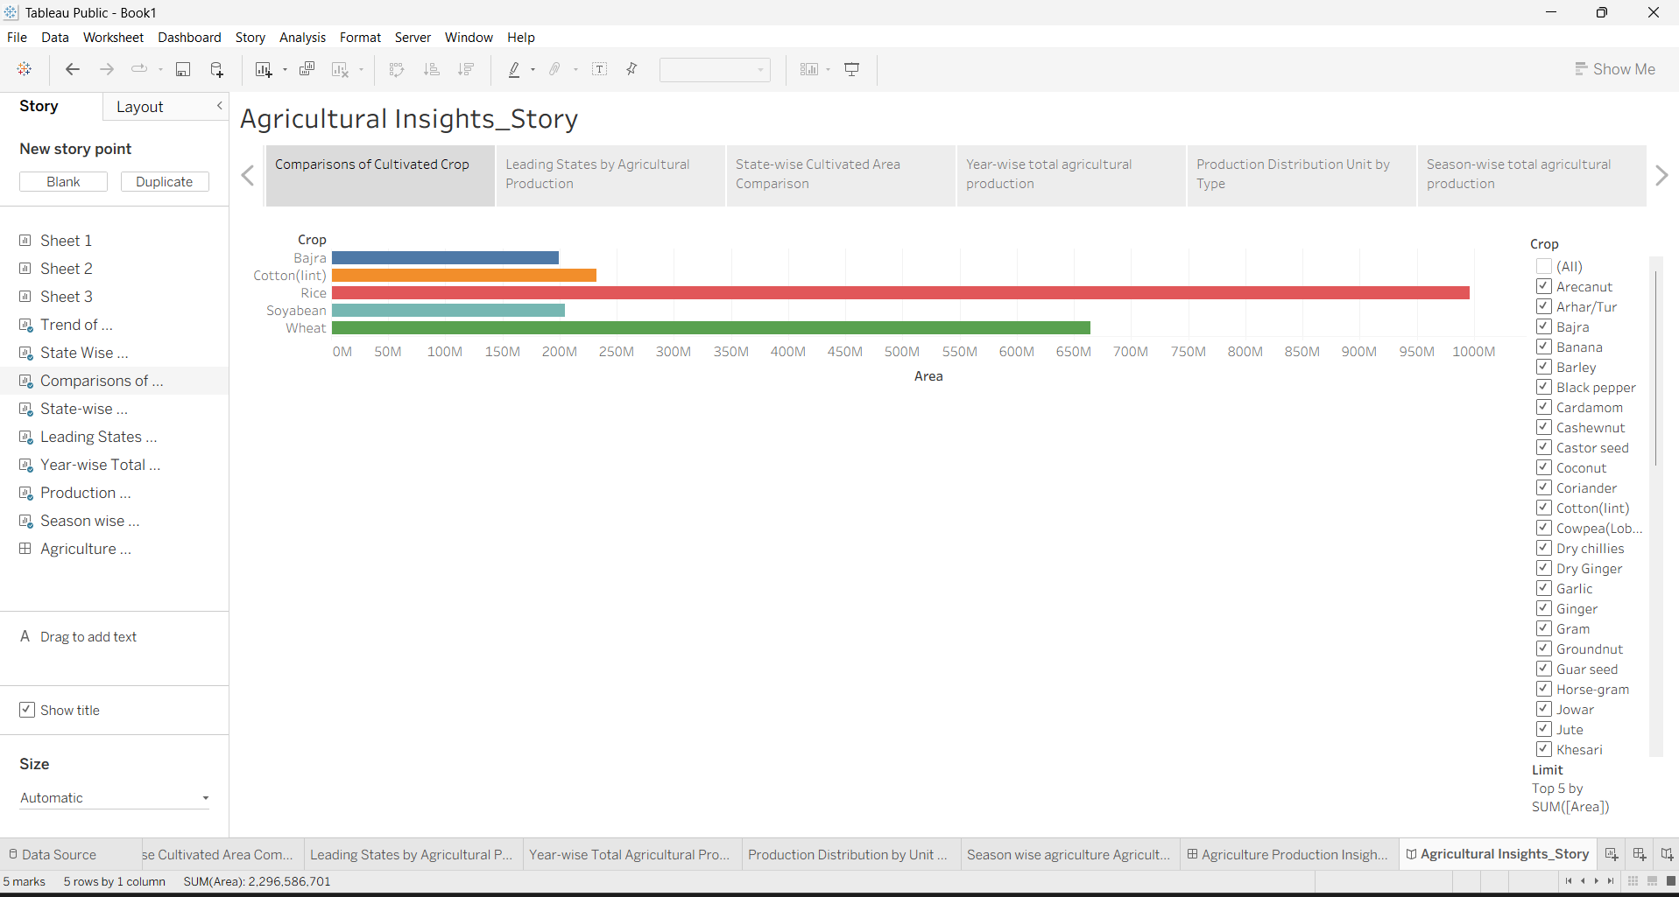
Figure 10: Story point 3 – Comparisons of Cultivated Crop
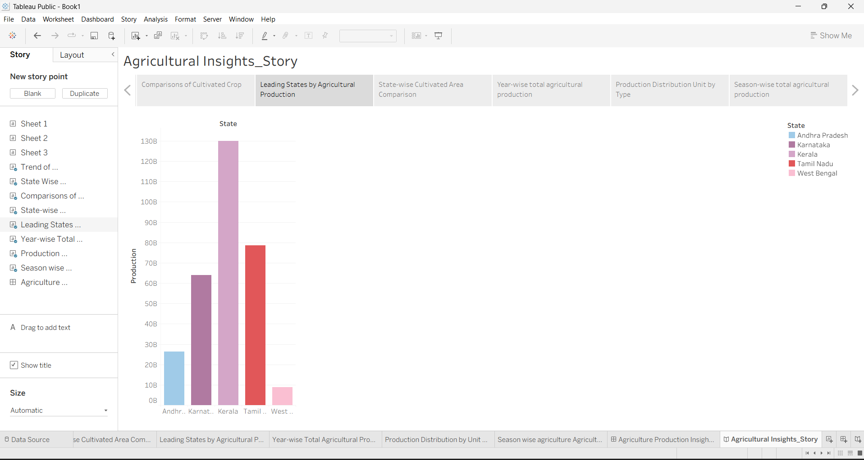
Figure 11: Story point 4 – Leading States by Agricultural Production
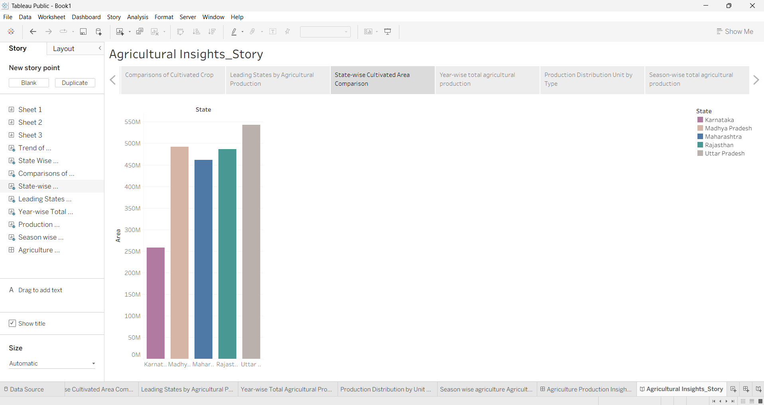
Figure 12: Story point 5 – State-wise Cultivated Area Comparison
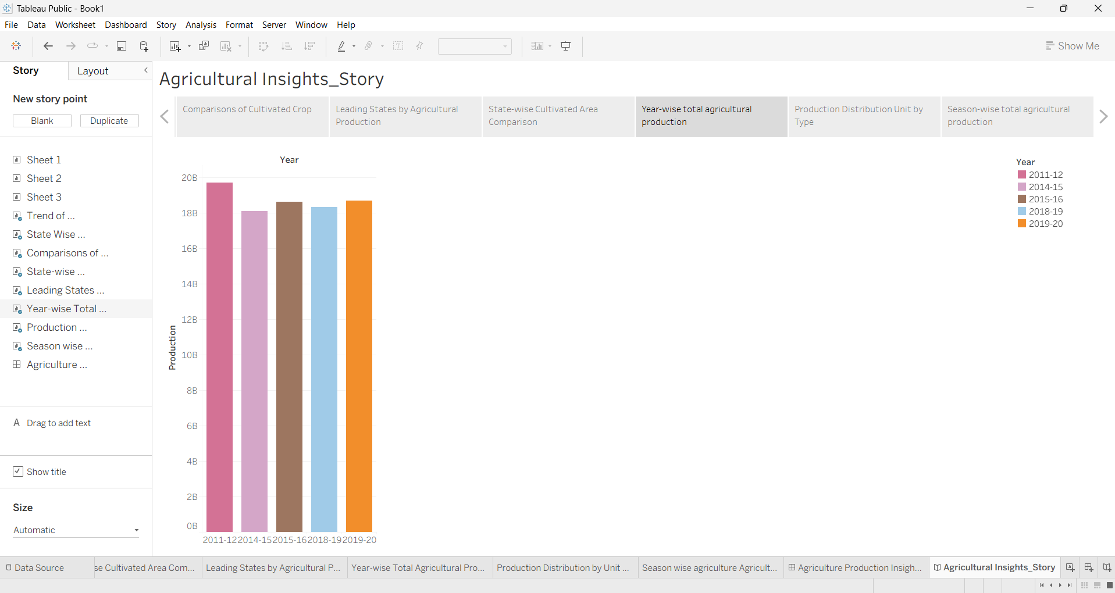
Figure 13: Story point 6 – Year-wise total agricultural production
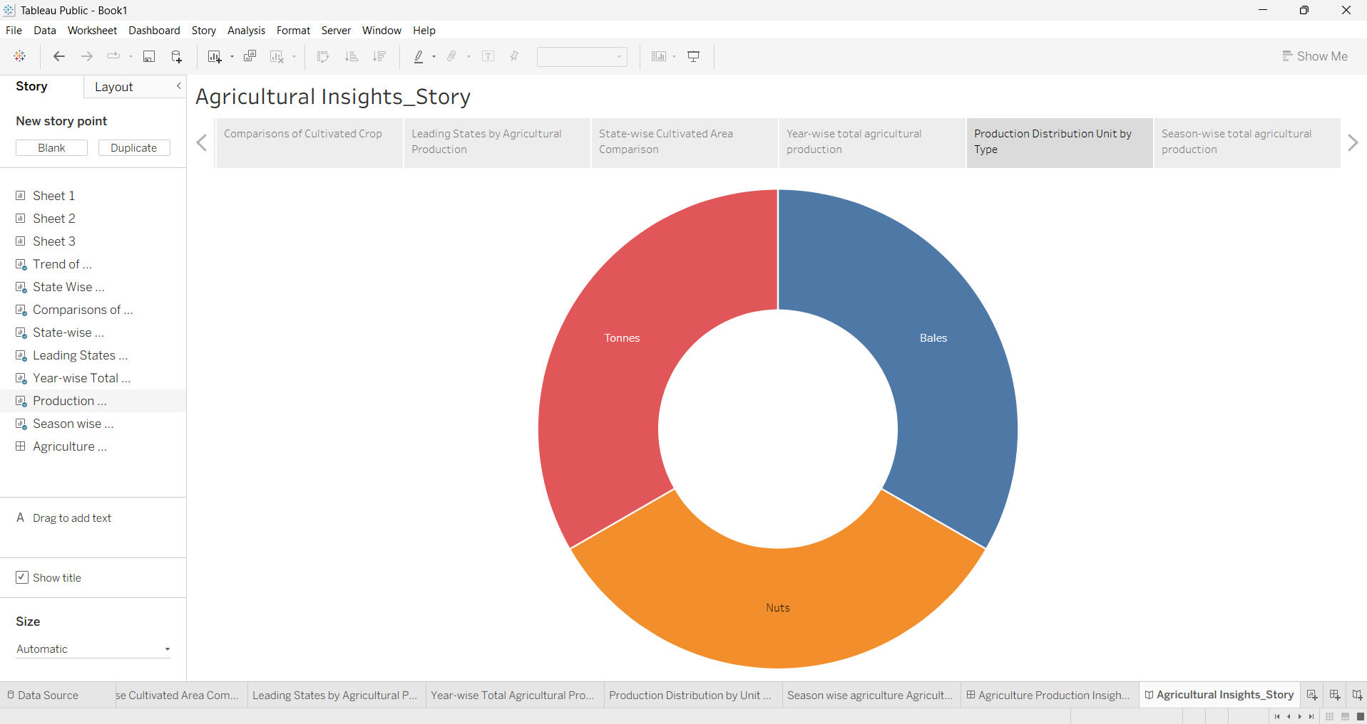
Figure 14: Story point 7 – Production Distribution Unit by Type
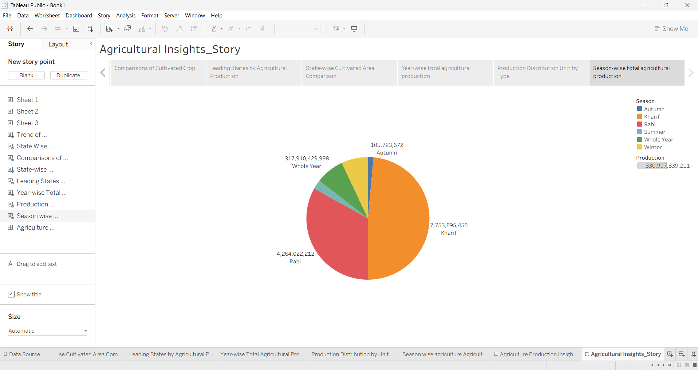
Figure 15: Story point 8 – Season-wise total agricultural production

7. Performance Testing

7.1 Utilization of Data Filters
Filters were used in every worksheet to keep views focused and fast. Sets act as filters on Crop, State, Year and Season, and the crop view additionally uses a Top 5 by SUM(Area) limit and an interactive crop filter.
Worksheet | Filters applied
State-wise Cultivated Area Comparison | State, Crop Set, Season Set 2, State Set, Year Set
Leading States by Agricultural Production | State, Season Set 2, Year Set, State Set, Crop Set, Production
Year-wise Total Agricultural Production | Crop Set, Year Set, State Set, Season Set 2, Year
Production Distribution by Unit Type | Crop Set, Season Set 2, State Set, Year Set
Season-wise Agricultural Production | Year Set, Crop Set, State Set
Comparison of Cultivated Crop | Crop (interactive), Top 5 by SUM(Area)

7.2 No. of Calculation Fields
No custom calculated fields were required. Analysis relied on Tableau’s built-in aggregations (SUM of Area, Production and Yield) and on five sets (Action Set, Crop Set, Season Set 2, State Set and Year Set). The generated Latitude and Longitude fields support the map.

7.3 No. of Visualizations
Item | Count
Worksheets (visualizations) | 8
Dashboards | 1
Stories | 1 (8 story points)
Chart types used | Filled map, bar, line, donut (radial), pie

8. Conclusion / Observation
- Kerala records the highest total production (about 130B), followed by Tamil Nadu (about 79B) and Karnataka (about 64B). West Bengal is lowest among the top five (about 9B).
- Uttar Pradesh has the largest cultivated area (about 540M), followed by Madhya Pradesh, Rajasthan and Maharashtra, each at roughly 460–490M. Karnataka is the smallest of the five at about 260M.
- Rice occupies the largest cultivated area (about 1,000M), followed by wheat (about 650M). Cotton, soybean and bajra each cover roughly 200–240M.
- Yield rose from about 470K in 1997-98 to about 1.5M by 2018-19, with dips around 2010-11 and 2012-13 and a peak near 2011-12. The sharp drop in 2020-21 most likely reflects incomplete data.
- Year-wise production across the selected years stays between roughly 18B and 20B, with 2011-12 the highest.
- By unit type, production is split among Tonnes, Nuts and Bales; Tonnes accounts for about 19.2B.
- By season, Whole Year production dominates (about 318B of about 331B), followed by Kharif (about 7.8B) and Rabi (about 4.3B).
Overall, the dashboard and story show that production is concentrated in a few states, cultivated area is concentrated in the northern and central states, and rice and wheat dominate cropping. Because production is recorded in different units, cross-crop comparisons of raw production should be made carefully.

9. Future Scope
- Normalize all production to a common unit (e.g. tonnes) for fairer comparisons across crops.
- Add district-level drill-downs and crop-wise maps.
- Include rainfall, irrigation and price data to explain yield and production changes.
- Add forecasting of yield and production using Tableau’s forecasting feature.
- Refresh the data for the latest years and publish the dashboard on Tableau Public for wider access.

10. Appendix

10.1 Source Code (if any)
Not applicable. The project was built using Tableau Public’s visual interface, with no custom code or calculated fields.

10.2 GitHub & Project Demo Link
GitHub: https://github.com/Vaibhavi410/India-s-Agricultural-Crop-Production-Analysis
Tableau Public / Demo video:
https://public.tableau.com/app/profile/vaibhavi.ghutukade/vizzes

