**MODULE: 1 (SDLC)**

Q-1. What is software? What is software engineering?

Ans-1. **Software is a set of instructions, data or programs used to operate computers and execute specific tasks. It is the opposite of hardware, which describes the physical aspects of a computer.** The two main categories of software are application software and system software.

**Software engineering is defined as a process of analyzing user requirements and then designing, building, and testing software application which will satisfy those requirements.**

**Q-2.** Explain types of software

**Ans-2.There are different types of software based on their classification. However, if we broadly classify the types of software in a computer, there are two major types as listed below:**

**• System Software**

**• Application Software**

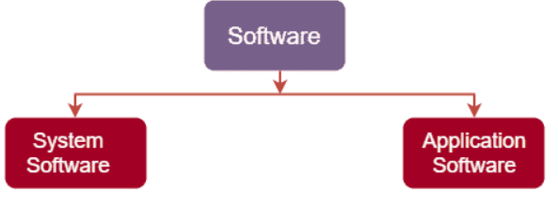

* **System Software:-**

**System software is usually defined as a set of various programs or instructions that help to control or manage the hardware devices connected to the computer and other important resources of the system. Specifically, it helps in making the working of the computer efficient, enables faster performance in a secure manner. In addition, the system software also establishes a platform to run the application software.**

**For example: mac OS, Linux, Android and Microsoft Windows.**

* **Application Software:-**

**Application software refers to a set of programs and instructions that help perform specific tasks, on a computer system. It is mainly designed to meet certain requirements of a particular environment. Application software can be downloaded and installed manually on the computer system and these software have nothing to do with the system core functions.**

**For example: Word Processor, Microsoft Word, Spreadsheet, Web browser.**

Q-3. What is SDLC? Explain each phase of SDLC

Ans-3 **The Software Development Life Cycle (SDLC) is a process used by software development organizations to plan, design, develop, test, deploy, and maintain software applications.**

**The SDLC typically includes the following phases:**

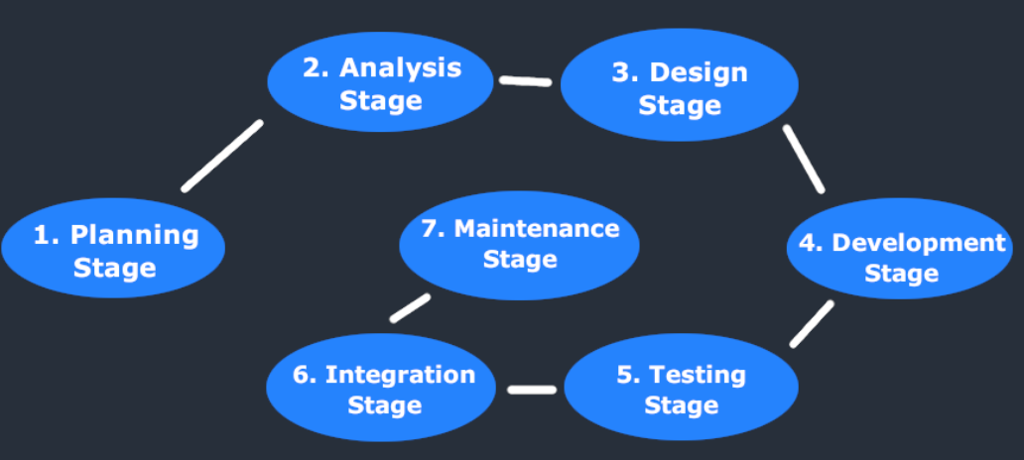

**1. Requirements gathering and analysis:** This phase involves gathering information about the software requirements from stakeholders, such as customers, end-users, and business analysts.

**2. Design:** In this phase, the software design is created, which includes the overall architecture of the software, data structures, and interfaces. It has two steps:

* **High-level design (HLD):** It gives the architecture of software products.
* **Low-level design (LLD):** It describes how each and every feature in the product should work and every component.

**3. Implementation or coding:** The design is then implemented in code, usually in several iterations, and this phase is also called as Development.

things you need to know about this phase:

* This is the longest phase in SDLC model.
* This phase consists of Front end + Middleware + Back-end.
* **In front-end:**Development of coding is done even SEO settings are done.
* **In Middleware:** They connect both the front end and back end.
* **In the back-end:** A database is created.

**4. Testing:**The software is thoroughly tested to ensure that it meets the requirements and works correctly.

**5. Deployment:** After successful testing, The software is deployed to a production environment and made available to end-users.

**6. Maintenance:**This phase includes ongoing support, bug fixes, and updates to the software.

There are **different methodologies** that organizations can use to implement the SDLC, such as**Waterfall, Agile, Scrum, V-Model**and**DevOps.**

Q-4. What is DFD? Create a DFD diagram on Flipkart

Ans-4. **A Data Flow Diagram (DFD) is a traditional visual representation of the information flows within a system. A neat and clear DFD can depict the right amount of the system requirement graphically. It can be manual, automated, or a combination of both.**

**It shows how data enters and leaves the system, what changes the information, and where data is stored.**

**The objective of a DFD is to show the scope and boundaries of a system as a whole. It may be used as a communication tool between a system analyst and any person who plays a part in the order that acts as a starting point for redesigning a system. The DFD is also called as a data flow graph or bubble chart.**

**DFD diagram on Flipkart:**

**Zero level DFD:-**

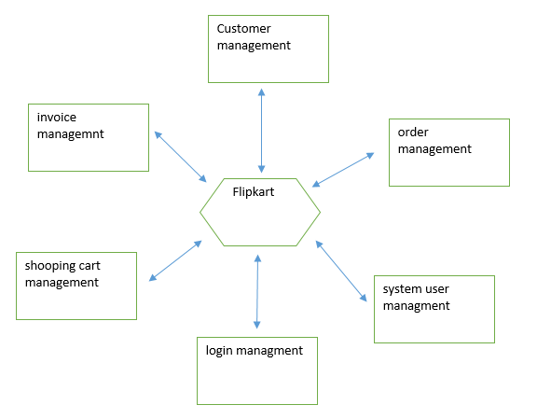

Q-5.What is Flow chart? Create a flowchart to make addition of two numberS

Ans-5. **Flowchart is a diagrammatic representation of sequence of logical steps of a program. Flowcharts use simple geometric shapes to depict processes and arrows to show relationships and process/data flow.**

**Flowchart to make addition of two numbers:-**

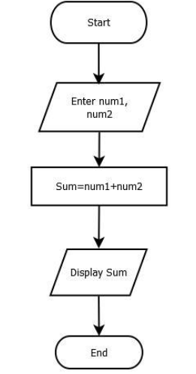

Q-6. What is Use case Diagram? Create a use-case on bill payment on paytm.

Ans-6. A use case diagram is used to represent the dynamic behavior of a system. It encapsulates the system's functionality by incorporating use cases, actors, and their relationships. It models the tasks, services, and functions required by a system/subsystem of an application. It depicts the high-level functionality of a system and also tells how the user handles a system.

Use-case diagram payment on paytm:-

