# Test Scenarios Indigo Flight Booking

### Flight Search Functionality

Scenario 1: Verify that users can select a one-way, roundtrip, or multicity option.

Steps: Select each travel option.

Expected Result: The interface should change according to the selected travel type.

Actual Result:

Scenario 2: Verify that a user can select a departure city.

Steps: Choose a city from the "From" dropdown.

Expected Result: The selected city is displayed in the "From" field.

Actual Result:

Scenario 3: Verify that a user can select a destination city.

Steps: Choose a city from the "To" dropdown.

Expected Result: The selected city is displayed in the "To" field.

Actual Result:

Scenario 4: Verify that the departure and arrival cities are different.

Steps: Select the same city in the "From" and "To" fields.

Expected Result: The system should prevent the selection.

Actual Result:

### Passenger and Class Selection

Scenario 5: Verify that the user can select the number of passengers (adults, children, infants).

Steps: Choose different combinations of passenger counts.

Expected Result: The total passenger count is accurately displayed and updated.

Actual Result:

Scenario 6: Verify that the system restricts the number of passengers to the maximum allowed.

Steps: Try selecting more than the maximum number of allowed passengers.

Expected Result: The system should prevent selection or display an error message.

Actual Result:

### Date Selection and Validation

Scenario 7: Verify that the user can select the travel and return dates.

Steps: Open the calendar and choose valid dates.

Expected Result: The selected dates should appear in the corresponding fields.

Actual Result:

Scenario 8: Verify that a user cannot select a travel date in the past.

Steps: Try selecting a past date from the calendar.

Expected Result: Past dates should be disabled or an error message should be triggered.

Actual Result:

Scenario 9: Verify that a user can select only valid return dates based on the travel date.

Steps: Select a departure date and then try selecting a return date before it.

Expected Result: The return date should default to a valid option after the departure date.

Actual Result:

### Search Functionality

Scenario 10: Verify that the search results page displays flights matching the selected criteria.

Steps: Enter valid data in all fields and click "Search Flights."

Expected Result: The search results page should display flights based on the chosen route and dates.

Scenario 11: Verify error handling when no flights are available for selected dates.

Steps: Choose a rare route and date combination.

Expected Result: The system should display a "No flights available" message.

Actual Result:

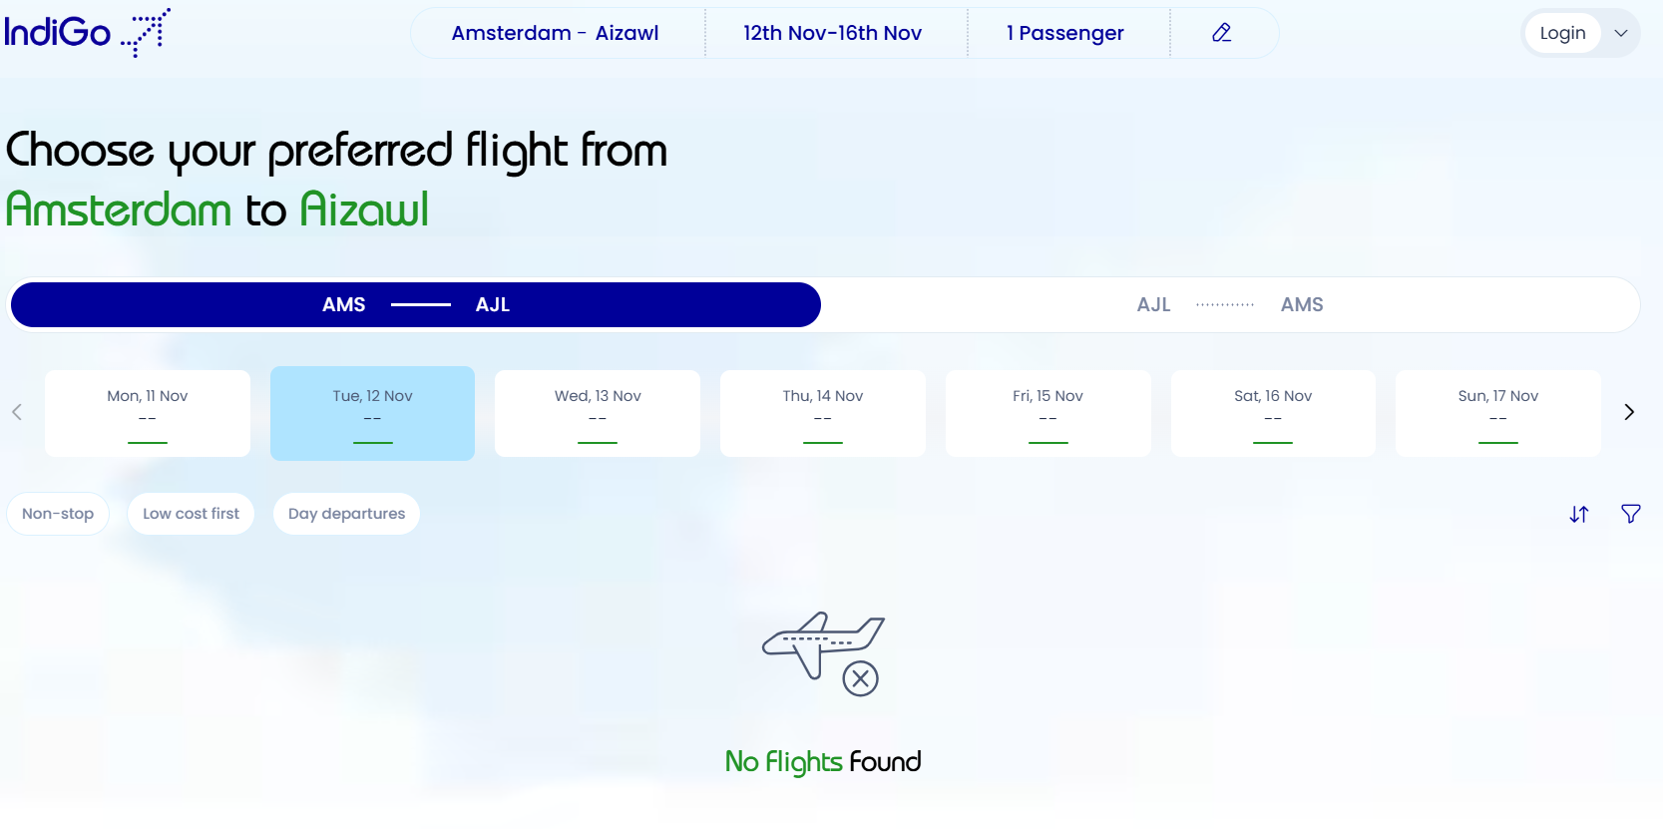

### Error Messages and Edge Cases

Scenario 12: Verify that meaningful error messages are displayed for invalid inputs.

Steps: Leave fields blank or input invalid data and submit.

Expected Result: The system should display error messages specific to the issues.

Actual Result:

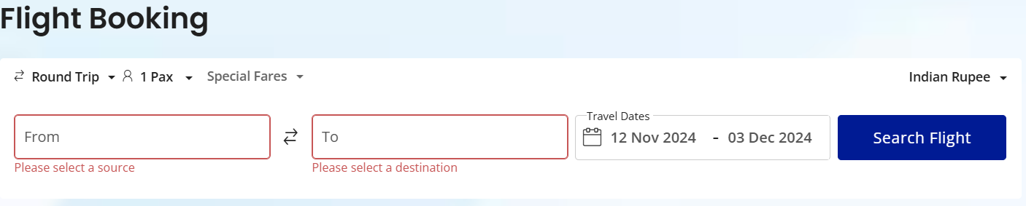

Scenario 13: Verify system response when the user’s session expires.

Steps: Leave the page idle for an extended period, then attempt to search.

Expected Result: The system should display a session timeout message.

### Responsive Design and Browser Compatibility

Scenario 14: Verify that the page is responsive on different screen sizes.

Steps: Test on desktop, tablet, and mobile views.

Expected Result: The page should adapt to different screens without layout issues.

Actual Result:

Scenario 15: Verify that the page works across multiple browsers (Chrome, Firefox, Safari, Edge).

Steps: Access the page on each browser and test basic functionalities.

Expected Result: The page should function consistently across all tested browsers.

Actual Result:

