**MINI-PROJECT REPORT**

**Personal Diary Management System**

**NAME: - Vaibhavi Musale**

**Electronics and Telecommunication**

**BE(2022)**

**Bharati Vidhyapeeth’s College of Engineering for Women**

**INDEX**

| **SERIAL No.** | **CONTENT** | **PAGE No.** |
| --- | --- | --- |
| 1 | Problem Statement | 3 |
| 2 | Description | 3 |
| 3 | Requirements | 4 |
| 4 | Architecture | 5 |
| 5 | Test Plan/Test cases | 6 |
| 6 | Expected results/Outcomes | 6-7 |
| 7 | Conclusion | 7 |

**INTRODUCTION:**

**PROBLEM STATEMENT**

To create a Personal Diary Management System using concepts of C and data structure. This system would help the user to create, edit and view the diary created by the user on this system.

**DESCRIPTION:**

Personal Diary Management System is a console application used for creating, viewing and managing the personal diary of a user. In this project, user can keep their personal record like they do in a diary. They can update, add and view the records of the diary. User can keep records of the important things they do in their daily life, like meetings and the activities which they do in their everyday life.

Their diary will be password protected hence they can freely share their experiences without the fear of getting read by someone else.

**REQUIREMENTS**

**Hardware Requirements**

* Ram 512MB or higher.
* Minimum 10MB hard disk space.
* Intel/Pentium powered system.
* Processor speed 1.7 GHZ

**Software Requirements: -**

* Windows 8 or higher versions.
* Visual Studio/Code::Blocks software.

**Functional Requirements: -**

In this project we used the concept of file handling, data structures, pointer and functions.

The basic user-defined functions used in this project are listed below:

* Password – Contains/Manages/Handles password protection
* Add record – To add new records
* View record – To view already added records.
* Edit record – To modify and update added records.
* Edit password – To modify/change password.
* Delete record – To delete/remove a record permanently from system file.

**ARCHITECTURE**

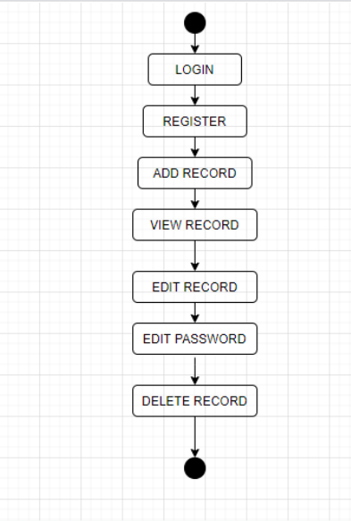

**TEST CASES: -**

| **Test case Id** | **Test scenario** | **Test data** |
| --- | --- | --- |
| 1 | Register the user | Username- user Password - pass |
| 2 | Login the user | Username – user Password – pass |
| 4 | Add Record | User can create a new record. |
| 5 | View Record | User can view the contents of this diary. |
| 6 | Edit Record | User can edit the contents of records if and when required. |
| 7 | Edit Password | Current password – pass New password – password |
| 8 | Delete Record | After entering password user can delete the records permanently. |

**EXPECTED OUTCOMES: -**

| **TEST CASE ID** | **EXPECTED RESULT** |
| --- | --- |
| 1 | User was registered successfully |
| 2 | User logged – in successfully |
| 3 | Entered data recorded successfully. |
| 4 | User can view records of the diary. |
| 5 | User can edit records. |
| 6 | User successfully changed the password. |
| 7 | User successfully deleted the record after entering correct password. |

**CONCLUSION: -**

With the help of this personal diary management system, user can register, login, create, edit and view the created records. User can also change the password. User gets the opportunity to save their personal information with the help of the password. This password protected system helps user to write their personal experiences and views which they otherwise don’t freely do in case of the traditional personal diary. This system therefore provides an edge with respect to the conventional manual hand-written diary.