

MANIPAL SCHOOL OF INFORMATION SCIENCES
(A Constituent unit of MAHE, Manipal)

Heart Disease Prediction: Logistic Regression vs. Random Forest

Reg. Number | Name | Branch
261100660002 | Akshaya | AIML
261100660016 | Vaibhavi | AIML
261100660023 | Siddhanth Suvarna | AIML

Under the guidance of

Dr. Richa Sharma
Assistant Professor,
Manipal School of Information Sciences,
MAHE, MANIPAL

04/11/2026


Table of Contents
1. Problem Statement and Dataset 1
1.1. Problem statement 1
1.2. Dataset 1
1.3. Data quality issues 2
2. Sampling and Experimental Methodology 3
2.1. Overview of the design 3
2.2. Sampling: the train/test split 3
2.3. Preprocessing (fitted on training data only) 3
2.4. Models 4
2.5. Evaluation and statistical tests 4
3. Observations, Decision, and Limitations 4
3.1. Descriptive observations 4
3.2. Model performance 5
3.3. Do the models really differ? 6
3.4. What the logistic model associates with disease 7
3.5. Decision 7
3.6. Limitations 7
4. Where We Use Probability and Statistics 8
LIST OF FIGURES
Figure 1.1: Observed disease prevalence by source. The four samples differ sharply. 2
Figure 3.1: Numerical features by disease status (zeros as recorded). 5
Figure 3.2: Confusion matrices for the two models. 6
Figure 3.3: ROC curves on the shared test set. The curves nearly overlap. 6

LIST OF TABLES
Table 1.1: Predictors 1
Table 1.2: Records and disease prevalence by source (95% Wilson intervals) 2
Table 2.1: Resulting training and test samples 3
Table 2.2: Model settings 4
Table 3.1: Metrics on the 184 held-out patients 5
Table 3.2: Confusion matrices on the test set 5
Table 3.3: Paired hypothesis tests 6
Table 3.4: Odds ratios whose 95% interval excludes 1 7
Table 4.1: Probability and statistics concepts used in the project 8

ABBREVIATIONS

AUC | Area Under the ROC Curve
CI | Confidence Interval
ECG | Electrocardiogram
LR | Logistic Regression
MLE | Maximum Likelihood Estimation
RF | Random Forest
ROC | Receiver Operating Characteristic
SD | Standard Deviation
UCI | University of California, Irvine (Machine Learning Repository)
VA | Veterans Affairs

Problem Statement and Dataset
Summary. Using 920 patient records from four hospitals, this project asks whether a random forest predicts heart disease measurably better than a logistic regression. On 184 held-out patients the two models perform almost identically (ROC-AUC 0.926 vs. 0.927). Two paired hypothesis tests (exact McNemar, p = 0.754; paired bootstrap on AUC, p = 0.815) find no evidence that they differ. The extra flexibility of the forest is not detectably worth it on this data.

Problem statement
Heart disease is diagnosed from a mix of demographic information, symptoms, and test results. A statistical model can turn those measurements into an estimated probability that a patient has disease. The question here is a model-comparison one: does a more flexible, non-linear model (random forest) predict heart disease better than a simple, interpretable one (logistic regression)?
Formally, the response is binary: disease present (original label num > 0) or absent (num = 0). Both models are trained on the same data and scored on the same held-out patients, and the difference in performance is tested rather than judged by eye.
The study has two secondary aims: (i) describe the data and its quality problems honestly, and (ii) report which predictors the logistic model associates with disease, with appropriate uncertainty.

Dataset
The data are the processed files of the UCI Heart Disease collection, from four sources: Cleveland, Hungarian, Switzerland and VA Long Beach. Together they hold 920 patients and 14 columns each (13 predictors plus the diagnosis). Missing values are coded as “?” in the source files.
Table 1.1: Predictors
Variable | Type | Meaning
age | Numeric | Age in years (28–77)
trestbps | Numeric | Resting blood pressure (mm Hg)
chol | Numeric | Serum cholesterol (mg/dl)
thalach | Numeric | Maximum heart rate achieved
oldpeak | Numeric | ST depression induced by exercise
sex, fbs, exang | Categorical (binary) | Sex; fasting blood sugar > 120 mg/dl; exercise-induced angina
cp, restecg, slope | Categorical | Chest-pain type; resting ECG result; slope of the peak-exercise ST segment
ca, thal | Categorical | Number of major vessels coloured by fluoroscopy; thalassemia test result

The diagnosis column has five levels (0–4). It was collapsed to binary: 509 patients (55.3%) have disease and 411 (44.7%) do not. The original class counts are 411, 265, 109, 107 and 28 for levels 0 to 4.
Table 1.2: Records and disease prevalence by source (95% Wilson intervals)
Source | Patients | With disease | Prevalence | 95% interval
Cleveland | 303 | 139 | 45.9% | 40.4% – 51.5%
Hungarian | 294 | 106 | 36.1% | 30.8% – 41.7%
Switzerland | 123 | 115 | 93.5% | 87.7% – 96.7%
VA Long Beach | 200 | 149 | 74.5% | 68.0% – 80.0%
Pooled | 920 | 509 | 55.3% | 52.1% – 58.5%
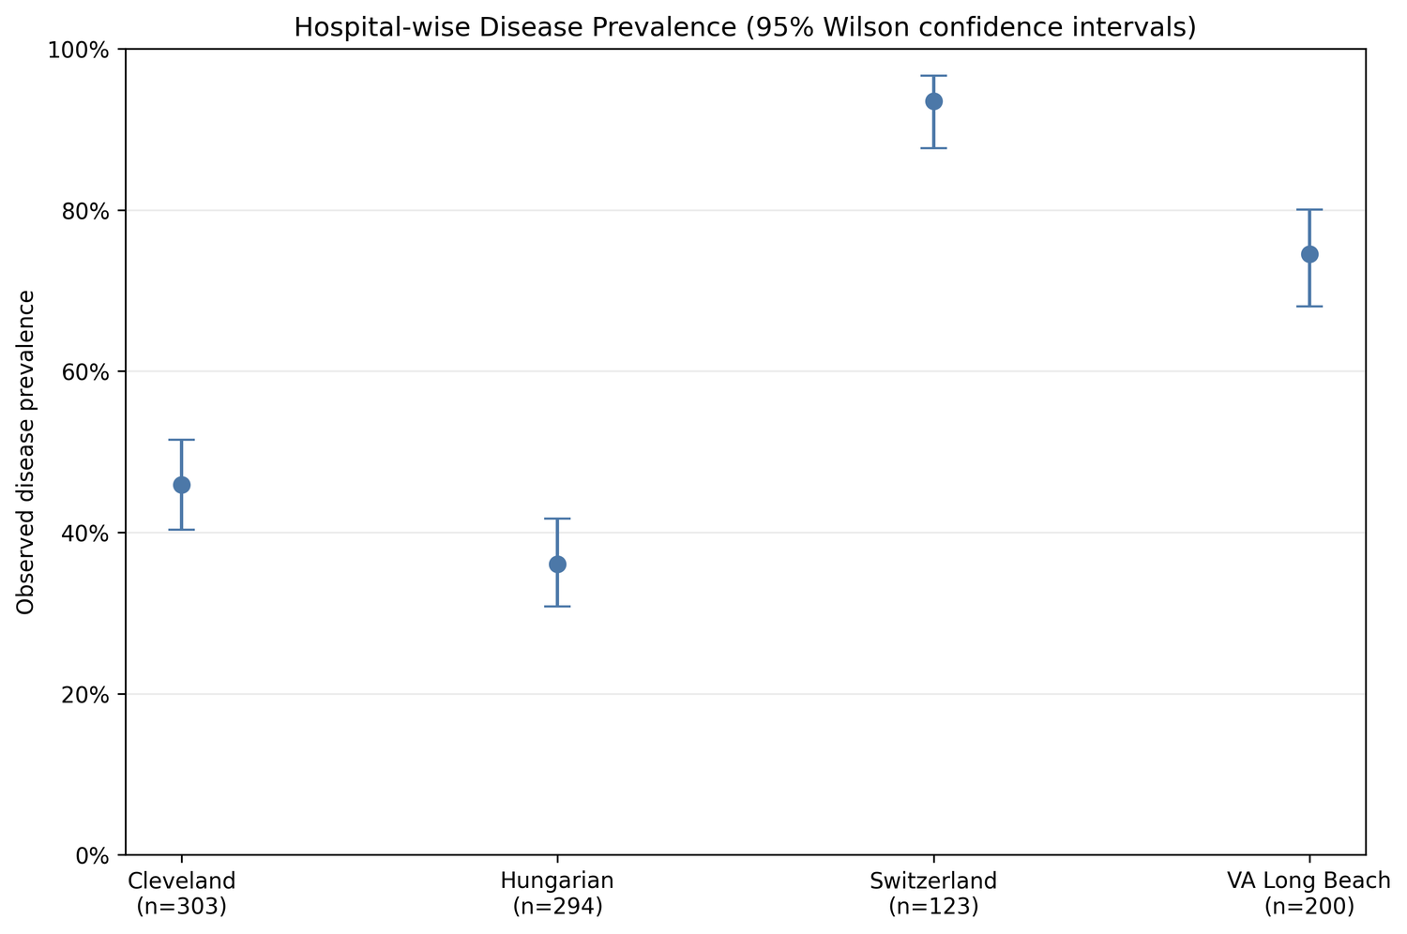
Figure 1.1: Observed disease prevalence by source. The four samples differ sharply.

Data quality issues
- Zero-coded measurements. Resting blood pressure has 1 zero (VA Long Beach) and cholesterol has 172 zeros: all 123 Switzerland records and 49 VA Long Beach records. These are not physiologically plausible, so the modelling pipeline treats them as missing.
- Heavy missingness in some predictors. After the zero conversion, ca is missing for 66.4% of patients, thal for 52.8%, slope for 33.6% and chol for 22.0%. Missingness is concentrated in particular hospitals (for example, ca is missing for about 99% of Hungarian and VA Long Beach patients).
- Source heterogeneity. Prevalence ranges from 36% to 93% across sources, so the pooled 55.3% describes this particular mix of samples, not a wider population.

Sampling and Experimental Methodology

Overview of the design
All 920 labelled records were pooled, split once into training and test sets, preprocessed using training information only, and used to fit both models. Both models were then evaluated on the identical test patients, which makes every comparison paired.

Sampling: the train/test split
A single stratified random split was drawn (80% train / 20% test, random seed 42). Stratifying on the binary target keeps the disease rate the same in both parts.
Table 2.1: Resulting training and test samples
Set | Patients | No disease | Disease | Disease rate
Training | 736 | 329 | 407 | 55.3%
Test | 184 | 82 | 102 | 55.4%

Test patients by source: Cleveland 55, Hungarian 64, Switzerland 28, VA Long Beach 37. The split was stratified on the target only, not on the source, so the source mix in the test set is whatever the random draw produced.

Preprocessing (fitted on training data only)
- Zeros to missing for trestbps and chol, as described above.
- Hospital-aware imputation. Missing numeric values are replaced by the training-set median for that hospital, and missing categorical values by the training-set mode for that hospital. Switzerland has no usable cholesterol value in training, so the global training median (239) is used as a fallback.
- Scaling and encoding. The five numeric predictors are standardized (mean 0, SD 1); the eight categorical predictors are one-hot encoded with no reference level dropped. This gives 28 encoded features.
- No leakage. Medians, modes, scaling parameters and encoder categories are learned from the 736 training patients and merely applied to the test patients. The hospital label is used for imputation but is not a predictor.

Models
Table 2.2: Model settings
Model | Configuration
Logistic regression | scikit-learn defaults with an L2 penalty (regularization), max_iter = 2000, seed 42
Random forest | 300 trees, scikit-learn defaults otherwise, seed 42

No hyperparameter tuning or cross-validation was performed; both models use fixed settings. Predicted classes use the models’ default decision rules (probability above 0.5 for logistic regression; majority vote for the forest).

Evaluation and statistical tests
- Descriptive statistics: means with Student t confidence intervals, medians, variances, quartiles; disease prevalence with Wilson intervals.
- Performance metrics on the test set: accuracy, precision, recall, F1 and ROC-AUC, plus confusion matrices and ROC curves.
- McNemar’s exact test on classification errors. H0: both models have the same error probability; H1: they differ. Only patients on whom the models disagree carry information.
- Paired stratified bootstrap on the AUC difference (logistic minus forest): 10,000 resamples of the same test patients within each class, giving a percentile 95% interval and a two-sided p-value from the null-centered distribution. H0: AUCs are equal.
- Odds ratios from the logistic model, with approximate 95% penalized-Wald intervals.
All tests use a significance level of α = 0.05.

Observations, Decision, and Limitations

Descriptive observations
Patients with disease are older on average (55.9 vs. 50.5 years), reach a lower maximum heart rate (128.3 vs. 148.8) and show more ST depression (oldpeak 1.26 vs. 0.42). Resting blood pressure is slightly higher in the disease group (134.0 vs. 129.9).
Cholesterol runs the other way (176.5 vs. 227.9) but this is an artifact: the recorded zeros, which are concentrated in the 93.5%-disease Switzerland sample, pull the disease-group mean down. The descriptive summaries keep zeros as recorded; the models do not.
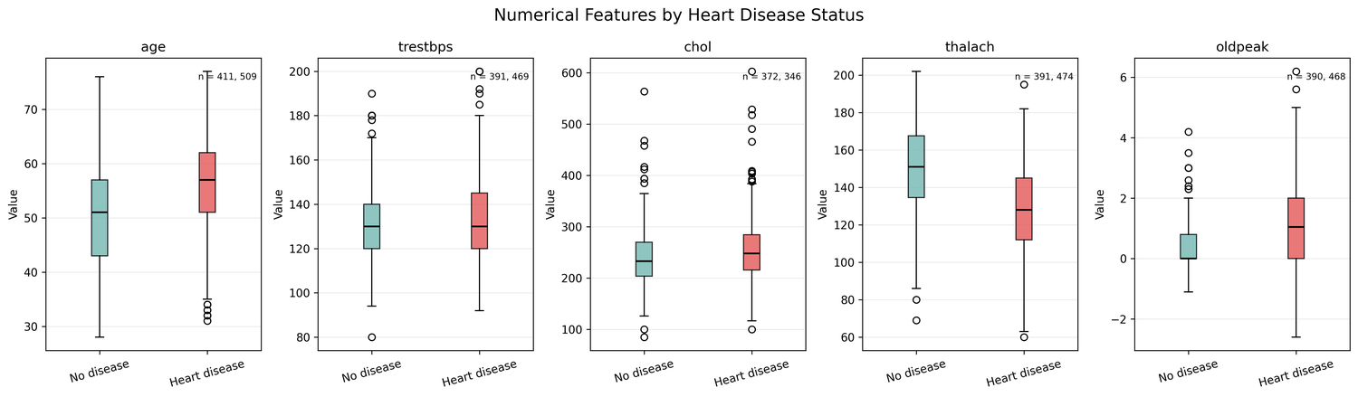
Figure 3.1: Numerical features by disease status (zeros as recorded).

Model performance
Table 3.1: Metrics on the 184 held-out patients
Model | Accuracy | Precision | Recall | F1 | ROC-AUC
Logistic regression | 0.848 | 0.849 | 0.882 | 0.865 | 0.926
Random forest | 0.859 | 0.865 | 0.882 | 0.874 | 0.927

The forest is nominally ahead on accuracy, precision and F1, with identical recall and a near-identical AUC. The accuracy gap is 2 patients out of 184 (158 vs. 156 correct). For context, the 95% Wilson intervals for accuracy (computed for this report from the confusion matrices) are about 78.9%–89.3% for logistic regression and 80.1%–90.2% for the forest, which overlap almost entirely.
Table 3.2: Confusion matrices on the test set
Model | True negative | False positive | False negative | True positive
Logistic regression | 66 | 16 | 12 | 90
Random forest | 68 | 14 | 12 | 90
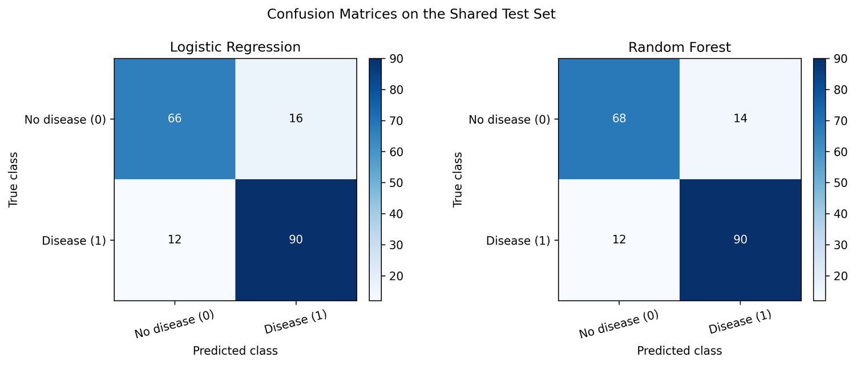
Figure 3.2: Confusion matrices for the two models.
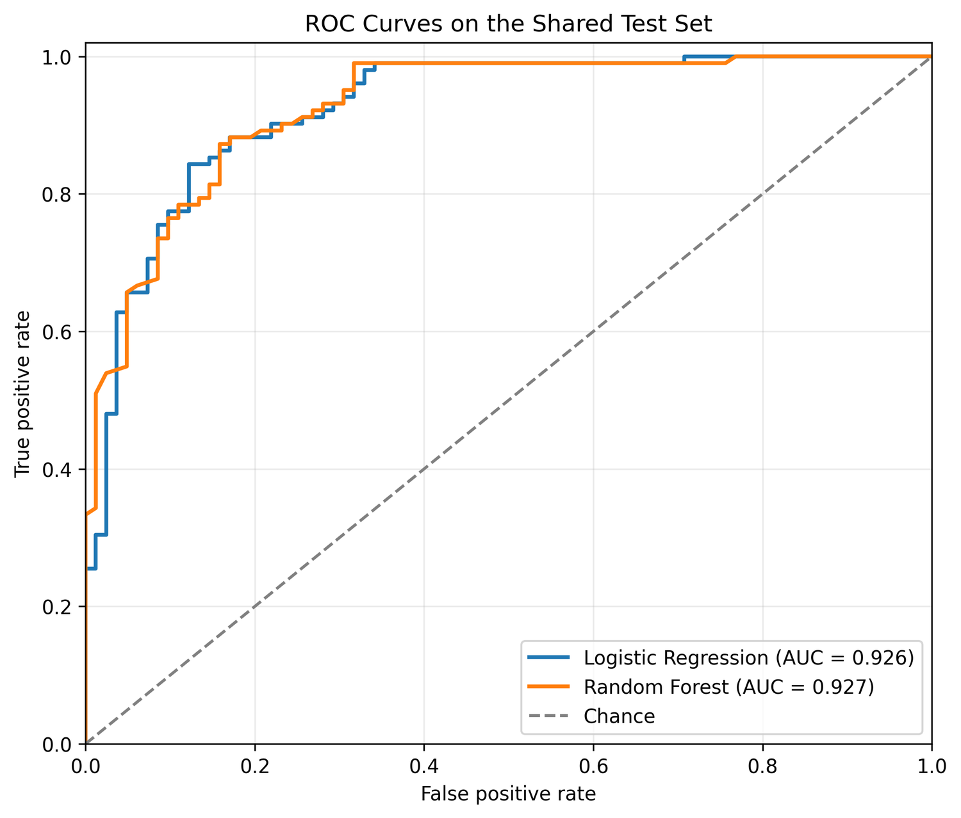
Figure 3.3: ROC curves on the shared test set. The curves nearly overlap.

Do the models really differ?
Table 3.3: Paired hypothesis tests
Test | Result | p-value | Decision (α = 0.05)
McNemar (exact) | Both correct 152; logistic only 4; forest only 6; both wrong 22. Only 10 discordant patients. | 0.754 | Fail to reject H0
Paired bootstrap, AUC | Difference (LR − RF) = −0.0018; 95% interval −0.0170 to +0.0136 | 0.815 | Fail to reject H0

Both tests agree. The 95% interval for the AUC difference runs from about −0.017 to +0.014, so differences larger than roughly 0.015 AUC in either direction are not well supported by this test set.

What the logistic model associates with disease
Of the 28 encoded coefficients, only three have 95% intervals that exclude an odds ratio of 1. Numeric predictors are standardized, so their odds ratios are per one standard deviation.
Table 3.4: Odds ratios whose 95% interval excludes 1
Predictor | Odds ratio | 95% interval | Reading
oldpeak (per 1 SD) | 1.707 | 1.309 – 2.226 | Higher ST depression → higher odds
chol (per 1 SD) | 1.290 | 1.051 – 1.582 | Higher cholesterol → higher odds
ca = 0 (indicator) | 0.196 | 0.063 – 0.609 | No coloured vessels → lower odds

These are conditional associations, not causal effects. Because categories are fully one-hot encoded without a reference level and the model is penalized, individual categorical coefficients are regularized contrasts rather than simple category-versus-reference comparisons. The cholesterol result deserves caution: cholesterol is missing or zero for 22% of patients and is imputed by hospital medians, and the Switzerland sample has the highest disease rate, so hospital-level differences could be leaking into this coefficient. This is our reading of the pipeline, not something the analysis tested.

Decision
- Statistical decision: fail to reject H0 in both tests. There is no evidence at the 5% level that the random forest and logistic regression differ in error rate or in AUC.
- Practical conclusion: the random forest’s flexibility does not buy a detectable gain here. Since the two perform equivalently, logistic regression is the sensible default because it is simpler and gives interpretable odds ratios with intervals. That preference is a judgment on parsimony, not a result of the tests.
- What the decision does not say: failing to reject is not proof of equality. With 184 test patients and only 10 discordant cases, a small true difference would be hard to detect.

Limitations
- Mixed hospital samples. Prevalence ranges from 36% to 93%, and the pooled data do not represent any single population. Results may not carry over to a single hospital, and the models were not tested on a hospital held out entirely.
- Missing and zero-coded values. Cholesterol is entirely unusable for Switzerland, and ca, thal and slope are mostly missing. Median/mode imputation understates uncertainty and may distort associations; no multiple-imputation or sensitivity analysis was done.
- One small test set. A single split of 184 patients gives wide uncertainty; a different seed could move the metrics. Repeated or nested cross-validation would be more stable.
- No tuning. Neither model’s hyperparameters were tuned, so the comparison is between two default configurations, not between the best versions of each.
- Binarized outcome. Disease stages 1–4 were merged, discarding severity information.
- Multiplicity and association. The odds-ratio intervals are exploratory with no multiplicity adjustment, and with 28 coefficients a few intervals excluding 1 are expected by chance alone. Nothing here is causal.
- Not a clinical tool. This is a statistical comparison on historical data.

Where We Use Probability and Statistics
The table below maps each probability or statistics idea to where it appears in the project.
Table 4.1: Probability and statistics concepts used in the project
Concept | Where it is used | What it does
Random sampling and stratification | 80/20 stratified train/test split with fixed seed | Gives a random test sample with the same disease rate as the training data, so the test estimate is not biased by class imbalance
Binomial model and Wilson interval | Disease prevalence overall and per hospital (Table 1.2) | Treats each patient as a Bernoulli trial; the interval measures sampling uncertainty in a proportion
Mean, median, variance, quartiles | Descriptive summary of age, trestbps, chol, thalach, oldpeak | Summarizes center and spread of each feature by disease group
Student t confidence interval | Interval for each feature’s group mean | Quantifies uncertainty in the mean, not the spread of individuals
Missing-data handling (median/mode) | Hospital-wise imputation from training data | Uses sample statistics as estimates to fill gaps; the zero-as-missing rule follows from checking data plausibility
Standardization (z-scores) | Numeric predictors before modelling | Puts predictors on a common scale so coefficients are comparable
Bernoulli likelihood and the logistic function | Logistic regression | Models P(disease | features) = 1 / (1 + e^−(β₀ + β·x)); coefficients estimated by maximum likelihood with an L2 penalty
Odds and odds ratios; Wald intervals | Logistic coefficients (Table 3.4) | exp(β) is the multiplicative change in odds; the interval uses the normal approximation of the coefficient estimator
Bootstrap aggregation and random subsets | Random forest (300 trees) | Each tree is fit on a bootstrap sample with random feature subsets; the predicted probability is the average vote of the trees
Classification probabilities and thresholds | Confusion matrices, precision, recall, F1 | Estimate conditional probabilities such as P(predicted positive | diseased)
ROC curve and AUC | Model comparison | AUC equals the probability that a randomly chosen diseased patient is scored higher than a randomly chosen healthy one
Hypothesis testing: H0, H1, α, p-value | McNemar and bootstrap tests | Decides whether an observed gap exceeds what chance would produce; controls Type I error at 5%
Exact binomial distribution | McNemar’s test | Under H0 each of the 10 discordant patients favors either model with probability ½, so the count is Binomial(10, 0.5); p = 2·P(X ≤ 4) = 0.754
Bootstrap resampling | Paired AUC test (10,000 resamples) | Approximates the sampling distribution of the AUC difference without a formula; gives a percentile interval and p-value
Paired design | Both models scored on the same patients | Removes patient-to-patient variability from the comparison, making the tests more sensitive
Type II error and power | Interpreting “fail to reject” | Explains why non-significance is not proof of equivalence on a small test set
Multiple comparisons | 28 odds-ratio intervals | With many intervals, a few will exclude 1 by chance; hence results are treated as exploratory

