**Some Screenshots of the working program :**

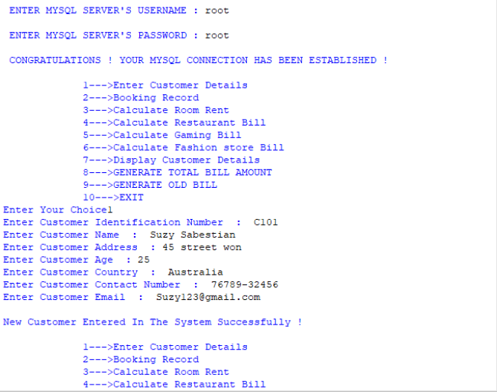

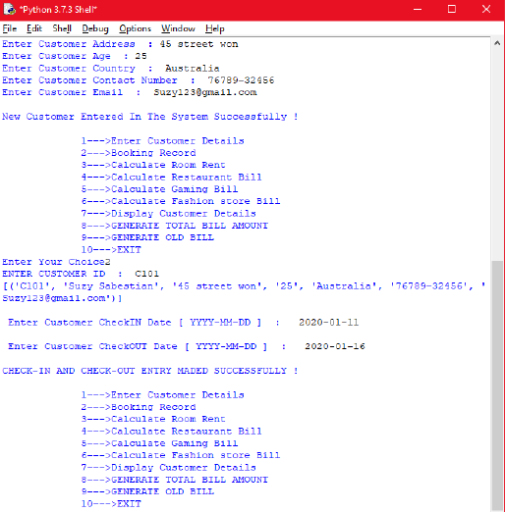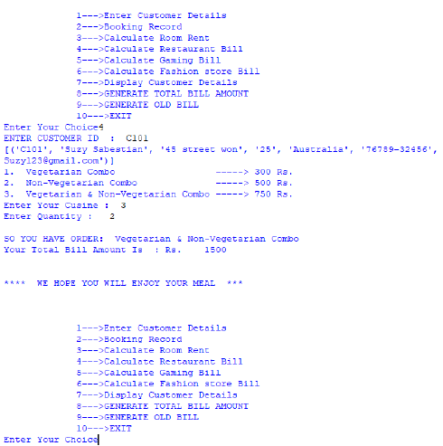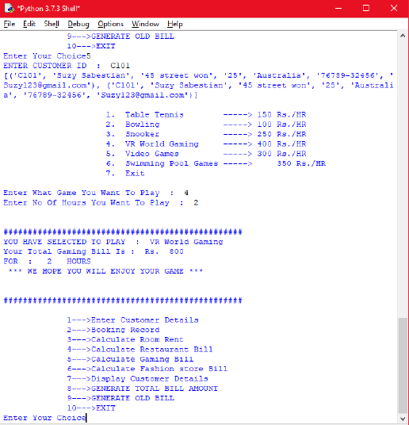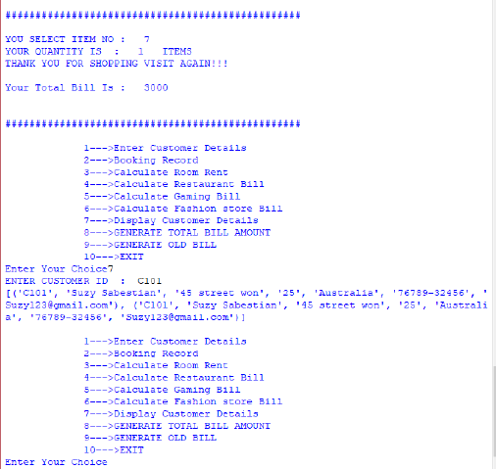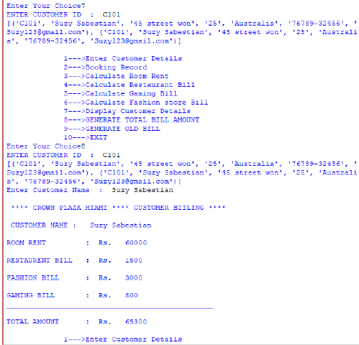

**MYSQL DATABASE AND TABLES USED IN THIS PROJECT**

**DATABASE**



**TABLE STRUCTURE 1 AND 2**



**TABLE STRUCTURE 3 AND 4**



**TABLE STRUCTURE 5 AND 6**



**TABLE STRUCTURE 7**

