House Price Prediction
Data Analysis using Python

Name: Vaibhavi Hambire
Batch Code: CX-143-MOR-JULY
Submitted To: CoachX Learning
Date: May 2026

1. Introduction
House price prediction is a common real-world data analysis problem where the goal is to estimate the selling price of a property using measurable factors such as its physical condition, location, and size. Accurate price estimation helps sellers set realistic listing prices, helps buyers judge whether a property is fairly priced, and helps real estate agents and developers make informed decisions.
This project works with the Ames Housing dataset (a well-known dataset used in the Kaggle "House Prices" competition), reduced here to 13 relevant columns. The objective was to explore the dataset thoroughly, clean and engineer useful features, and understand which factors most strongly influence SalePrice, the target variable.
The dataset provided 2,919 total rows, split into 1,460 rows with a known SalePrice (used as the training/analysis data throughout this report) and 1,459 rows with SalePrice missing (held out as unseen test data).

2. Methodology
The analysis was carried out in three structured stages using Python:
- Task 1 - Basic Data Exploration: loading the dataset, inspecting its structure, and understanding what each column represents.
- Task 2 - Data Cleaning and Analysis: checking for missing values, examining numerical vs categorical vs temporal features, studying distributions, and applying log transformation to skewed data.
- Task 3 - Feature Engineering and Advanced Analysis: detecting outliers, studying categorical and numerical relationships with price, encoding categorical variables, scaling numerical variables, engineering temporal (age-based) features, and answering five advanced business questions (Q11-Q15).
All analysis in Tasks 1-3 was performed on the 1,460-row labeled subset, since this is the only portion of the data containing the target variable, SalePrice. The unlabeled 1,459-row subset was kept aside as it would be used only for generating final predictions.

3. Requirement Analysis
Tools and libraries used for this project:
Component | Details
Language | Python 3
Data Handling | pandas, numpy
Visualization | matplotlib, seaborn
Machine Learning | scikit-learn (LinearRegression, StandardScaler, train_test_split)
Dataset Size | 2,919 rows total (1,460 train / 1,459 test), 13 columns
Target Variable | SalePrice (continuous, numerical)

4. Data Overview and Key Steps

4.1 Task 1: Basic Data Exploration
The dataset contains 9 numerical columns and 4 categorical columns. Id is a unique identifier with no predictive value and was excluded from modeling. MSSubClass, though stored as a number, is actually a categorical dwelling-type code rather than a true numerical measure.

4.2 Task 2: Data Cleaning and Analysis
Missing value checks (performed on the full 2,919-row dataset) found only 6 missing values in total, across MSZoning, Exterior1st, TotalBsmtSF and BsmtFinSF2 - and all of them happened to fall in the unlabeled test rows. This meant the standard "mean price when missing vs present" comparison was not computable on this dataset, since no row was missing a feature while also having a known SalePrice.
YearBuilt showed a moderate positive correlation with SalePrice (0.52) - newer homes tend to sell for more.
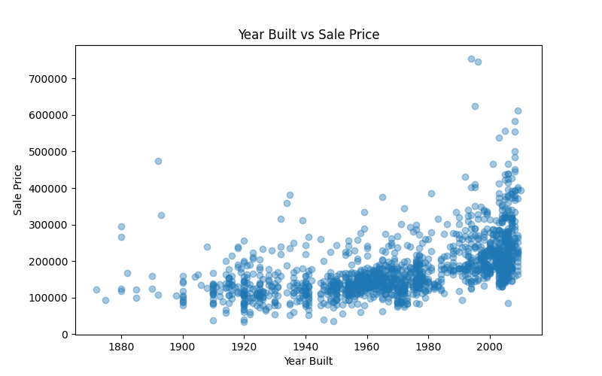
Figure 1: Year Built vs Sale Price
OverallCond (the 1-10 condition rating) did not show a clean linear relationship with price - ratings 5 and 9 had unusually high average prices, suggesting condition rating interacts with other features rather than driving price on its own.
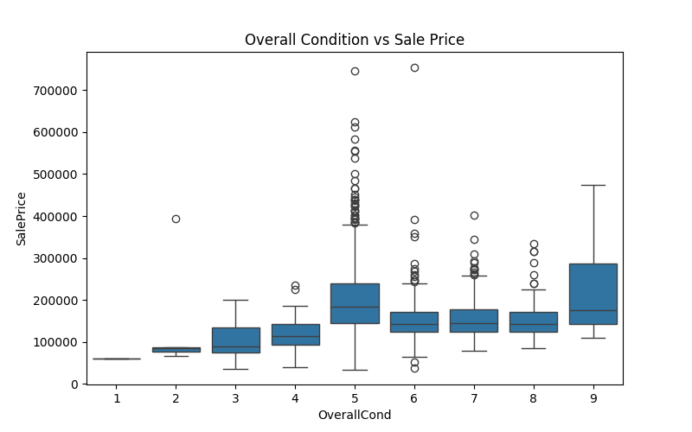
Figure 2: Overall Condition vs Sale Price
SalePrice and LotArea were both right-skewed. A log1p transformation was applied to bring their distributions closer to normal, which is a standard step before feeding continuous targets/features into linear models.
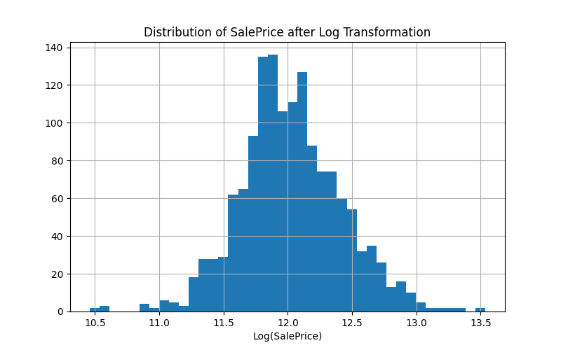
Figure 3: SalePrice Distribution After Log Transformation

4.3 Task 3: Feature Engineering and Advanced Analysis
An IQR-based outlier check flagged 61-69 outliers in most continuous columns; BsmtFinSF2 flagged 167, almost entirely because most houses simply have a value of 0 for this feature, showing why outlier flags need to be interpreted with domain context rather than applied blindly.
The correlation heatmap below confirms TotalBsmtSF (0.61) and YearBuilt (0.52) as the strongest numerical predictors of price, while OverallCond and MSSubClass showed a weak negative correlation.
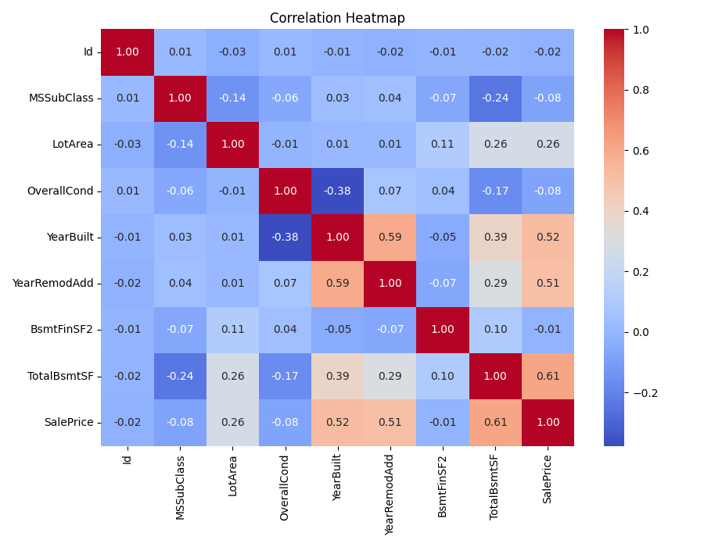
Figure 4: Correlation Heatmap of Numerical Features
Among categorical features, zoning classification (MSZoning) showed a clear price gradient - Floating Village Residential (FV) zoning fetched the highest average prices, while Commercial (C) zoning fetched the lowest.
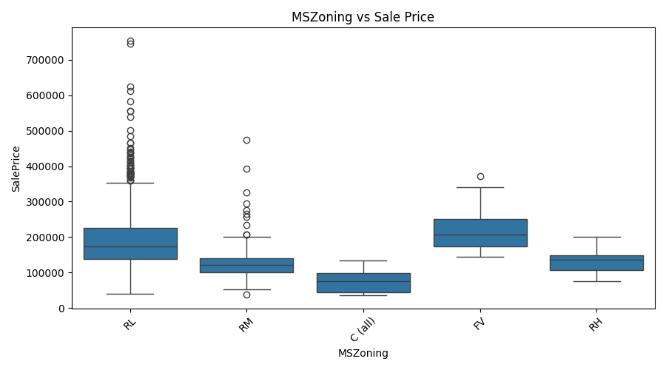
Figure 5: MSZoning vs Sale Price
Continuous features LotArea, TotalBsmtSF and BsmtFinSF2 were plotted against SalePrice together for comparison. TotalBsmtSF showed the clearest upward trend, LotArea a weaker trend, and BsmtFinSF2 essentially no relationship.
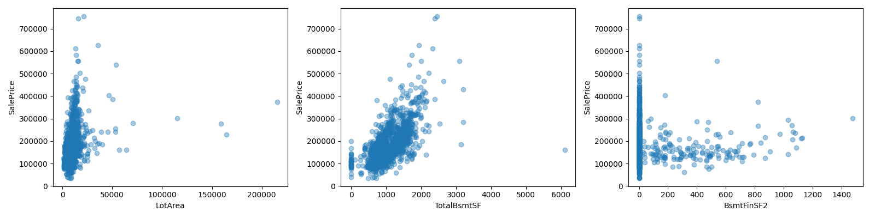
Figure 6: Continuous Features vs Sale Price
Feature engineering included one-hot encoding of categorical columns (expanding the dataset from 13 to 35 columns), standard scaling of continuous numerical columns, and creation of two new temporal features - HouseAge and YearsSinceRemod - derived from YearBuilt and YearRemodAdd.

5. Advanced Questions (Q11-Q15)

Q11: How does location (zoning + lot configuration) influence price?
The combination of FV zoning with a Cul-de-Sac lot configuration produced the highest average sale price, well above other combinations - indicating that zoning and lot configuration together matter more than either factor alone.

Q12: What is the impact of overall condition on sale price?
Overall condition alone was a weak and inconsistent predictor of price. Correlation with SalePrice was slightly negative (-0.08), and average prices did not increase steadily with higher condition ratings, suggesting other features dominate the pricing relationship.

Q13: Does the presence of a basement significantly affect price?
Yes. Houses with a basement (TotalBsmtSF > 0) averaged approximately Rs. 1,82,878 in sale price, compared to approximately Rs. 1,05,653 for houses without one - a substantial and consistent difference.
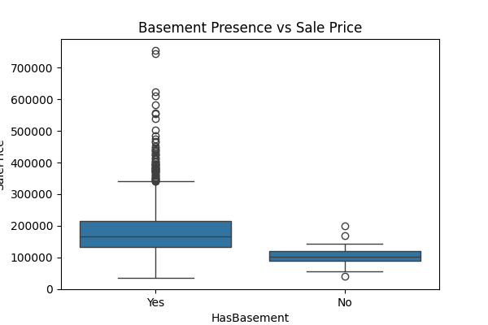
Figure 7: Basement Presence vs Sale Price

Q14: How do remodeling and renovations influence value over time?
Average sale price rose consistently with more recent remodel decades - from roughly Rs. 1,21,634 for homes remodeled in the 1950s to roughly Rs. 3,36,964 for homes remodeled in the 2010s, showing that renovation recency adds measurable value.
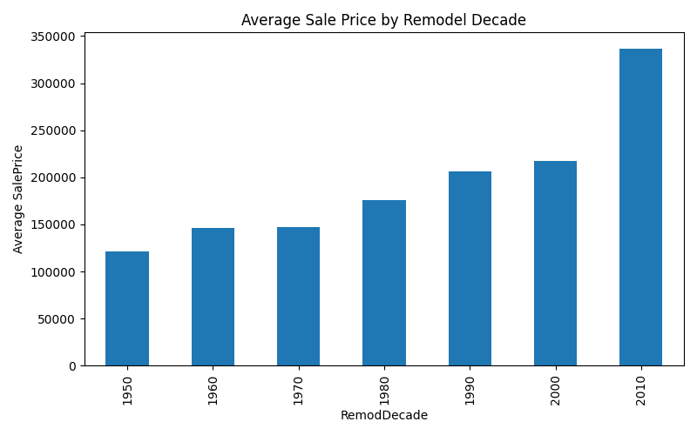
Figure 8: Average Sale Price by Remodel Decade

Q15: Can house prices be predicted using only categorical features?
A Linear Regression model trained using only one-hot encoded categorical features (MSZoning, LotConfig, BldgType, Exterior1st) achieved an R-squared score of approximately 0.25 on the test split. This confirms that categorical features alone explain only about a quarter of the variation in house prices - numerical features such as TotalBsmtSF, LotArea and YearBuilt are essential for building an accurate prediction model.

6. Model Building (Task 4)
With EDA and feature engineering complete, a simple regression model was built to actually predict SalePrice for the 1,459 test rows that had no known price. Missing values in the test set (MSZoning, Exterior1st, TotalBsmtSF, BsmtFinSF2) were filled using statistics learned from the train set only (mode for categorical columns, median for numerical columns), keeping the test set fully unseen during training. Train and test were temporarily combined only for one-hot encoding, so both ended up with identical columns, then split back apart.
Two models were trained on an 80/20 train-validation split of the train data and compared on the same validation set:
Model | R-squared | MAE | RMSE
Linear Regression | R2 = 0.62 | MAE = Rs. 34,123 | RMSE = Rs. 54,023
Random Forest Regressor | R2 = 0.82 | MAE = Rs. 22,906 | RMSE = Rs. 37,269

Random Forest clearly outperformed Linear Regression. This lines up with the EDA findings from Task 2 and Task 3 - features like OverallCond showed non-linear, inconsistent relationships with price, which a straight-line model like Linear Regression cannot capture but a tree-based model can. Random Forest was therefore selected as the final model and retrained on the full train dataset before predicting on the test set.
Feature importance from the final Random Forest model confirms the EDA results: TotalBsmtSF was by far the most influential feature, followed by HouseAge, YearBuilt and LotArea - the same features that stood out as strong correlators with SalePrice back in Task 3.
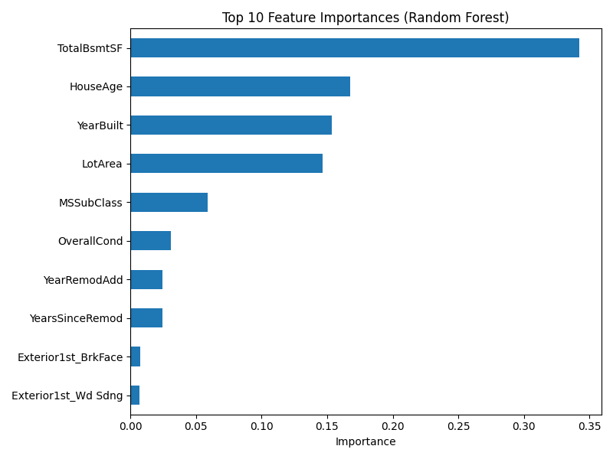
Figure 9: Top 10 Feature Importances (Random Forest)
The Actual vs Predicted plot below (on the validation set) shows predictions clustered fairly close to the red dashed line representing a perfect prediction, with more scatter appearing at higher price ranges - a common pattern, since expensive homes are rarer and more variable, giving the model less data to learn that range well.
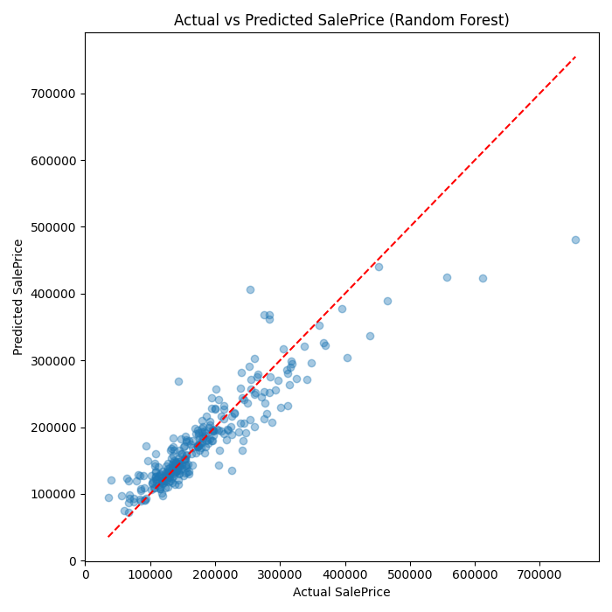
Figure 10: Actual vs Predicted Sale Price (Random Forest)
Final predictions for all 1,459 test rows were saved to predictions.csv in the standard Id/SalePrice submission format.

7. Key Insights
- TotalBsmtSF and YearBuilt are the two strongest numerical drivers of sale price in this dataset.
- OverallCond, despite being an intuitive quality measure, is a weak standalone predictor - it likely needs to be combined with other features.
- Basement presence alone accounts for a roughly 73% average price difference between homes with and without one.
- Zoning classification (MSZoning) creates large average price gaps, with FV zoning commanding a strong premium.
- Categorical features alone are insufficient for accurate price prediction (R2 = 0.25); a complete model needs both numerical and categorical inputs.
- SalePrice and LotArea are right-skewed and benefit from log transformation before being used in linear models.
- A Random Forest model using all engineered features achieved R2 = 0.82 on validation data, a large improvement over Linear Regression (R2 = 0.62), confirming that price is driven by non-linear feature interactions.

8. Conclusion
This project walked through a complete, structured data analysis workflow for the House Price Prediction dataset - from initial exploration, through cleaning and distribution analysis, feature engineering, advanced business-question analysis, and finally model building. The results show that a small number of features (basement size, construction year, and zoning) carry most of the predictive signal for house prices, while some intuitively important features (like overall condition) turned out to be weaker predictors than expected. A Random Forest model built on the engineered features achieved a validation R-squared of 0.82, clearly outperforming a plain Linear Regression baseline (R2 = 0.62), and was used to generate final SalePrice predictions for all 1,459 unseen test rows.

Vaibhavi Hambire | B.E. Information Technology | CGPA: 8.5 | CoachX Program | April 2026
hambirevaibhavi21@gmail.com · github.com/Vaibhavihambire · linkedin.com/in/vaibhavi-hambire

