Market Size Analysis on
Electric Vehicles Industries
A Comprehensive Python-Based Market Analysis

Name: Vaibhavi Hambire
Batch Code: CX-143-MOR-JULY
Submitted To: CoachX Learning
Dataset : Washington State DOL — Electric Vehicle Population Data (~177,861 records)
Tools Used: Python | Pandas | NumPy | Matplotlib | SciPy | WordCloud
Date: May 2025

Executive Summary
This report presents an end-to-end market size analysis of the Electric Vehicle (EV) industry, using the Washington State Department of Licensing's EV Population dataset of 177,861 vehicle registrations. The analysis follows an eight-phase structure: data cleaning, descriptive statistics, time-series trend analysis, geographic distribution, make/model popularity, EV technology analysis, forecasting, and multi-variable correlation analysis.
The core finding is that Washington's EV market has grown approximately 74-fold between 2011 and 2023, with growth accelerating sharply after 2021. This growth is heavily concentrated geographically (King County / Seattle metro accounts for over half of all registrations) and by manufacturer (Tesla holds a 44.78% market share). The market is transitioning from a mixed BEV/PHEV landscape toward battery-electric dominance (78.3% BEV vs. 21.7% PHEV), while manufacturer strategies remain split — some brands (Tesla, Nissan, Volkswagen) have committed fully to BEV, while others (Toyota, Jeep) continue to rely primarily on plug-in hybrids.
Forecasting future registrations proved non-trivial: a simple linear regression model underestimates future growth (predicting 2026 registrations below the already-observed 2023 total), while an ARIMA(1,1,1) model better captures the market's acceleration but carries wide uncertainty due to the limited 13-year training window. Several important data-quality issues were identified and handled transparently throughout the analysis, including a near-total absence of reported Base MSRP values (~98% missing) and a systematic collapse in Electric Range reporting for Battery Electric Vehicles after model year 2020.

Phase 1: Data Cleaning and Preparation
The raw dataset contained 177,866 records across 17 columns. Initial inspection found the data to be largely clean, with no duplicate rows, but several columns required deliberate handling decisions rather than blanket cleaning rules.

Cleaning Decisions
Issue | Decision | Reason
5 rows missing County/City/Postal Code/Utility/Census Tract | Dropped | Fully incomplete rows; negligible loss (0.003% of data)
389 missing Legislative District values | Filled with 'Unknown' | Minor field; dropping rows would waste usable data
Electric Range = 0 (91,950 rows, ~51.7%) | Flagged via new 'Range Reported' column | Zero almost certainly means unrecorded, not a true 0-mile range
Base MSRP = 0 (174,522 rows, ~98%) | Kept, excluded from statistical analysis | Column is unreliable for pricing conclusions; imputing would fabricate data
Vehicle Location text field (9 missing) | Parsed into Latitude/Longitude columns | Required for geospatial analysis in Phase 4

Final cleaned dataset: 177,861 rows, 20 columns (after adding Range Reported, Latitude, and Longitude). Saved as ev_data_cleaned.csv, forming the single source of truth for all subsequent phases.

Phase 2: Descriptive Analysis
Summary statistics were computed for Electric Range (limited to reported values) and Base MSRP, along with a profile of Model Year distribution.
Metric | Electric Range (Reported only) | Base MSRP (Non-zero only)
Count | 85,911 | 3,343
Mean | 121.81 miles | $57,065.73
Median | 84.00 miles | $59,900.00
Std. Dev. | 99.22 | —
Min / Max | 6 / 337 miles | —

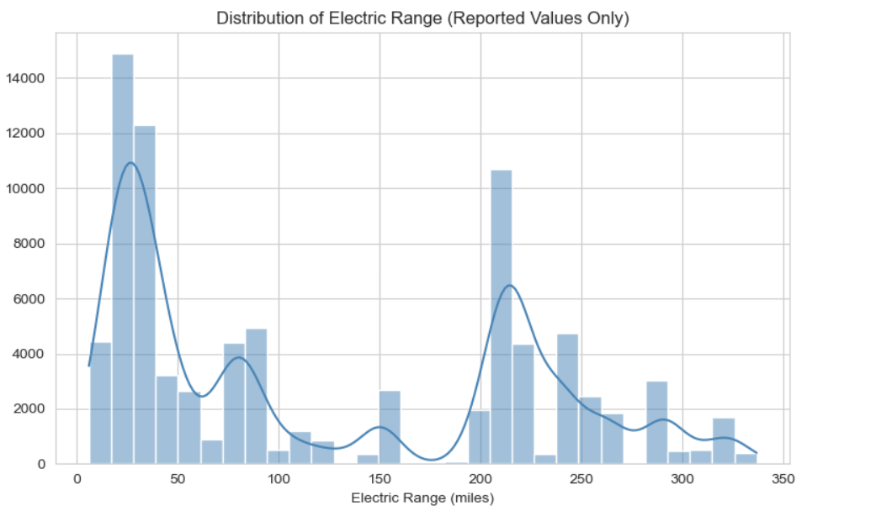
Figure 2.1 — Distribution of Electric Range (Reported Values Only)
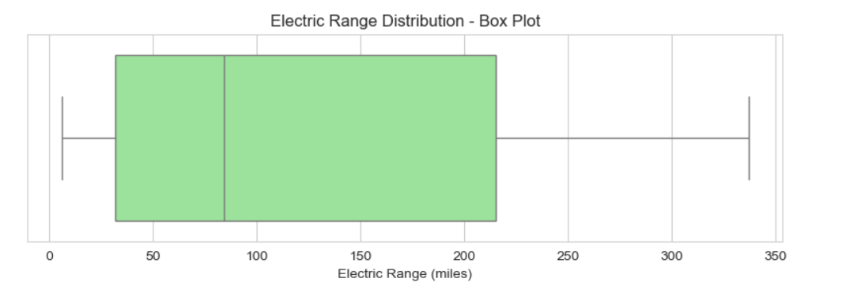
Figure 2.2 — Electric Range Distribution, Box Plot
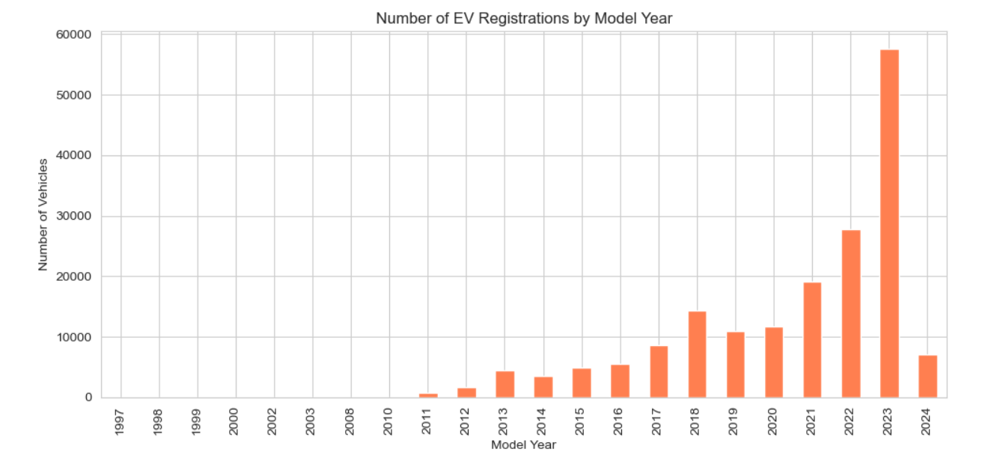
Figure 2.3 — Number of EV Registrations by Model Year

Key Findings
- Electric Range is multimodal (peaks near 25, 80, and 215 miles) — later shown in Phase 6 to reflect distinct vehicle categories (PHEV vs. early BEV vs. modern BEV), not a single smooth trend.
- No outliers detected in the range box plot — reported range data is clean and trustworthy.
- 75% of all vehicles in the dataset are Model Year 2019 or newer, confirming explosive recent EV growth.

Phase 3: Time-Series Analysis
Registrations were aggregated by Model Year to assess historical growth trends, year-over-year (YoY) growth rate, and cumulative market size over time.
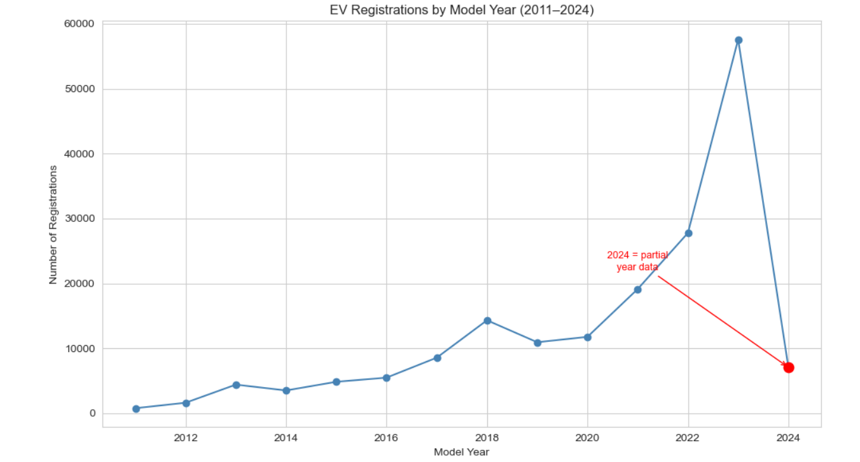
Figure 3.1 — EV Registrations by Model Year (2011–2024), with 2024 flagged as partial-year data
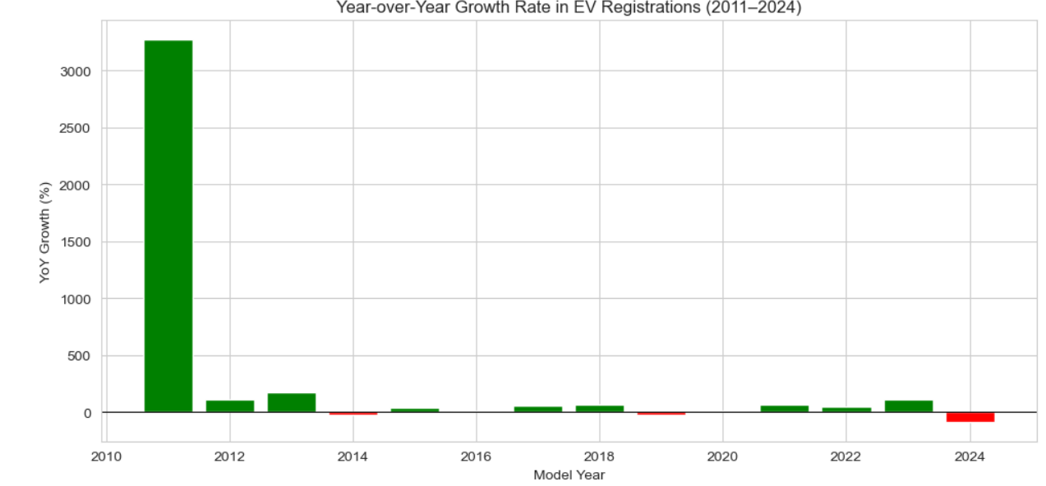
Figure 3.2 — Year-over-Year Growth Rate (2011–2024)
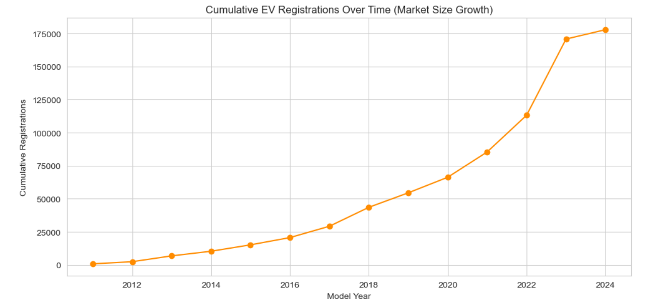
Figure 3.3 — Cumulative EV Registrations Over Time (Market Size Growth)

Key Findings
Finding | Insight
Registrations grew from ~775 (2011) to ~57,587 (2023) | ~74x growth over 12 years — explosive market expansion
2024 shows an apparent 87.7% drop | Data artifact from partial-year collection, not a real decline
Early YoY % swings (2011–2013) are extreme | Small-base effect; percentages are unstable when starting counts are tiny
Two real dips: 2014 and 2019 | Minor slowdowns flagged as areas for further investigation
Cumulative curve shows a clear inflection ~2021 | Strongest acceleration phase of the EV market begins here

Phase 4: Geographical Distribution Analysis
Since the dataset is ~99.8% Washington-registered vehicles (177,477 of 177,861), the remaining ~384 out-of-state rows were excluded from geographic analysis to keep scope consistent with the project's stated focus on Washington State.
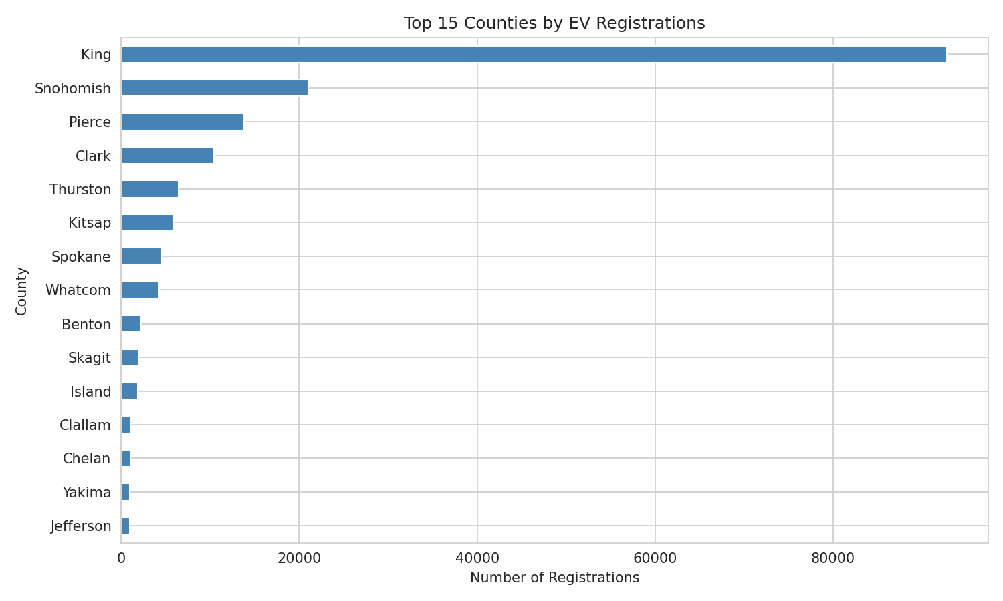
Figure 4.1 — Top 15 Counties by EV Registrations
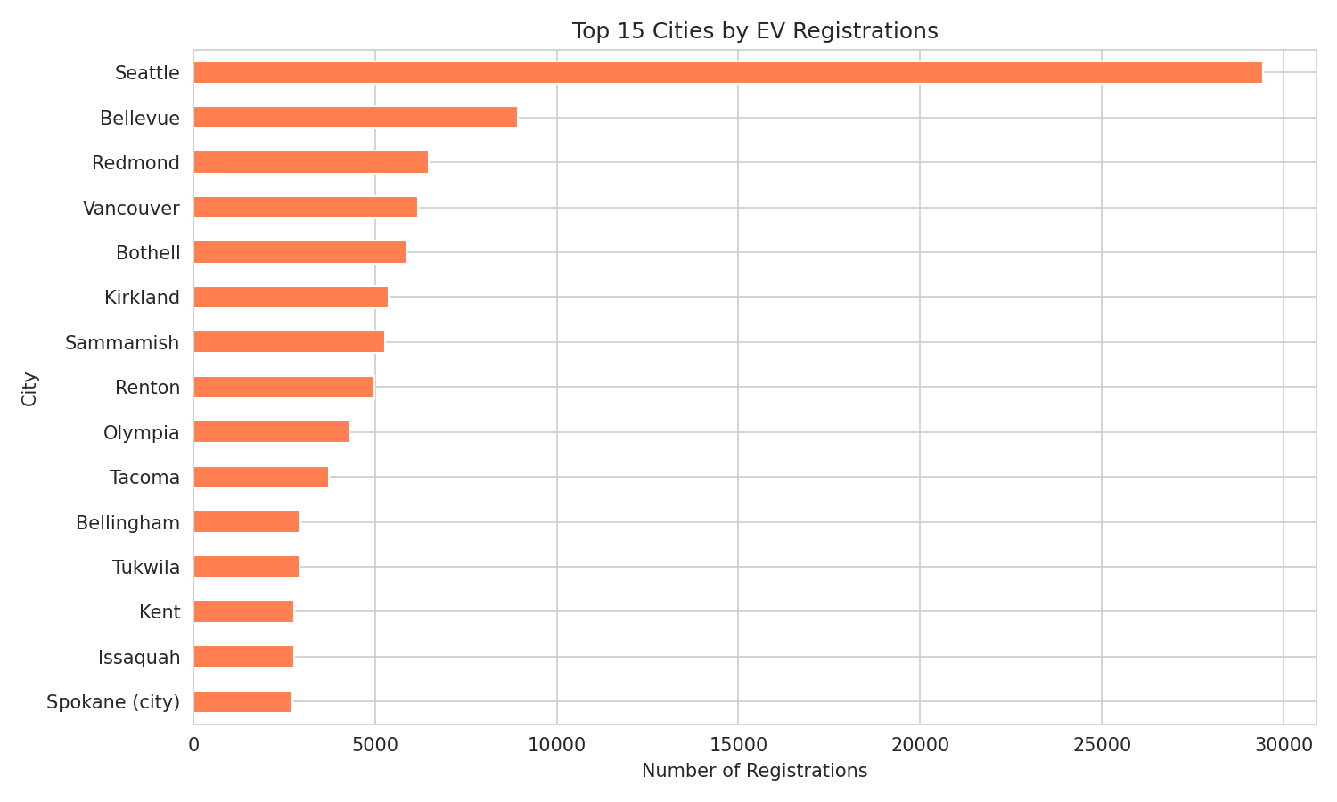
Figure 4.2 — Top 15 Cities by EV Registrations

Geospatial Clustering (KMeans)
A KMeans model (k=6) was fit on vehicle Latitude/Longitude coordinates to formally identify adoption hotspots, independently validating the county/city findings above.
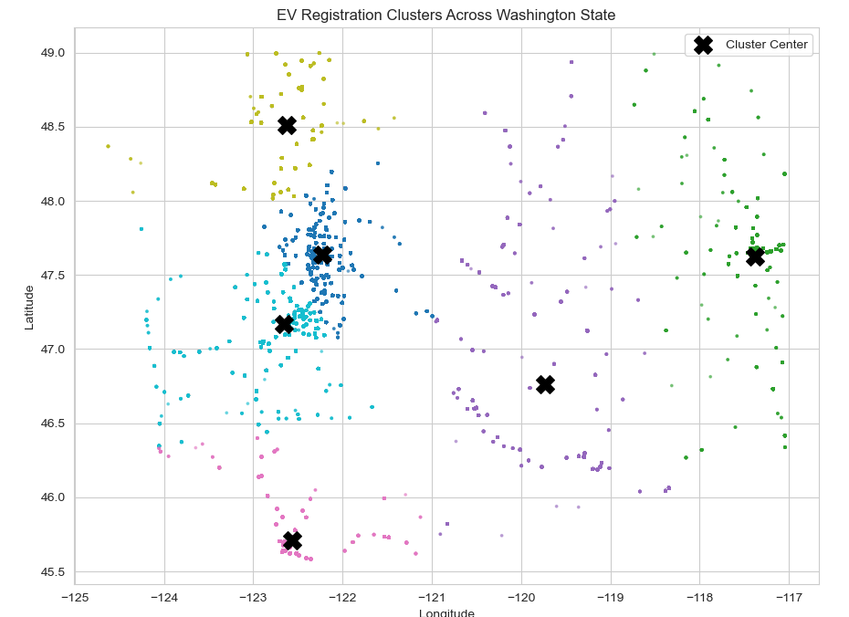
Figure 4.3 — EV Registration Clusters Across Washington State
Cluster | Vehicles | Approx. Location
0 | 118,938 | Seattle metro core (King / Snohomish)
5 | 23,598 | South Puget Sound (Pierce / Thurston)
3 | 11,835 | Vancouver, WA area (Clark County)
4 | 10,740 | Bellingham / Whatcom area
2 | 6,979 | Central WA (Yakima / Tri-Cities)
1 | 5,383 | Spokane area (Eastern WA)

Three independent methods — county-level counts, city-level counts, and KMeans clustering — all converge on the same conclusion: the Seattle metro area (King County) accounts for over half of all EV registrations in Washington, and clustering shows it specifically at ~67% of all geographically-mapped vehicles.

Phase 5: Make and Model Popularity
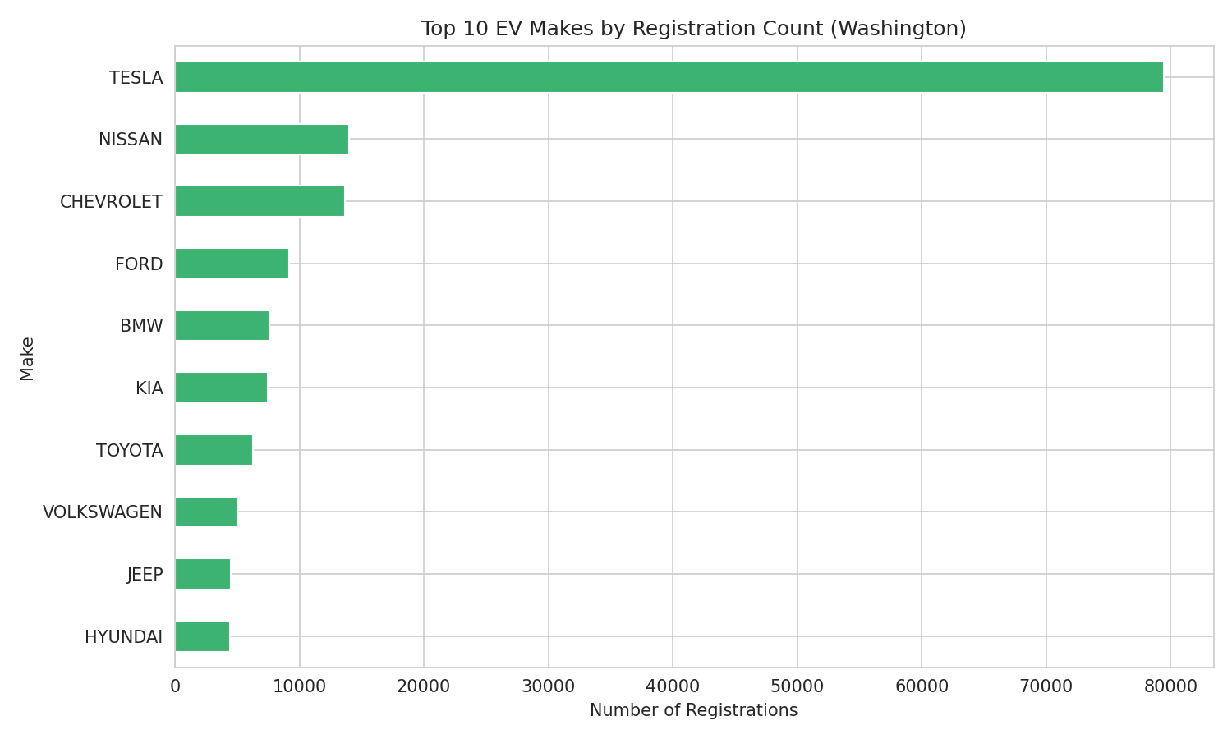
Figure 5.1 — Top 10 EV Makes by Registration Count
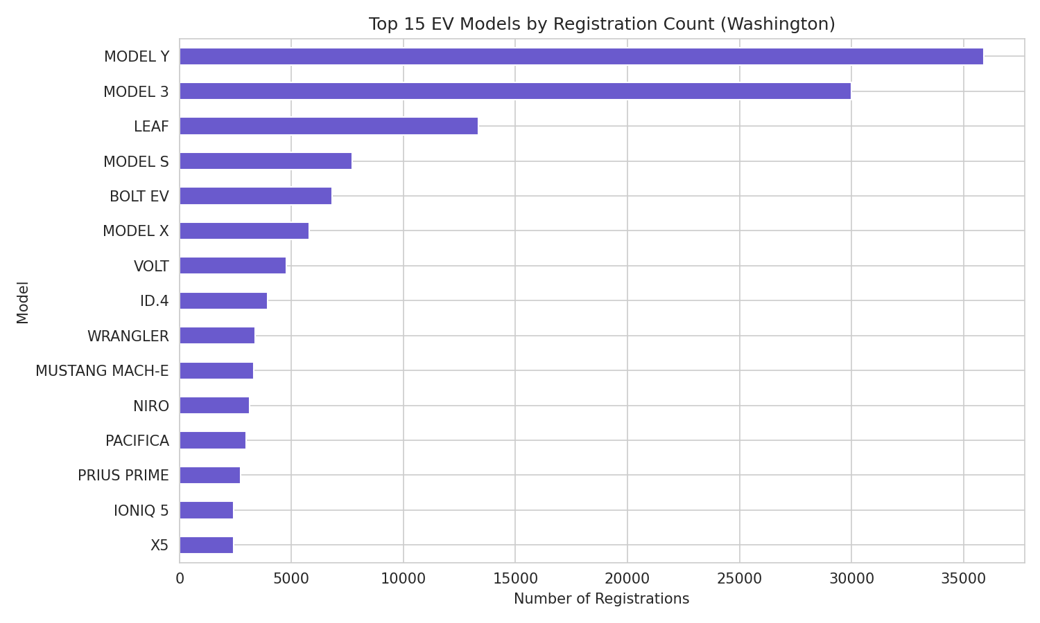
Figure 5.2 — Top 15 EV Models by Registration Count

Market Share and Vehicle Type Strategy
Tesla holds a commanding 44.78% share of the Washington EV market — more than the next four makes (Nissan, Chevrolet, Ford, BMW) combined (24.99%). Model Y and Model 3 alone account for approximately 37% of all registered EVs statewide.
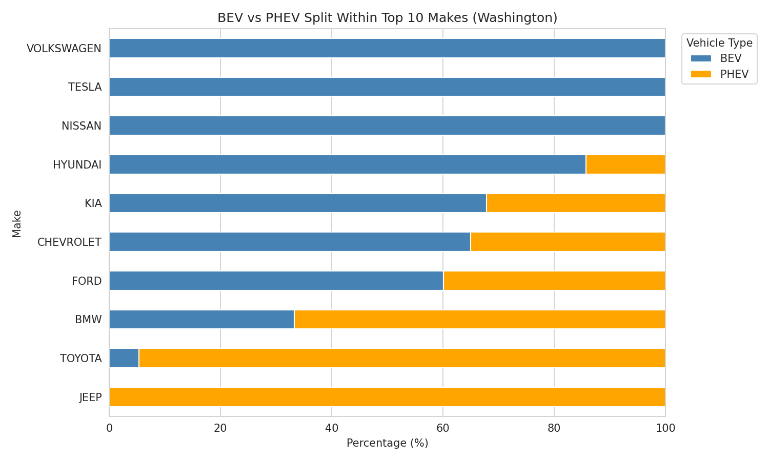
Figure 5.3 — BEV vs. PHEV Split Within Top 10 Makes
Manufacturer Strategy Group | Makes | Pattern
Pure BEV | Tesla, Nissan, Volkswagen | 100% battery-electric, no hybrid offering
Pure PHEV | Jeep | 100% plug-in hybrid — no full-BEV models
PHEV-leaning | Toyota (94.6%), BMW (66.8%) | Hybrid-first strategy
BEV-majority, mixed | Chevrolet, Ford, Kia, Hyundai | Offer both, lean BEV overall
Overall vehicle-type split: 78.29% BEV vs. 21.71% PHEV — confirming the Washington market is predominantly full-electric rather than hybrid-leaning.

Phase 6: Electric Vehicle Types and Technology Analysis
This phase explains the multimodal Electric Range distribution observed in Phase 2 by separating it by vehicle type, and tracks range progression across model years.
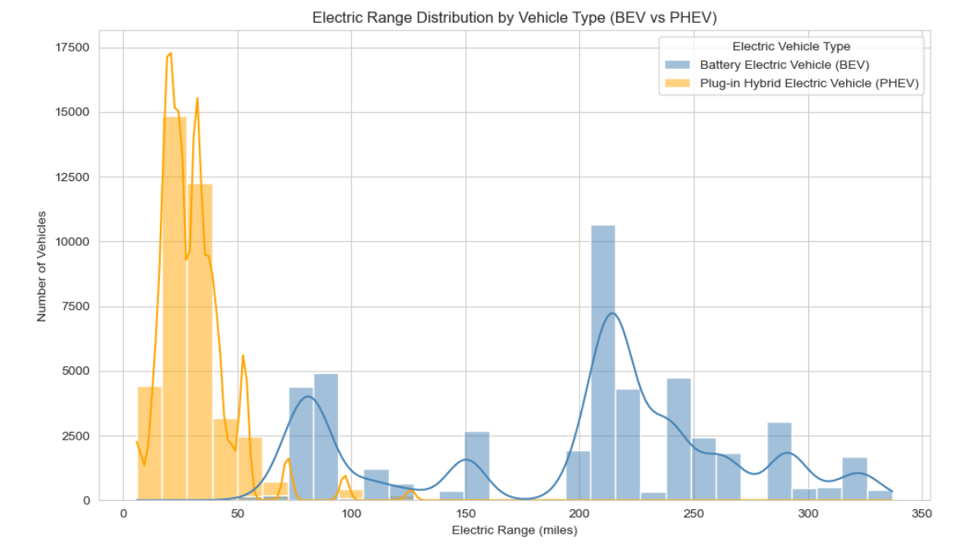
Figure 6.1 — Electric Range Distribution by Vehicle Type (BEV vs. PHEV)
PHEVs cluster almost entirely between 0–60 miles (small battery, gas-engine backup), while BEVs spread from roughly 70–335 miles with their own two-peak shape reflecting distinct technology eras (early mass-market BEVs vs. modern long-range BEVs).
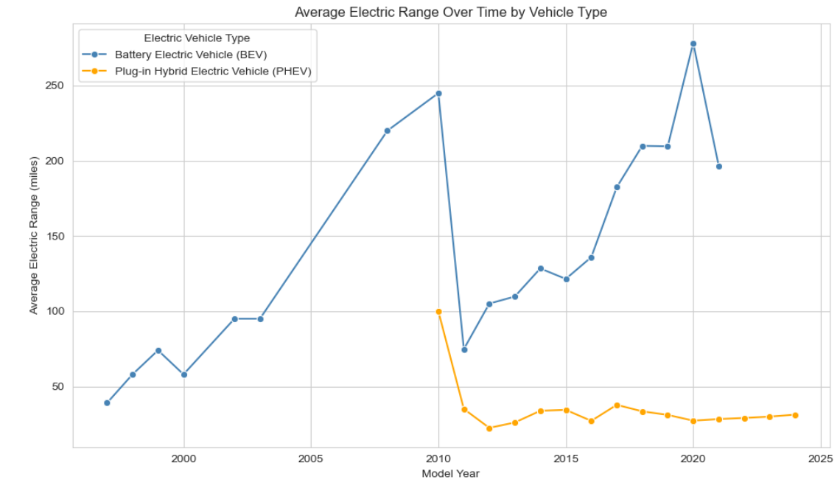
Figure 6.2 — Average Electric Range Over Time by Vehicle Type

Data Quality Finding: BEV Range-Reporting Gap
Model Year | % Range Reported | % Unknown
2020 | 99.4% | 0.6%
2021 | 3.7% | 96.3%
2022 | 0% | 100%
2023 | 0% | 100%
2024 | 0% | 100%

BEV range reporting was reliable through model year 2020 but collapsed to near-zero from 2021 onward — a sharp, discrete break consistent with a reporting policy change by a major manufacturer (most likely Tesla) rather than gradual data decay. Range progression analysis for BEVs is therefore only valid through approximately model year 2020; trends visible beyond that point reflect PHEVs only.

Range vs. Base MSRP Correlation
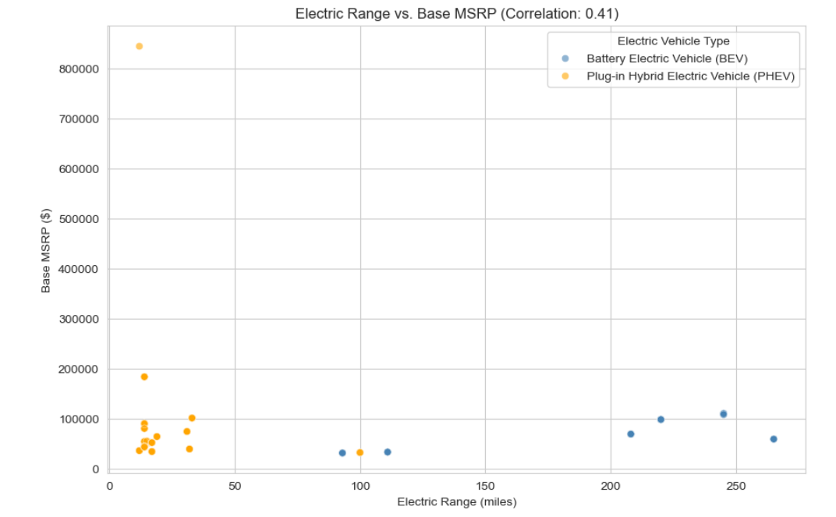
Figure 6.3 — Electric Range vs. Base MSRP (filtered to reported-range, non-zero-MSRP rows)
Subset | Rows Used | Correlation (r)
All qualifying rows (incl. Porsche 918 outlier) | 3,331 | 0.407
Excluding Porsche 918 Spyder outlier | 3,330 | 0.524

A single outlier — a Porsche 918 Spyder (12-mile range, $845,000 MSRP) — was identified and confirmed as a legitimate but non-representative luxury hybrid hypercar. Excluding it revealed a moderately strong relationship (r = 0.524) between range and price. This analysis is based on only ~1.9% of the WA dataset due to widespread missing MSRP data, so the finding should be treated as directional rather than conclusive.

Phase 7: Forecasting
Two forecasting approaches were built and compared, both trained on the reliable 2011–2023 window (excluding noisy pre-2011 years and the artificially low, partial-year 2024 count).

Linear Regression
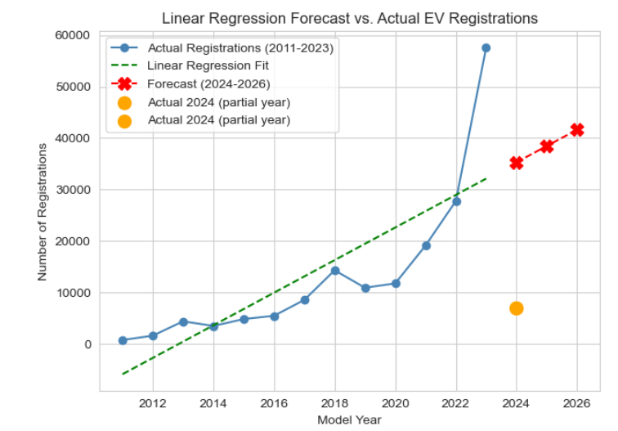
Figure 7.1 — Linear Regression: Actual vs. Predicted vs. Forecast

ARIMA(1,1,1)
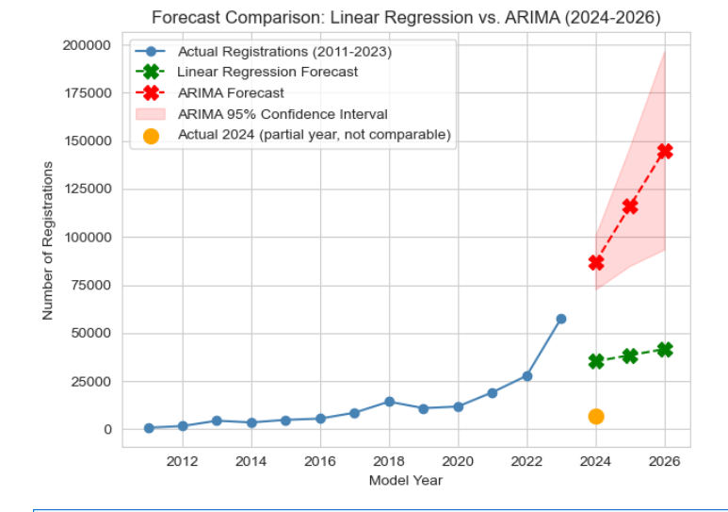
Figure 7.2 — Forecast Comparison: Linear Regression vs. ARIMA (2024–2026)
Model | 2024 Forecast | 2026 Forecast | Fit Quality | Key Limitation
Linear Regression | 35,300 | 41,634 | R² = 0.643 (moderate) | Underfits accelerating growth; 2026 forecast falls below actual 2023 total (57,587)
ARIMA(1,1,1) | 86,766 (72,745–100,787) | 145,124 (93,554–196,694) | MA term not significant (p=0.979) | Trained on only 13 points; wide, fast-growing confidence intervals

Neither model should be treated as a precise prediction. Linear regression clearly underestimates future growth by ignoring the market's accelerating trend, while ARIMA better captures this momentum but carries substantial uncertainty due to the limited 13-year training window and a statistically insignificant moving-average coefficient. The true 2024–2026 registration count most likely falls between the two models' estimates, with ARIMA's lower confidence bound (~72,745 for 2024) offering a more defensible conservative estimate than either point forecast alone.

Phase 8: Correlation and Trend Analysis
A full correlation matrix was built across all meaningful numerical variables (Model Year, Electric Range, Base MSRP, Latitude, Longitude), using the Range Reported filter established in Phase 1.
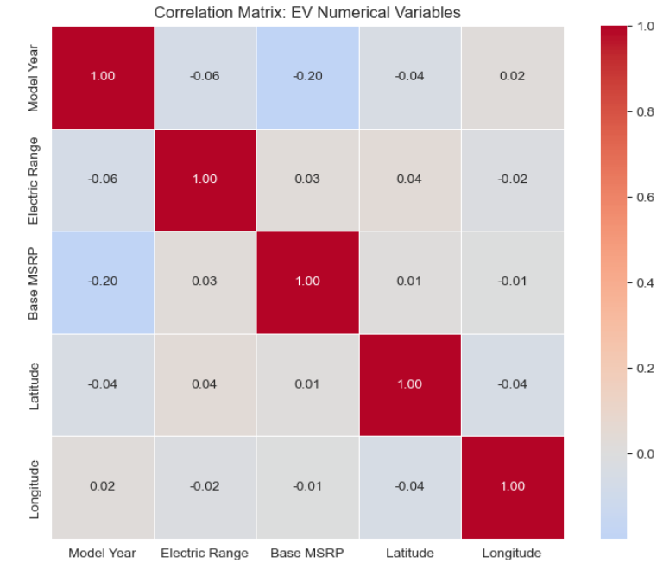
Figure 8.1 — Correlation Matrix: EV Numerical Variables
Variable Pair | Correlation | Interpretation
Electric Range vs. Base MSRP (all rows) | 0.027 | Misleadingly weak due to ~98% zero-MSRP rows; true relationship is 0.407–0.524 per the filtered Phase 6 analysis
Model Year vs. Base MSRP | -0.199 | Real, moderate trend: EVs became more affordable as mainstream models proliferated in later years
Model Year vs. Electric Range | -0.060 | Understated due to the post-2020 BEV range-reporting gap; true trend is positive through 2020
Latitude / Longitude vs. all variables | ~±0.01–0.04 | No meaningful geographic relationship to range, price, or model year

This phase served as an important cross-check: the near-zero Range–MSRP correlation here is not a contradiction of Phase 6's finding, but a demonstration of how unfiltered zero-as-missing values can mask a real relationship — reinforcing the importance of the data-quality decisions made in Phase 1.

Conclusion
This market size analysis of the Washington State EV industry demonstrates a market in the midst of rapid, accelerating growth — roughly 74-fold between 2011 and 2023 — but one that remains geographically and competitively concentrated. The Seattle metro area (King County) accounts for over half of all registrations, and Tesla alone commands nearly 45% market share. The industry is shifting decisively toward full battery-electric vehicles (78.3% of the market), though manufacturer strategies remain split between BEV-committed brands and PHEV-focused brands such as Toyota and Jeep.
Several data-quality limitations were identified and transparently documented throughout this analysis rather than papered over: near-total missingness in Base MSRP, a systematic collapse in BEV range reporting after 2020, and a small usable sample for price-based conclusions. These limitations do not undermine the core findings, but they do mean that forecasts and price-based conclusions should be treated as directional estimates rather than precise predictions.
Overall, the data strongly supports continued, significant growth in the Washington EV market, with the direction of that growth better captured by the ARIMA model than by a simple linear trend — though stakeholders should plan around a range of outcomes (roughly 73,000–100,000 projected 2024 registrations) rather than a single point estimate.

Vaibhavi Hambire | B.E. Information Technology | CGPA: 8.5 | CoachX Program | April 2026
hambirevaibhavi21@gmail.com · github.com/Vaibhavihambire · linkedin.com/in/vaibhavi-hambire

