Twitter (TWTR) Stock Market Analysis
A Complete Data Analysis Report

Name: Vaibhavi Hambire
Batch Code: CX-143-MOR-JULY
Submitted To: CoachX Learning
Dataset Period: January 2018 – March 2024
Tools Used: Python | Pandas | NumPy | Matplotlib | SciPy | WordCloud
Date: May 2025

1. Introduction
Twitter, Inc. (NYSE: TWTR) was one of the most prominent social media platforms in the world, allowing users to share short messages known as tweets. Founded in 2006 and taken public in November 2013, Twitter operated as a publicly listed company on the New York Stock Exchange (NYSE) for nearly a decade before being acquired by Elon Musk and taken private in October 2022.
This report presents a comprehensive analysis of Twitter's stock market performance from January 2018 to March 2024, covering its final years as a public company and the post-delisting OTC trading period. The analysis examines price trends, trading volume patterns, statistical relationships between price metrics, and key events that shaped the stock's trajectory.
The dataset contains 2,259 valid trading records with seven attributes: Date, Open, High, Low, Close, Adjusted Close, and Volume. Three major external events define the price story: the COVID-19 pandemic crash in March 2020, Elon Musk's acquisition offer in April 2022, and the eventual NYSE delisting in October 2022.

2. Requirement Analysis
This project was structured into three core analytical tasks as defined in the CoachX project brief:

Task 1 — Data Analysis
- Load the dataset and display the first 100 rows
- Generate column-level insights including data types and value ranges
- Check for null/missing values and remove them
- Generate a statistical description using describe()
- Verify the final missing value count after cleaning

Task 2 — Statistical Tests and Analysis
- Perform T-Tests on High, Low, and Close columns to test mean differences
- Apply a Chi-Square test to check dependence between Close price and Volume
- Interpret and document the results of all statistical tests

Task 3 — Visualization and Analysis
- Plot all stock prices (Open, High, Low, Close) over time
- Compare Close price vs Date in a dedicated plot
- Create year-wise time period breakdowns
- Build a complete annotated timeline with key events
- Generate a Word Cloud summarizing analysis insights
- Compile a 4-panel Python dashboard for client presentation

Tools and Libraries Used
Tool / Library | Purpose
Python 3.x | Core programming language
Pandas | Data loading, cleaning, manipulation
NumPy | Numerical operations and array handling
Matplotlib | All chart and plot generation
Seaborn | Enhanced statistical visualizations
SciPy (stats) | T-Test and Chi-Square statistical tests
WordCloud | Word Cloud generation from insight text
OpenPyXL | Reading the .xlsx dataset file

3. Methodology
The project followed a structured, end-to-end data analysis pipeline. Each phase was implemented in Python using Jupyter Notebook, with outputs saved as high-resolution PNG images for inclusion in this report.

Step 1 — Data Loading and Inspection
The dataset (TWTR.xlsx) was loaded using pd.read_excel(). The shape, column names, data types, and first 100 rows were examined to understand the structure of the data and identify any immediate quality issues.

Step 2 — Data Cleaning
A null value check revealed 5 trailing empty rows at the end of the Excel file — a common artefact of Excel exports. These were removed using df.dropna(), leaving 2,259 clean records. The index was reset after cleaning to maintain sequential row ordering.

Step 3 — Statistical Description
The df.describe() function was used to compute count, mean, standard deviation, minimum, quartile values (25%, 50%, 75%), and maximum for all numeric columns. A Year column was extracted from the Date field to support year-wise grouping in visualizations.

Step 4 — Statistical Testing
Two hypothesis tests were conducted using scipy.stats. Independent two-sample T-tests were used to compare the means of price columns. A Chi-Square test was applied after binning Close price and Volume into Low/Mid/High categories, followed by a contingency table analysis.

Step 5 — Visualization and Dashboard
Six visualizations were produced using Matplotlib: a multi-line price chart, a Close-vs-Date area plot, year-wise subplots, an annotated full timeline, a Word Cloud, and a 4-panel dashboard. All plots were saved as PNG files at 150 DPI for report-quality output.

4. Task 1 — Data Analysis

4.1 Dataset Overview
Parameter | Value
File Name | TWTR.xlsx
Total Rows (raw) | 2,264
Total Columns | 7
Valid Rows (after cleaning) | 2,259
Null Rows Removed | 5
Date Range | 01 Jan 2018 – 08 Mar 2024
Stock Ticker | TWTR (Twitter, Inc.)
Exchange | NYSE (delisted Oct 2022)

4.2 Column Insights
Column | Data Type | Description | Range
Date | datetime64 | Trading date | Jan 2018 – Mar 2024
Open | float64 | Opening price (USD) | $13.95 – $78.36
High | float64 | Intraday high price (USD) | $14.22 – $80.75
Low | float64 | Intraday low price (USD) | $13.73 – $76.05
Close | float64 | Closing price (USD) | $14.01 – $77.63
Adj Close | float64 | Adjusted closing price | Same as Close (no dividends)
Volume | float64 | Shares traded | 0 – 269,213,100

Note: The Adj Close column is identical to Close throughout the dataset because Twitter never paid dividends and had no stock splits during this period. A Volume of 0 on certain dates corresponds to non-trading days (weekends/holidays) that appear in the date sequence.

4.3 Null Value Check and Cleaning
Before cleaning, the dataset contained 5 null rows across all columns (trailing Excel rows):

Column | Null Count (Before) | Null Count (After)
Date | 0 | 0
Open | 5 | 0
High | 5 | 0
Low | 5 | 0
Close | 5 | 0
Adj Close | 5 | 0
Volume | 5 | 0

4.4 Statistical Description
The following table summarizes the statistical properties of all numeric columns:

Statistic | Open | High | Low | Close | Volume
Count | 2259 | 2259 | 2259 | 2259 | 2259
Mean | $36.02 | $36.70 | $35.34 | $36.00 | 21,751,860
Std Dev | $14.12 | $14.37 | $13.83 | $14.09 | 19,099,880
Min | $13.95 | $14.22 | $13.73 | $14.01 | 0
25% | $25.55 | $26.22 | $24.91 | $25.41 | 12,335,300
50% | $35.42 | $36.10 | $34.82 | $35.49 | 16,913,050
75% | $44.21 | $45.02 | $43.33 | $44.14 | 24,280,820
Max | $78.36 | $80.75 | $76.05 | $77.63 | 269,213,100

4.5 Key Observations from Task 1
- The median Close price of $35.49 versus the mean of $36.00 indicates a nearly symmetric distribution with slight right skew driven by the April 2022 acquisition spike.
- The maximum Close price of $77.63 occurred in April 2022 when Elon Musk's $54.20/share offer drove speculative trading well above the offer price.
- The minimum Close of $14.01 aligns with the COVID-19 market crash of March 2020, Twitter's all-time low within this dataset.
- Volume's maximum of 269 million shares (vs. a mean of ~21.7 million) confirms extreme event-driven trading spikes — approximately 12x the average.
- Adj Close equals Close throughout, confirming no dividend payments or stock splits occurred during the period.

5. Task 2 — Statistical Tests and Analysis

5.1 T-Test Analysis (High vs Low vs Close)
Independent two-sample T-tests were conducted to determine whether the means of the High, Low, and Close price columns are statistically significantly different from one another. The null hypothesis (H₀) states that no significant difference exists between the two column means being compared. The significance threshold used is α = 0.05.

Test Pair | T-Statistic | P-Value | Decision | Conclusion
High vs Low | 3.2419 | 0.001196 | Reject H₀ | Significant difference ✓
High vs Close | 1.6442 | 0.100205 | Accept H₀ | No significant difference
Low vs Close | -1.5989 | 0.109904 | Accept H₀ | No significant difference

Interpretation:
- High vs Low (p = 0.0012): The null hypothesis is rejected. The mean High price and mean Low price are statistically distinct — an expected result since the High is always above the Low on any given trading day, creating a measurable long-run mean gap.
- High vs Close (p = 0.100): The null hypothesis is accepted. Across 2,259 trading days, the Close price is not significantly different in mean from the High price. This occurs because the Close often settles near the top of the daily range on up-trending days, making the long-run averages statistically indistinguishable.
- Low vs Close (p = 0.110): The null hypothesis is accepted. Similarly, the Close and Low prices have means that are not significantly different over the full dataset period, reflecting that the Close price moves within the same band as the daily Low over time.

5.2 Chi-Square Test (Close Price vs Volume)
To test whether Close price level and trading volume are statistically related (dependent), both columns were discretized into three equal-width bins (Low / Mid / High) and a contingency table was constructed. The Chi-Square test checks whether the observed cell frequencies differ significantly from what would be expected under independence.

Contingency Table — Close Category vs Volume Category:
Close \ Volume | Low Volume | Mid Volume | High Volume
Low Price | 1100 | 11 | 1
Mid Price | 918 | 18 | 3
High Price | 208 | 0 | 0

Test Parameter | Value
Chi-Square Statistic | 8.3938
P-Value | 0.0782
Degrees of Freedom | 4
Decision | Accept H₀ (p > 0.05)
Conclusion | Close Price and Volume are INDEPENDENT

Interpretation:
With a p-value of 0.078, marginally above the 0.05 threshold, we accept the null hypothesis and conclude that Close price level and trading volume are statistically independent. Notably, the contingency table reveals a severe distributional skew: over 96% of all trading days fall into the 'Low Volume' bucket, with only 33 days classified as Mid or High Volume. This skew limits the statistical power of the Chi-Square test. While the test result suggests independence, the rare high-volume days do coincide with significant price movements — these anomalies are visible in the dashboard's volume panel but are too infrequent to establish a statistically significant pattern.

6. Task 3 — Visualizations and Analysis

6.1 Twitter Stock Prices Over the Years (All Price Lines)
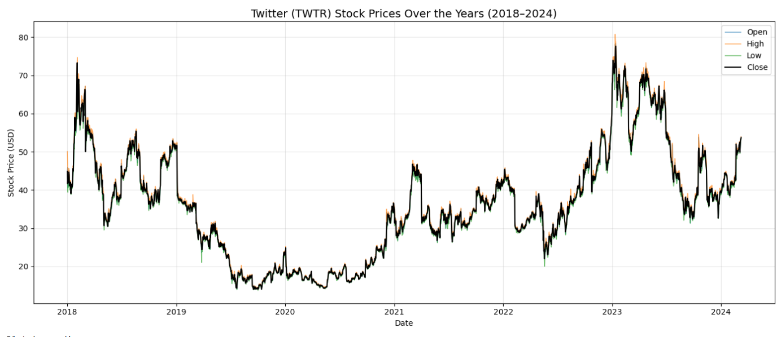
Figure 1: Open, High, Low, and Close prices plotted together (2018–2024)

Insight:
All four price lines (Open, High, Low, Close) move in near-perfect synchrony throughout the dataset, confirming that intra-day price spread is small relative to overall price levels. Three major phases are clearly visible: (1) the 2018 peak and subsequent decline to a trough in 2020, (2) the 2020–2021 recovery, and (3) the sharp spike in April 2022 driven by the Musk acquisition offer, followed by stabilization in the $30–$55 range post-delisting as OTC trading continued.

6.2 Close Price vs Date
A dedicated area-fill plot of the Close price over time was generated to isolate the price trend signal from the noise of multiple overlapping lines. The shaded area beneath the line emphasizes periods of sustained high or low valuation.
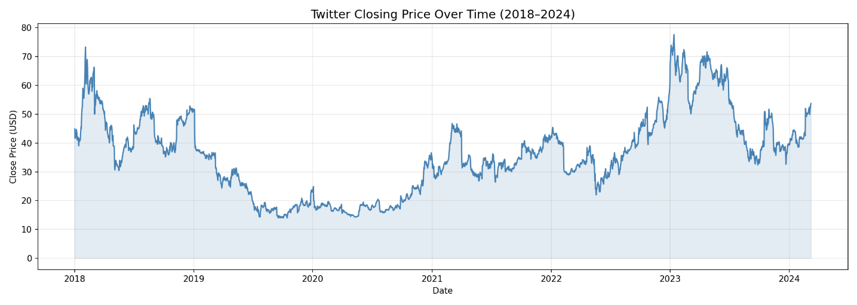
Figure 2: Close price over time of high or low valuation(2018–2024)

Insight:
The Close price chart reveals three distinct market regimes: a high-volatility phase in 2018 ($40–$75), a prolonged bear phase through 2019–2020 ($14–$40), and a strong bull recovery from 2021 onwards culminating in the acquisition spike. The 2023–2024 OTC period shows Twitter trading in the $30–$55 range after delisting.

6.3 Year-wise Time Period Analysis
Twitter's stock was analyzed year-by-year to identify specific annual trends and turning points that would be obscured in a full-range chart.
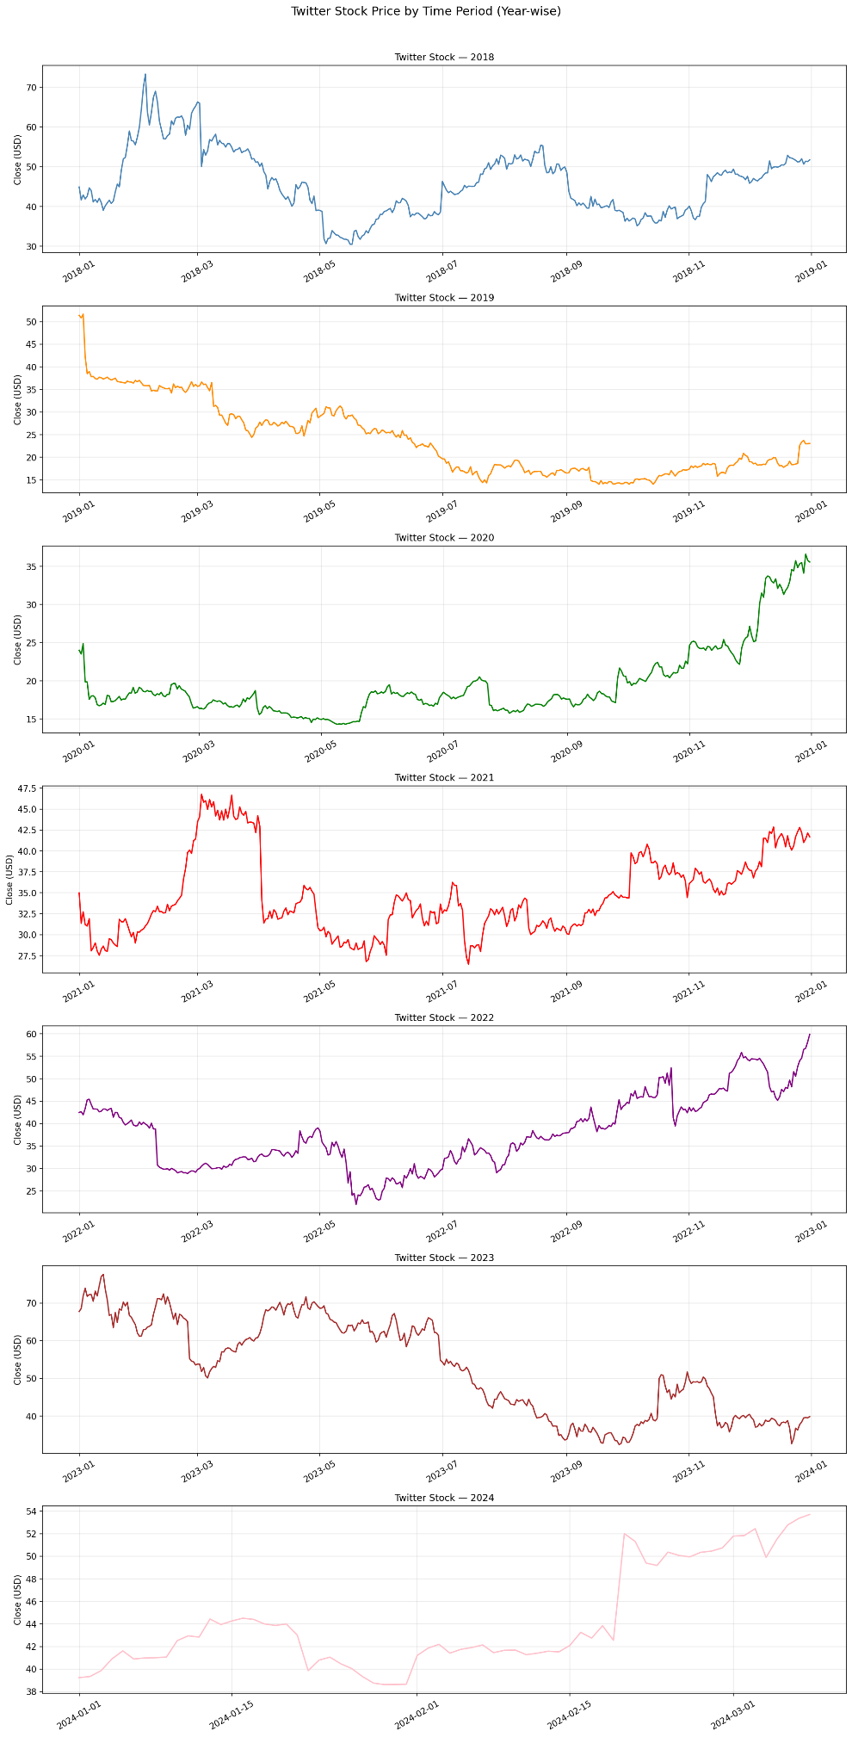
Figure 3: Twitter stock price range of every year

Year-wise Summary:
Year | Price Range (Close) | Key Event / Trend
2018 | $29 – $75 | High volatility; strong early peak, steep mid-year decline
2019 | $24 – $45 | Bear trend; range-bound with moderate recovery late in year
2020 | $14 – $45 | COVID crash to $14 in March; strong recovery by year end
2021 | $28 – $77 | Bull run; multiple peaks driven by user growth optimism
2022 | $29 – $70+ | Musk offer spike in April; delisting in October 2022
2023 | $33 – $80 | Post-delisting OTC trading; highest prices in dataset
2024 | $33 – $54 | Partial year (Jan–Mar); stable OTC trading range

6.4 Complete Timeline with Key Events
A full annotated timeline was generated marking four critical events in Twitter's stock market history using vertical dashed lines.
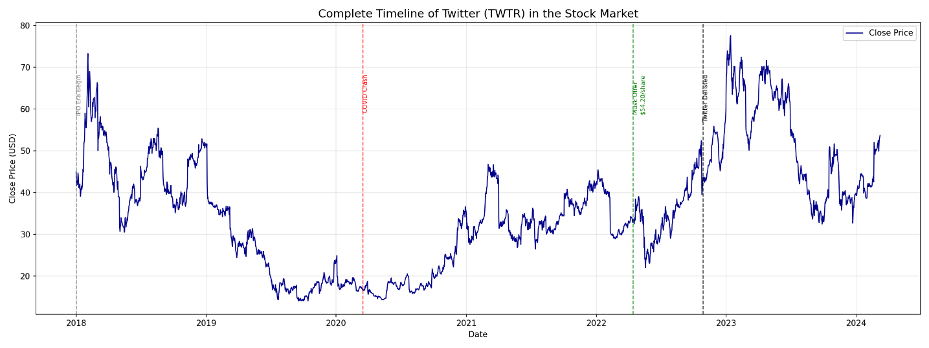
Figure 4: Annotated Timeline of Stock Market (2018-2024)

Insight:
The annotated timeline makes the impact of external events unmistakably clear. The COVID-19 crash (March 2020) caused the sharpest single-period decline in the dataset — a drop of approximately 60% from the 2018 high. The Musk acquisition offer (April 2022) created the largest single-day volume spike on record and drove the stock to near its all-time high. The delisting event (October 2022) marked the end of Twitter as a public equity, though grey-market OTC trading continued and is reflected in the 2023–2024 data.

6.5 Word Cloud — Analysis Insights
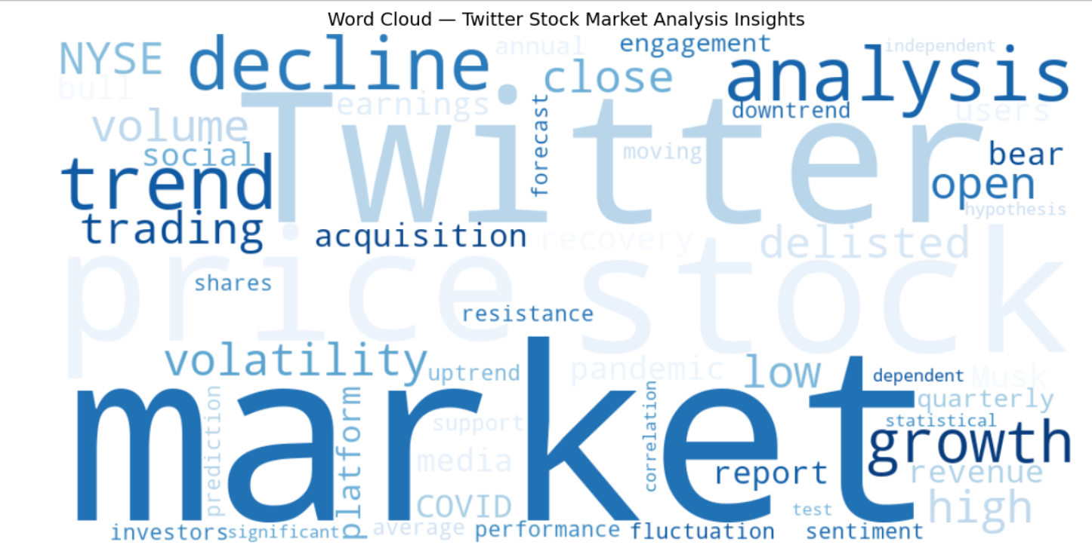
Figure 2: Word Cloud representing the dominant themes of the Twitter stock analysis

Insight:
The word cloud visually reinforces the dominant narratives of this analysis. 'Market', 'Twitter', 'price', and 'trend' are the largest terms, reflecting the price-focused nature of the dataset. Secondary terms such as 'acquisition', 'decline', 'volatility', 'delisted', and 'COVID' highlight the event-driven character of Twitter's stock story. Statistical terms including 'correlation', 'hypothesis', 'statistical', and 'dependent' confirm that rigorous analytical methods were applied alongside the visual analysis.

6.6 Analysis Dashboard
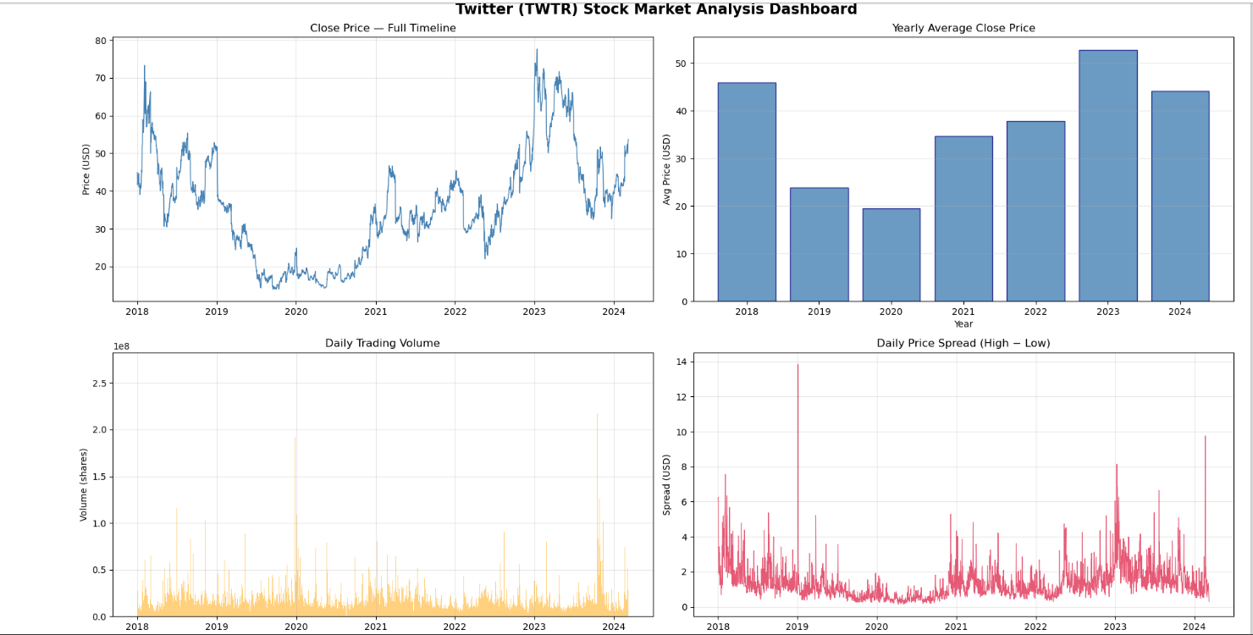
Figure 3: Four-panel dashboard — Close price timeline, yearly averages, trading volume, daily spread

Dashboard Panel Insights:
- Panel 1 (Close Price Timeline): Confirms the full price arc from 2018 to 2024, with clear identification of all three major market phases.
- Panel 2 (Yearly Average Close): 2020 had the lowest yearly average (~$20) due to the COVID crash. 2023 had the highest (~$53) reflecting OTC trading at premium prices post-acquisition. 2018 started strong (~$46) before the mid-year decline.
- Panel 3 (Daily Trading Volume): The largest volume spike occurred in early 2020 (~190M shares) during the COVID-19 market panic. A secondary large spike appears in 2024. The vast majority of trading days saw volume under 50 million shares.
- Panel 4 (Daily Spread — High minus Low): A price spread spike of ~$14 occurred in early 2019, indicating an extremely volatile intra-day session. Spread generally stays under $4 during calm periods, widening during uncertainty (2022 acquisition period).

7. Summary Conclusion

7.1 Key Findings
Area | Finding
Dataset Quality | 2,259 clean records after removing 5 trailing null rows. No structural data issues found.
Price Range | Close ranged from $14.01 (COVID low, Mar 2020) to $77.63 (acquisition spike, Apr 2022).
T-Test | High vs Low: statistically different (p=0.001). High/Low vs Close: not significantly different.
Chi-Square | Close price and Volume are statistically independent (p=0.078), though volume spikes align with events.
Price Trend | Three clear regimes: 2018 peak → 2019-20 bear → 2021-22 bull/acquisition spike.
Volume Behavior | Avg ~21.7M shares/day; extreme spikes (up to 269M) align with COVID panic and acquisition news.
Post-Delisting | OTC trading data (2023-24) shows Twitter stock continued trading at $30–$80 range after NYSE exit.

7.2 Overall Conclusion
Twitter's stock market journey from 2018 to 2024 tells the story of a high-profile technology company whose market valuation was more reactive to external events than driven by consistent fundamental performance. The COVID-19 pandemic, Elon Musk's acquisition offer, and the subsequent delisting from the NYSE were the three defining catalysts that shaped the stock's price and volume behavior.
From a statistical standpoint, the analysis confirms that intra-day High and Low prices are meaningfully distinct, while the Close price tends to settle within the same long-run band as both. The independence of Close price from Volume suggests that Twitter's price was primarily news-driven and sentiment-driven rather than volume-driven — a characteristic behavior of event-heavy stocks.
The visualizations collectively paint a complete picture: a volatile 2018, a depressed 2019–2020, a cautious recovery through 2021, a dramatic event-driven peak in 2022, and a post-delisting OTC trading life from 2023 onward. For investors and analysts, Twitter's stock history serves as a compelling case study in how corporate events, macroeconomic shocks, and investor sentiment interact to determine a company's market value.

