**CHAPTER 1**

**INTRODUCTION**

* 1. **INTRODUCTION TO SQL**

SQL is used to communicate with a database. According to ANSI (American National Standards Institute), it is the standard language for relational database management systems. SQL statements are used to perform tasks such as update data on a database, or retrieve data from a database.

Some common relational database management systems that use SQL are: Oracle, Sybase, Microsoft SQL Server, Access, Ingres, etc.

Although most database systems use SQL, most of them also have their own additional proprietary extensions that are usually only used on their system. However, the standard SQL commands such as “Select”, “Insert”, “Update”. “Delete”, “Create”, and “Drop” can be used to accomplish almost everything that one needs to do with a database.

MySQL is the most popular Open Source Relational SQL Database Management System. MySQL is one of the best RDBMS being used for developing various web-based software applications.

MySQL is developed, marketed and supported by MySQL AB, which is a Swedish company. A database is a separate application that stores a collection of data. Each database has one or more distinct APIs for creating, accessing. Managing, searching and replicating the data it holds.

Other kinds of data stores can also be used, such as files on the file system or large hash tables in memory but data fetching and writing would not be so fast and easy with those types of systems. Nowadays, we use relational database management systems (RDBMS) to store and manage huge volume of data.

MySQL is released under an open-source license. So you have nothing to pay to use it. MySQL is a very powerful program in its own right. It handles a large subset of the functionality of the most expensive and powerful database packages.

MySQL uses a standard form of the well-known SQL data language. MySQL works on many operating systents and with many languages including PHP, PERL, C, C++, JAVA, etc. MySQL works very quickly and works well even with large data sets.

**1.2 INTRODUCTION TO FRONT END SOFTWARE**

* PHP started out as a small open source project that evolved as more and more people found out how useful it was. Rasmus Lerdorf unleashed the first version of PHP way back in 1994.
* PHP is a recursive acronym for "PHP: Hypertext Preprocessor".
* PHP is a server side scripting language that is embedded in HTML. It is used to manage
* dynamic content, databases, session tracking, even build entire e-commerce sites.
* It is integrated with a number of popular databases, including MySQL, PostgreSQL, Oracle,
* Sybase. Informix, and Microsoft SQL Server.
* .PHP is pleasingly zippy in its execution, especially when compiled as an Apache module on the Unix side. The MySQL server, once started, executes even very complex queries with huge result sets in record-setting time.
* PHP supports a large number of major protocols such as POP3, IMAP, and LDAP. PHP4 added support for Java and distributed object architectures (COM and CORBA), making n-tier.
* Development a possibility for the first time. PHP is forgiving: PHP language tries to be as forgiving as possible.
* PHP Syntax is C-Like.
* PHP performs system functions, i.e. from files on a system it can create, open, read, write, and close them.
* PHP can handle forms, i.e. gather data from files, save data to a file, through email

you can send data, return data to the user.

* You add, delete, modify elements within your database through PHP. Access cookies variables and Set cookies.

.

**CHAPTER 2**

# **REQUIREMENT SPECIFICATION**

# **2.1 SOFTWARE REQUIREMENTS**:

A condition or capability needed by a user to solve a problem or achieve an objective.

# Operating System : 64/32 Bit Operating System, X64-Based Processor.

Database : Mysql

Tools : XXAMP server

Scripting Language: PHP admin.

**2.2 HARDWARE REQUIREMENTS**: To be used efficiently, all computer software needs certain hardware components or other software resources to be present on a computer.

|  |  |
| --- | --- |
| Processor | :Any Of Speed 1.60ghz |
| RAM | : 2.00 GB Or More |
| Hard Disk | :200 GB Or More |
| Compact Disk | :ANY DISK |
| Input Device | :Keyboard |
| Output Device | :Laptop Display Screen |

**CHAPTER 3**

**DESIGN**

The online bookstore management System is a PHP/MySQL project that provides multiple books of various genres in one central page. The system allows the user to view and choose the books of their choice by providing a list of catagories in which various genres of books are listed. This system allows the user to to view the description of the book, the editor and also the publisher of a book. The users can add their favourite books to the cart and can buy them whenever they want to. This system helps the user to buy a book online with just one click.The system accepts the payment after the delivery of the book which will make the user feel safe about both the parcel and the money.The mode of payment here used id cash on delivery.

The system has two types of users , the user(the buyer) and the Admin user. The Admin user can manage all the data in the system, including managing the catagories ,adding the books, deleting the books and updating the books. The buyer or user can only track the ordered books and manage the list of books where the origin or the destination of a parcel is under the logged-in Admin user. The books have multiple attributes which are ,ISBN of the book ,TITLE of the book , PUBLISHER of the book ,EDITIOR of the book and NO OF PAGES in the book.

The system also has a special feature called CONTACT wherein the users can contact the admin users and can ask them queries,provide suggesions or can contact them personally.

**3.1 THE ABSTRACT OF THE PROJECT ONLINE BOOK-STORE MANAGEMENT SYSTEM:**

* Members can register themselves directly on the bookstore application for any notification of old book sales and pay for the advance booking of any boos. Shopkeepers can also broadcast their offers.
* If the shopkeeper and members are not aware of policies then the admin will make him contact with this application and help him to complete the whole process.
* Admin will maintain the record and atomicity by using the proper table to save records so that no one can access it and make the data safe from members’ perspectives as well as shopkeepers’ perspectives.
* Customers need not bother about his/her payment and without moving from their place or making so many phone calls they can make the payment.
* No need of worrying about status you can track the book from your place.
* Customers can check new information related to bookstores and books through the application which will motivate them and all things would be uploaded from the admin’s end.
* The whole process of getting work done will become faster than the conventional way of getting insurance. Let us look at the different aspects which we have designed to make the website work properly. Here we are not discussing the admin module in that much depth because all other modules will cover the admin module part so to remove the same content from the report, we are ignoring the admin part.

**3.2 OBJECTIVES OF ONLINE BOOK-STORE SYSTEM:**

These are some key features of the system which is as follows:

To reduce the headache of maintaining the record of bookkeepers and customer-related documents.

To reduce the cumbersome job of maintaining several documents like whom we have issued the book and when will he return that.

It will eliminate the delays in making the payments, where people use to stand for a long time in the queue to pay and get their book.

Searching will become more efficient and fast in comparison to manual searching.

It will also provide assurance that we have a proper record of the selling of the books so that we can limit our books stock according to that.

Overall, it will reduce the cost and time of the shopkeeper who will take care of the shop.

**3.3 FUNCTIONALITIES PROVIDED BY BOOK-STORE MANAGEMENT SYSTEM:**

### Login

### The page where the admin user submits their system credentials to access the admin side of the system.

**Home Page**

The page where the admin user is being redirected by default after logging into the system. This page displays a summary of the data of the system.

**Admin edit Page**

The page where the admin can edit the information of the existing books,add new books or delete the existing books.

**View cart Page**

The page where all the books selected by the user are placed ,the user can change this list anytime.

**Registration Page**

The page where a new user registers themselve, here all the details of the user is stored. So that the the user only has to login every time he/she enters the system.

**Contact Page**

The page where all of the users of the system can send their queries to the admin.

**Checkout Page**

The page where the users need to reenter their information for shipping details.

**Order confirmation page**

The page where user confirms the order, this is the last step in buying a the book.

**3.4 SCOPE OF PROJECT BOOK-STORE MANAGEMENT SYSTEM:**

Create different system users and assign different roles with related permissions.

Manage all the account details such as user name, phone numbers, address.

Websites, email addresses of the entire customer from one central location.

Manage all the details regarding features of the books such Company, book dimension, book cost.

Track all the customers and their contact details.

Group the contacts together in a single account according to some criteria.

Capture, View and edit all user transactions.

Confirmation of end user identity and will verify which users are authorized to receive support.

Maintain history of each customer and their related information about the book sale, & support related transactions.

View all the details of all the interactions made with the customer

**3.5 REPORTS OF BOOK-STORE MANAGEMENT SYSTEM**

* It provides various types of books in various genres.
* In house delivery of the books can be extremely beneficial if you do it well.
* Supports cash on delivery for better security.
* Ensure that customers have a great buying experience.
* Deliveries are time-sensitive.

**3.6 FEATURES OF BOOK-STORE MANAGEMENT SYSTEM**

* Customer loyalty programs that keep customers coming back for more.
* All types of books are available in all genre.
* The books are sorted in the category section which is easy for the user to search the favourite books.
* User friendly interface
* Features developed for book publishers and wholesalers.
* Admin-Login.
* Multiple Numbers of Customers and Users Logins.
* Data Security.
* Multiple User Level Access Limitations.

**CHAPTER 4**

**IMPLEMENTATION**

**4.1 ER DIAGRAM**

The E-R Diagram constitutes a technique for representing the logical structure of a database in a pictorial manner. This analysis is then used to organize data as a relation, normalizing relation and finally obtaining a relation database.

**ENTITIES**: Which specify distinct real-world items in an application. PROPERTIES/ATTRIBUTES: Which specify properties of an entity and and relationships.

**RELATIONSHIPS**: Which connect entities and represent meaningful dependencies between them.

**WEAK ENTITIES:** A weak entity is an entity that cannot be uniquely identified by its attributes alone; therefore, it must use a foreign key in conjunction with its attributes to create a primary key.

**MULTIVALUED ENTITIES: A** multivalued attribute of an entity is an attribute that can have more than one value associated with the key of the entity

**CARDINALITY RATIO:** defines the maximum number of relationship instances in which an entity can participate.

**TYPES OF CARDINALITY RATION**

* MANY-TO-MANY(m:n)
* MANY-TO-ONE(m:1)
* ONE-TO-MANY(1:n)
* ONE-TO-ONE(1:1)

**Fig 4.1:ER diagram of book-store management system**

**4.2 MAPPING OF ER DIAGRAM TO SCHEMA**

**STEP1:**

For each regular entity type E in the ER Schema, create relation R that includes all simple attributes of E.

**STEP2:**

For each weak entity type W in the ER Schema with owner entity type E create a Relation R and include all simple attributes of Was attributes. In addition include as foreign key attribute of R the primary key attribute that correspond to owner entity**.**

**STEP 3: MAPPING OF 1-N RELATIONSHIP**

For each regular binary 1-N relationship type R identify the relation S that represents the participating entity type at the N side of the relation type include as foreign key in S the primary key of relation T that represents the other entity type participating in R**.**

**STEP4: MAPPING OF M-N RELATONSHIP TYPE**

Create a new Relation S to represent R include as foreign key in S1. The primary keys of relation S that represents the participating entity types their combination will form primary key of S. Also include any simple attributes of the M-N relationship types as attributes of S.

**Fig 4.2:Mapping** **of ER diagram to schema.**

**Fig 4.3: MAPPING OF THE ER SCHEMA TO RELATIONS**

**CHAPTER 5**

**IMPLEMENTATION OF TABLES**

**5.1 CREATION OF TABLES**

**1.CREATE TABLE BOOK** CREATE TABLE IF NOT EXISTS `book` (`b_id` int(4) NOT NULL AUTO_INCREMENT, `b_nm` varchar(60) NOT NULL, `b_subcat` varchar(25) NOT NULL,

`b_desc` longtext NOT NULL, `b_publisher` varchar(40) NOT NULL,`b_edition` varchar(20) NOT NULL,`b_isbn` varchar(10) NOT NULL,`b_page` int(5) NOT NULL, `b_price` int(5) NOT NULL,`b_img` longtext NOT NULL,`b_pdf` longtext NOT NULL, PRIMARY KEY (`b_id`) ENGINE=InnoDB DEFAULT CHARSET=latin1 AUTO_INCREMENT=51 ;

1. **CREATE TABLE CATEGORY**

CREATE TABLE IF NOT EXISTS `category` (`cat_id` int(4) NOT NULL AUTO_INCREMENT `cat_nm` varchar(30) NOT NULL, PRIMARY KEY (`cat_id`)) ENGINE=InnoDB DEFAULT CHARSET=latin1 AUTO_INCREMENT=22 ;

**3.CREATE TABLE CONTACT**

CREATE TABLE IF NOT EXISTS `contact`(`con_id` int(4) NOT NULL AUTO_INCREMENT,`con_nm` varchar(25) NOT NULL,`con_email` varchar(35) NOT NULL, `con_query` longtext NOT NULL, PRIMARY KEY (`con_id`)) ENGINE=InnoDB DEFAULT CHARSET=latin1 AUTO_INCREMENT=5 ;

**4.CREATE TABLE SHIPPING_DETAILS**

CREATE TABLE IF NOT EXISTS `shipping_details`(`id` int(11) NOT NULL AUTO_INCREMENT, `name` char(50) NOT NULL, `address` text NOT NULL, `postal_code` bigint(20) NOT NULL, `city` varchar(50) NOT NULL,`state` varchar(50) NOT NULL,`phone` bigint(20) NOT NULL, `f_id` varchar(50) NOT NULL, PRIMARY KEY (`id`)) ENGINE=InnoDB DEFAULT CHARSET=latin1 AUTO_INCREMENT=3 ;

**5.CREATE TABLE SUBCAT**

CREATE TABLE IF NOT EXISTS `subcat`(`subcat_id` int(4) NOT NULL AUTO_INCREMENT, `parent_id` int(4) NOT NULL, `subcat_nm` varchar(35) NOT NULL,

PRIMARY KEY (`subcat_id`)) ENGINE=InnoDB DEFAULT CHARSET=latin1 AUTO_INCREMENT=36 ;

1. **CREATE TABLE USER**

CREATE TABLE IF NOT EXISTS `user` ( `u_id` int(4) NOT NULL AUTO_INCREMENT,

`u_fnm` varchar(35) NOT NULL, `u_unm` varchar(25) NOT NULL, `u_pwd` varchar(20) NOT NULL,`u_gender` varchar(7) NOT NULL, `u_email` varchar(35) NOT NULL, `u_contact` varchar(12) NOT NULL, `u_city` varchar(20) NOT NULL, PRIMARY KEY (`u_id`)) ENGINE=InnoDB DEFAULT CHARSET=latin1 AUTO_INCREMENT=7 ;

**5.2 INSERTION OF TUPLES**

**INSERT OF 'BRANCHES’:**

(1, 'A Dictionary of Architecture ', '1', 'Containing over 5,000 entries from Aalto to ziggurat, this is the most comprehensive and up-to-date dictionary of architecture in paperback. Beautifully illustrated and written in a clear and concise style, it is an invaluable work of reference for both students of architecture and the general reader, as well as professional architects. Covers all periods of Western architectural history, from ancient times to the present day Concise biographies of leading architects, from Brunelleschi and Imhotep to Le Corbusier and Richard Rogers Over 250 illustrations specially drawn for this volume', 'THE BOOK SHOP', '2007', '89564636 ', 200, 500, 'upload_image/ARC9.jpg', 'upload_ebook/arc.txt'),

(2, 'Elephant Kingdom : Sculptures from Indian Architecture ', '1', 'Elephants occupy a special place in the life and art of India. Since ancient times, they have been treasured and pampered as the ultimate beasts of burden, venerated as the vehicles of gods and kings and even worshipped in their own right. Their legendary attributes of strength, intelligence, nobility and longevity are eulogized in myth, epic and popular literature. In the figural and decorative arts, elephants provide an enduring fascination. Elephant Kingdom traces the myriad stories and symbolisms behind India''s much-loved animal, through its depictions in architectural sculpture. At the heart of the study is a collection of over 60 colour photographs from a diversity of antique settings-many of them in remote parts of the subcontinent. At centuries-old temples, monasteries, forts and palaces, elephants flank ceremonial entrances, enrich columns and capitals, form balustrades to stairways or stand as enigmatic sentinels of vast courtyards. Some are legendary characters in tales of dreams and salvation; others enact scenes from a faithfully observed natural history. Some transport kings and heroes into battle and the hunt; others are celestial messengers of rain, fertility and good fortune. From monumental freestanding sculptures to finely-worked narrative friezes, the warmth and energy of these depictions bear testimony to the achievements of countless anonymous artisans. ', 'Vikramjit Ram', '2006', '81-88204-6', 250, 1000, 'upload_image/ARC8.jpg', 'upload_ebook/arc2.txt'),

(3, 'Close to Events-Works of Bikash Bhattacharjee', '2', 'Launching his creative career in the late ?50s, Bikash Bhattacharjee stood out among his contemporaries by making hard-edged chiseled realism the core appeal of his canvases when realism or naturalism of every shade was considered a retrograde trend. Bikash?s strengths were his exceptional technical mastery and his power to charge the tangible appearance of the surface with the reality of the depth beneath. He was admired not merely for the near-illusionist evocation of realistic details, but for the obvious or subtle distortions in his imagery as a key to their complex multi-layered meanings. His realistic idiom is fascinatingly robust and compulsive, laced with rich irony, strong-veined allegory and lush visual metaphors. His portrait-based images enact the artist?s own experience of our time with all its dark social and moral tones and textures. Close to Events: Works of Bikash Bhattacharjee deals with Bikash?s early life in an old North Calcutta locality, the urban social ambience that shaped his creative personality and explores why he chose to remain ?close to events? and free from the dominant trends in post-Independence Indian art. It also analyses the technical and stylistic development of art with detailed exposition of some of the themes and subjects in the major series of his paintings. ', 'Manasij Majumder', '2008', '978818973', 250, 2000, 'upload_image/ART6.JPG', 'upload_ebook/art1.docx'),

(4, 'A Social History of Indian Architecture ', '1', 'Studies in Indian architecture have been confined to those exploring the building techniques of palaces, temples, and tombs. Little attention has traditionally been paid by scholars to the patterns and influences involved in the making of domestic residences, market places, inns, community halls, courts, and other ''lesser'' buildings. The result is the emergence of a very partial picture of what constitutes architecture in India. This volume se eks to overcome this inadequacy by examining the geographical, historical, and functional aspects of architecture in India. Looking beyond the point of view of dynasties, periods or religions, the book traces the various social and historical developments in the field. Following a multi-disciplinary approach that emphasizes sociological aspects, the volume examines in detail, settlement patterns, the architecture of individual houses and chaityas, as also structural materials used for their construction, in addition to those of palaces, funerary monuments, temples, mosques, and monasteries. While examining the planning and design orientation of peoples and architectural techniques across India, the volume pays special attention to that of western India especially Gujarat and Rajasthan. The author also addresses rural and urban patterns of setlement and the linkages between the two. He explains regional and period-specific phenomena, while also quoting from ancient accounts of towns. These vary from the typical urban and rural houses to the Muslim aristocratic residences and Rajput palaces. Based on extensive fieldwork, the author also documents family histories, lifestyles and usage of space to provide a comprehensive social history of Indian architecture. Complemented by over eighty figures including photographs, plans, and detailed diagrams, this book will interest scholars of architecture, history, sociology, and the informed lay reader', 'V.S. Pramar ', '2007', '87558769 ', 300, 1000, 'upload_image/ARC10.jpg', 'upload_ebook/arc3.txt'),

(5, 'YOGIS, DESTINY & THE WHEEL OF TIME ', '5', 'Contents: Dedication; Acknowledgements; About the author; Preface; Preface to the 2nd edition; 1. That great guru; 2. Profile of a guru''s life; 3. Prabhu bejoy Krishna Goswami; 4. I meet my guru; 5. Awakened kundalini; 6. Astrological instruction; 7. Pre-destination: The negative side; 8. Rokadia Hanuman Baba; 9. My Jyotish guru-1; 10. My Jyotish guru-2; 11. Pre-destination & divine bliss; 12. Nagari Das Baba; 13. Ranga Avadhoot; 14. Religion of yogis; 15. Caution & warning; 16. Ecstasies spring from fire-1; 17. Ecstasies spring from fire-2; 18. Ecstasies spring from fire-3; 19. Ecstasies spring from fire-4; 20. Ecstasies spring from fire-5; 21. Ecstasies spring from fire-6; 22. The seers; 23. Astrology, when it is an illumination; 24. Memory glows; 25. Why astrology at all?; 26. Poetical guidance; 27. Bliss & confusion; Index.', 'K.N. Rao', '2005', '2589697 ', 285, 300, 'upload_image/ASTRO1.jpg', 'upload_ebook/ASTR1.doc'),

(6, 'You Deserve, We Conserve A Biotechnological Approach to Wild', '3', 'There is a tremendous wealth of mega-biodiversity in the world. But the very existence of this wealth is under threat due to habitat destruction, pushing animals towards inbreeding depression and thereby paving way for their extinction. This has made essential human intervention and assisted reproductive technologies. Thus, the issues of conservation of wildlife and biodiversity have become the need of the hour, especially in terms of policy making at the government level. You deserve, We Conserve: A Biotechnological Approach to Wildlife Conservation contains 16 articles by scientists engaged in research on the conservation of wildlife, role of reproductive technologies and modern approaches being followed in wildlife conservation.'MW Pandit/S Shivaji', '2006', '9788189866', 160, 659, 'upload_image/forest.jpg', 'upload_ebook/forest.docx'),(7, 'Visual Basic 2005', '17', '''VB connectivity''', 'Pearson', '2009', 'VB111', 350, 120, 'upload_image/comp8.jpg', 'upload_ebook/read.pdf'),(8, 'Java & Xml', '17', '''Complete Reference''','TATA Mcgerw Hill', '2010', 'JJ123', 1800, 500, 'upload_image/comp9.jpg', 'upload_ebook/java.pdf');

**INSERT INTO ‘CATEGORY’:**

INSERT INTO `category` (`cat_id`, `cat_nm`) VALUES(1, 'Architecture'),(2, 'Art And Culture'),(3, 'Forest'),(4, 'Sports'),(5, 'Astrology'),(6, 'Business'),(7, 'Economics'),(8, 'Low Books'),(9, 'Tourism'),(10, 'Yoga'),(11, 'Religion'),(12, 'Management'),(13, 'Terrorism'),(14, 'Tracking'),(15, 'Fiction'),(16, 'Comics'),(17, 'Computer'),(18, 'Cooking'),(19, 'Science'),(20, 'Compititive Exam'),(21, 'tess');

**INSERT INTO CONTACT:**

INSERT INTO `contact` (`con_id`, `con_nm`, `con_email`, `con_query`) VALUES (1, 'Hiren', 'hiru@gmail.com', 'English Novels...'),(2, 'Shital', 'shital@yahoo.com', 'ARE ALL BOOKS AVAILABE HERE?'),(3, 'Manali', 'manali@yahoo.com', 'Java Complete Reference is available?'),(4, 'Rina', 'rina@gmail.com', 'Artificial Intelligence');

**INSERT INTO SHIPPING DETAILS:**

INSERT INTO `shipping_details` (`id`, `name`, `address`, `postal_code`, `city`, `state`, `phone`, `f_id`) VALUES(1, 'sanjeev kumar', ' 141 delhi', 110009, 'delhi', 'delhi', 9015501897, 'sanjeev'),(2, 'sanjeev kumar', ' 141 delhi', 110009, 'delhi', 'delhi', 9015501897, 'sanjeev');

**INSERT INTO SUBCAT:**

INSERT INTO `subcat` (`subcat_id`, `parent_id`, `subcat_nm`)VALUES(1, 1, 'Architecture'),(2, 2, 'Art And Culture'),(3, 3, 'Forest'),(4, 4, 'Sports'),(5, 5, 'Astrology'),(6, 6, 'Business'),(7, 7, 'Economics'),(8, 8, 'Low Books'),(9, 9, 'Tourism'),(10, 10, 'Yoga'),(11, 11, 'Religion'),(12, 12, 'Management'),(13, 13, 'Terrorism'),(14, 14, 'Tracking'),(15, 15, 'Fiction'),(16, 16, 'Comics'),(17, 17, 'Programming'),(18, 17, 'Database'),(19, 17, 'Web-Design'),(20, 17, 'Networking'),(22, 18, 'Pasta'),(23, 18, 'Tea - offee'),(24, 18, 'Soup - Sauce'),(25, 18, 'Vegetarian Item'),(26, 19, 'Physics'),(27, 19, Biology'),(28, 19, 'Medical'),(29, 17, 'O.S.'),(33, 20, 'CAT'),(31, 20, 'GMAT'),(32, 20, 'MBA'),(34, 20, 'BBA'),(35, 21, 'test1');

**INSERT INTO USER:**

INSERT INTO `user` (`u_id`, `u_fnm`, `u_unm`, `u_pwd`, `u_gender`, `u_email`, `u_contact`, `u_city`) VALUES(1, 'Hiren Bhaliya', 'Hiren', 'hiru', 'Male', 'hiru@gmail.com', '9925136522', 'Rajkot'),(2, 'Shital', 'shital', 'shital', 'Female', 'shital@yahoo.com', '9985689856', 'Rajkot'),(3, 'Lina', 'Lina123', '123', 'Female', 'lina123@gmail.com', '9456325663', 'Amreli'),(4, 'admin', 'admin', 'admin123', 'Female', 'admin@gmail.com', '9859632561', 'Rajkot'),(5, 'Kaushik', 'Darcy', '160160160', 'Male', 'darcy@gmail.com', '9016388880', 'Rajkot'),(6, 'sanjeev', 'kumar', 'sanjeev', 'Male', 'sanjeevtech2@gmail.com', '9015501897', 'Ahmedabad');

**CHAPTER 6**

**TRIGGERS**

**6.1 CREATION OF TRIGGERS**

A trigger is a special kind of stored procedure that automatically executes when an event occurs in the database server. DML triggers execute when a user tries to modify data through a data manipulation language (DML) event. DML events are INSERT, UPDATE, or DELETE statements on a table or view.

**TRIGGER:**  
CREATE TRIGGER logs

AFTER INSERT ON category FOR EACH ROW

INSERT INTO logs VALUES (null,new.cat_nm,'inserted',NOW());

**CHAPTER 7**

**FRONTEND DESIGN**

**1.Index code:**

<?php session_start();?>

<!DOCTYPE html PUBLIC "-//W3C//DTD XHTML 1.0 Strict//EN" "http://www.w3.org/TR/xhtml1/DTD/xhtml1-strict.dtd">

<html xmlns="http://www.w3.org/1999/xhtml">

<head>

<?php

include("includes/head.inc.php");

?>

</head>

<body>

<!-- start header -->

<div id="header">

<div id="menu">

<?php

include("includes/menu.inc.php");

?>

</div>

</div>

<div id="logo-wrap">

<div id="logo">

<?php

include("includes/logo.inc.php");

?>

</div>

</div>

<!-- end header -->

<!-- start page -->

<div id="page">

<!-- start content -->

<div id="content">

<div class="post">

<h1 class="title">Welcome to

<?php

if(isset($_SESSION['status']))

{

echo $_SESSION['unm'];

}

else

{

echo 'Book Store';

}

?>

</h1>

<div class="entry">

</div>

</div>

<br>

<br>

<object width="550" height="700">

<!--<param name="movie" value="somefilename.swf">-->

<img src="images/obsimg.jpg" alt=""/>

</object>

<br><br>

</div>

<!-- end content -->

<!-- start sidebar -->

<div id="sidebar">

<?php

include("includes/search.inc.php");

?>

</div>

<!-- end sidebar -->

<div style="clear: both;">&nbsp;</div>

</div>

<!-- end page -->

<!-- start footer -->

<div id="footer">

<?php

include("includes/footer.inc.php");

?>

</div>

</body>

</html>

**2. Registration code:**

<?php session_start(); ?>

<!DOCTYPE html PUBLIC "-//W3C//DTD XHTML 1.0 Strict//EN" "http://www.w3.org/TR/xhtml1/DTD/xhtml1-strict.dtd">

<html xmlns="http://www.w3.org/1999/xhtml">

<head>

<?php

include("includes/head.inc.php");

?>

</head>

<body>

<!-- start header -->

<div id="header">

<div id="menu">

<?php

include("includes/menu.inc.php");

?>

</div>

</div>

<div id="logo-wrap">

<div id="logo">

<?php

include("includes/logo.inc.php");

?>

</div>

</div>

<!-- end header -->

<!-- start page -->

<div id="page">

<!-- start content -->

<div id="content">

<div class="post">

<h1 class="title">Welcome to Registeration.</h1>

<div class="entry">

<br><br>

<?php

if(isset($_GET['error']))

{

echo '<font color="red">'.$_GET['error'].'</font>';

echo '<br><br>';

}

if(isset($_GET['ok']))

{

echo '<font size="90%">you are successfully Registered..</font size>';

echo '<br><br>';

}

?>

<table>

<form action="process_register.php" method="POST">

<tr>

<td><b>Full Name :</b>&nbsp;&nbsp;</td>

<td><input type='text' size="30" maxlength="30" name='fnm'></td>

</tr>

<tr><td>&nbsp;</tr>

<tr>

<td><b>User Name :</b>&nbsp;&nbsp;</td>

<td><input type='text' size="30" maxlength="30" name='unm'></td>

<td>&nbsp;</td>

</tr>

<tr><td>&nbsp;</tr>

<tr>

<td><b>Password :</b>&nbsp;&nbsp;</td>

<td><input type='password' name='pwd' size="30"></td>

</tr>

<tr><td>&nbsp;</tr>

<tr>

<td><b>Confirm Password:</b>&nbsp;&nbsp;</td>

<td><input type='password' name='cpwd' size="30"></td>

</tr>

<tr><td>&nbsp;</tr>

<tr>

<td><b>Gender:</b>&nbsp;&nbsp;</td>

<td><input type="radio" value="Male" name="gender" id='m'><label> Male</label>&nbsp;&nbsp;&nbsp;

<input type="radio" value="Female" name="gender" id='f'><label>Female</label></td>

<td>&nbsp;</td>

</tr>

<tr><td>&nbsp;</tr>

<tr>

<td><b>E-mail Address:</b>&nbsp;&nbsp;</td>

<td><input type='text' name='mail' size="30"></td>

</tr>

<tr><td>&nbsp;</tr>

<tr>

<td><b>Contact No.:</b>&nbsp;&nbsp;</td>

<td><input type='text' name='contact' size="30"></td>

</tr>

<tr><td>&nbsp;</tr>

<tr>

<td><b>City:</b>&nbsp;&nbsp;</td>

<td>

<select style="width: 195px;" name="city">

<option>hubli

<option>dharwad

<option>mysore

<option>banglore

<option>manglore

<option>haveri

<option>belagavi

<option>bagalkote

<option>raichur

<option>gadag

<option>bidar

<option>udupi

<option>other

</select>

</tr>

<tr><td>&nbsp;</tr>

<tr>

<td colspan='2' align='center'>

<input type='submit' value=" OK ">

</td>

</tr>

</form>

</table>

</div>

</div>

</div>

<!-- end content -->

<!-- start sidebar -->

<div id="sidebar">

<?php

include("includes/search.inc.php");

?>

</div>

<!-- end sidebar -->

<div style="clear: both;">&nbsp;</div>

</div>

<!-- end page -->

<!-- start footer -->

<div id="footer">

<?php

include("includes/footer.inc.php");

?>

</div>

<!-- end footer -->

</body>

</html>

**3. Connection code**

<?php

$conn=mysqli_connect("localhost","root","","book_store")or die("Can't Connect...");

?>

**CHAPTER 8**

**TESTING**

This chapter gives the outline of all testing methods that are carried out to get a bug free system. Quality can be achieved by testing the product using different techniques at different phases of the project development.

The purpose of testing is to discover errors. Testing is the process of trying to discover every conceivable fault or weakness in a work product. It provides a way to check the functionality of components sub-assemblies and/or a finished product. It is the process of exercising software with the intent of ensuring that the Software system meets its requirements and user expectations and does not fail in an unacceptable manner. There are various types of test. Each test type addresses a specific testing requirement.

**8.1 TESTING PROCESS**

Testing is an integral part of software development. Testing process certifics whether the product that is developed compiles with the standards that it was designed to. Testing process involves building of test cases against which the product has to be tested.

**8.2 TESTING OBJECTIVES**

The main objectives of testing process are as follows:

Testing is a process of executing a program with the intent of finding an error. A good test case is one that has high probability of finding undiscovered error. A successful test is one that uncovers the undiscovered error.

**8.3 TEST CASES FOR PROJECT**

In my system the following testing is done.

When a record is inserted in the front end, it gets saved in the back end.

Deletion of a record will delete individual tables are tested, hence unit testing done .

All forms are linked and checked therefore integration testing is done. Finally system testing is done on deployment.

|  |  |  |  |  |
| --- | --- | --- | --- | --- |
| **Sl No** | **Test Input** | **Expected**  **Results** | **Observed Results** | **Remarks** |
| 1 | Insert a Record | New tuple should be inserted | Query OK I row  affected or inserted | PASS |
| 2 | Insert a Record | New tuple should be  inserted | ERROR | PASS |
| 3 | Search a Record | Display the Record | Required Record  Displayed | PASS |
| 4 | Search a Record | Display the Record | No Record Found | PASS |
| 5 | Delete a Record | Delete the Record | Query OK I row  affected or Record  Deleted | PASS |
| 6 | Create trigger | Trigger Created | Query OK Trigger  created | PASS |
| 7 | Create Stored  Procedures | Stored Procedures  Created | Query OK Stored  Procedures Created | PASS |

Fig 8.1 Table of Test Case Report for Book-store Management System

**CHAPTER 9**

**RESULT**

This section describes the output or the "BOOK-SHOP MANAGEMENT SYSTEM". The snapshots are shown 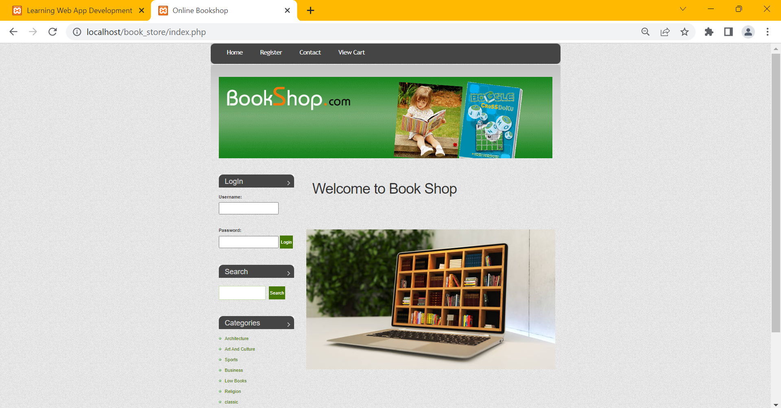 **Fig 9.1: Home page of book-shop management system**

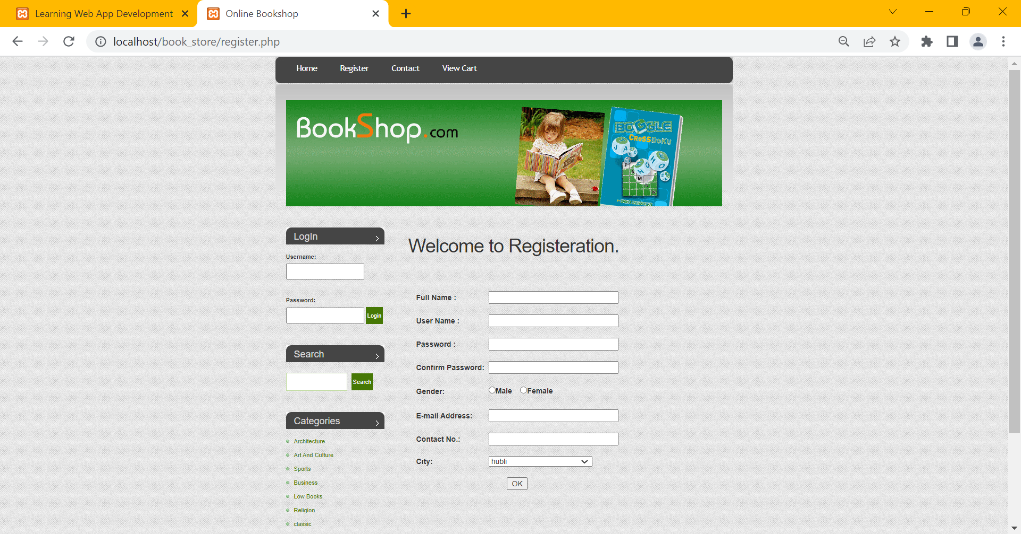**Fig 9.2:Registration page of book-shop management system**

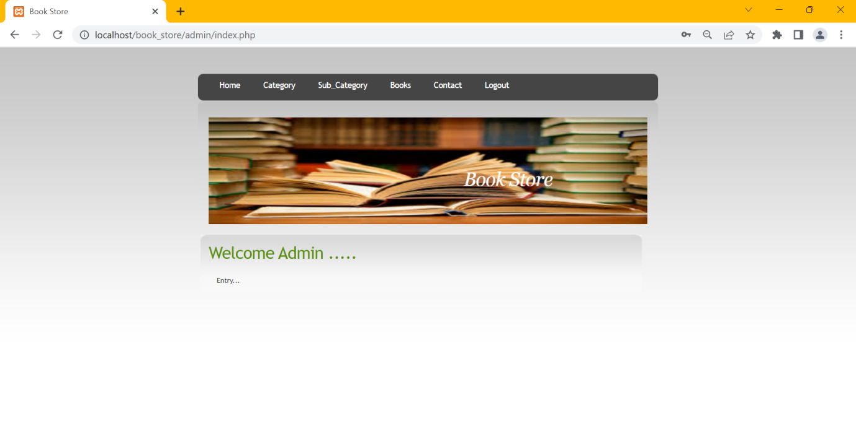**Fig 9.3:Admin control page**

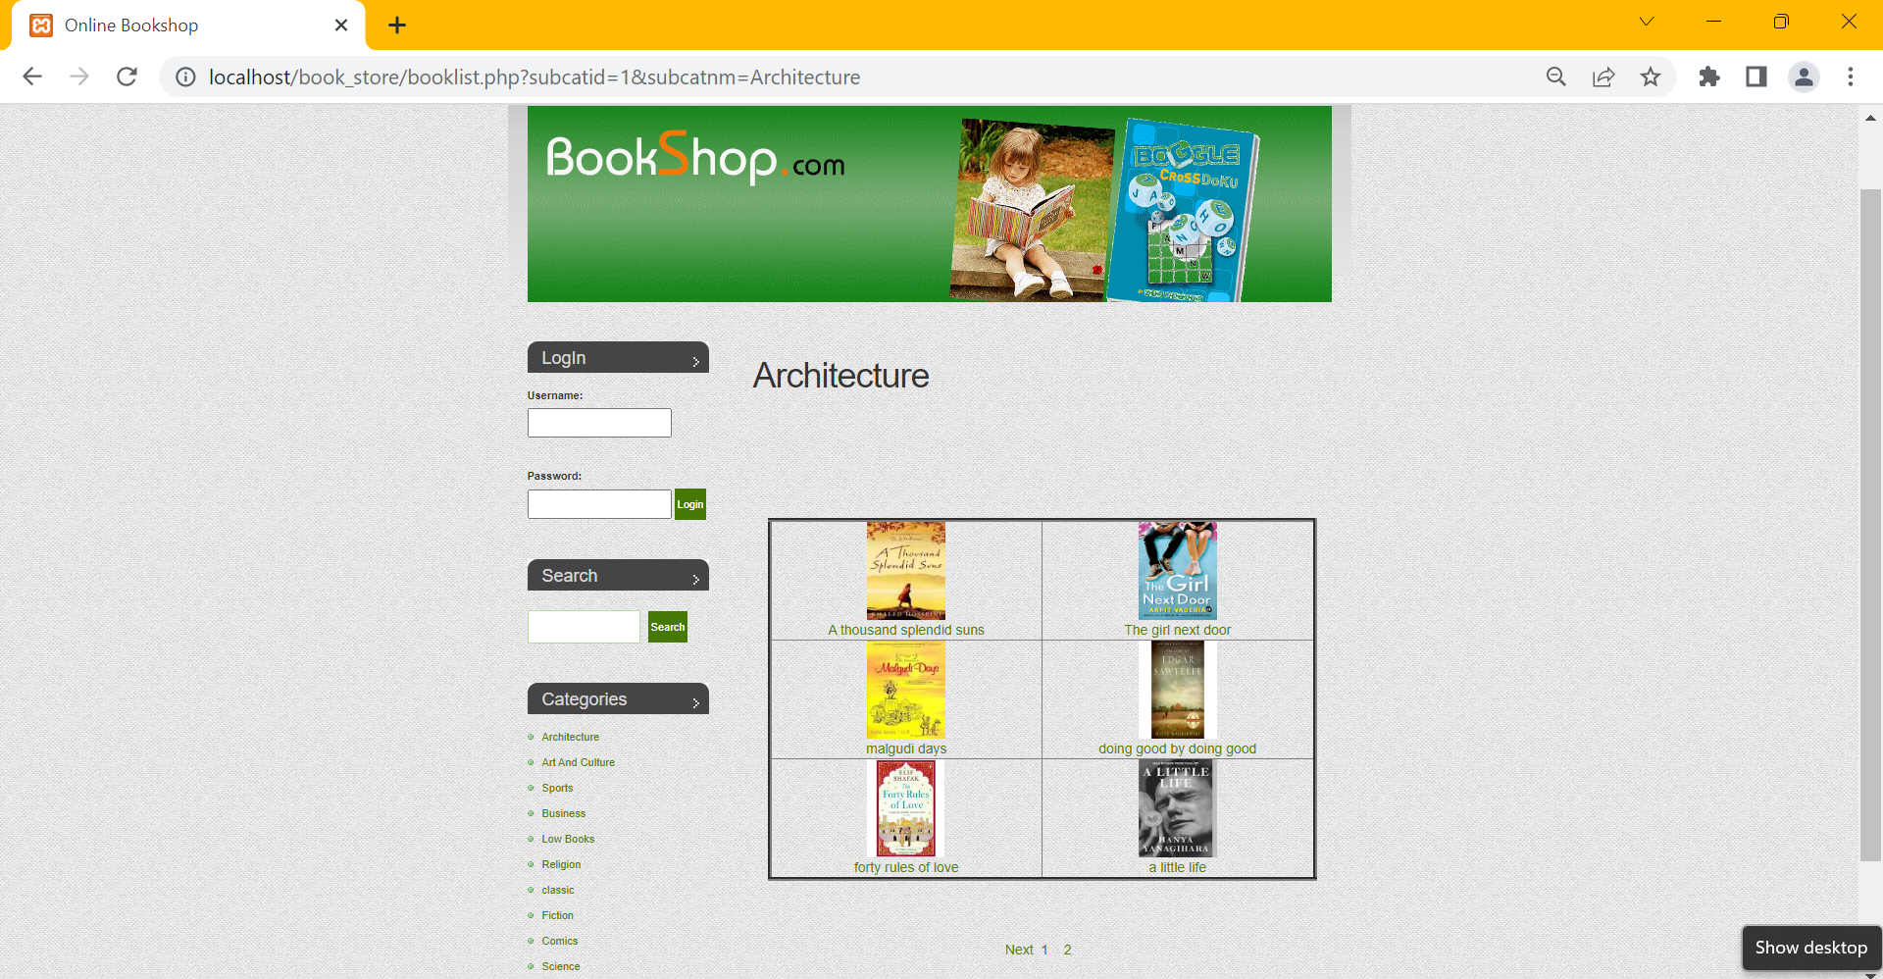

**Fig 9.4: Search page**

**Fig 9.5:Book viewing and updation page for admin.**

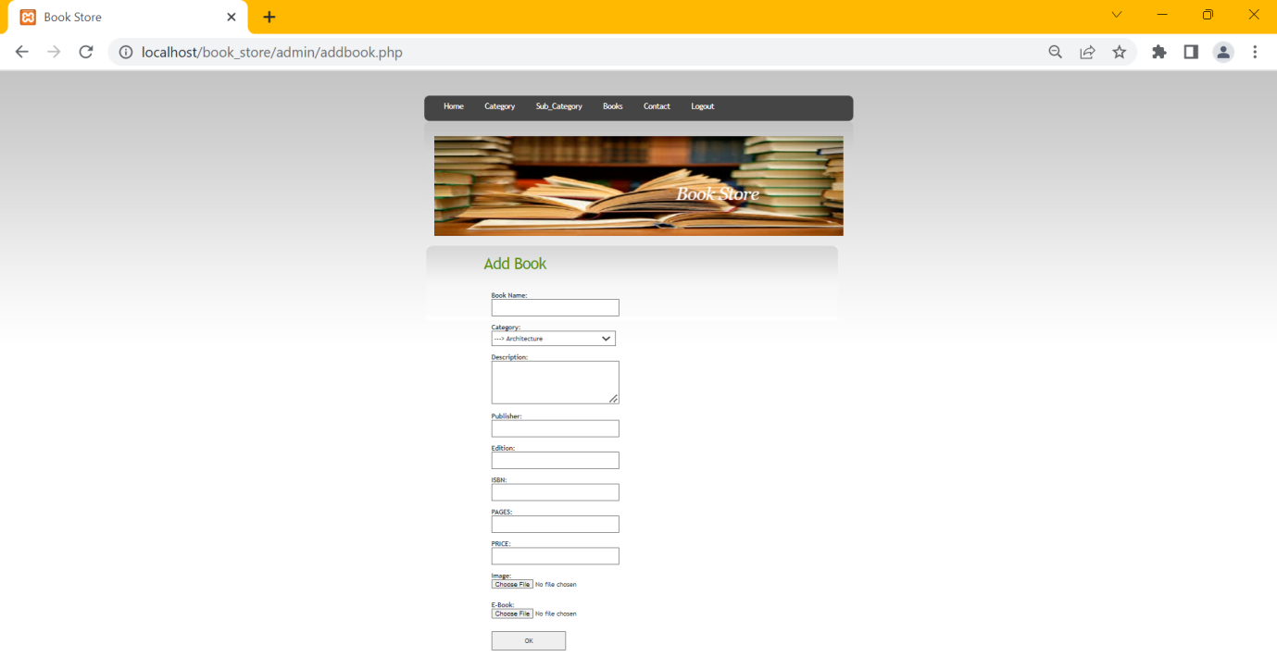

**Fig 9.6:Add book page.**

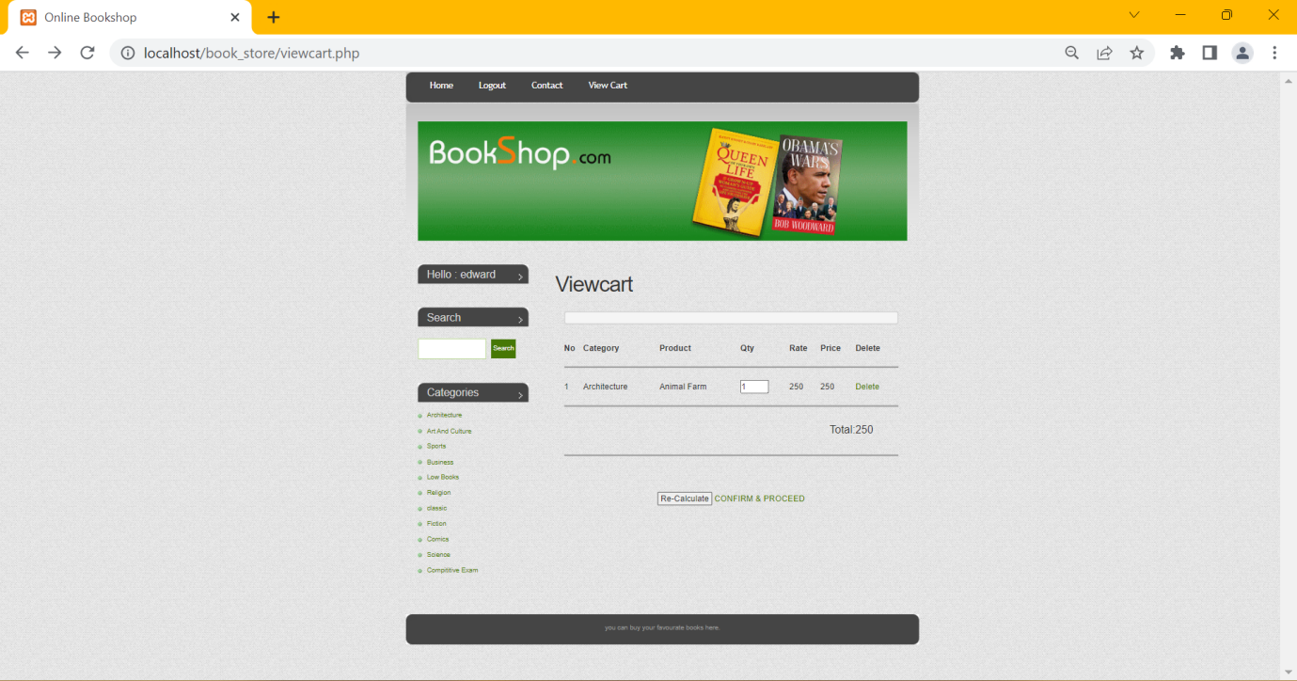

**Fig 9.7:View cart page**

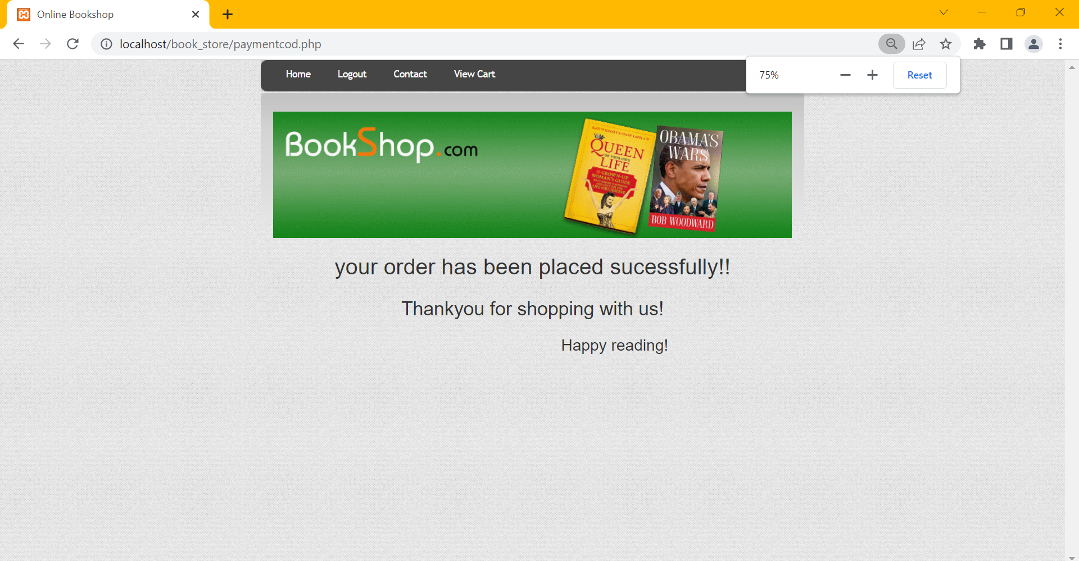

**Fig 9.8: order confirmation page**

**CONCLUSION**

The project titled ‘Bookstore management’ provides efficient delivery of books to the customers. This system provides users various options to explore books of various genres.This system does not involve any manual work,and thus it reduces the labour work. The system delivers books efficiently to the various ensure their satisfaction.The system provides books in various categories which makes it easy for them to order and find out the books. The system involves cash on delivery for efficient amount transaction.

# **REFERENCES**

Fundamentals of Database Systems,Ramez Elmasri and Shamkant B. Navathe,7th Edition,2017,Pearson.

Database management systems,Ramakrishnan,and Gehrke.3rd Edition,2014,McGrawHill.

Greken T and Ratschiller T,2000.Web applications development with PHP.Now riders publishing,2000.

Ware B,open source development with LAMP using linux,Apache,My SQL,And PHP Addison-wesley Longman publishing Co-Inc.,2002.

Welling L and Laura Thomson PHP and My SQL web development Same publishing,2003.

WEBSITES:

* 1. [www.php.net/manual](http://www.php.net/manual)
  2. [www.mysql.com](http://www.mysql.com/)
  3. [www.apachefriends.org](http://www.apachefriends.org)