**A**

**PROJECT REPORT**

**ON**

**“Bluetooth Controlled Robo”**

Submitted by

**HARSHAD GAHANE (I21)**

**RONAK PAWAR (I22)**

**VAIBHAV LANJEWAR (I23)**

# F.Y. B.Tech.

UNDER THE GUIDANCE OF

**Dr. Suhas S. Gajre**

**Mrs. Vinaya V. Khiste**

**Ms. Madhuri M. Baswade**

**Mr. Suraj D. Kulkarni**

(Engineering Exploration Lab)



**Academic Year 2021-22**

**Semester-2**

# CERTIFICATE

This is to certify that, the Project report entitled

**“Bluetooth Controlled Car”**

Submitted by

**HARSHAD GAHANE (I21)**

**RONAK PAWAR (I22)**

**VAIBHAV LANJEWAR (I23)**

As the partial fulfillment of Engineering Exploration Lab

For the academic year 2021-22, Sem-2

This project is a record of student’s own work, carried out by them under our supervision and guidance.

**Mrs. Vinaya V. Khiste Ms. Madhuri M. Baswade Mr. Suraj D. Kulkarni Dr.S.S.Gajre**

## ACKNOWLEDGEMENT

For all the efforts behind the project work, we first & foremost would like to express our sincere appreciation to the staff of Department of Engineering Exploration Lab, for their extended help & suggestions at every stage of this project.

It is with a great sense of gratitude that we acknowledge the support, time to time suggestions and highly indebted to our guide.

Finally, we pay our sincere thanks to all those who indirectly and directly helped us towards the successful completion of this project report.

**ABSTRACT**

Cost-Efficient Bluetooth-Controlled Robot Car which reacts in accordance to the corresponding voice and button command. Abstract Nowadays, material handling with the help of robotics knowledge is the emerging part in our day-to-day life. Material handling can be used to diminish the physical efforts. The cost-efficient Bluetooth-controlled robot car has made it possible for increasing number of handling tasks that is the main benefit of this project. In this project, we have designed and implemented the Bluetooth-controlled robot car for material handling using Arduino Mega 2560, Motor driver, and Bluetooth module which prove to be lower in cost than the pre-existing designs. Simple voice commands and button like left, right, forward, back, stop are used to run the car. These commands are given to Bluetooth module via an android application which uses google speech to text services. The Bluetooth module and control unit are combined to store and test the voice commands. This work has been limited to ZigBee system in short-range (100 mts range), and is linked to the car over a long distance via long-range modules. This device can be beneficial to farmers, storage go-downs, educational organization, Medicals, industries and general public for reducing their physical labors.

Keywords: Arduino Mega 2560, Bluetooth module, ZigBee system, Robotics

**GANTT CHART**

|  |  |  |  |  |
| --- | --- | --- | --- | --- |
| SR.NO | TASK | START DATE | END DATE | DURATION |
| 1 | Deciding Need and Problem Statement | 20-06-2022 | 21-06-2022 | 1 |
| 2 | Research for solutions. | 22-06-2022 | 23-06-2022 | 1 |
| 3 | Collecting Components | 24-06-2022 | 24-06-2022 | 0 |
| 4 | Creating PCC and PUGH chart | 25-06-2022 | 26-06-2022 | 1 |
| 5 | Coding and Uploading | 27-06-2022 | 28-06-2022 | 1 |
| 6 | Debuing | 29-06-2022 | 30-06-2022 | 1 |
| 7 | Making of model | 01-07-2022 | 02-07-2022 | 1 |
| 8 | Creating report and PPT | 03-07-2022 | 04-07-2022 | 1 |

**Chart 1: Task Table**

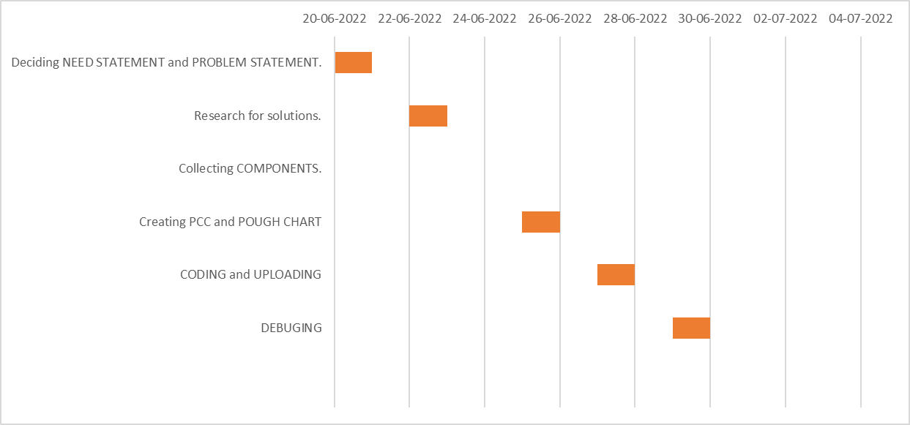

**PUGH CHART**

|  |  |  |  |  |  |
| --- | --- | --- | --- | --- | --- |
| **Criteria** | **Weight** | **Voice /Bluetooth**  **Controlled**  **Car** | **Conventional**  **Cars** | **Remote**  **(Joystick)**  **Controlled**  **Cars** | **Electrical**  **Self**  **Driving**  **Cars** |
| **Cost** | 1 | ++ | D | + | ---- |
| **Safe** | 2 | - | A | + | -- |
| **Maintenance** | 2 | + | T | --- | -- |
| **Ease of use** | 2 | ++ | U | ++ | ++++ |
| **Mobility** | 2 | ++ | M | + | ++ |
|  |  |  | |  |  |
| + | 12 | 0 | 9 | 12 |
| 0 | 0 | 9 | 0 | 0 |
| - | 2 | 0 | 6 | 12 |
|  | Total | 10 | 0 | 3 | 0 |

**Chart 2 : Pugh Chart**

**PAIR WISE COMPARISON CHART**

**Objectives:** Ease off use, Durable, Noise, Cost, Reliable.

**Constraints:** Safe.

**Functions:** Reduce human efforts.

**Means:** User friendly interface.

|  |  |  |  |  |  |  |
| --- | --- | --- | --- | --- | --- | --- |
|  | **Ease of use** | **Durable** | **Reduce human effort** | **Cost** | **Reliable** | **Total** |
| **Ease of use** | **-----** | **1** | **1** | **1** | **0** | **3** |
| **Durable** | **0** | **-----** | **0** | **0** | **0** | **0** |
| **Reduce human effort** | **0** | **1** | **-----** | **1** | **0** | **2** |
| **Cost** | **0** | **1** | **0** | **-----** | **0** | **1** |
| **Reliable** | **1** | **1** | **1** | **1** | **-----** | **4** |

|  |  |  |  |  |  |
| --- | --- | --- | --- | --- | --- |
|  |  |  | **Chart 3. PCC** |  |  |
|  |  |  |  |  |  |
|  |  |  |  |  |  |
| Rank of objectives:   1. Reliable 2. Ease of Use 3. Reduce human effort 4. Cost 5. Durable |  |  |  |  |  |
|  |  |  |  |  |  |
|  |  |  |  |  |  |
|  |  |  |  |  |  |

**TABLE OF CONTENTS**

Abstract 4

Gantt Chart 5

Pugh Chart 6

Pairwise Comparison Chart 7

List of Contents 8

List of Figures 26

List of Charts 26

**INDEX**

**Sr. No Contents Page No.**

**1 Introduction. 11**

1.1 Need Statement 11

1.2 Problem Statement 11

**2 Literature Survey. 12**

2.1Specifications of Components

And Material Used 13

**3 Block Diagram. 18**

**4 System Design. 19**

4.1 Working Principle 19

4.2 Code 21

**5 Application. 23**

**6 Conclusion and Future Scope. 25**

**References. 26**

1. **INTRODUCTION**

Robotics is an evolving technology. There are Various approaches to build robots, and no one is sure which method or technology will be used 100 years from now. Robotics is evolving like the Darwinian evolutionary theory of survival of the fittest. The framework equipment comprises of a controller outfitted with Bluetooth communication module. It’ll be connected to the motors and other alternative components of car. When the Bluetooth app is turned on and is connected with the current system via Bluetooth, one will operate the car by giving wireless commands from the app using the functions already programmed in the app. The vehicle will motion in four directions: Forward, Backward, Right and Left. In forward movement, all motors will motion in the same direction and for backward motion; movement of the motors will be in opposite direction. For left and right movements, either of the motors will rotate and to stop the motors will stop. Instructions are given to the motors through the Bluetooth app of Android Smartphone by the user.

In this project, we will demonstrate how to control a robot controlled car using Bluetooth module through Bluetooth application of an android mobile phone. The benefit of using robot-controlled car is it can be used to reduce manual work. This project can be modified quite easily to include a camera well that can stream the videos to the user over Wi-Fi using Wi Fi module.

**1.1 NEED STATEMENT**

We are living in the world which is continuously evolving and advancing its technology every moment. We need to save human efforts in every aspect, whether it is physical or mental. We need to continuously monitor the equipment, which still needs human assistance which further require human efforts. Moreover, according to census 2011, there are 26 million people suffering from one or the other kind of disability which is equivalent to 2.1% of the population. These are the trends that a student must be able to overcome using wireless and voice recognition technology.

**1.2 PROBLEM STATEMENT**

We must make a car that can be operated using wireless technology (Bluetooth) and voice recognition technology to improve existing technology and reduce human efforts

**2. LITERATURE SURVEY**

The 12v battery is characterized solely by its 12volt potential. This higher voltage is typically

found in SLA (sealed lead-acid) car batteries for SLI (Starting, Lighting, Ignition) purposes, or A23/27 batteries for radio frequency-transmitting in Bluetooth devices and home security systems.

In 2003, Worldwide speculation in modern robots up 19%. In 2004, orders for robots were up another 18% to the highest level ever recorded. Overall development in the period 2004-2007 conjecture at a normal yearly pace of about 7%. More than 600,000 family unit robots being used several millions in the next few years. Various researches have been made by different researchers in developing this project. Be that as it may, they serve an alternate application and have various innovations actualized. Some of those papers are mentioned below stating their technology and application. Robot Control Design Using Android Smartphone Authors: Mrumal K Pathak, Javed Khan, Aarushi Koul, Reshma Kalane Raunak Varshney. The motivation behind this paper is to furnish amazing computational android stages with less difficult robot equipment design. This paper depicts how to control a robot utilizing portable through Bluetooth communication, a few highlights about Bluetooth innovation, segments of the versatile and robot. It presents an audit of robots constrained by smart phone by means of moving the robot upward, reverse, left and right side by the android application, for example,

Arduino, Bluetooth Smart Phone Controlled Robot using ATMEGA328 Microcontroller. Authors: Aniket R. Yeole, Sapana M. Bramhankar, Monali D. Wani, Mukesh P. Mahajan. In this paper have structured a robot that can be controlled using an application running on an android smartphone. It sends control order by means of Bluetooth which has certain highlights like controlling the speed of the engine, detecting and sharing the data with telephone about the bearing and separation of the robot from the closest hindrance.

Android Controlled Bluetooth Robot Using 8051 Microcontroller. Authors: Ritika Pahuja, Narender Kumar. A robot is normally an electro-mechanical machine that is guided by PC and electronic programming. Numerous robots have been worked for producing reason and can be found in production lines around the globe. This paper built up the remote fastens in the android application which control the robot movement with them. What's more, in which Bluetooth communication is use to interface controller and android. Controller is interfaced to the Bluetooth module however UART convention Robot Controlled Car Using Wi-Fi Module Authors: S R Madkar, Vipul Mehta, Nitin Bhuwania, Maitri Parida. This paper, deliberate how to control robot controlled vehicle utilizing Wi-Fi module through android application of an android Smart Phone. It is additionally show that the apparatuses can be controlled even without an android telephone by sending an ordinary SMS. This task can be adjusted effectively to incorporate a covert agent camera too that can stream the recordings to the client over Wi-Fi. Sunlight based cells are rather than the customary lithiumion battery for the venture.

**2.1 SPECIFICATIONS OF COMPONENTS AND MATERIAL USED**

**1. Arduino Mega 2560**

*Figure 1 : Arduino Mega 2560*

The Mega 2560 is a microcontroller board based on the [ATmega2560.](http://www.atmel.com/Images/Atmel-2549-8-bit-AVR-Microcontroller-ATmega640-1280-1281-2560-2561_datasheet.pdf) It has 54 digital input/output pins (of which 15 can be used as PWM outputs), 16 analog inputs, 4 UARTs (hardware serial ports), a 16 MHz crystal oscillator, a USB connection, a power jack, an ICSP header, and a reset button. It contains everything needed to support the microcontroller; simply connect it to a computer with a USB cable or power it with a AC-to-DC adapter or battery to get started. The Mega 2560 board is compatible with most shields designed for the Uno and the former boards Duemilanove or Diecimila.

**Technical Specifications:**

Microcontroller: ATmega2560

Operating Voltage: 5V

Input Voltage (recommended): 7-12V

Input Voltage (limit): 6-20V

Digital I/O Pins: 54 (of which 15 provide PWM output)

Analog Input Pins: 16

DC Current per I/O Pin: 20 mA

DC Current for 3.3V Pin: 50 mA

Flash Memory: 256 KB of which 8 KB used by bootloader

SRAM: 8 KB

EEPROM: 4 KB

Clock Speed: 16 MHz

LED_BUILTIN: 13

1. **Bluetooth module HC-05**

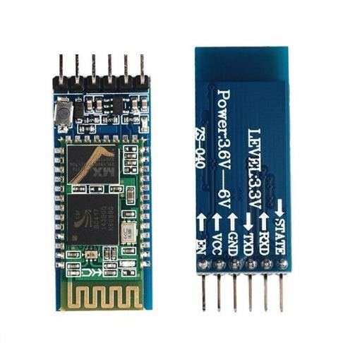

*Figure*

*2*

*:*

*HC*

*-*

*05*

*Bluetooth Module*

Designed to replace cable connections HC-05 uses serial communication to communicate with the electronics. Usually, it is used to connect small devices like mobile phones using a short-range wireless connection to exchange files. It uses the 2.45GHz frequency band.

1. **JUMPER WIRES**

*Figure 3: Jumper WIres*

Jumper wires are simply wires that have **connector pins at each end**, allowing them to be used to connect two points to each other without soldering. Jumper wires are typically used with breadboards and other prototyping tools in order to make it easy to change a circuit as needed

1. **DC GEARED MOTORS**

*Figure 4: DC geared motor*

A Direct Current (DC) motor is a rotating electrical device that converts direct current, of electrical energy, into mechanical energy. An Inductor (coil) inside the DC motor produces a magnetic field that creates rotary motion as DC voltage is applied to its terminal.

DC Gearmotors are electric motors that utilize a type of gear system on the output of the motor. This gearing arrangement is called a gear reducer or gearbox. The combination of an electric motor and gearbox reduces design complexity and lowers cost, particularly for motors built for high torque and low speed applications. In addition, gearboxes can be used as a means to reorient the output shaft in a different direction

1. **ROBOT WHEELS**

*Figure 5: Robot Wheels*

Wheeled robots are robots that navigate around the ground using motorized wheels to propel themselves. This design is simpler than using treads or legs and by using wheels they are easier to design, build, and program for movement in flat, not-so-rugged terrain.

1. **L298N MOTOR DRIVER**

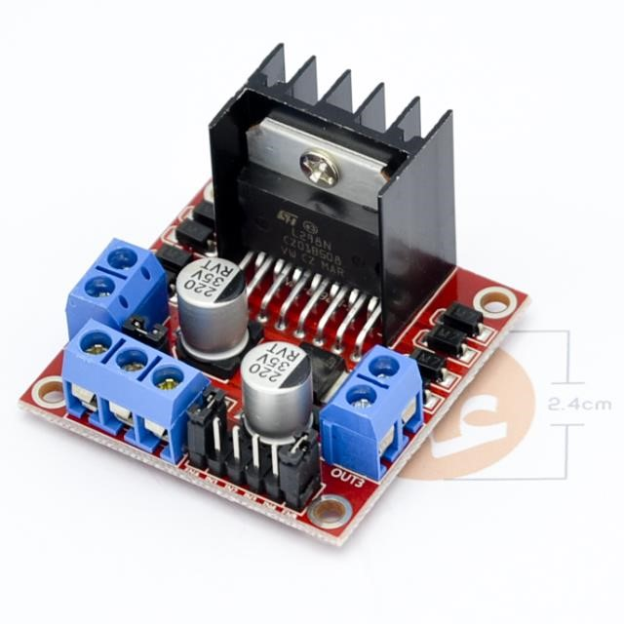

*Figure 6: L298N Motor Driver*

The L298N motor driver is based on the **H-bridge configuration** (an H-bridge is a simple circuit that lets us control a DC motor to go backward or forward.), which is useful in controlling the direction of rotation of a DC motor. It is a high current dual full H-bridge driver that is constructed to receive standard TTL logic levels.

1. **CHASIS**

*Figure 7: Chasis*

Chassis is very essential in robots as well as many mechanical devices. It helps in providing support to PCB, accessories and various parts which are connected to it. Robot chassis is particularly designed for robots and other mechanical devices.

1. **12 Volt BATTERY**

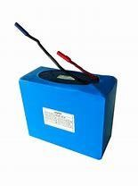 *Figure 8: 12V Battery*

### BLOCK DIAGRAM

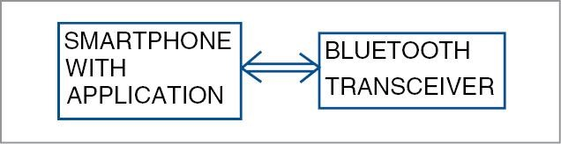

HC-05 BLUETOOTH

TRANSCEIVER

L298D

MOTOR

DRIVER

ARDUINO

MEGA

2560

RIGHT

MOTOR

LEFT

MOTOR

### 

### 4.SYSTEM DESIGN

### 4.1 WORKING PRINCIPLE

Bluetooth and Voice Commands are processed by phone. Text or button command is then sent to the receiver side via Bluetooth. Text received via Bluetooth is forwarded to Arduino Mega 2560 board using TX & RX pins serial communication. Arduino code checks the text received. Whenever the text is a matching string, Arduino controls the movements of the robot accordingly in forward, backward, Turning Right, Turning Left & Stop.

The block diagram of the simple voice and Bluetooth controlled robotic vehicle is given it consists of the smartphone that recognizes the voice commands and are being wirelessly transferred to the Bluetooth module HC05. The module at that point changes over the order to content and the series of characters are sent to the Arduino for additional handling. The Arduino microcontroller decodes the string got and correspondingly performs further capacities. The signals are sent to the motor that hence powers and drives the motors connected to it. On the Transmitter area, commands are given to the Mobile Application through the mic. This portable handset is associated with the moving vehicle by means of Bluetooth module. The portable application utilized, is modified so that the voice orders given to the handset are received by the mic and these simple voice orders are changed over to advanced word successions (A to D transformation). These stored sequences are than transmitted to the robotic vehicle via Bluetooth transceiver module and are sent to the transceiver controller. Android application transceiver is used to decode the received signal with the Bluetooth module. The controller contrasts these signals and the put away program orders in it and convert them into voice strings. The voice strings are then used to run the servo engines for of the engine driver. The yield of the Arduino goes to the engine driver IC and it controls the specific engine. A DC power supply is required to run the system. The DC power supply feeds the Microcontroller and the Bluetooth module. the ideal interval of time. The microcontroller, sends directions, which when executed, helps in working **Schematic Diagram**

The circuit consist of Arduino UNO Board, HC-05/HC-06 Bluetooth Module, L293D Motor Driver IC, a pair of DC Geared Motors of 200 RPM and a 9V Battery.

The TX, RX pins of Arduino is connected to Rx, Tx pins of Bluetooth Module. The Bluetooth Module is supplied with 5V. Similarly, left DC motor is connected to pin no 3 & 6 of L293D and right DC motor to pin no 14 & 11 of L293D. Arduino digital pins 3,4,5,6 is connected to L293D 2, 7, 10, 15 respectively.

The L293D IC Pins 2, 5, 12, 13 is GND pins and 9, 1, 16 is supplied with 5V. But pin 8 of L293D is directly supplied with 9V.

Signal logic levels at the different stages of the circuits for proper controlling of the robotic car are given below.

**4.2 CODE:**

// Voice/bluetooth Controlled Car Code v3

String c;

String voice; int inp1=12; int inp2=11; int inp3=10; int inp4=9; int enA = 4; int enB = 5;

void setup()

{

Serial.begin(9600); pinMode(inp1, OUTPUT); //RIGHT MOTOR pinMode(inp2, OUTPUT); //RIGHT MOTOR pinMode(inp3, OUTPUT); //LEFT MOTOR pinMode(inp4, OUTPUT); //LEFT MOTOR

pinMode(enA, OUTPUT); // Enable A pinMode(enB, OUTPUT); // Enable B

} void loop() { analogWrite(enA, 180); analogWrite(enB, 180); while(Serial.available()>0)

{

Serial.println("inside while"); delay(10); char c = Serial.read();

//Serial.println(c);

if(c=='#') { break; } voice+= String(c);

Serial.println(voice);

}

if(voice=="forward"){ digitalWrite(inp1, LOW); digitalWrite(inp2, HIGH); digitalWrite(inp3, LOW); digitalWrite(inp4, HIGH); delay(3000);

} else if(voice=="back"){ digitalWrite(inp1, HIGH); digitalWrite(inp2, LOW); digitalWrite(inp3, HIGH); digitalWrite(inp4, LOW); delay(2000);

}

else if(voice=="right"){ digitalWrite(inp1, LOW); digitalWrite(inp2, HIGH); digitalWrite(inp3, HIGH); digitalWrite(inp4, LOW); delay(100); } else if(voice=="left"){ digitalWrite(inp1, HIGH); digitalWrite(inp2, LOW); digitalWrite(inp3, LOW); digitalWrite(inp4, HIGH); delay(100);

}

//Stop digitalWrite(inp1, LOW); digitalWrite(inp2, LOW); digitalWrite(inp3, LOW); digitalWrite(inp4, LOW);

//Stop voice =

"";

}

### 5.APPLICATION:

### 1.Trying to shifting materials can be hazardous in a family. The device is used in household applications like kitchen, storeroom, etc.

### 2. Industrial Applications: This device is more suitable for industrial purpose. It can be used to deliver the valuable documents, ﬂies, materials, etc.

### 3. Educational Applications: To transfer the important documents, papers, ﬁles, etc of school, college from source to destination, this device is very useful. This proposed device is also suitable for the laboratory and library.

### 4. Others Applications: This proposed device is also applicable for hospitals, banks, ofﬁces, etc

**5.APPLICATION**

### 1.Trying to shifting materials can be hazardous in a family. The device is used in household applications like kitchen, storeroom, etc.

### 2. Industrial Applications: This device is more suitable for industrial purpose. It can be used to deliver the valuable documents, ﬂies, materials, etc

### 3. Educational Applications: To transfer the important documents, papers, ﬁles, etc of school, college from source to destination, this device is very useful. This proposed device is also suitable for the laboratory and library.

### 4. Others Applications: This proposed device is also applicable for hospitals, banks, ofﬁces, etc

### 5. Pesticide Spraying: The pesticide spraying mechanism is done by a special motor used in pumping water. This inlet of water pump is attached to the same tank which is used for watering and the outlet of it is attached to the sprayer via pipe. Whenever pesticide spraying is turned ON the water-pump starts pumping pesticide from the water tank to the sprayer. Thus spraying pesticide in the farm.

### 6.CONCLUSION AND FUTURE SCOPE

The proposed framework of our project shows that how a robot can be control utilizing Bluetooth. The voice controlling orders are effectively transmitted through Bluetooth innovation and the desired activities effectively happen. This task lessens human endeavours at spots or circumstances where human intercessions are troublesome. Such frameworks can be brought into utilization at spots, for example, businesses, military and guard, investigate purposes, and so forth.

1. This task work has been limited to short range Bluetooth module. Utilizing a long-range modules and other availability gadgets will bring about network with the robot for significant distances.
2. Picture preparing can be executed in the robot to distinguish the shading and the items.
3. A warm camera can be introduced to detect the warmth produced by bodies valuable in military purposes to distinguish foes on the lines.
4. Programmed Targeting System can be executed in the robot for following the objective.
5. Further upgrade in venture can be utilized for Home Security and military purposes where the orders can be given to robot without chance by expanding the range and by introducing cameras.
6. The robot is valuable in places where people discover hard to reach however human voice comes to. For example, in fire circumstances, in profoundly poisonous zones.
7. It is the one of the significant phase of Humanoid robots.
8. Discourse and voice acknowledgment security frameworks.
9. The robot can be used for monitoring or investigation.

### REFERENCES

1. <https://create.arduino.cc/projecthub/Yug_Ajmera/>
2. <https://drive.google.com/drive/folders/0BwsV1jJYW9dndjZKaTBwakJ>
3. <https://www.instructables.com/id/>
4. <https://www.researchgate.net/publication/325722323_IJSRST173866_>
5. <https://ieeexplore.ieee.org/document/8093565>
6. <https://www.viralsciencecreativity.com/post/>
7. <https://nevonprojects.com/>
8. <https://www.hackster.io/Yug_Ajmera/>
9. [IRJET-V7I5770.pdf](https://www.irjet.net/archives/V7/i5/IRJET-V7I5770.pdf?msclkid=69f51b15a94d11ecb4b2cf5ed267ccf1)
10. [VOICE CONTROLLED Car - Arduino Project Hub](https://create.arduino.cc/projecthub/aqarrout/voice-controlled-car-ee1464?msclkid=e633a022a95111eca3413a74ef806777)

### List of Figures:

**Figure No. Name of Figure Page No.**

1. Arduino Mega 2560 12
2. Bluetooth Module HC-05 13
3. Jumper Wires 13
4. DC Geared Motor 14
5. Robot Wheels 14
6. L298N Motor Driver 15
7. Chasis 16
8. 12 V Battery 16

### List of charts:

**Table No. Chart Name Page No.**

1. Pairwise Comparison Chart 07
2. Pugh Chart 06
3. Gantt Chart 05