PROCUREFLOW
  - Purchase-to-Pay Workflow Platform
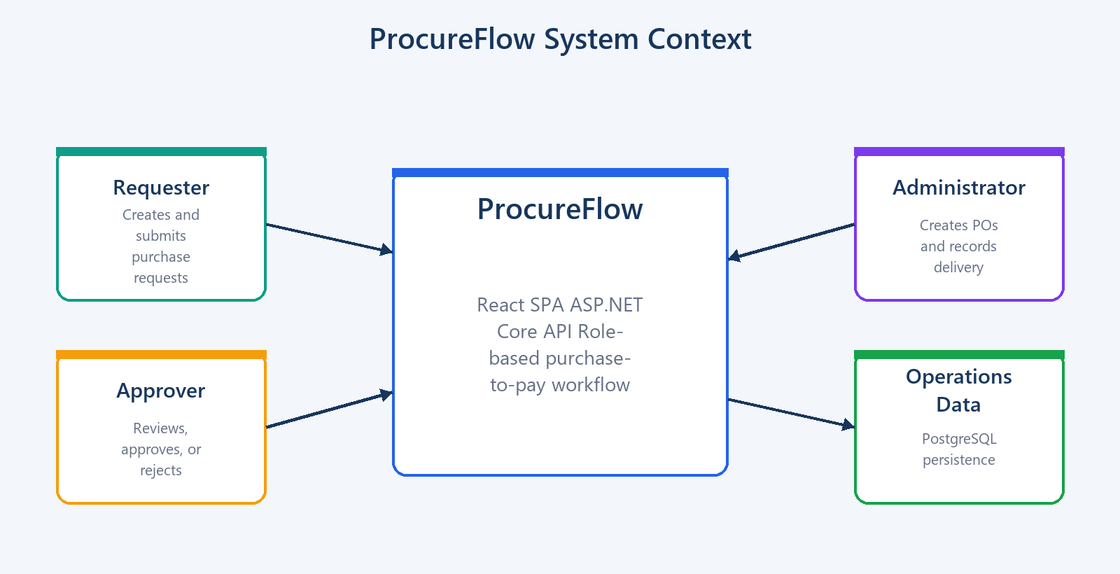

Technical Design and Implementation Documentation
Architecture • Frontend • Backend • Database • Cloud • Deployment

Purpose | A code-grounded description of the current ProcureFlow implementation and its operational characteristics.
Baseline | Current repository implementation
Classification | Technical assessment material; not a production DP World system

Document Guide
Right-click and select Update Field if the table of contents is not populated.
Scope: This document describes the repository as implemented. Proposed production improvements are explicitly labelled and are not presented as completed features.

1. Executive Summary
ProcureFlow is a role-based purchase-to-pay assessment application. It demonstrates a controlled workflow from purchase request creation through approval, purchase-order creation, delivery recording, and completion. A React single-page application communicates with a .NET 8 API over JSON/HTTPS. PostgreSQL stores users, master data, transactional entities, audit fields, and immutable purchase-request status history.
- Requester: creates, edits, deletes, submits, and views owned purchase requests.
- Approver: reviews Submitted requests and approves or rejects them with a reason.
- Admin: creates a purchase order for an Approved request, records delivery, and completes the transaction.
- The API is the security and workflow boundary; frontend route guards are only user-experience controls.
- Conditional atomic updates and database uniqueness constraints protect workflow invariants under concurrent requests.
Figure 1 — System context and primary actors

2. Business Scope and Requirements

2.1 Functional scope
Capability | Requester | Approver | Admin
Authenticate | Yes | Yes | Yes
View dashboard | Yes | Yes | Yes
Search/list PRs | Owned PRs | All PRs | All PRs
Create/edit/delete PR | Draft only | No | No
Submit PR | Draft → Submitted | No | No
Approve/reject | No | Submitted only | No
Create PO | No | No | Approved PR only
Record delivery/complete | No | No | Yes

2.2 Workflow invariants
- Only Draft requests can be edited or deleted.
- Submission is Draft → Submitted; approval/rejection is available only from Submitted.
- A purchase order can be created only for an Approved PR, and a PR can have at most one PO.
- Delivery requires a Created PO and moves the linked PR from PO Created to Delivered.
- Completion requires Delivered state and atomically updates PO, delivery, and PR.
- Rejected requests are final in the current workflow; there is no resubmit path.
- Partial deliveries and multi-line PRs/POs are outside the current scope.
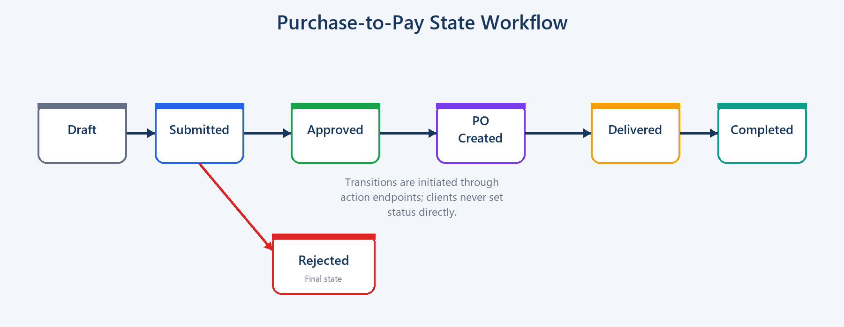
Figure 2 — Purchase request state machine

3. Technology Stack
Area | Technology | Purpose
Frontend | React 18 + TypeScript 5 + Vite 5 | Typed SPA and production bundling
UI | Material UI 6 + MUI X Data Grid 7 | Responsive components and server-driven grids
State/API | Redux Toolkit, React Redux, RTK Query | Authentication state, API calls, caching, invalidation
Forms | React Hook Form + Zod | Client validation and reusable PR form
Backend | .NET 8 ASP.NET Core Web API | HTTP endpoints, middleware, DI, authorization
Persistence | EF Core 8 + Npgsql + PostgreSQL 16 | Relational mapping, transactions, migrations
Identity | ASP.NET Core Identity + JWT Bearer | Users, password hashing, roles, authentication
Mapping/validation | AutoMapper + FluentValidation | DTO mapping and server validation
Testing | xUnit + Moq | Workflow unit tests and integration project smoke test
Cloud/CI-CD | GitHub Actions + Azure Static Web Apps + Azure App Service | Independent frontend/API deployments

4. Architecture
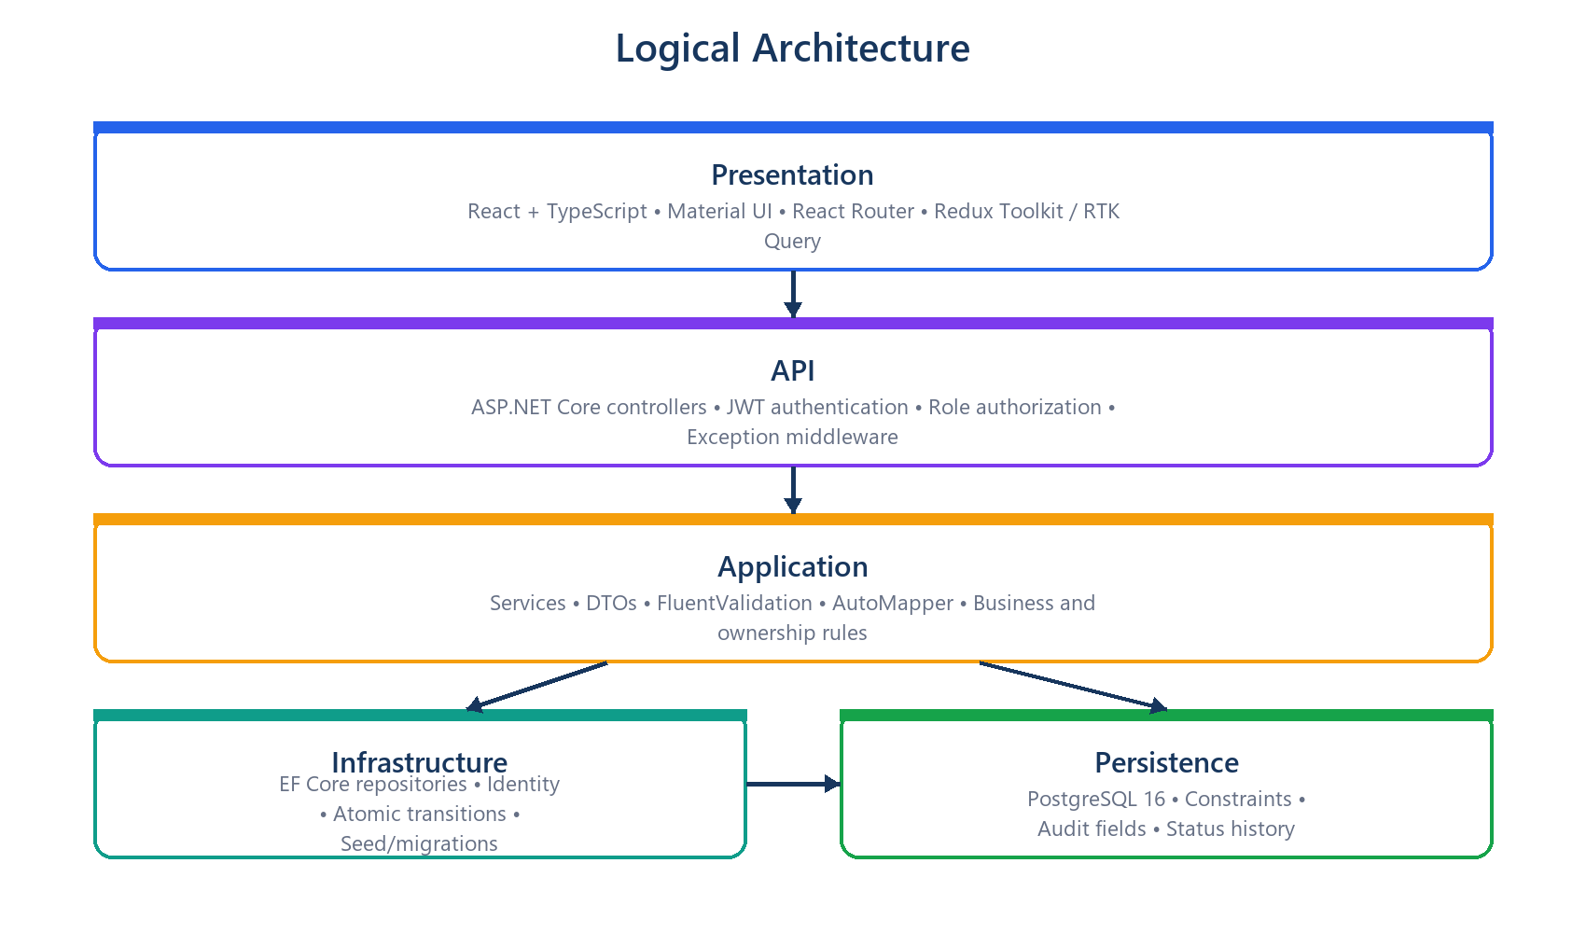
Figure 3 — Logical application architecture

4.1 Dependency boundaries
- Domain contains entities, shared audit fields, and workflow enums and has no inward application dependency.
- Application contains DTOs, service/repository contracts, mapping, validators, and business services.
- Infrastructure implements persistence, Identity authentication, repositories, migrations, and seed data.
- API composes the layers and owns controllers, middleware, CORS, Swagger, authentication, and authorization setup.
- Frontend is independently built and knows only HTTP contracts; it does not reference backend assemblies.

4.2 Typical request flow
- A React page calls an RTK Query hook.
- The base query reads the JWT from Redux and sends it in the Authorization header.
- ASP.NET Core validates the token and role policy before invoking the controller.
- The controller delegates to an application service.
- The service checks ownership and business rules and calls a repository abstraction.
- The repository uses EF Core or a conditional atomic update inside a transaction.
- DTOs are returned as camel-cased JSON; mutation tags cause affected frontend queries to refetch.
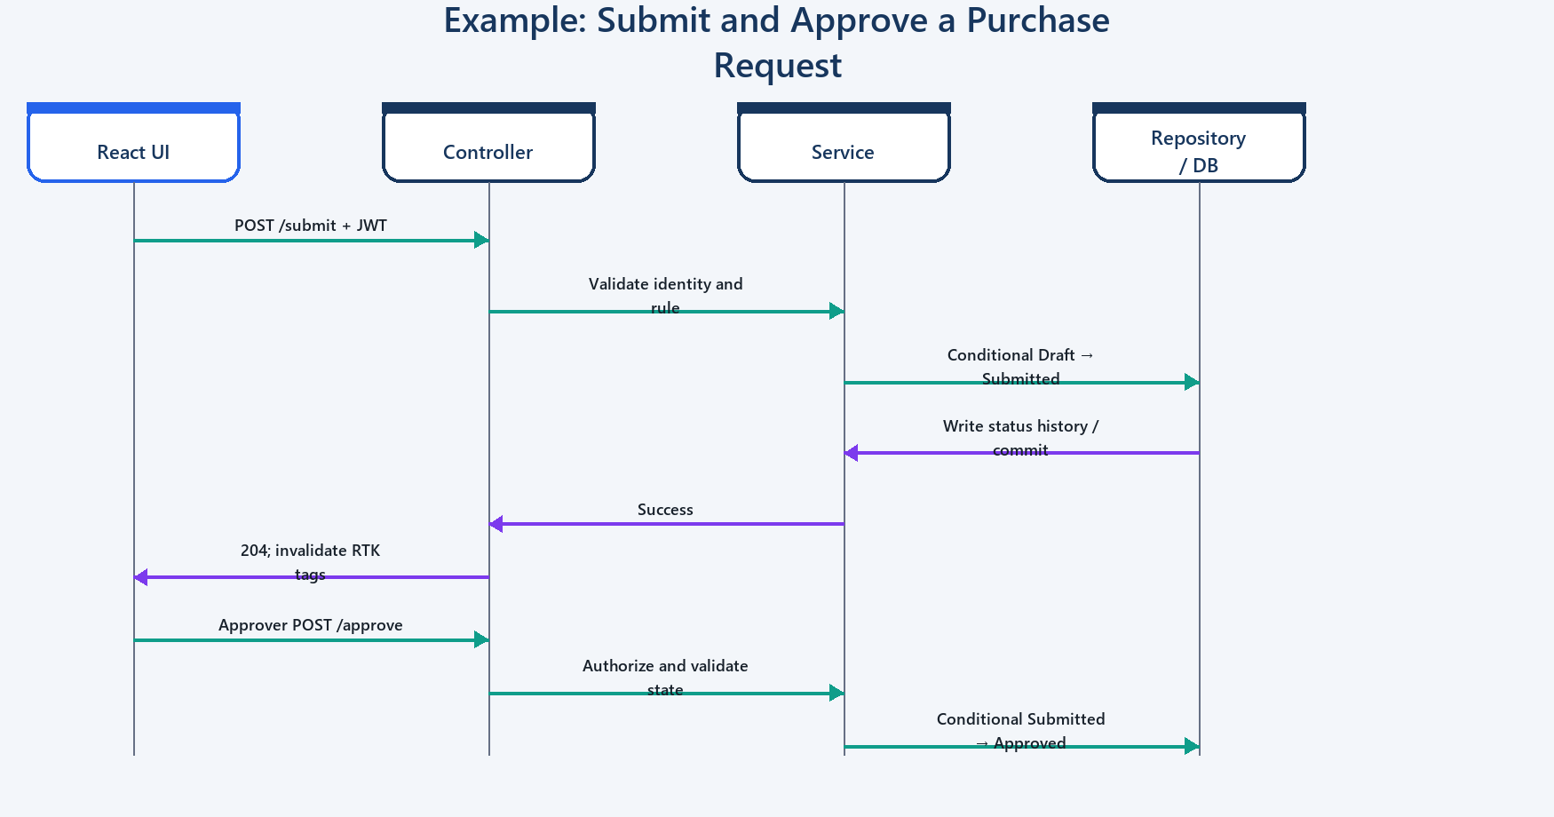
Figure 4 — Submit/approve request sequence

5. Frontend Design

5.1 Application shell and navigation
Layout.tsx provides a dark responsive sidebar, fixed application bar, compact/expanded desktop drawer, temporary mobile drawer, user identity display, logout, and persisted light/dark mode. Navigation entries are role-aware. ProtectedRoute prevents unauthorized UI navigation, while backend authorization remains authoritative.

5.2 Routes
Route | Access | Purpose
/login | Public | JWT login
/ | Authenticated | Dashboard
/purchase-requests | Authenticated | PR list; requester actions
/purchase-requests/new | Requester | Direct create route
/purchase-requests/:id | Authenticated/ownership | PR details and history
/purchase-requests/:id/edit | Requester | Direct Draft edit route
/approvals | Approver | Pending approval queue
/purchase-orders | Admin | PO search and creation
/deliveries | Admin | Delivery and completion operations

5.3 State and API integration
- Redux stores the authenticated response and persists it under procureflow_auth in localStorage.
- RTK Query centralizes endpoints, bearer headers, request state, cache, and refetch behavior.
- Tags PR, Approval, PO, and Dashboard are invalidated after workflow mutations.
- The production API base URL is injected at build time through VITE_API_URL; localhost fallback is development-only.
- Global Snackbar and error parsing convert the stable API error envelope into actionable messages.

5.4 Forms and grids
- PurchaseRequestForm is reused by create and edit dialogs/routes to prevent validation drift.
- Required master-data selections, positive amount, currency, description, and non-past required date are validated client-side; the server repeats authoritative validation.
- PR/PO/approval/delivery screens use server pagination and compact viewport-filling Data Grids.
- Search is debounced; PR sorting and status filters are sent as query parameters.

5.5 Dashboard
- KPI cards use dashboard counts for total PRs, pending approval, total POs, pending delivery, and completed requests.
- A CSS conic-gradient donut displays the PR status distribution without another chart dependency.
- Six-month PR and PO bars are derived from up to 100 records returned by the existing paged list APIs.
- The work queue changes by role: pending approvals, Approved PRs ready for PO, or Draft PRs.
- Recent Activity uses lastActivityAt, calculated from status history, not the original creation time.

6. Backend Design

6.1 Controllers and services
Controller | Service | Responsibility
AuthController | AuthService | Login, JWT creation, current user
PurchaseRequestsController | PurchaseRequestService | CRUD, ownership, submit
ApprovalsController | ApprovalService | Pending queue, approve/reject
PurchaseOrdersController | PurchaseOrderService | PO search/get/create
DeliveriesController | DeliveryService | Deliver and complete
DashboardController | DashboardService | Workflow counts
MasterDataController | MasterDataService | Department/category/vendor lookup

6.2 API endpoint summary
Method | Route | Role | Result
POST | /api/auth/login | Anonymous | Authenticate and return JWT
GET | /api/auth/me | Authenticated | Current identity
GET | /api/dashboard/summary | Authenticated | PR status and PO counts
GET | /api/purchase-requests | Authenticated | Paged/search/filter/sort PRs
GET | /api/purchase-requests/{id} | Authenticated | PR detail and history
POST | /api/purchase-requests | Requester | Create Draft
PUT/DELETE | /api/purchase-requests/{id} | Requester | Modify/delete owned Draft
POST | /api/purchase-requests/{id}/submit | Requester | Submit Draft
GET | /api/approvals | Approver | Submitted PR queue
POST | /api/approvals/{id}/approve | Approver | Approve Submitted PR
POST | /api/approvals/{id}/reject | Approver | Reject with reason
GET/POST | /api/purchase-orders | Auth/Admin | Search/create PO
POST | /api/deliveries/{poId}/deliver | Admin | Record delivery
POST | /api/deliveries/{poId}/complete | Admin | Complete transaction
GET | /api/departments|categories|vendors | Authenticated | Active lookups

6.3 Validation and errors
FluentValidation validates create/update PR DTOs. ExceptionMiddleware maps validation to 400, ownership to 403, missing resources to 404, workflow conflicts to 409, and unexpected exceptions to a generic 500 response. Stack traces are logged but not returned.
{ "statusCode": 409, "message": "Purchase request was modified...", "errors": [] }

7. Authentication, Authorization, and Security
- ASP.NET Core Identity stores users, password hashes, and roles; unique email is required and minimum password length is eight.
- Login creates an HMAC-SHA256 JWT valid for eight hours with subject, user ID, email, full name, and role claims.
- Controllers use [Authorize] and role policies; Requester ownership is also enforced in the service layer.
- CORS uses an explicit AllowedOrigins array rather than AllowAnyOrigin.
- The browser currently stores JWT data in localStorage. This is convenient for an assessment but requires an XSS-conscious production security review.
- Secrets and production connection strings belong in Azure App Settings, user-secrets, or another secret store, not committed appsettings.json.
Security boundary: Hiding a menu item is not authorization. Every sensitive mutation is protected by backend role checks and workflow validation.

8. Database Design
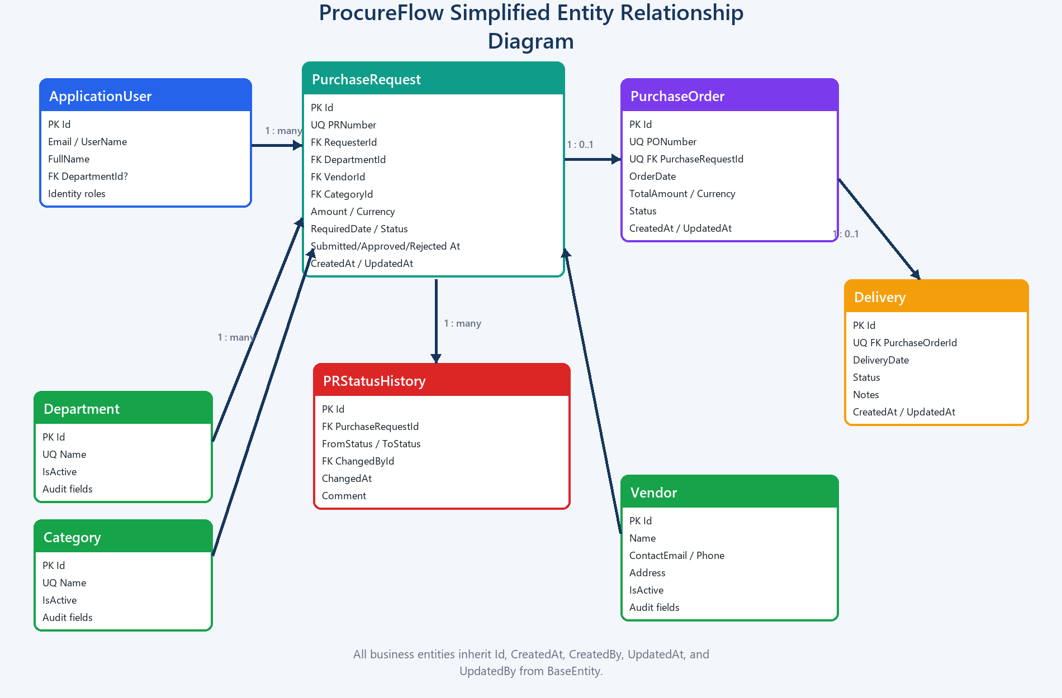
Figure 5 — Simplified relational model

8.1 Core relationships and constraints
Relationship/constraint | Implementation reason
ApplicationUser 1 → many PurchaseRequests | Identifies requester; delete is restricted
Department/Category/Vendor 1 → many PRs | Normalized lookup data; deletes restricted
PurchaseRequest 1 → 0..1 PurchaseOrder | Unique PurchaseRequestId prevents duplicate POs
PurchaseOrder 1 → 0..1 Delivery | Unique PurchaseOrderId prevents duplicate delivery records
PurchaseRequest 1 → many StatusHistory | Immutable transition audit and activity timing
Unique PRNumber and PONumber | Business identifiers
numeric(18,2) amount columns | Avoids floating-point money errors
Enum-to-string persistence | Readable database values while API currently emits numeric enums

8.2 Audit and activity timestamps
BaseEntity supplies CreatedAt/CreatedBy and UpdatedAt/UpdatedBy. DbContext stamps tracked additions and modifications in UTC. Conditional SQL and ExecuteUpdate operations bypass the change tracker, so repositories explicitly update audit fields. Each PR state transition also writes PurchaseRequestStatusHistory.ChangedAt. The list DTO exposes lastActivityAt as the newest status-history time, falling back to UpdatedAt and CreatedAt.

8.3 Migrations and seed behavior
- The InitialCreate EF Core migration defines the current schema; no additional migration is needed for lastActivityAt because it is a computed DTO field.
- On API startup, SeedData applies pending migrations with MigrateAsync; if no migrations exist for a new database it uses EnsureCreatedAsync.
- Roles, lookup data, and three demo users are seeded idempotently.
- For production scale-out, applying migrations as a dedicated deployment step is safer than allowing several app instances to migrate concurrently.

9. Concurrency and Transaction Design
- Status transitions use conditional WHERE clauses, so a stale action updates zero rows and becomes a 409 conflict.
- Approve succeeds only when the row is still Submitted; submit succeeds only while Draft.
- PO creation updates PR state and checks for an existing PO inside a database transaction; a unique index provides the final invariant.
- Delivery and completion atomically coordinate PO, PR, delivery, and status-history changes in transactions.
- This optimistic approach avoids long-lived locks while making competing transitions deterministic.

10. Deployment and Configuration
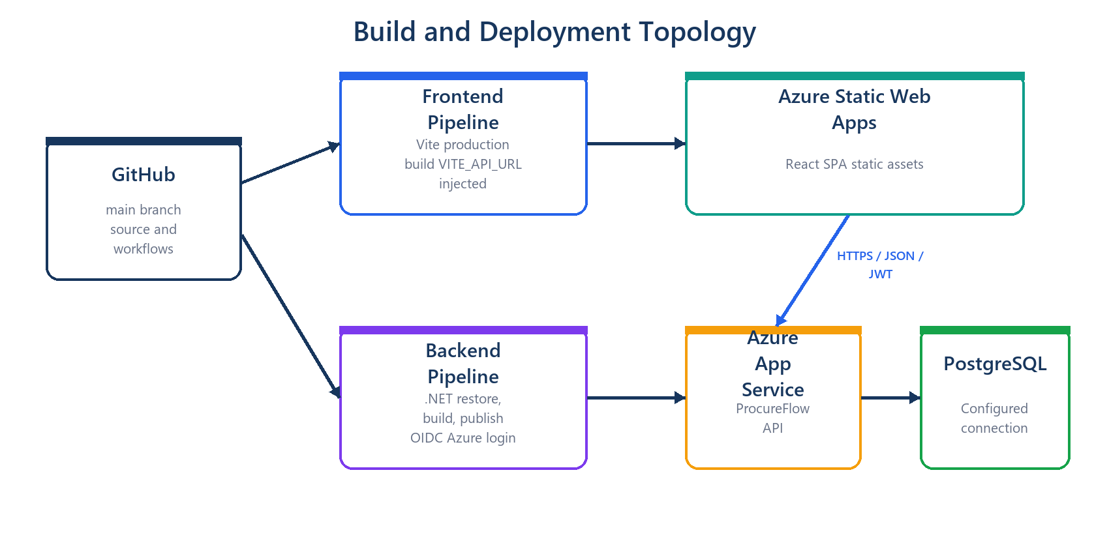
Figure 6 — CI/CD and Azure deployment topology

10.1 Frontend pipeline
- Triggered by pushes and pull requests targeting main.
- Azure Static Web Apps builds frontend/ and publishes dist/.
- VITE_API_URL is injected from a GitHub repository variable with the deployed API URL as workflow fallback.
- Changing the API URL requires a new frontend build because Vite environment values are compiled into the bundle.

10.2 Backend pipeline
- Triggered on pushes to main or manual workflow dispatch.
- Restores, builds, and publishes the API with .NET 8 in Release configuration.
- Uploads the publish artifact and deploys it to Azure App Service procureflow-api using OIDC credentials.
- Runtime App Settings must supply the production connection string, JWT settings, and allowed frontend origin.
Setting | Development | Production source
VITE_API_URL | http://localhost:5080/api | GitHub variable at frontend build
ConnectionStrings__DefaultConnection | Local PostgreSQL | Azure App Service setting/secret store
Jwt__Key/Issuer/Audience | appsettings/user-secrets | Azure App Service settings
AllowedOrigins__0 | http://localhost:5173 | Static Web App origin

11. Local Setup and Verification
Prerequisites: .NET 8 SDK, Node.js 20 or supported LTS, npm, and Docker Desktop/PostgreSQL 16.
docker compose up -d postgres
dotnet run --project backend/src/ProcureFlow.API/ProcureFlow.API.csproj
cd frontend && npm install && npm run dev
dotnet test backend/ProcureFlow.sln
cd frontend && npm run build
Demo users: requester@procureflow.demo, approver@procureflow.demo, and admin@procureflow.demo use Demo@123 for local assessment demonstrations only.

12. Testing Strategy
- Eight unit tests cover submission, invalid edit/approval, approval, PO creation, duplicate PO rejection, delivery/completion, and premature completion.
- One integration-project smoke test currently verifies project wiring; it is not yet an HTTP/PostgreSQL integration suite.
- Frontend production compilation is used as a type and bundle verification gate; automated component/E2E tests are not configured.
- Recommended next layer: Testcontainers PostgreSQL API integration tests and Playwright critical-path tests.

13. Key Technical Decisions
Decision | Why | Trade-off
Layered architecture | Clear separation and interview-friendly maintainability | More interfaces/files than a small CRUD app
RTK Query | Caching, loading state, tag invalidation, centralized API | Adds Redux concepts
Explicit action endpoints | Workflow intent and authorization are clear | More endpoints than generic status update
Atomic conditional updates | Safe concurrent transitions | Audit fields must be set explicitly
Status history table | Traceability and accurate activity time | Additional writes/storage
PostgreSQL constraints | Protect invariants even if application logic fails | Schema changes require migrations
CSS dashboard charts | No new dependency for simple visuals | Not suitable for advanced analytics
Independent deployments | Frontend/API scale and release separately | Requires CORS and build-time API configuration

14. Known Limitations and Production Roadmap
Current limitation | Recommended improvement
Count-based PR/PO numbers can race | Use database sequences or a dedicated numbering service
JWT stored in localStorage; no refresh/revocation | Evaluate secure HTTP-only cookies or refresh-token rotation
Dashboard trend reads latest 100 list records | Add server-side aggregate/trend endpoint
Recent activity is latest PR state, not a full event feed | Add paged activity projection/outbox
No partial delivery or line items | Introduce PR/PO lines and delivery receipts
Master data is seed-only | Add governed CRUD, validation, and audit UI
Swagger enabled in all environments | Restrict or secure outside Development
No frontend automated tests | Add Vitest/RTL and Playwright
Integration test is only smoke-level | Use WebApplicationFactory + Testcontainers
AutoMapper advisory and EF version mismatch warnings | Upgrade AutoMapper and align EF packages
Startup migrations can contend | Run migrations once in CI/CD before app rollout
Bundle exceeds Vite chunk advisory | Lazy-load routes and define manual chunks
No structured tracing/outbox | Add OpenTelemetry, correlation IDs, metrics, and reliable events

15. Appendix: Status and Currency Values
PR value | Meaning | PO/Delivery value | Meaning
1 | Draft | 1 | Created / Pending
2 | Submitted | 2 | Delivered
3 | Approved | 3 | Completed
4 | Rejected | — | —
5 | PO Created | — | —
6 | Delivered | — | —
7 | Completed | — | —

Currency value | Code
1 | INR
2 | USD
3 | EUR
4 | GBP

