Introduction to RAG
Welcome to your AI learning journey! If you want to build a career in Artificial Intelligence, you are in the right place. Today, we will learn about a very important AI technique called RAG. By the end of this lesson, you will understand what RAG is, why it matters, and how it works.

1. What is RAG?
RAG stands for Retrieval-Augmented Generation.
That is a big phrase. Let us break it down into simple parts:
- Retrieval: Finding the right documents or information from a knowledge base. A knowledge base is a collected set of information, like a digital library or a folder of notes.
- Augmented: Adding or combining that found information to help the AI.
- Generation: Making a clear, helpful answer for the user.
Before we continue, let us talk about what an LLM is. LLM stands for Large Language Model. It is a type of AI trained on a massive amount of text to understand and generate human language.
Think of RAG like a student taking an open-book exam.
Imagine you are writing an exam. If the teacher asks a hard question, you do not just guess from memory. You open your textbook, find the correct page, read the facts, and then write your answer.
RAG lets an AI do the exact same thing. Instead of guessing blindly, the AI looks at a trusted source first. Then, it writes an answer based on that source.

2. Why does RAG matter?
To understand why RAG is useful, we must look at how standard AI models work. An AI model learns from a huge amount of data during its training. But an AI working only from its existing knowledge has two big limits:
- Outdated information: It can become old. The AI does not know about news or updates that happened after its training ended.
- No private information: A public AI does not know your company's secret product manual or your personal notes.
Because of these limits, AI models can sometimes suffer from a hallucination. A hallucination is when an AI gives an answer that sounds confident but contains incorrect or completely made-up information. Think of an AI without RAG like a smart person who refuses to check the calendar or a map. They might talk very smoothly, but they can still give you the wrong date or get lost.
RAG matters because retrieving relevant, external information gives the AI the exact facts it needs. This helps the AI give more accurate answers using up-to-date and specific facts, though it does not completely prevent all hallucinations.

3. How does RAG work?
A RAG system works in a simple step-by-step flow:
- Step 1: The user asks a question.
- Step 2: The system searches the external knowledge base to find the most useful and relevant pieces of information.
- Step 3: The system takes your question and the retrieved text, and puts them together as context.
- Step 4: The LLM reads this combined context and generates a helpful, human-like response for you.
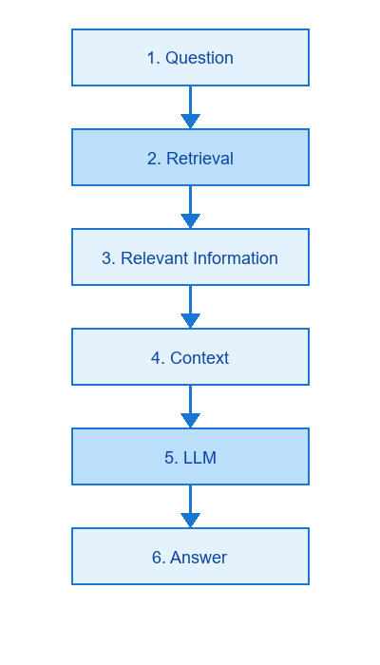

4. A Simple Example
Let us look at a simple fictional example.
Imagine a fictional college that has a thick student rulebook. A student asks the college's AI chatbot: "What is the rule for a fee refund if I drop a class?"
Without RAG:
The chatbot does not have the rulebook. It uses its general training data. It might guess and say, "You get a full refund within 30 days," which could be completely wrong for this specific college.
With RAG:
The system first searches the digital student rulebook for the words "fee refund" and "drop a class." It retrieves the exact rule: "Students receive a 50% refund if they drop a class within the first two weeks." The AI is given this rule as context. The AI then answers the student correctly: "According to the rulebook, you will get a 50% refund if you drop the class within the first two weeks."
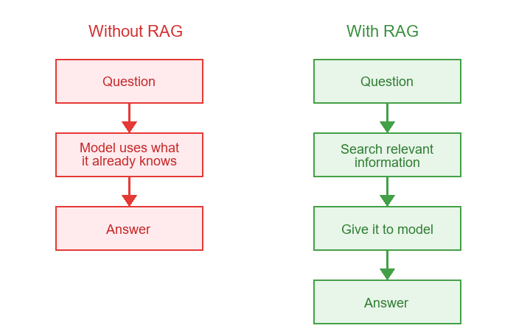

5. Important Terms
- RAG: Retrieval-Augmented Generation. Connecting an AI to external documents before it answers.
- LLM: Large Language Model. A type of AI trained to understand and generate text.
- Knowledge base: A collected set of information, like a digital library or document folder.
- Retrieval: Searching the knowledge base for relevant information.
- Embedding: A piece of text converted into a list of numbers so the computer can search it quickly.
- Vector: That exact list of numbers representing the text.
- Vector database: A special type of storage designed to quickly compare vectors and find matching meanings.
- Context window: The amount of information an AI model can read and consider at one time when generating an answer.
- Hallucination: When an AI gives an answer that sounds confident but is actually incorrect or made-up.

6. Important Limitations
RAG is a powerful tool, but it is not magic. You should remember these important points:
- Retrieval quality matters: If the retrieved documents contain mistakes or are poorly written, the AI might still give a poor answer.
- Information can be incomplete: Sometimes the search might miss the right document, meaning the AI will not have the facts it needs.
- Does not completely stop hallucinations: While RAG reduces the chance of made-up answers, it does not guarantee a perfect answer every time. The AI can still misunderstand the retrieved text.

7. Quick Summary
- What: RAG (Retrieval-Augmented Generation) is a technique that lets an AI look up facts from a knowledge base before answering a question.
- Why: It matters because it helps the AI provide accurate, up-to-date answers based on private or recent information, reducing hallucinations.
- How: A user asks a question, the system retrieves relevant documents, adds them as context, and the LLM generates a grounded answer.

