!! SOLARICA SYSTEMS PRIVATE LIMITED!!

PROPOSAL FOR SOLAR ROOFTOP
POWER GENERATING SYSTEM
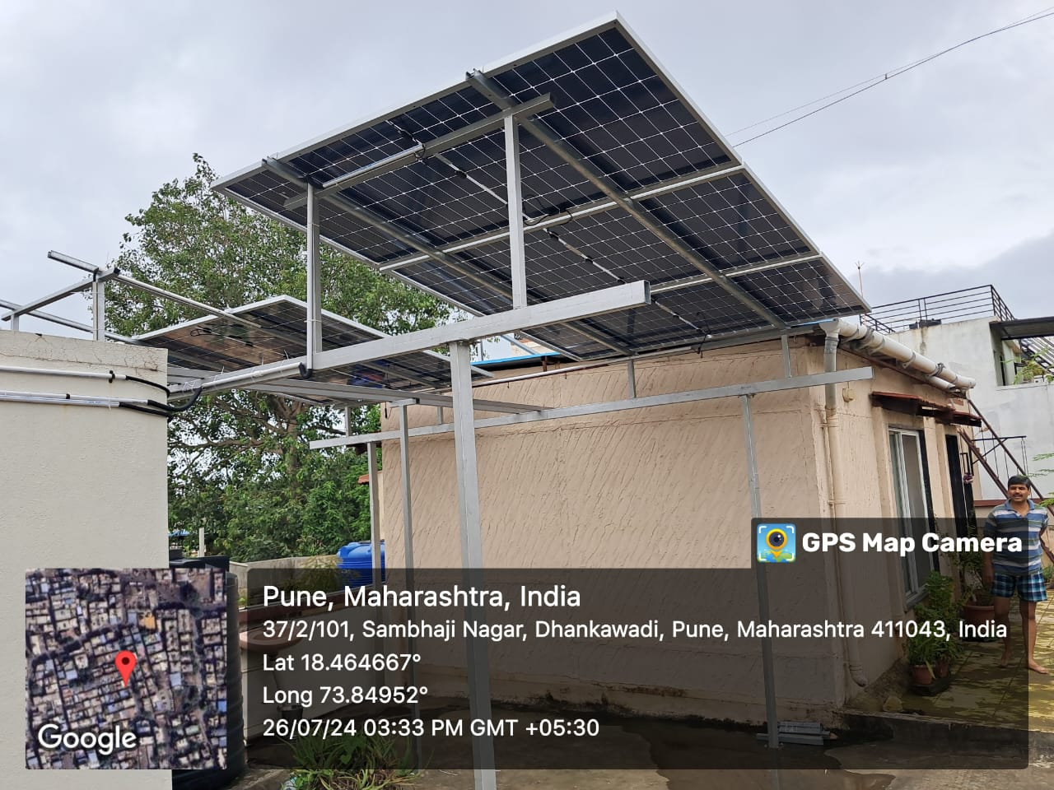
SOLARICA

FROM :  SOLARICA SYSTEMS PRIVATE LIMITED  Corporate Office :AudumbarNivya Complex, Office No 203, Narhe, Shree Control Chowk, Near Canara Bank, Pune-411041.  Factory Adress :  Shop No 2 PariChowk, Narhe, Sinhagad Road, Pune -411041.  Contact Numbers : 9272177947/ 9325389168  Email : Eresh@solarica.in / Kiran@solarica.in | TO:  Name : {{client_name}}  Email : {{client_email}}  Consumer No : {{consumer_number}}  Billing No. : {{billing_number}}  Customer No. : {{customer_number}}  GST No. : {{gst_number}}

{{system_capacity}}KW -3ph
SOLAR POWER
GENERATING SYSTEM PROPOSAL

INDEX OF PROPOSAL
ABOUT US | Page No 4
TECHNICAL DISCRIPTION | Page No 5
SCOPE OF WORK | Page No 6
CUSTOMER SCOPE | Page No 6
FINANCIAL ANALYSYS | Page No 7
BILL OF MATERIAL | Page No 8 and 9
TERMS AND CONDITIONS | Page No 10
COMPANY BANK DETAILS AND CONTACT DETAILS | Page No 11

About Solarica AND gROUP cOMPANY
SOLARICAis One of Growingand Fast-MovingGROUP and a major SolarManufacturer and Solar equipment Supplier and Service Provider
Our company (SOLARICA SYSTEMS PRIVATE LIMITED)provides Solar Power Projects, Residential Rooftop Projects, Home Lighting Solutions and Commissioning and Related services to corporate entities, individuals and SME businesses sectors.
Established as a Private Limited Company firm in the year 2024 with having Experience of our group company Solarica Energy India Pvt Ltd and become one of the fast growing start up under Solar Industry.
Since its incorporation, we have supplied, installed, and serviced many variable solar Projects under PM SuryagharYojna and Non Govt Schemes. We had also provided guidance for solar power projects and continuing the same
Our Promotor and Chief Financial Director Mr. KiranJagtap is is our guiding light to the future who is having experience of more than 7 years in solar industry. Our Chief Executive Director, Mr. EreshInde is having more than 3 years of Experience in Solar , Interior and Service industry.
OUR PRODUCT AND SERVICES
- Solar Rooftop Systems – Residential and Commercial
- Solar Lights Manufacturing and Service
- Manufacturer and Supplier of Solar Panels and Inverters
- Supplier of Solar Garden Lights
- Solar Decorative Poles and Street Light Poles
- Solar Water Pumps and Solar Water Systems
- Any Manufacturer of Many CustomisedSolar products.
GROUP COMPANIES-SOLARICA

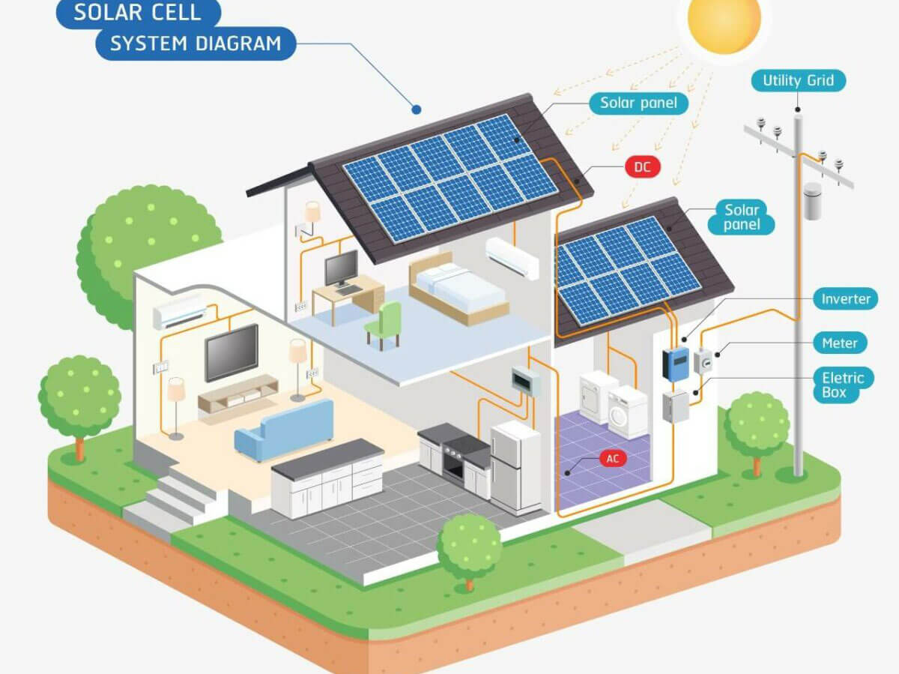
SOLAR ROOFTOP SYSTEM DIAGRAM

SOLAR ROOFTOP POWER GENERATION SYSTEM

OUR Scope Of Work
Scope of Work in this offer includes the following
- Design & Engineering
- System design
- Engineering drawings if required
- Detailed Bill of Materials & Report
- Electrical and Solar Works
- Procurement of Best Material
- Wiring of Modules
- Cabling from Modules to Inverter
- Cabling from Inverter to AC Distribution box
- Cabling from AC Distribution Box
- Earthling
- Full scope up to Net Metering
- Lesioning up to Meter Installation
- Installation Work

Customer Scope:
- Customer to provide space for storing of materials.
- Making the site ready and clearing the terrace / roof of any unwanted items is not included in scope of work.
- Safety of material supplied would be in customer scope after delivery at site
- Customer to provide LAN (Ethernet facility) for Inverter monitoring.
- Cleaning of Modules is not in our scope. Customer is requested to clean panels twice a week.
- Net-metering charges would be in the scope of ours.We will extend support in applying for a net-meter with relevant DISCOM by fulfilling all technical documentation up to Completion.
- Fees and Charges related to any sort of statutory approvals & clearance from local authorities, DISCOM will be borne by us related to solar only. (Load extension is not included in scope)
- Water & Electricity required for construction of solar power plant shall be in Customer’s scope.

Financial OFFER:

Sr. No | ItemDescription | Total System Cost
1 | Supply of Solar Material-Solar Panels, Inverters Etc. | {{system_cost}}/-
2 | Supply of Array junction Boxes, ACDB, DCDB withMOV/SPD,etc.
4 | Supply of lightningarrester &GI-earthingsystem, Net Meter, Generation Meter, Mc4 Connector etc.
5 | Packing, unpacking, loading & unloading,warrantyservices, Installation,Lesioning, etc.
6 | GST | {{gst_amount}}/-
7 | TOTAL COST OF THE SYSTEM | {{total_system_cost}}/-
8 | CFA -Subsidy to customer  1Kw -Rs 30,000/-  2 KW -Rs 60,000/-  3 Kw and Above – Rs 78,000/- | {{subsidyAmount}}/-
9 | Net cost of Investment to the Customer | {{net_investment_cost}}/-
Solar Unit Generation: Per Kw per day Minimum 3-4 Units and Maximum 6 Units

BILL OF MATERIAL
Sr.  No. | Item Name | Specification | Make | Qty.
1 | Solar PvModules | {{specification_1}} | {{make_1}} | 6 NOS
2 | SolarInverter | High Efficiency > 21% | {{make_2}} | 1 each
3 | Solar Structure | 10 Years Product Warranty | Solarica | 1 set
4 | ACDB | Ip65 Enclosure with McbProtection,Spd'sandMisc.Items 3 phase.  2 Years Warranty. | Solarica | 1 Each
5 | DCDB | Ip65 Enclosure with Dc  Fuses, DcSpd'sAnd  Misc.Items3 phase  2 Years Warranty | Solarica | 1 Each
6 | Solar Net Meter | AsPerSpecificationsOfMseb. | Adani | 1Nos.
 | Solar Generation Meter | AsPerSpecificationsOfMseb. | Hpl/ L&T | 1 Nos
7 | Earthing Plats and Cable | {{specification_7}} | Polycab/Waree | APR
8 | AcCable | {{specification_8}} | Polycab | APR
9 | DC cable | {{specification_9}} | Polycab/Waree/Apar | APR
10 | Lighting Arrestor | Solid LA with Base | TUV Protected  ISI Approved | 1nos
11 | Misc. Material | Mc4 Connectors, Plugs, Accessories. | TUV Protected | APR
12 | Installation | APR | Solarica | APR
13 | Transportation | Includes | Solarica | APR
14 | Lesioning | Includes | SOLARICA | -

TERMS & CONDITIONS :
Prices | Prices are inclusive of all including two time transport of material at site.
Payment Terms : | - 20%advancewith Purchase/ Workorderconfirmation.  - 70% immediate after Completion of Solar Structure at Site.  - 10%beforecommissioning and Completion oftherooftopsolarsystem (at the time of Net metering (After Receiving –Release Order from department and Net metering Agreement).
Validity | This offer is valid for {{validity_days}} days from the date of this offer.
Timeline of Project | Total Timeline for Project Completion will be 21-29 Working Days from Acceptance and Receipt of Advance on time.  - 2 days for process of documentation and taking Sanction for solar from MSEDCL. (consumer support required)  - 10-12 working Days for Solar System Material Procurement and System installation.  - 10-15 Working Days for MSEDCL and National Portal Work and Lesioning up to completion of project up to installation of Solar Meter.  - SubsidyDisbursementwithin 30 Days from Meter installation Date.
Documents Required for System | - Adhar Card Self attested copy  - PAN Card Self attested copy  - latest Electricity Bill with Payment Receipt  - Tax Receipt/ Index 2 of Residence/ Address  - Mobile Number Registered with MSEB  - Email ID registered with MSEB  - Cancelled cheque of consumer
Company Bank Details | Name:SOLARICA SYSTEMS PVT LTD  Account No- 1357102000018294  Bank: IDBI Bank  Branch: Narhe Pune 411041  IFSC - IBKL0001357  Communication Mail for Payments: accounts@solarica.in/ 7397859167

CORPORATE OFFICE ADDRESS:
AudumbarNivya Complex, Office No 203,
Narhe, Shree Control Chowk, Narhe Dhayari Road,
Pune -411041, Maharashtra India.

CONTACT DETAILS:
E MAIL :Business@solarica.in/ Kiran@solarica.in/ Eresh@solarica.in.
Contact :
- Mr EreshInde : 9272177947
- Mr Kiran Jagtap : 9325389168

SOLARICA SYSTEMS PRIVATE LIMITED
Where Solar Meets with Savings

Thank You

