Home automation using an Arduino Uno with a Bluetooth module HC-05 is a popular and effective way to control various devices remotely. Here's a brief overview of how to set up such a system, including controlling devices like an RC fan, buzzer, water pump, and LED using relays.

### **Components Required:**

1. **Arduino Uno**: The microcontroller board that controls the automation system.
2. **HC-05 Bluetooth Module**: Provides Bluetooth communication between your Arduino and a smartphone or computer.
3. **Relay Module**: Used to control high-voltage devices like fans, pumps, and other appliances. Each relay can switch on or off an external device.
4. **RC Fan**: A fan typically used in radio-controlled vehicles; it can be controlled through relays.
5. **Buzzer**: An audio signaling device that can be turned on or off.
6. **Water Pump**: A device for pumping water, controlled by a relay.
7. **LED**: A simple light-emitting diode that can be turned on or off.
8. **Jumper Wires**: To connect the components.

### **Wiring:**

1. **HC-05 Bluetooth Module**:
   * **TXD (Transmit)**: Connect to Arduino's RX (Pin 0).
   * **RXD (Receive)**: Connect to Arduino's TX (Pin 1).
   * **VCC**: Connect to Arduino's 5V.
   * **GND**: Connect to Arduino's GND.
2. **Relay Module**:
   * **IN1, IN2, IN3, IN4**: Connect to Arduino's digital pins (e.g., Pins 2, 3, 4, and 5).
   * **VCC**: Connect to Arduino's 5V.
   * **GND**: Connect to Arduino's GND.
   * **COM (Common)**: Connect to the power source of the device.
   * **NO (Normally Open)**: Connect to the device you want to control.
3. **Devices**:
   * **RC Fan**: Connect to one of the relay's NO and COM terminals.
   * **Buzzer**: Connect to another relay's NO and COM terminals.
   * **Water Pump**: Connect to a third relay's NO and COM terminals.
   * **LED**: Connect to the remaining relay's NO and COM terminals.

### **Controlling Devices with a Bluetooth App:**

1. **Arduino Bluetooth Apps**:
   * **Bluetooth Terminal Apps**: Apps like "Bluetooth Terminal" or "Serial Bluetooth Terminal" can be used to send commands from a smartphone to the HC-05 module. Commands like 1, 2, 3, etc., are sent to control different devices.
   * **Custom Bluetooth Apps**: You can use apps like "Bluetooth Electronics" or "Arduino Bluetooth Controller" to create a custom interface with buttons to control each device.
2. **Control Methods**:
   * **Keyboard Input**: Enter commands directly into the terminal app or a custom app to control devices.
   * **Buttons**: Use a custom app with buttons mapped to specific commands (1 for RC Fan ON, 2 for RC Fan OFF, etc.).
   * **Voice Commands**: If using an advanced app or integration with voice assistants, configure voice commands to send appropriate Bluetooth commands to the HC-05 module.

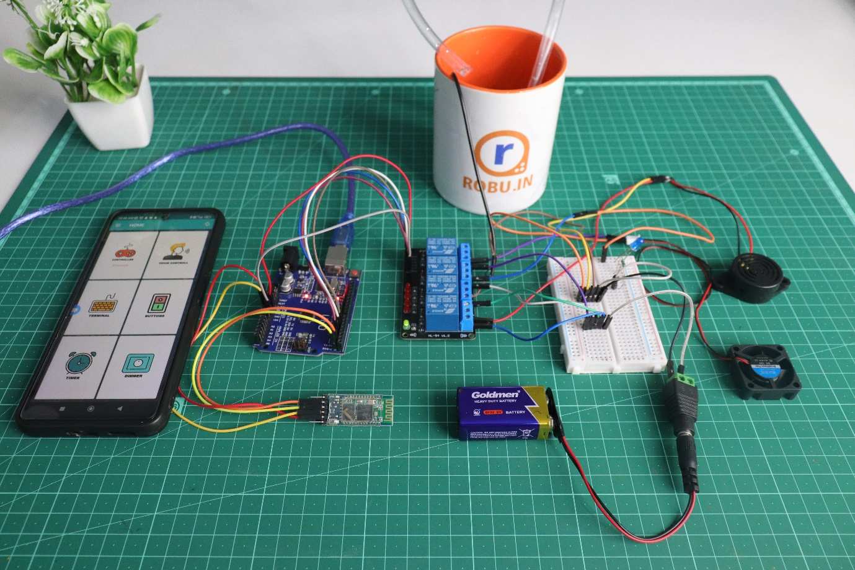

**Component:-**

|  |  |  |
| --- | --- | --- |
| **Component** | **Specification** | **Quantity** |
| Arduino UNO | Microcontroller Board | 1 |
| Relay Module | 4 relays, 5V control | 1 |
| HC-05 Bluetooth Module | Bluetooth Serial Communication Module | 1 |
| DC Power Jack Adapter Connector | For connecting to 9V battery | 1 |
| Battery | Standard 9V battery | 1 |
| Mini Breadboard | Small prototype board | 1 |
| DC 3-6V Mini Micro Submersible Water Pump | 3-6V Submersible Pump | 1 |
| Cooling Fan | 12V Cooling Fan, 30mm x 10mm | 2 |
| LED | 5mm Blue LED | 1 |
| Male to Female Jumper Wires | 20cm long, male to female | 20(PCS) 1 PACK |
| Male to Male Jumper Wires | 20cm long, male to male | 9(PCS) 1PACK |
| DC Power Jack Adapter | For connecting to external power supply | 1 |

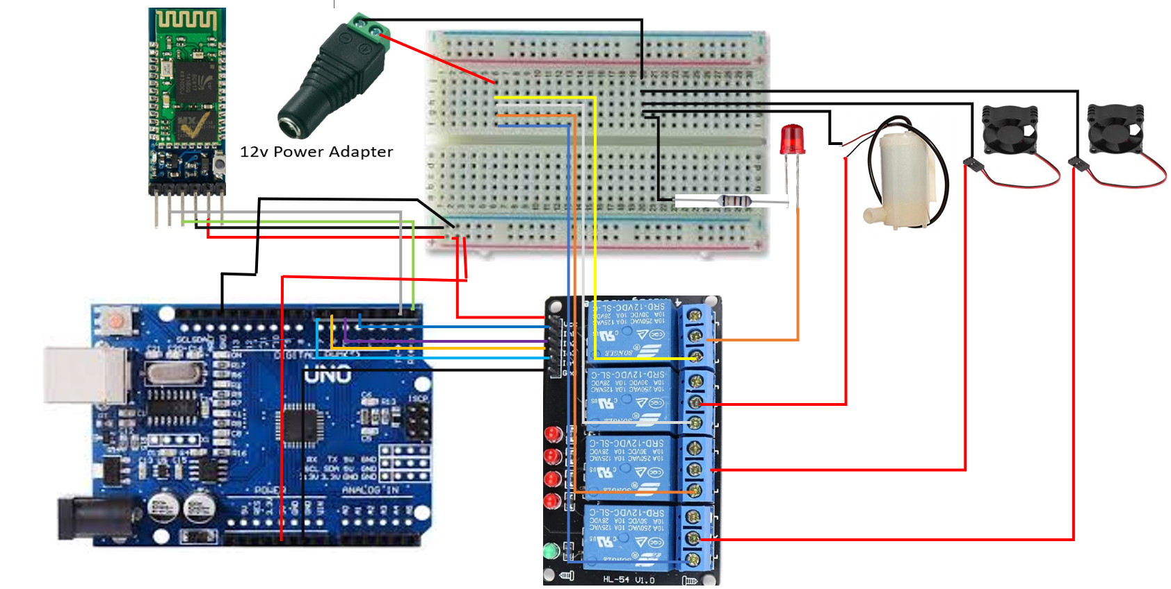**Circuit Diagram :-**

**HC 05 Bluetooth Module to Arduino UNO**

|  |  |
| --- | --- |
| **HC 05 Bluetooth Module** | **Arduino UNO** |
| VCC | 5v |
| GND | GND |
| TX | RX(0) |
| RX | TX(1) |

**5v 4 Chanel Relay Module to Arduino UNO**

|  |  |
| --- | --- |
| **Relay Module** | **Arduino UNO** |
| VCC | 5V |
| GND | GND |
| IN1 | D4 |
| IN2 | D5 |
| IN3 | D6 |
| IN4 | D7 |

Code:-

#include <Arduino.h>

#include <Wire.h>

#include <SoftwareSerial.h>

int Livingroom = 4;

int kitchen = 7;

int Diningroom = 6;

int Garden = 5;

SoftwareSerial Bluetooth(0, 1);

char Data;

void sendData(String transmitData){

Bluetooth.println(transmitData);}

void setup(){

    Bluetooth.begin(9600);

    pinMode(Livingroom,OUTPUT);

    pinMode(kitchen,OUTPUT);

    pinMode(Diningroom,OUTPUT);

    pinMode(Garden,OUTPUT);

}

void loop(){

    if(Bluetooth.available()){

        Data=Bluetooth.read();

        if(Data==('5')){

            digitalWrite(Livingroom,1);

            sendData(" Living Room Buzzer OFF");

        }

        if(Data==('1')){

            digitalWrite(Livingroom,0);

            sendData("Living Room Buzzer ON");

        }

        if(Data==('6')){

            digitalWrite(kitchen,1);

            sendData("kitchen Fan OFF");

        }

        if(Data==('2')){

            digitalWrite(kitchen,0);

            sendData("Kitchen Fan ON");

        }

        if(Data==('7')){

            digitalWrite(Diningroom,1);

            sendData("Dining Room Light OFF");

        }

        if(Data==('3')){

            digitalWrite(Diningroom,0);

            sendData("Dining Room Light ON");

        }

        if(Data==('8')){

            digitalWrite(Garden,1);

            sendData("Water Pump OFF");

            }

        if(Data==('4')){

            digitalWrite(Garden,0);

            sendData("Water Pump  ON");

            }

        if(Data==('9')){

            digitalWrite(Livingroom,1);

            digitalWrite(kitchen,1);

            digitalWrite(Diningroom,1);

            digitalWrite(Garden,1);

            sendData("ALL DEVICE'S OFF");

        }

        if(Data==('0')){

            digitalWrite(Livingroom,0);

            digitalWrite(kitchen,0);

            digitalWrite(Diningroom,0);

            digitalWrite(Garden,0);

            sendData("ALL DEVICE'S ON");

        }

    }

}

### **Key Points:**

* **Safety**: Ensure that the relays are rated for the voltage and current of the devices you're controlling to avoid any electrical hazards.
* **Bluetooth Communication**: The HC-05 module allows easy wireless control via a smartphone or computer, making the automation system user-friendly.
* **Expandability**: This basic setup can be expanded with additional devices and more complex control schemes as needed.

This setup provides a robust and flexible home automation solution using Arduino and Bluetooth.