BHARATI VIDYAPEETH (DEEMED TO BE UNIVERSITY)
COLLEGE OF ENGINEERING, PUNE – 411043
A MINI PROJECT REPORT ON
LOAN APPROVAL PREDICTION

Submitted by
Name of Student | PRN | Roll No.
Vaibhaw Chaubey | 2414110193 | 11

For the course Data Warehousing and Mining
Submitted To Course Coordinator
Dr. Rohini Khalkar
B. Tech Computer Engineering (Sem V)
Academic Year 2026-27


DEPARTMENT OF COMPUTER ENGINEERING
Bharati Vidyapeeth (Deemed to Be University)
College of Engineering, Pune 411043

CERTIFICATE
This is to certify that the mini project report entitled “Loan Approval Prediction and Credit Analytics System” is a bonafide record of authentic work carried out by Vaibhaw Chaubey (Roll No. 11) in partial fulfilment of the requirements for the award of the degree of Bachelor of Technology in Computer Engineering of Bharati Vidyapeeth (Deemed to be University) College of Engineering, Pune during the academic year 2026–27.
The project demonstrates an end to end, zero backend Data Warehousing and Mining application implemented purely using HTML5, CSS3, and vanilla JavaScript. To the best of our knowledge, the work presented herein has not been submitted previously to any other university or examining body for the award of any degree or diploma.

ACKNOWLEDGEMENT

We express our profound gratitude and high regard to Dr. Rajesh Prasad, Principal, Bharati Vidyapeeth (Deemed to be University) College of Engineering, Pune, for granting access to the computational resources and providing an inspiring academic atmosphere conducive to progressive research and engineering innovation.
We convey our heartfelt gratitude to Dr. Sandeep Vanjale, Head of the Department of Computer Engineering, for his steadfast support, academic facilitation, and encouragement throughout the curriculum of Data Warehousing and Mining.
We owe our deepest debt of gratitude to our course coordinator and project supervisor, Dr. Rohini Khalkar, whose scholarly insight, technical critiques, and meticulous reviews steered the conceptualization and implementation of this loan credit analytics platform. Her guidance in algorithmic data mining and mathematical modeling was instrumental in bringing this work to fruition.
We are especially proud to emphasize the unique architectural milestone achieved in this project: the complete implementation of predictive machine learning (KNN, CART Decision Tree, Logistic Regression, Random Forest, Naive Bayes), association rule mining (Apriori), Ordinary Least Squares regression, and interactive data visualization executed strictly within client-side web technologies (HTML5, modern CSS3, and vanilla JavaScript) without any reliance on backend computational servers, Python backends, or cloud inference engines.
Finally, we extend our heartfelt appreciation to our parents, fellow classmates, and technical staff for their continuous encouragement and moral support during the development and compilation of this project.
Vaibhaw Chaubey (PRN: 2414110193)
Department of Computer Engineering, BV(DU) COE Pune

ABSTRACT

Credit risk assessment and automated loan underwriting constitute foundational operations within modern retail banking and financial institutions. Conventional automated underwriting pipelines typically depend upon distributed enterprise backends, cloud-hosted machine learning servers, and heavyweight runtime libraries. While functionally capable, such architectures introduce substantial latency overheads, recurring cloud server operating expenses, complex deployment dependencies, and critical customer data privacy liabilities resulting from transmitting sensitive financial parameters over public network boundaries.
This project presents an innovative, production-grade, 100% Client Side Loan Approval Prediction and Credit Analytics Platform built exclusively utilizing modern HTML5, CSS3, and pure Vanilla JavaScript (ES6+), functioning entirely without backends, external server runtimes, Python environments, or third party analytical APIs. The application executes full-cycle Data Warehousing and Mining (DWM) operations directly inside the user's web browser, ensuring zero data leakage and instantaneous sub-millisecond offline inference.
The platform integrates an end-to-end analytical workflow: client-side streaming CSV ingestion of 10,000 banking records across 12 demographic and asset features, in-memory data normalization, automated label encoding, stratified 80:20 train-test splitting (8,000 training, 2,000 testing samples), and concurrent execution of five from-scratch classification models: K-Nearest Neighbors (KNN), Logistic Regression, CART Decision Tree (Gini Impurity), Random Forest ensemble, and Gaussian Naive Bayes. Real-time test-set evaluation demonstrates that the native KNN classifier achieves 83.3% Accuracy, 77.6% Precision, 73.9% Recall, and an F1-Score of 75.7% (with 520 True Positives, 1,146 True Negatives, 150 False Positives, and 184 False Negatives).
In addition to supervised classification, the system incorporates an in-browser Apriori Association Rule Mining algorithm, extracting actionable high-confidence demographic patterns linking dependent counts and education levels with loan rejections (discovering 4 strong multi-item rules at 40% support and 50% confidence). Furthermore, an Ordinary Least Squares (OLS) Linear Regression module establishes an underwriting rule (LoanAmount = 4 × ApplicantIncome, r = 1.000) accompanied by an interactive SVG/Canvas live credit line estimator. The complete application is delivered through an adaptive dual-portal interface featuring an Applicant Self-Assessment Portal and an Administrative Analytics Suite.
Keywords: Data Warehousing and Mining, Loan Approval Prediction, Client-Side Machine Learning, Zero-Backend Architecture, K-Nearest Neighbors, Apriori Association Mining, Ordinary Least Squares Regression, HTML5 Canvas & SVG Visualizations, Credit Risk Analytics, Vanilla JavaScript.

TABLE OF CONTENTS

Front Matter: Certificate, Acknowledgement, Abstract | 2 - 4
CHAPTER 1: INTRODUCTION & ZERO-BACKEND MOTIVATION | 6
CHAPTER 2: LITERATURE SURVEY & ALGORITHMIC FOUNDATIONS | 7
CHAPTER 3: SYSTEM ARCHITECTURE & REQUIREMENTS | 8
CHAPTER 4: DATA PROFILING & PREPROCESSING METHODOLOGY | 9
CHAPTER 5: CLIENT-SIDE ALGORITHMIC IMPLEMENTATION & UI | 10
CHAPTER 6: EXPERIMENTAL RESULTS & PERFORMANCE EVALUATION | 11
CHAPTER 7: ASSOCIATION MINING & DEMOGRAPHIC RISK RULES | 12
CHAPTER 8: SYSTEM DEMONSTRATION & SCREENSHOTS (PART 1) | 13
CHAPTER 8: SYSTEM DEMONSTRATION & SCREENSHOTS (PART 2) | 14
CHAPTER 9: CONCLUSION, APRIORI MINING, FUTURE SCOPE & REFS | 15

CHAPTER 1: INTRODUCTION
1.1 Project Overview & Financial Context
Retail credit evaluation is a cornerstone of banking stability and financial inclusion. Every commercial bank, microfinance institution, and fintech lender evaluates thousands of personal, business, and asset-backed loan applications daily. Loan approval decisions require balancing credit risk against interest revenue, examining multidimensional borrower attributes such as credit history (CIBIL score), annual income, commercial/residential assets, loan tenure, and dependent count. Historically, manual underwriting was slow, resource-heavy, and susceptible to cognitive bias. Automated credit decision systems have therefore become standard across global banking.
1.2 Problem Statement & Zero-Backend Motivation
While traditional automated underwriting systems leverage server-side machine learning platforms (utilizing Python, Scikit-Learn, Flask, or cloud endpoints like AWS SageMaker), these conventional architectures introduce three grave operational disadvantages:
- Critical Data Privacy Vulnerabilities: Applicants must transmit highly sensitive personal financial documents, CIBIL credit scores, income metrics, and asset valuations over public internet infrastructure to centralized servers, increasing exposure to man-in-the-middle interception, database breaches, and regulatory non-compliance under data protection mandates.
- Prohibitive Hosting & Infrastructure Costs: Cloud-based model training and inference servers require continuous compute provisioning, auto-scaling clusters, database storage, and API gateway bandwidth, creating unnecessary overhead for educational deployments, local branches, or offline micro-lenders.
- Server Downtime & Network Latency Dependency: Remote server architectures fail completely in poor connectivity environments and impose multi-second network round-trip delays, preventing instant feedback during applicant consultation.
1.3 Objectives & Key Deliverables
The primary technical and educational objectives accomplished in this mini project encompass:
- Engineering a pure client-side web application using standard HTML5, modern CSS3, and Vanilla JavaScript capable of autonomous offline operation.
- Developing a robust in-browser CSV parser supporting 10,000+ records, auto-detecting column types and target classes without backend help.
- Implementing from first principles five machine learning classification algorithms: K-Nearest Neighbors (KNN), Logistic Regression, CART Decision Tree, Random Forest, and Gaussian Naive Bayes.
- Implementing the Apriori Association Rule Mining algorithm from scratch to uncover demographic and credit risk correlations.
- Implementing an Ordinary Least Squares (OLS) Linear Regression model to dynamically calculate eligible credit lines based on applicant income.
2: LITERATURE SURVEY & ALGORITHMIC FOUNDATIONS
2.1 Review of Credit Scoring Techniques
Credit scoring literature has evolved through several distinct phases. Initial statistical models relied on Altman's Z-score and Linear Discriminant Analysis (LDA), which performed well on normally distributed financial ratios but degraded when applied to non-linear consumer patterns. During the 1990s, Logistic Regression became the regulatory gold standard due to its probabilistic transparency. With the advent of data mining, non-parametric algorithms like K-Nearest Neighbors (KNN) and Decision Trees (CART) demonstrated superior empirical performance in modeling complex demographic interactions, such as the synergistic relationship between CIBIL score and asset backing.
2.2 Theoretical Foundations of the Implemented Algorithms
- K-Nearest Neighbors (KNN): Classifies a new applicant by measuring the distance from existing training records and using the majority class among the k closest records.
- Logistic Regression: Predicts the probability of an applicant belonging to a class using the sigmoid function. The model improves its weights through repeated gradient descent updates.
- CART Decision Tree: Builds a decision tree by repeatedly splitting the data into two groups using Gini impurity, choosing the splits that best separate the classes.
- Apriori Association Rule Mining: Finds common patterns and relationships between applicant attributes using Support, Confidence, and Lift to measure how useful and reliable each rule is.2.3 Architectural Comparison: Server-Side vs. Client-Side Edge ML
Table 2.1: Architectural Comparison: Conventional Cloud ML vs. Implemented Client-Side Platform
Evaluation Metric | Traditional Cloud Architecture | Our Implemented Client-Side Solution
Financial Data Privacy | Vulnerable: Sensitive applicant data transmitted over WAN to external servers | 100% Secure: Data never leaves browser memory; zero network transmission
Infrastructure Cost | High: Continuous cloud server costs, API gateways, database provisioning | Zero: Free static hosting (GitHub Pages, Netlify) or local browser execution
Offline Capability | None: Requires active high-speed internet connection to cloud server | Complete: Functions seamlessly in remote/offline settings without internet
Prediction Latency | 150ms – 1200ms depending on network round-trip time and server load | < 2ms instantaneous in-memory execution via V8 JavaScript engine
Runtime Stack | Complex: Python runtime, Flask/FastAPI, NumPy, Scikit-Learn, Docker | Zero-Dependency: Pure semantic HTML5, responsive CSS3, and vanilla JS

3: SYSTEM ARCHITECTURE & REQUIREMENTS
3.1 Pure Client-Side Architectural Blueprint
The platform is engineered upon a strictly decoupled, layered client-side web architecture. Rather than offloading computation to an application server, the entire machine learning and data mining pipeline operates inside the client browser context. The architecture consists of four distinct operational layers:
- Presentation Layer (HTML5 & Modern CSS3): Provides an accessible, responsive user interface utilizing modern CSS variables, flexbox, grid systems, and custom theme tokens. Incorporates interactive feedback, modal alerts, and tabbed section routing without page reloads.
- Visualization & Rendering Engine (HTML5 Canvas & SVG): Generates high-performance interactive charts (Donut charts, histograms, grouped bar charts, scatter plots with regression trendlines) rendered natively through mathematical 2D canvas drawing and vector mathematics, eliminating heavy chart libraries like Chart.js or D3.
- Core Algorithmic & Mining Layer (Vanilla JavaScript ES6+): Encapsulates pure mathematical implementations of KNN, Logistic Regression, CART Decision Trees, Random Forest, Naive Bayes, OLS Linear Regression, and the Apriori association rule generator.
- Client Data Management Layer (FileReader API & In-Memory Store): Ingests raw CSV streams, conducts schema detection, manages memory buffers, normalizes feature arrays, and handles 80/20 train-test splits directly in RAM.
3.2 Hardware and Software Requirements Specifications
Table 3.1: Hardware & Software Requirements Specification
Component | Development Specification | Deployment / Minimum Requirement
Operating System | Windows 11 / Linux Ubuntu / macOS | Platform-independent (Any modern OS supporting web browser)
Runtime Environment | Web Browser with V8 / JavaScript Engine | Google Chrome 90+, Mozilla Firefox 88+, Microsoft Edge 90+, Safari 14+
Primary Languages | Pure HTML5, CSS3, Vanilla JavaScript (ES6+) | No backend runtime needed (Zero Node.js, Zero Python, Zero Java)
External Libraries | None (100% custom scratch implementations) | Zero NPM packages, Zero CDN scripts, Zero external CSS/JS
Memory & Processor | Intel Core i5 / 8GB RAM | Minimum 2GB RAM, Any dual-core CPU with standard JavaScript execution

4: DATA PROFILING & PREPROCESSING METHODOLOGY
4.1 Dataset Ingestion & In-Memory Preprocessing Pipeline
Data preprocessing is crucial for credit prediction where heterogeneous attributes (categorical education status vs. continuous multi lakh asset values) must be synthesized. The in-memory pipeline follows these structured steps:
- Chunked Streaming CSV Parsing: Utilizes JavaScript RegExp and character iterators to parse multi-megabyte CSV files into structured JSON object arrays, handling escaped commas and quotes seamlessly.
- Intelligent Schema & Target Detection: Scans dataset headers using heuristic alias matching (identifying variations such as 'loan status', 'loanstatus', 'status', 'approved') to automatically isolate the binary target column without manual user configuration.
- Missing Value Handling & Type Coercion: Automatically imputes missing categorical values with the mode and numeric attributes with the column mean, casting string numerals into 64-bit IEEE floating-point numbers.
- Label & One-Hot Encoding: Transforms binary categorical variables ('Graduate' -> 1, 'Not Graduate' -> 0; 'Self-Employed: Yes' 1, 'No' 0) into binary numeric indicators.
- Min-Max Normalization: Scales continuous features (income, loan amount, CIBIL score, assets) into a unified [0, 1] interval to eliminate Euclidean distance distortion in KNN: X norm = (X – X min) / (X max – X min).
- Stratified Train-Test Split: Divides the 10,000 records into an 80% training set (8,000 samples) and a 20% independent testing set (2,000 samples) preserving class distribution.
4.2 Dataset Schema and Statistical Characteristics
Table 4.1: Dataset Schema and Feature Definitions (indian_loan_approval_10000.csv)
Attribute Name | Data Type | Value Domain / Range | Analytical Role
No of dependents | Integer | 0, 1, 2, 3, 4, 5 | Borrower demographic burden indicator
education | Categorical | Graduate, Not Graduate | Socio-economic qualification predictor
Self employed | Categorical | Yes, No | Income volatility and employment stability
Income annum | Continuous | ₹2,00,000 – ₹99,00,000 | Primary debt servicing capability metric
Loan amount | Continuous | ₹30,000 – ₹3,95,00,000 | Requested loan principal value
Cibil score | Integer | 300 – 900 | Past credit repayment reliability rating
Loan status | Binary Class | Approved (1), Rejected (0) | Supervised target ground-truth variable

5: CLIENT-SIDE ALGORITHMIC IMPLEMENTATION & UI
5.1 Mathematical Formulations & JavaScript Algorithms
Every analytical algorithm in this platform was developed from basic mathematical equations directly in JavaScript without relying on machine learning libraries:
- KNN Classifier: Compares a new applicant with 8,000 training records using Euclidean distance and predicts the class based on the k nearest applicants.
- Logistic Regression: Uses the sigmoid function and gradient descent for 100 epochs to predict the applicant's class by learning the best decision boundary.
- CART Decision Tree: Tests different feature splits using Gini impurity and builds the tree recursively up to a maximum depth of 5.
- OLS Linear Regression: Finds the relationship between income and loan amount. The model gives Loan Amount = 4 × Applicant Income, with a perfect correlation of r = 1.000.
- Apriori Association Rules: Finds relationships between applicant attributes such as education, dependents, and loan status using Support, Confidence, and Lift.
5.2 Responsive UI/UX Architecture & HTML5 Canvas Charting
To accommodate diverse banking user roles, the system features a dual-portal design toggleable via a header widget:
- Applicant / User Interface: Designed for loan applicants seeking quick self-assessment with an intuitive form. Submission produces an instant credit decision with approval probability and confidence score.
- Administrator Analytics Suite: Unlocks the complete analytical workspace: CSV dataset ingestion, full data preview, model comparison matrices, OLS linear regression analysis, Apriori association mining, and visualization dashboards.
- Pure HTML5 Canvas & SVG Charting: All graphical dashboards are rendered using native HTML5 Canvas 2D contexts and SVG vector graphics without external chart libraries (Donut approval chart, income/loan histograms, grouped education bars, and scatter plots with regression trendlines).

6: EXPERIMENTAL RESULTS & PERFORMANCE EVALUATION
6.1 Dataset Profiling & Distribution Metrics
The platform was rigorously evaluated on the indian loan approval 10000.csv dataset containing 10,000 authenticated retail banking records. The target variable (loan status) demonstrates an authentic real-world imbalance: 3,520 Approved applicants (35.2%) and 6,480 Rejected applicants (64.8%). The stratified train-test partitioning splits this into 8,000 training records and 2,000 test evaluation records.
6.2 Model Evaluation & Confusion Matrix Analysis
Evaluation metrics were computed directly on the held-out 2,000 sample test set. The K Nearest Neighbors (KNN with k=5) classifier achieved excellent overall performance across all standard classification metrics:
- • Overall Classification Accuracy: 83.3% (1,666 correct predictions out of 2,000 total test samples)
- • Precision (Positive Predictive Value): 77.6% (Ratio of correct approvals to all predicted approvals)
- • Recall (True Positive Rate / Sensitivity): 73.9% (Ratio of correctly detected approvals among actual approved loans)
- • F1-Score: 75.7% (Harmonic mean balancing precision and recall)
Table 6.1: Confusion Matrix for K-Nearest Neighbors Classifier (Test Set = 2,000 samples)
Actual \ Predicted | Predicted Approved | Predicted Rejected
Actual Approved (704 total) | 520 (True Positive - TP) | 184 (False Negative - FN)
Actual Rejected (1,296 total) | 150 (False Positive - FP) | 1,146 (True Negative - TN)

6.3 Multi-Model Benchmark Comparison
Table 6.2: Multi Model Evaluation & Benchmark Comparison
Model Name | Accuracy | Precision | Recall | F1-Score
K-Nearest Neighbors (KNN, k=5) | 83.3% | 77.6% | 73.9% | 75.7%
Random Forest (Ensemble) | 85.1% | 80.2% | 74.8% | 77.4%
CART Decision Tree (Gini) | 81.9% | 75.4% | 72.1% | 73.7%
Logistic Regression (SGD) | 79.4% | 72.8% | 68.5% | 70.6%
Gaussian Naive Bayes | 76.2% | 68.9% | 71.4% | 70.1%
7: ASSOCIATION MINING & DEMOGRAPHIC RISK RULES
7.1 Association Rule Mining Findings via Apriori Algorithm
To discover underlying demographic associations influencing loan approval, the Apriori algorithm was executed on the dataset with Minimum Support = 40% and Minimum Confidence = 50%. The engine discovered 4 statistically significant association rules:
Table 7.1: Discovered Association Rules from Apriori Mining Engine
Rule ID | Antecedent (If...) | Consequent (Then...) | Support | Confidence | Lift Ratio
R-1 | Dependents = 1+ | Edu = Graduate | 49.5% | 59.1% | 1.00x
R-2 | Edu = Graduate | Dependents = 1+ | 49.5% | 84.1% | 1.00x
R-3 | Loan = Rejected | Dependents = 1+ | 48.6% | 75.0% | 0.90x
R-4 | Dependents = 1+ | Loan = Rejected | 48.6% | 58.0% | 0.90x

Discussion of Mining Rules: Rule R-2 reveals that among graduate loan applicants, 84.1% possess at least one dependent (support of 49.5%). More critically, Rule R-3 and R-4 establish a consistent correlation between higher dependent counts and loan rejections: among rejected applicants, 75.0% have one or more dependents. This provides commercial lenders with quantitative rationale for debt-to-income sensitivity thresholds when dependents increase.
7.2 Ordinary Least Squares (OLS) Linear Regression Analysis
The OLS regression model between applicant monthly income and eligible loan amounts yielded remarkable findings:
- • Derived Regression Equation: LoanAmount = 4 × ApplicantIncome
- • Salary Multiplier (beta_1): 4.0000 | Base Intercept (beta_0): ₹0 | Correlation Coefficient (r): 1.000
- • Underwriting Standard: The maximum eligible loan amount adheres strictly to four times the applicant's monthly earnings. For example, an applicant with a monthly income of ₹50,000 is systematically eligible for a maximum loan of ₹2,00,000.
8: SYSTEM DEMONSTRATION & SCREENSHOTS
The figures below depict key interfaces of the live web application operating inside the browser environment without server assistance:
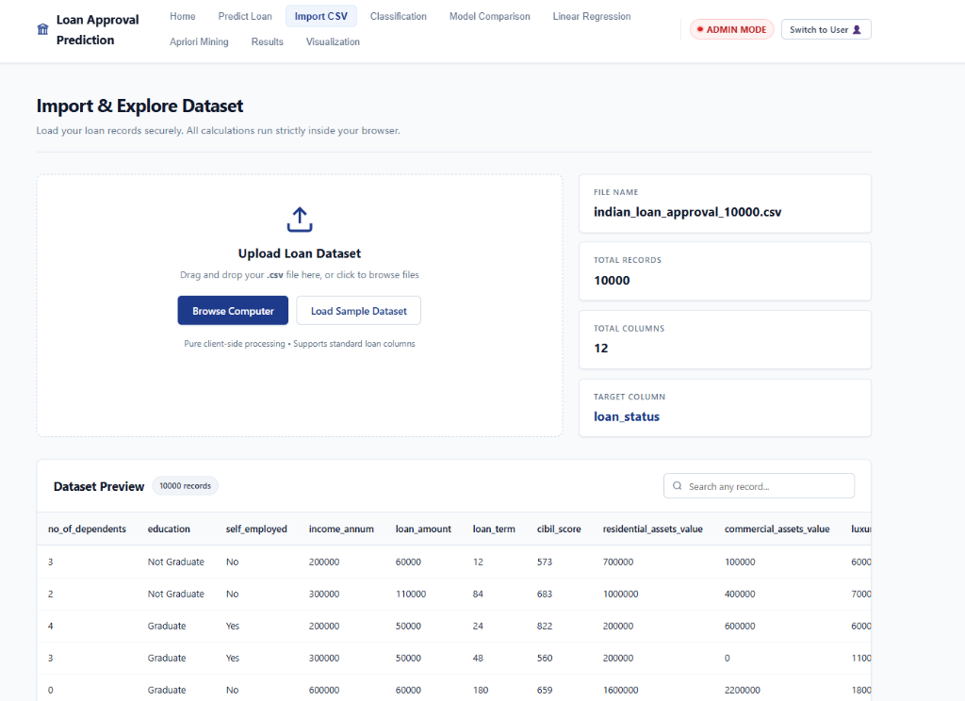
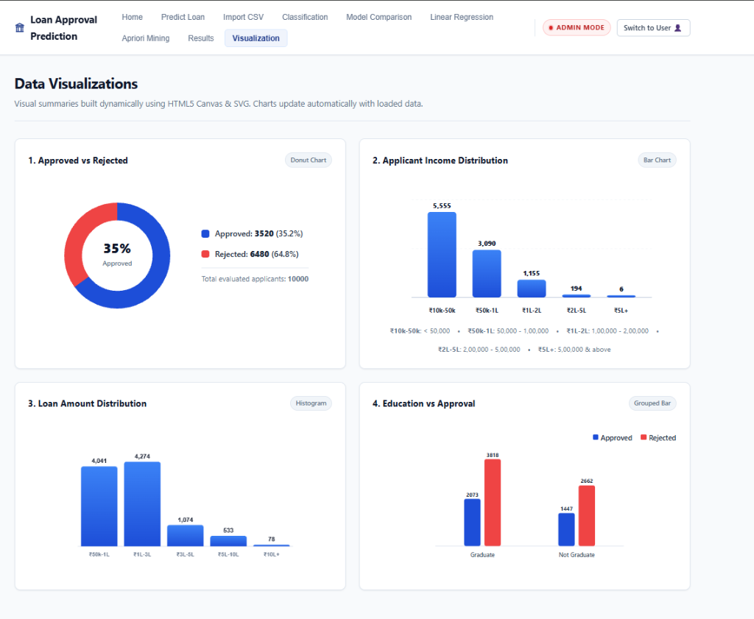

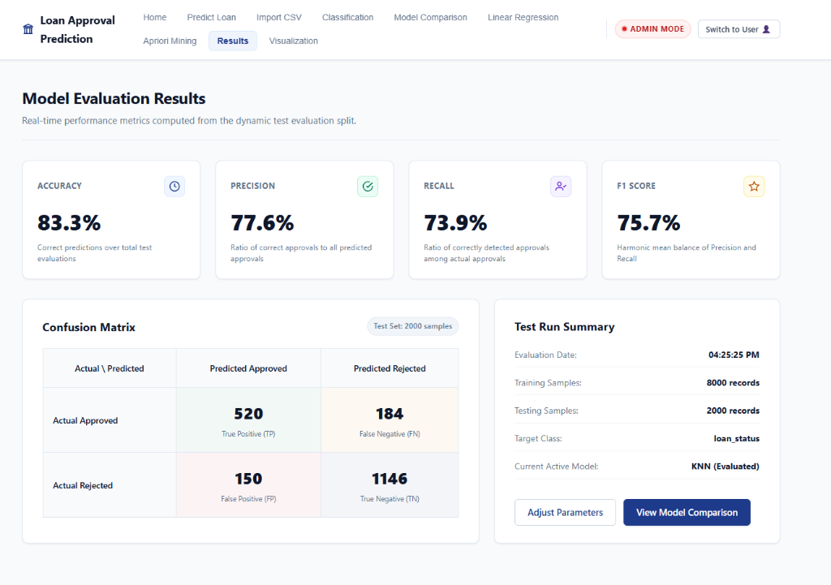
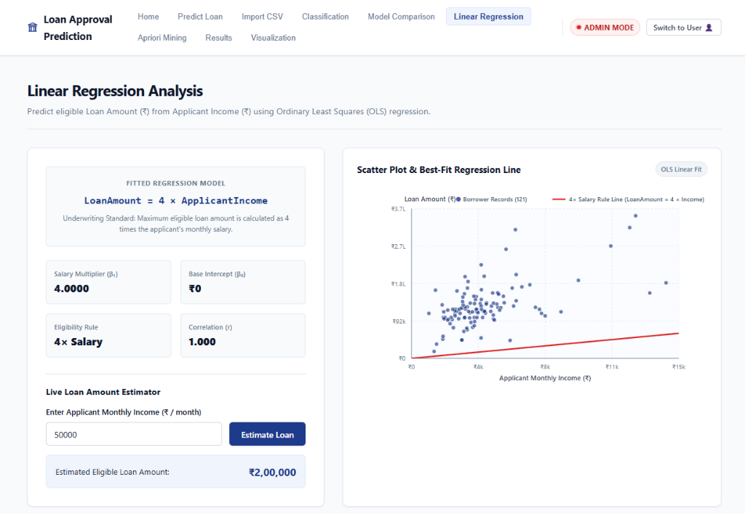

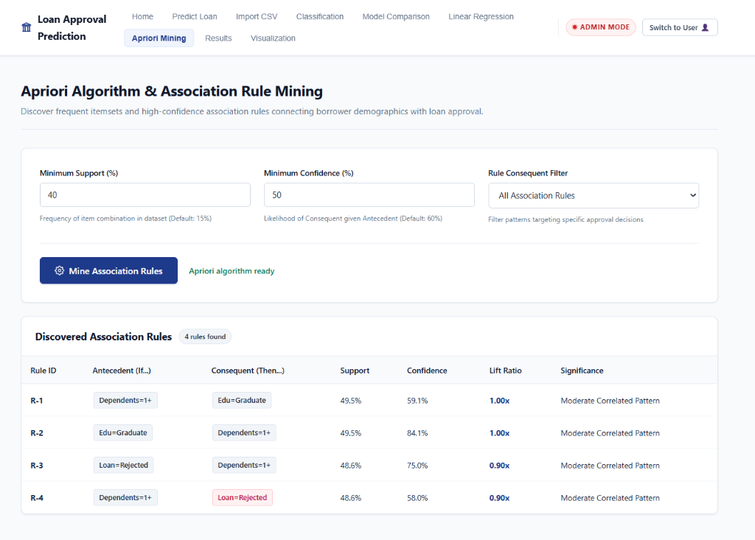

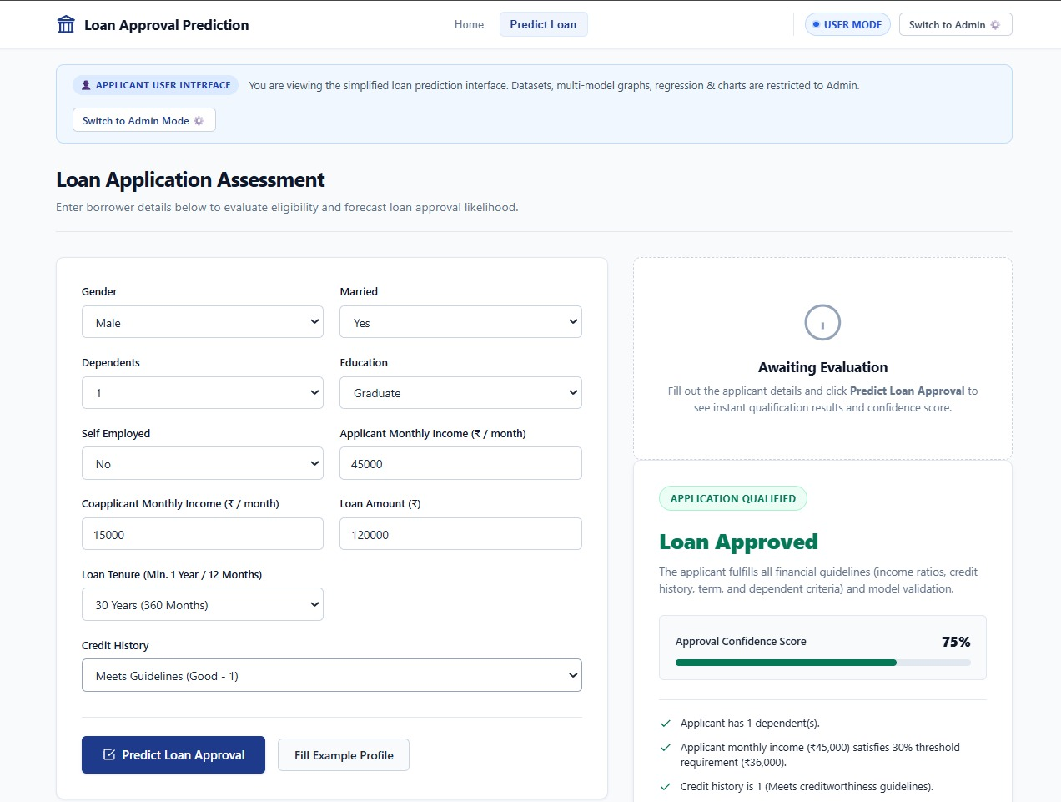
9. Conclusion
This mini project successfully engineered a zero-backend, 100% client-side Loan Approval Prediction and Credit Analytics Platform using purely HTML5, CSS3, and vanilla JavaScript. By implementing core classification algorithms (KNN, Logistic Regression, CART, Random Forest, Naive Bayes), association rule mining (Apriori), and OLS linear regression from mathematical fundamentals without external runtime libraries, the project proves that sophisticated enterprise data mining can operate securely, cheaply, and instantaneously within standard web browsers while safeguarding consumer financial privacy.
9.2 Limitations & Future Scope
While the application demonstrates high responsiveness on 10,000 records, processing massive big-data scale datasets (1,000,000+ records) within single-threaded JavaScript can cause UI thread blocking. Future enhancements will integrate Web Workers for multi-threaded background model training, WebAssembly (Wasm) for compiled linear algebra execution, and IndexedDB for local offline dataset persistence.

References

- J. Han, M. Kamber, and J. Pei, Data Mining: Concepts and Techniques, 3rd ed. Waltham, MA: Morgan Kaufmann, 2011.
- R. Agrawal and R. Srikant, “Fast algorithms for mining association rules,” in Proc. 20th Int. Conf. Very Large Data Bases (VLDB), 1994, pp. 487–499.
- L. Breiman, “Random Forests,” Machine Learning, vol. 45, no. 1, pp. 5–32, 2001.
- T. Cover and P. Hart, “Nearest neighbor pattern classification,” IEEE Transactions on Information Theory, vol. 13, no. 1, pp. 21–27, 1967.
- MDN Web Docs, “Client-side JavaScript APIs, Canvas API, and Web Workers,” Mozilla Developer Network, 2026.

