**SSO (Single Sign-On)** is an authentication process that allows a user to log in to multiple applications or services with a single set of credentials. This eliminates the need for users to log in separately to each application, providing a seamless and secure user experience.

**Key Concepts in SSO**

1. **Identity Provider (IdP):** The system or service that authenticates the user's identity (e.g., Okta, Google, Microsoft Azure AD).
2. **Service Provider (SP):** The application or service the user wants to access.
3. **Authentication Token:** A secure credential that verifies the user's identity between the IdP and SP.
4. **Protocols Used in SSO:** Common protocols include:
   * **SAML (Security Assertion Markup Language):** Often used in enterprise applications.
   * **OAuth and OpenID Connect (OIDC):** Common in modern, cloud-based systems.

**SSO Flow**

The flow depends on the protocol used, but the steps generally follow this sequence:

**1. User Requests Access**

* The user tries to access an application (Service Provider, SP).

**2. Redirect to Identity Provider**

* If the user is not authenticated, the SP redirects the user to the Identity Provider (IdP) for authentication.

**3. Authentication at the IdP**

* The user provides their credentials (username and password) at the IdP.
* If successful, the IdP creates a session for the user.

**4. Token or Assertion Generation**

* The IdP generates an authentication token (e.g., SAML Assertion or OAuth Access Token) to confirm the user's identity.

**5. Token Validation at the SP**

* The user is redirected back to the SP with the token.
* The SP validates the token by either:
  + Verifying it directly (if it's self-contained, e.g., JWT).
  + Sending it back to the IdP for verification.

**6. Grant Access**

* Once the token is validated, the SP creates a session for the user and grants access to the requested resource.

**7. Seamless Access to Other SPs**

* If the user tries to access another application integrated with the same IdP, they are automatically authenticated using the existing session at the IdP.

**Diagram Representation**

markdown

Copy code

1. User -> Service Provider (SP): Request access to Application A.

2. SP -> Identity Provider (IdP): Redirect for authentication.

3. User -> IdP: Authenticate (e.g., username/password).

4. IdP -> User: Issue authentication token/assertion.

5. User -> SP: Submit token/assertion.

6. SP: Validate token and grant access.

**Benefits of SSO**

1. **Improved User Experience:**
   * Users only need to log in once.
2. **Enhanced Security:**
   * Centralized authentication reduces password reuse.
3. **Simplified IT Management:**
   * Easier to manage user access across multiple applications.
4. **Increased Productivity:**
   * Less time spent on multiple logins.

**Common SSO Use Cases**

* Corporate environments with multiple enterprise applications.
* SaaS platforms (e.g., Office 365, Salesforce).
* Consumer ecosystems (e.g., Google Account for Gmail, YouTube, Drive).

When Microsoft Azure is used for authentication, the process typically involves Azure Active Directory (Azure AD), which acts as the **Identity Provider (IdP)**. Below are the key steps to configure and use Microsoft Azure for authentication:

**Steps to Use Microsoft Azure for Authentication**

**1. Set Up Azure Active Directory (Azure AD)**

1. **Sign in to the Azure Portal:**
   * Log in to [Azure Portal](https://portal.azure.com) with administrative access.
2. **Create or Use an Existing Azure AD:**
   * Navigate to **Azure Active Directory** in the Azure services list.
   * Create a new directory or use the existing one.

**2. Register the Application**

1. **Go to "App Registrations":**
   * Under Azure AD, click on **App Registrations**.
2. **Register a New Application:**
   * Click on **New Registration**.
   * Provide the following details:
     + **Name:** A name for your application.
     + **Supported Account Types:** Choose the audience (e.g., Single tenant, Multi-tenant).
     + **Redirect URI:** Enter the callback URL where Azure will send the authentication response (for example, https://yourapp.com/callback).
   * Click **Register**.
3. **Note the Application (Client) ID and Directory (Tenant) ID:**
   * These will be needed in your application configuration.

**3. Configure API Permissions**

1. **Navigate to "API Permissions":**
   * In your registered application, go to the **API Permissions** section.
2. **Add Required Permissions:**
   * Click **Add a Permission**.
   * Choose **Microsoft Graph** or other APIs.
   * Select the required permissions (e.g., email, openid, profile, offline_access for OAuth-based apps).
   * Grant Admin Consent if necessary.

**4. Set Up Authentication**

1. **Go to the "Authentication" Section:**
   * Configure platform-specific settings, such as **Web**, **Single-Page Application**, or **Mobile/Desktop**.
2. **Configure Redirect URIs:**
   * Add the appropriate redirect URIs for your application (e.g., https://yourapp.com/auth/callback).
3. **Enable ID Tokens:**
   * Ensure **ID tokens (used for implicit and hybrid flows)** is checked if using OpenID Connect.

**5. Generate Client Secret (Optional)**

1. **Navigate to "Certificates & Secrets":**
   * Under your registered application, go to **Certificates & Secrets**.
2. **Create a New Secret:**
   * Click **New Client Secret**.
   * Provide a description and expiration period.
   * Note the generated secret value (it will not be visible again).

**6. Configure Your Application**

* Update your application to integrate with Azure AD using:
  + **Client ID** (from the app registration).
  + **Tenant ID** (from the app registration).
  + **Client Secret** (if applicable).
  + **Redirect URI** (matching the one configured in Azure).
* Use libraries like **MSAL.js** (for JavaScript apps) or **MSAL.NET** (for .NET apps) for seamless integration.

**7. Authentication Flow**

* The flow will depend on the protocol used (e.g., OAuth 2.0, OpenID Connect):
  1. **User Initiates Login:**
     + The user attempts to log in via your application.
  2. **Redirect to Azure AD:**
     + The user is redirected to the Azure AD login page.
  3. **User Authenticates:**
     + The user enters their credentials.
  4. **Token Issued:**
     + Azure AD issues an **ID token** (for authentication) and optionally an **Access Token** (for API access).
  5. **Redirect to Application:**
     + The user is redirected back to the application with the token(s).

**8. Validate Tokens in Your Application**

* Validate the token(s) received from Azure AD:
  + Use the **Microsoft Identity Platform endpoint** for token validation.
  + Check the token signature, expiration, and claims.

**Common Use Cases**

1. **Single Sign-On (SSO):**
   * Configure SSO for internal/external apps using Azure AD.
2. **OAuth Authorization:**
   * Use Azure AD for granting access to APIs.
3. **Federated Authentication:**
   * Enable login via social accounts (e.g., Google, Facebook) through Azure AD.

**Additional Considerations**

1. **Custom Domains:**
   * Configure a custom domain for Azure AD if required.
2. **Conditional Access Policies:**
   * Set up MFA, location-based restrictions, or device compliance rules.
3. **Role-Based Access Control (RBAC):**
   * Assign roles based on user permissions using Azure AD Groups or custom roles.

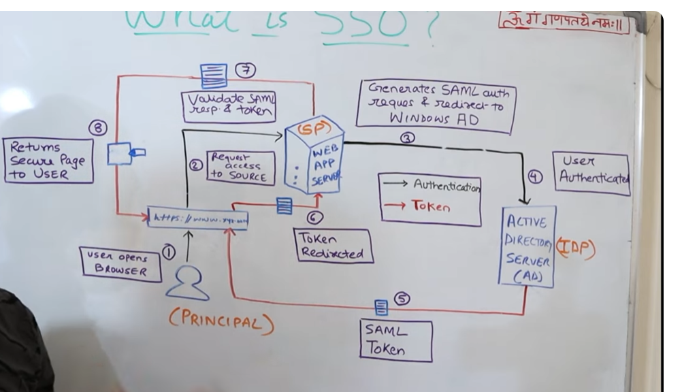

This setup allows applications to securely authenticate users through Azure AD while leveraging Microsoft’s robust identity management and security features.

**OAuth (Open Authorization)** is an open standard for secure access delegation. It enables applications to access resources (e.g., user data or APIs) on behalf of a user without exposing the user's credentials. OAuth is widely used for enabling users to grant third-party applications limited access to their resources, such as data from social media, email, or cloud services.

**Key Concepts in OAuth**

1. **Resource Owner:** The user who owns the resource being accessed.
2. **Client:** The application requesting access to the resource on behalf of the user.
3. **Authorization Server:** The server responsible for authenticating the user and issuing access tokens.
4. **Resource Server:** The server hosting the protected resource (e.g., APIs or user data).
5. **Access Token:** A credential issued by the Authorization Server that the Client uses to access the Resource Server.

**How OAuth Works**

OAuth follows a structured flow to ensure secure access to resources:

**1. Client Requests Authorization**

* The Client application redirects the user to the Authorization Server.
* The user is asked to grant or deny permission for the application to access specific resources.

**2. User Grants Authorization**

* The user authenticates (e.g., logs in) on the Authorization Server and grants consent.

**3. Authorization Server Issues Authorization Code**

* If the user consents, the Authorization Server redirects the user back to the Client with an **Authorization Code**.

**4. Client Exchanges Authorization Code for Access Token**

* The Client sends the Authorization Code to the Authorization Server along with its credentials (e.g., Client ID and Client Secret).
* The Authorization Server validates the Authorization Code and issues an **Access Token** (and sometimes a Refresh Token).

**5. Client Accesses Resource**

* The Client uses the Access Token to request data from the Resource Server.
* The Resource Server validates the token and provides access to the requested resource.

**OAuth Grant Types**

OAuth supports different grant types for different use cases:

**1. Authorization Code Grant**

* Used by server-side applications.
* Tokens are exchanged securely via server-to-server communication.

**2. Implicit Grant**

* Designed for single-page applications (SPAs).
* The Access Token is returned directly in the URL but is less secure.

**3. Client Credentials Grant**

* Used for machine-to-machine communication.
* The Client itself (not a user) authenticates with the Authorization Server to obtain a token.

**4. Resource Owner Password Credentials (ROPC) Grant**

* The user provides their credentials directly to the Client.
* Used only in trusted environments (e.g., internal applications).

**5. Refresh Token**

* Allows the Client to obtain a new Access Token when the current one expires, without requiring the user to re-authenticate.

**Diagram Representation of OAuth Flow**

arduino

Copy code

1. Client -> Authorization Server: Request authorization.

2. Authorization Server -> User: Ask for consent.

3. User -> Authorization Server: Grant consent.

4. Authorization Server -> Client: Return Authorization Code.

5. Client -> Authorization Server: Exchange Code for Access Token.

6. Client -> Resource Server: Use Access Token to access resources.

**Why Use OAuth?**

1. **Enhanced Security:**
   * User credentials are never exposed to the Client application.
2. **Granular Access Control:**
   * Users can grant limited access to specific resources.
3. **Scalability:**
   * Suitable for various applications, from mobile apps to cloud services.
4. **Industry Standard:**
   * Widely adopted by services like Google, Facebook, GitHub, and Microsoft.

**Real-World Examples of OAuth**

1. **Login with Google/Facebook:**
   * Users can log in to a website or app without sharing passwords.
2. **Third-Party Apps Accessing APIs:**
   * A fitness app retrieves your health data from Google Fit.
3. **Cloud Integrations:**
   * Grant an app access to your Dropbox files for specific tasks.

**OAuth vs. OpenID Connect (OIDC)**

* OAuth handles **authorization** (granting access to resources).
* OIDC extends OAuth to include **authentication** (verifying user identity).

