UPES, DEHRADUN
School of Computer Science · Artificial Intelligence Cluster

Prim's Minimum Spanning Tree Algorithm
Mid-Semester Assignment Report

Course: | Design and Analysis of Algorithms (CSEG3053)
Student: | Vaibhavi Gupta
SAP ID: | 590011778
Batch: | B17
Semester: | III (Aug–Dec 2026)
Submitted to: | Kunwar Siddharth, Assistant Professor
Date: | 17 October 2026

Animation / code repository: https://github.com/your-username/your-repo

Abstract
Prim's algorithm is a classic greedy method for finding a minimum spanning tree (MST) of a connected, weighted, undirected graph: a set of edges that links every vertex at the smallest possible total cost. It matters because the same idea underlies the design of cheap cable, pipeline and road networks, and appears inside clustering and approximation algorithms. This report explains the algorithm from first principles, proves why its greedy choice is safe using the cut property, gives pseudocode and a short Python implementation, and traces a seven-vertex example by hand to an MST of weight 39. Running time is analysed for three priority-queue implementations: O(V²) with an array, O(E log V) with a binary heap and O(E + V log V) with a Fibonacci heap. A step-by-step visualiser written in Python and matplotlib accompanies the report. After reading it, a student should understand that Prim grows a single tree outward from one vertex, always attaching the cheapest edge that reaches a new vertex.
Contents
1. Introduction 3
2. Intuition and Core Idea 3
2.1 Why is the greedy choice safe? 4
3. Mathematical Formulation 4
3.1 Definitions 4
3.2 The key array 4
3.3 Cut property and correctness 5
4. Algorithm / Procedure 5
4.1 Line-by-line explanation 5
4.2 Python implementation 6
5. Worked Example (Step by Step) 6
5.1 Trace table 7
5.2 Reading the trace 8
6. Animation / Software Demonstration 8
7. Analysis 8
7.1 Time complexity 8
7.2 Space complexity 9
7.3 Comparison with Kruskal's algorithm 9
7.4 Strengths, limitations and assumptions 10
8. Applications 10
9. Conclusion 10
Declaration of AI Tool Use 10
References 11

1. Introduction
Suppose a university must connect its academic blocks, hostels and library with fibre-optic cable. Every pair of buildings can be linked, but each link has a different cost depending on distance and terrain. The goal is to choose links so that every building can reach every other one, while the total cost is as small as possible. This is the minimum spanning tree problem and it is one of the oldest problems in combinatorial optimisation [1], [2].
Formally, we are given a connected, undirected graph G = (V, E) with a weight w(u, v) on every edge. A spanning tree is a subset of edges that connects all vertices without forming a cycle; an MST is a spanning tree of least total weight. In the course Design and Analysis of Algorithms this topic belongs to the unit on greedy algorithms, where a locally best choice is shown, by proof, to lead to a globally best answer.
Prim's algorithm solves the problem by growing one tree outward from a starting vertex. It was published by R. C. Prim in 1957 [3], after earlier work by V. Jarník (1930), and is therefore sometimes called the Prim–Jarník algorithm. Its main rival, Kruskal's algorithm [4], reaches the same answer by a different route, which Section 7 compares. This report covers the intuition (Section 2), the mathematics (Section 3), the algorithm and code (Section 4), a hand-traced example (Section 5), the accompanying visualiser (Section 6), complexity analysis (Section 7) and applications (Section 8).

2. Intuition and Core Idea
Imagine you are the cable engineer. You start at one building and it is already "connected". At every step you look at all cables that go from a connected building to an unconnected one, pick the cheapest of them, and lay it. The newly reached building joins the connected group. You repeat until every building is connected. You never look at cables between two buildings that are already connected, because they could only create a loop, which wastes money.
Key Idea
Prim's algorithm keeps one growing tree. At each step it adds the cheapest edge that leaves the tree and reaches a new vertex. Because the cheapest edge across any split of the graph always belongs to some MST, this greedy rule never has to be undone.

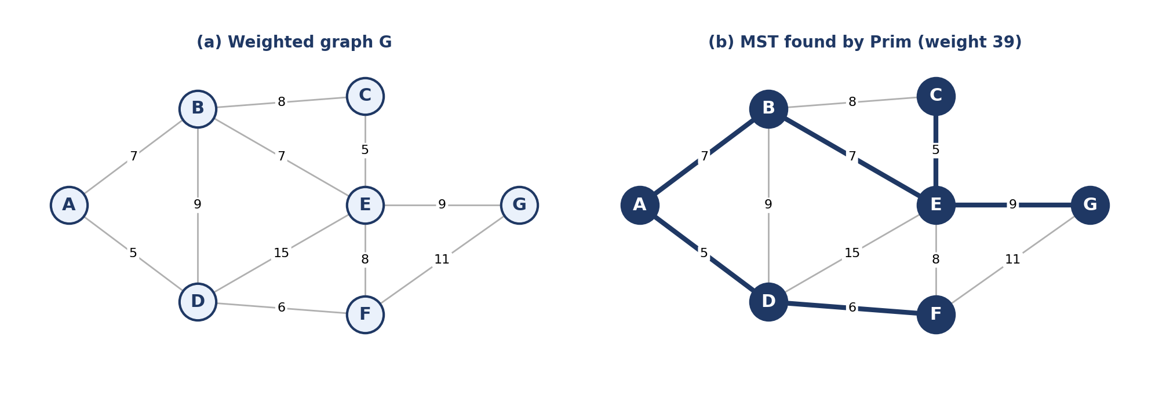
Figure 1. A weighted graph on seven vertices (left) and its minimum spanning tree (right). The tree uses six edges (V − 1) and has total weight 5 + 6 + 7 + 7 + 5 + 9 = 39.

2.1 Why is the greedy choice safe?
Split the vertices into two groups: S, the vertices already in the tree, and V \ S, the rest. Such a split is called a cut. Every edge with one end in each group "crosses" the cut. The cut property says: if one edge is strictly lighter than every other edge crossing the cut, it belongs to every MST; if there are ties, at least one lightest crossing edge belongs to some MST. Prim's algorithm applies this property V − 1 times, once for each vertex it adds. Figure 2 illustrates one such cut.
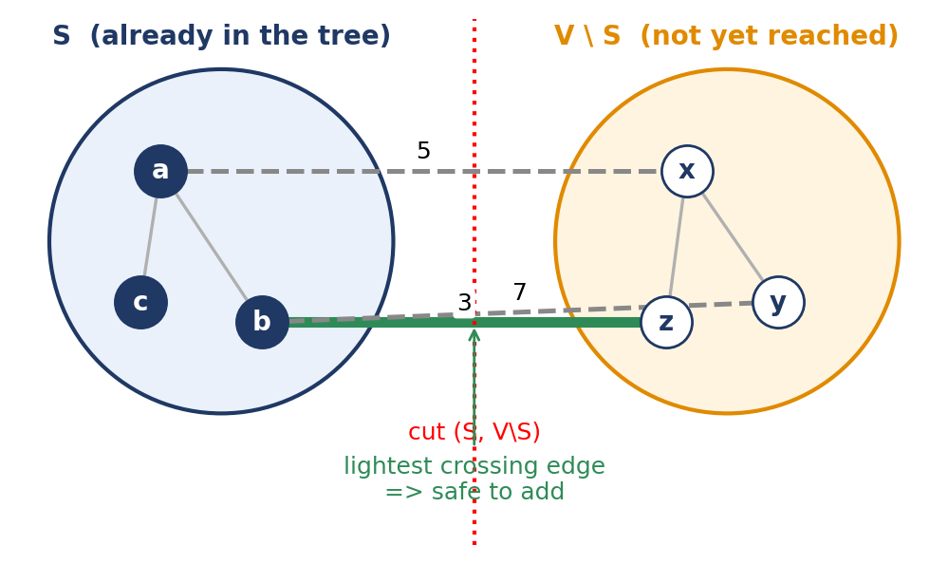
Figure 2. The cut property. S is the set of vertices already chosen. Among the three edges crossing the cut (weights 5, 3 and 7), the weight-3 edge is the lightest, so it is safe to add.

3. Mathematical Formulation

3.1 Definitions
- G = (V, E): connected, undirected graph with |V| = n vertices and |E| = m edges. Where complexity is written, V and E stand for these counts.
- w : E → ℝ: weight function. Weights may be negative; Prim does not require them to be positive.
- T ⊆ E: a spanning tree, meaning |T| = |V| − 1 and T is connected and acyclic.
The MST problem asks for the tree of least total weight:
T* = argmin_{T ∈ 𝒯(G)} w(T), w(T) = Σ_{(u,v) ∈ T} w(u, v) (1)
where 𝒯(G) is the set of all spanning trees of G. This set can be enormous: by Cayley's formula the complete graph on n vertices has n^{n−2} spanning trees, so trying them all is hopeless, and a clever method is required.

3.2 The key array
While running, Prim keeps for every vertex v outside the tree a value key[v]: the weight of the cheapest edge joining v to the current tree S. Initially key[r] = 0 for the root r and key[v] = ∞ otherwise. The vertex extracted at each step is
u = argmin_{v ∈ V \ S} key[v], key[v] = min_{x ∈ S, (x,v) ∈ E} w(x, v) (2)
After u joins S, every neighbour v of u still outside S is relaxed: key[v] ← min(key[v], w(u, v)). Together with a parent[v] array this gives the tree edges (parent[v], v).

3.3 Cut property and correctness
Theorem (cut property). Let A ⊆ T* be a set of edges already known to lie in some MST, let (S, V \ S) be a cut that no edge of A crosses, and let (u, v) be a lightest edge crossing the cut. Then A ∪ {(u, v)} is also contained in some MST.
Proof sketch. Let T* be an MST containing A. If it already contains (u, v), we are done. Otherwise adding (u, v) to T* creates a cycle. That cycle must cross the cut at least twice, so it contains another crossing edge (x, y). Remove (x, y) and keep (u, v): the result is still a spanning tree, and its weight is w(T*) − w(x, y) + w(u, v) ≤ w(T*) because (u, v) is a lightest crossing edge. So the new tree is also an MST, and it contains A ∪ {(u, v)}. ∎
Loop invariant for Prim. Before each iteration, the edges chosen so far form a tree on S and belong to some MST. This holds at the start (no edges). In each iteration the chosen edge is a lightest edge crossing the cut (S, V \ S), because key[] stores exactly the lightest crossing edge for each outside vertex and we extract the smallest. The cut property keeps the invariant true. When S = V, the chosen edges are a spanning tree contained in an MST, so they are an MST.

4. Algorithm / Procedure
Algorithm 1 gives the standard version in the style of Cormen et al. [1]. The priority queue Q holds every vertex not yet in the tree, ordered by key. Sedgewick and Wayne [6] give a similar treatment.
Algorithm 1: PRIM(G, w, r)
1 for each u ∈ V do key[u] ← ∞; parent[u] ← NIL
2 key[r] ← 0; Q ← V
3 while Q ≠ ∅ do
4 u ← EXTRACT-MIN(Q)
5 for each v adjacent to u do
6 if v ∈ Q and w(u, v) < key[v] then
7 parent[v] ← u; key[v] ← w(u, v) (DECREASE-KEY)
8 return { (parent[v], v) : v ∈ V \ {r} }

4.1 Line-by-line explanation
- Lines 1–2 (initialise). Every vertex is unreached (key = ∞) except the root, whose key is 0 so that it is extracted first.
- Lines 3–4 (greedy choice). Extract the vertex with the smallest key. By Equation 2 this is the endpoint of a lightest edge crossing the cut, so the cut property applies.
- Lines 5–7 (relaxation). The new tree vertex u may offer a cheaper connection to its neighbours. If w(u, v) is smaller than the current key[v], remember u as the better parent. Vertices already in the tree are skipped, which avoids cycles.
- Line 8 (output). Every non-root vertex has a parent; the V − 1 pairs (parent[v], v) are the tree edges.

4.2 Python implementation
The excerpt below uses Python's heapq module. Because heapq has no decrease-key operation, it uses a common "lazy deletion" variant: a vertex may be pushed several times with different weights, and stale entries are skipped when popped. The running time stays O(E log V). The full program, including the visualiser, is in the repository.
1 import heapq
2
3 def prim(graph, start):
4 # graph: {u: [(v, weight), ...]} (undirected)
5 visited = {start}
6 heap = [(w, start, v) for v, w in graph[start]]
7 heapq.heapify(heap)
8 mst, total = [], 0
9 while heap and len(visited) < len(graph):
10 w, u, v = heapq.heappop(heap)
11 if v in visited:
12 continue # stale entry, skip
13 visited.add(v)
14 mst.append((u, v, w))
15 total += w
16 for x, wx in graph[v]:
17 if x not in visited:
18 heapq.heappush(heap, (wx, v, x))
19 return mst, total

Run on the graph of Figure 1 starting at A, this function returns the edges A–D, D–F, A–B, B–E, E–C, E–G with total weight 39, matching the hand trace in Section 5.

5. Worked Example (Step by Step)
We trace Prim's algorithm on the graph of Figure 1, starting from vertex A. Table 1 lists its eleven edges.
Edge | Weight | Edge | Weight | Edge | Weight
A–B | 7 | B–E | 7 | E–F | 8
A–D | 5 | C–E | 5 | E–G | 9
B–C | 8 | D–E | 15 | F–G | 11
B–D | 9 | D–F | 6
Table 1. Edge list of the example graph.
At each step the algorithm looks at every edge crossing the cut (dashed orange in the figures), picks the lightest, and adds it (green). Figures 3 and 4 show the seven stages; Table 2 records the key array after each step.
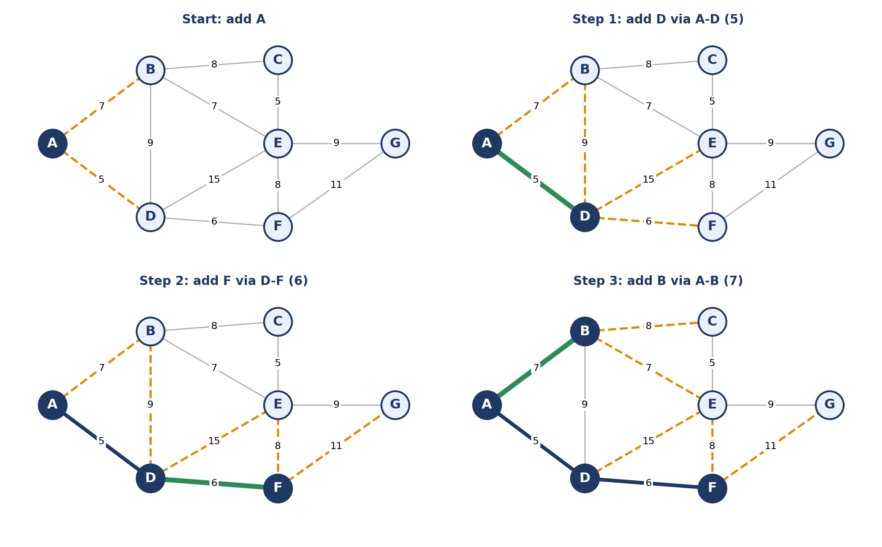
Figure 3. Prim's algorithm from vertex A: initial state and the first three steps. Candidate edges are orange and dashed; the chosen edge is green.
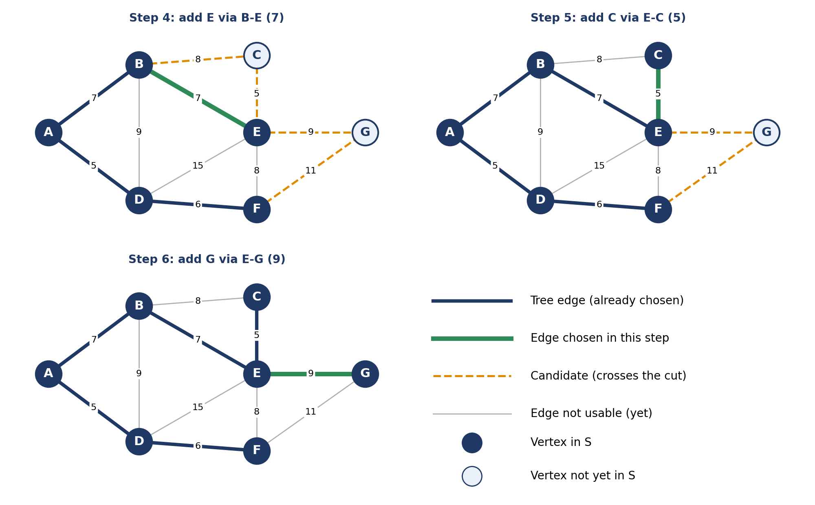
Figure 4. Remaining steps. After E is added, C is reached through the weight-5 edge and G through the weight-9 edge, completing the tree.

5.1 Trace table
Step | Extract | Edge | A | B | C | D | E | F | G | Weight so far
1 | A | root | - | 7 | ∞ | 5 | ∞ | ∞ | ∞ | 0
2 | D | A-D | - | 7 | ∞ | - | 15 | 6 | ∞ | 5
3 | F | D-F | - | 7 | ∞ | - | 8 | - | 11 | 11
4 | B | A-B | - | - | 8 | - | 7 | - | 11 | 18
5 | E | B-E | - | - | 5 | - | - | - | 9 | 25
6 | C | E-C | - | - | - | - | - | - | 9 | 30
7 | G | E-G | - | - | - | - | - | - | - | 39
Table 2. Key values after each step. A dash means the vertex is already in the tree. Columns A–G show key[v].

5.2 Reading the trace
- Step 1. A has key 0 and is extracted. Its neighbours are relaxed: key[B] = 7, key[D] = 5.
- Step 2. D (key 5) is smallest, so edge A–D joins the tree. Relaxing D's neighbours sets key[E] = 15 and key[F] = 6; key[B] stays 7 because the old value 7 beats 9.
- Step 3. F (key 6) is extracted via D–F. key[E] improves from 15 to 8 and key[G] becomes 11.
- Step 4. B (key 7) is extracted via A–B. key[C] = 8; key[E] improves from 8 to 7 through B–E.
- Step 5. E (key 7) joins via B–E. key[C] improves from 8 to 5, key[G] from 11 to 9.
- Steps 6–7. C (key 5, via E–C) and finally G (key 9, via E–G) join. All seven vertices are in the tree.
The final weight is 5 + 6 + 7 + 7 + 5 + 9 = 39, using six edges, which equals V − 1 as expected. Note that the heaviest edges (D–E with 15 and F–G with 11) are never used.

6. Animation / Software Demonstration
Tool used: Python 3 with matplotlib (and Pillow if a GIF is wanted). No other libraries are needed.
Link: https://github.com/your-username/your-repo (replace with your own repository link)
How to run: pip install matplotlib pillow, then python prim_demo.py --gif.
What the viewer can change: the starting vertex (option --start D) and the graph itself, by editing the vertex positions and the edge list at the top of the script. Each frame shows the current tree in navy, the candidate edges in orange and the chosen edge in green, so the cut property can be seen at every step. The final MST weight is printed to the terminal.

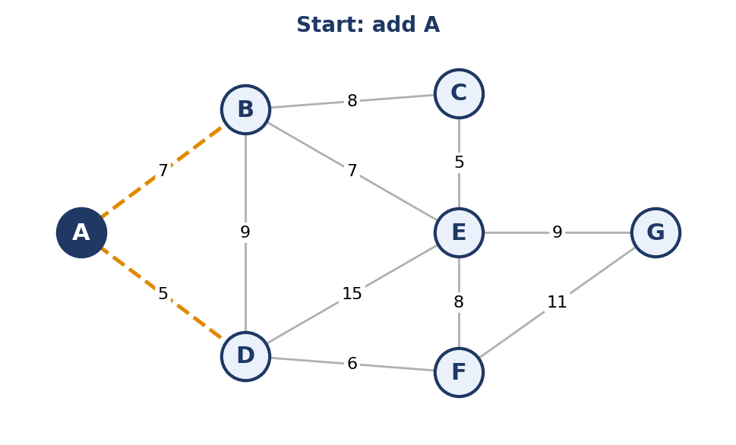  (a) Start | 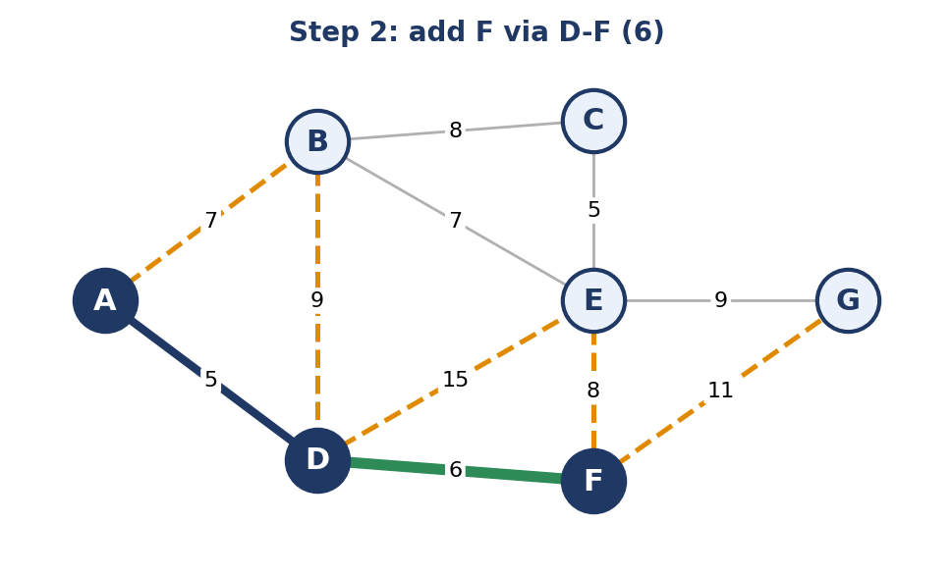  (b) Early | 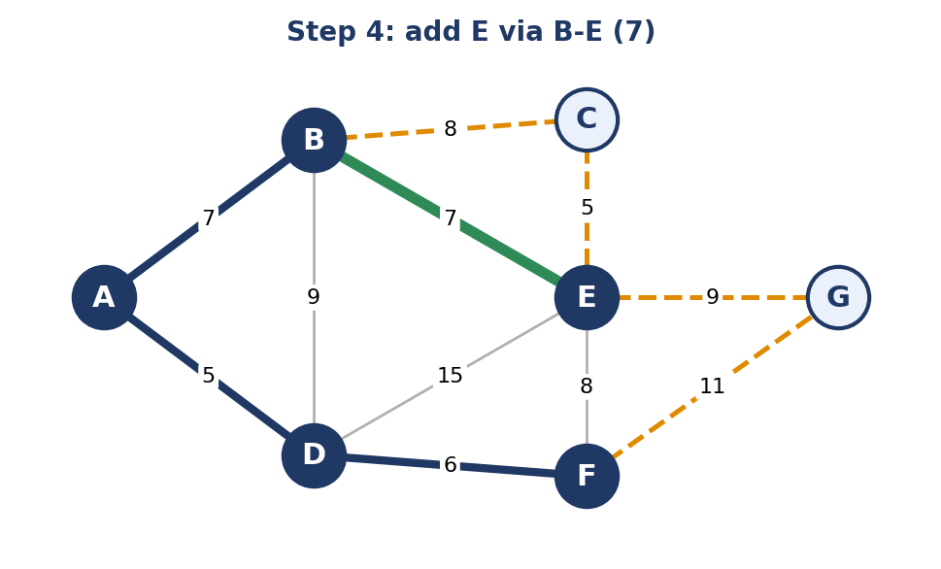  (c) Middle | 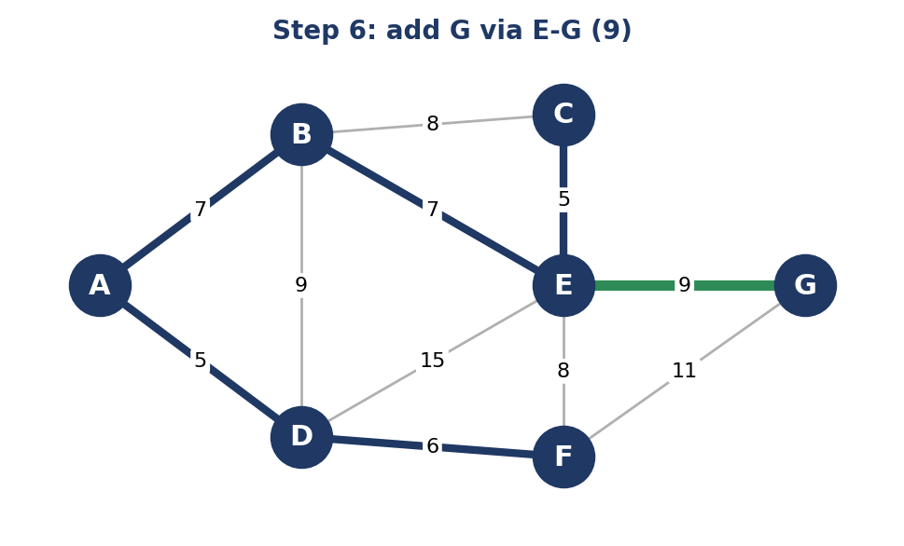  (d) End
Figure 5. Key frames produced by the visualiser (stages 0, 2, 4 and 6 of 7).

7. Analysis

7.1 Time complexity
The algorithm performs V EXTRACT-MIN operations and at most one DECREASE-KEY per edge direction, so at most 2E of them. Writing T_{ext} and T_{dec} for the cost of these operations:
T(V, E) = V · T_{ext} + E · T_{dec} + O(V + E) (3)
The total therefore depends on the priority-queue implementation (Table 3); the Fibonacci-heap bound is due to Fredman and Tarjan [5].
Priority queue | EXTRACT-MIN | DECREASE-KEY | Total time
Unsorted array (adjacency matrix) | O(V) | O(1) | O(V²)
Binary heap (adjacency list) | O(log V) | O(log V) | O((V + E) log V) = O(E log V)
Fibonacci heap (adjacency list) | O(log V) amortised | O(1) amortised | O(E + V log V)
Table 3. Running time of Prim's algorithm by priority-queue implementation.
Best, worst and average case. Prim has no early exit: it always performs V − 1 extractions and scans every edge once, so the running time depends on the graph's size and density, not on how the weights are arranged. For a given implementation the best, average and worst cases coincide asymptotically. The array version is better for dense graphs (E close to V²), and the heap versions for sparse ones (E close to V). Figure 6 shows the crossover for V = 1000.
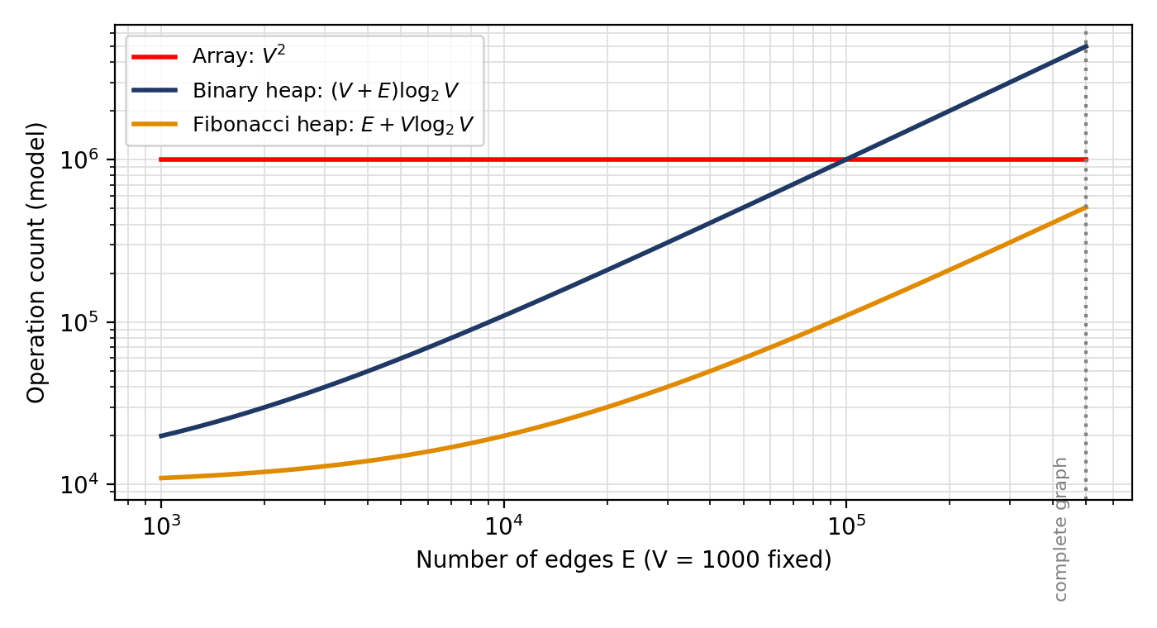
Figure 6. Modelled operation counts against edge count for V = 1000 (log–log scale). The array version wins only when the graph is dense; the Fibonacci heap is asymptotically best but has large constant factors in practice.

7.2 Space complexity
Beyond the graph itself, the algorithm stores key[], parent[] and the priority queue, which is O(V) extra space (O(E) for the lazy-deletion version in Section 4.2, because stale entries may remain in the heap).

7.3 Comparison with Kruskal's algorithm
Criterion | Prim's algorithm | Kruskal's algorithm
Strategy | Grows one tree from a root vertex | Merges a forest by adding globally cheapest safe edge
Data structure | Priority queue on vertices | Sorted edge list + disjoint-set (union–find)
Time | O(E log V) with a binary heap; O(V²) with an array | O(E log E) = O(E log V), dominated by sorting
Best for | Dense graphs, adjacency-matrix input | Sparse graphs, edges already sorted
Intermediate result | Always a single connected tree | A forest that may be disconnected until the end
Limitation | Needs a connected graph; otherwise run once per component | Needs all edges listed; sorting cost
Table 4. Prim compared with Kruskal.

7.4 Strengths, limitations and assumptions
- Strength: simple, with a proof based on one idea; handles negative weights; works well with adjacency matrices.
- Limitation: applies to undirected graphs. For a minimum spanning arborescence in a directed graph, the Chu–Liu/Edmonds algorithm is needed.
- Uniqueness: if all edge weights are distinct, the MST is unique and every correct algorithm returns it; with ties, different start vertices or tie-breaking can give different trees of the same weight.
- Not Dijkstra: the two algorithms look almost identical, but Dijkstra keys a vertex by its total distance from the source, whereas Prim keys it by the weight of a single connecting edge. Prim's tree does not give shortest paths.

8. Applications
- Network design. Laying fibre, electricity lines, water pipes or roads so that all sites are connected at minimum total length, as in the campus example of Section 1. Edge weights are the installation costs, and the MST is the cheapest connected layout.
- Approximation for the travelling salesman problem. For metric instances, a preorder walk of an MST gives a tour at most twice the optimal length, because removing any edge of the optimal tour leaves a spanning tree that is at least as heavy as the MST [1].
- Clustering. Building an MST of data points and deleting its k − 1 heaviest edges produces k clusters; this is equivalent to single-linkage hierarchical clustering. Because Prim works well on dense distance matrices, it is a natural choice here.
- Other uses. Generating random mazes (apply Prim to a grid with random weights) and reducing broadcast cost in communication networks.

9. Conclusion
Prim's algorithm shows how a greedy rule can be both simple and provably optimal. The whole correctness argument rests on the cut property, and the implementation reduces to maintaining a priority queue of keys. Tracing the seven-vertex example by hand and drawing it frame by frame made the role of the cut much clearer: the orange candidate edges change shape at every step, yet the cheapest one is always safe. A noticeable detail was how the key of a vertex can drop several times (E went from 15 to 8 to 7) before the vertex is extracted.
One question worth exploring further is how much the Fibonacci heap's better bound matters in practice: for which real graph sizes does it actually beat a plain binary heap, given its large constant factors?

Declaration of AI Tool Use
Tools used: ____________________________________________
What for: ____________________________________________
Approximate share of AI-generated content: ______ % (course limit: 20%)
I confirm that this report and the animation are my own individual work.
Signature: ______________________ Date: ________________

References
[1] T. H. Cormen, C. E. Leiserson, R. L. Rivest and C. Stein, Introduction to Algorithms, 4th ed. Cambridge, MA, USA: MIT Press, 2022.
[2] R. L. Graham and P. Hell, "On the history of the minimum spanning tree problem," IEEE Annals of the History of Computing, vol. 7, no. 1, pp. 43–57, 1985.
[3] R. C. Prim, "Shortest connection networks and some generalizations," Bell System Technical Journal, vol. 36, no. 6, pp. 1389–1401, 1957.
[4] J. B. Kruskal, "On the shortest spanning subtree of a graph and the traveling salesman problem," Proceedings of the American Mathematical Society, vol. 7, no. 1, pp. 48–50, 1956.
[5] M. L. Fredman and R. E. Tarjan, "Fibonacci heaps and their uses in improved network optimization algorithms," Journal of the ACM, vol. 34, no. 3, pp. 596–615, 1987.
[6] R. Sedgewick and K. Wayne, Algorithms, 4th ed. Upper Saddle River, NJ, USA: Addison-Wesley, 2011.

