Evaluation of STM32N6 Series Microcontroller for MxSense Sensing Platform
The objective of this document is to evaluate the STM32N6 series microcontrollers from STMicroelectronics and determine their suitability for use as the main controller in the MxSense sensing platform.
The analysis focuses on the features of the STM32N6 series and how they support the requirements of the multi-channel sensing architecture, including sensor acquisition, preprocessing, edge AI capability, secure communication, and system control.
1,System Requirements
The MxSense sensing platform consists of multiple sensing channels including environmental sensors, VOC sensors, selective gas sensors, particulate sensors, vision modules, and spectroscopy modules.
The main microcontroller must support sensor acquisition, preprocessing, device control, secure communication, and interaction with the edge AI processor. Therefore, the microcontroller must meet several hardware and system requirements.
Requirement | Description
Multi-sensor interfacing | Support communication interfaces such as I²C, SPI, UART, and ADC for connecting environmental, VOC, gas, and PM sensors
Data processing capability | Ability to preprocess sensor signals and perform feature extraction
Memory capacity | Sufficient RAM to buffer sensor data and intermediate processing results
AI capability | Support for running lightweight machine learning models for sensor fusion and anomaly detection
Security | Hardware cryptography support for secure communication and firmware protection
Peripheral support | Interfaces for camera modules, external memory, and other peripherals
Real-time control | Ability to control actuators such as fans or pumps used in sampling systems
Communication | Reliable communication with edge processors and connectivity modules
Power efficiency | Efficient operation for embedded sensing systems

2.STM32N6 Overview
The STM32N6 series microcontrollers from STMicroelectronics are designed for high-performance embedded systems and edge AI applications.
These microcontrollers are based on the Arm Cortex-M55 processor and include the Neural-ART AI accelerator, enabling efficient execution of machine learning models directly on the device.
The STM32N6 series integrates large on-chip SRAM, multiple high-speed peripheral interfaces, hardware security features, and dedicated accelerators for graphics and multimedia processing.
These capabilities make the STM32N6 series suitable for applications that require sensor fusion, edge intelligence, real-time processing, and secure communication.
Key Features of STM32N6
- Arm Cortex-M55 CPU
- Neural-ART AI accelerator
- Up to 4.2 MB SRAM
- Hardware cryptography and secure boot
- Multiple I²C, SPI, UART interfaces
- High-resolution ADC
- DMA controllers for efficient data transfer
- Camera interface
- Support for external memory

3.Key Features of STM32N657 Relevant to the MxSense System
A. Cortex-M55 Processor- The STM32N657 microcontroller is based on the Arm Cortex-M55 processor, which is designed for high-performance embedded applications and edge AI systems.

The Cortex-M55 core provides significantly improved computational performance compared to traditional microcontrollers and supports efficient signal processing operations.

Relevance to the MxSense System

In the MxSense sensing platform, the processor is responsible for:

Managing multiple sensing channels

Processing sensor data

Running signal preprocessing algorithms

Coordinating communication with the edge AI processor

The high processing capability of the Cortex-M55 allows the system to handle multiple sensors simultaneously while maintaining real-time performance.
B. AI Acceleration (Neural-ART Accelerator)
The STM32N657 microcontroller integrates a dedicated Neural-ART accelerator, which is designed to efficiently execute machine learning and neural network operations directly on the device.

This hardware accelerator significantly improves the performance of AI inference compared to running machine learning models on the CPU alone. It enables faster processing, reduced CPU workload, and improved power efficiency for edge AI applications.
Relevance to the MxSense System
The MxSense sensing platform collects data from multiple sensors such as VOC sensors, gas sensors, environmental sensors, particulate sensors, and vision modules.

AI models can be used to analyze this sensor data to detect patterns related to freshness, spoilage, adulteration, or anomalies.

The Neural-ART accelerator enables the system to:

Run lightweight machine learning models directly on the microcontroller

Perform sensor fusion from multiple sensing channels

Detect anomalies or classification results in real time

Reduce the amount of raw data that needs to be sent to the cloud or edge processor

This capability enables edge intelligence, allowing the system to make faster and more efficient decisions.
C. On-Chip Memory (SRAM)
The STM32N657 microcontroller includes a large amount of on-chip SRAM (up to approximately 4.2 MB).

This internal memory allows the system to store sensor data, intermediate processing results, and machine learning model parameters without relying heavily on external memory devices.

Relevance to the MxSense System
The MxSense sensing platform processes data from multiple sensing channels including environmental sensors, VOC sensors, gas sensors, particulate sensors, and vision modules.

Large internal memory is required for:

Buffering sensor data streams

Performing signal preprocessing and feature extraction

Storing temporary results during AI inference

Managing communication buffers and logs

The large SRAM available in the STM32N657 helps support real-time multi-sensor data processing and improves overall system performance.

D. Peripheral Interfaces for Sensor Integration
The STM32N657 microcontroller provides a wide range of peripheral interfaces including I²C, SPI, UART, and Analog-to-Digital Converters (ADC).

These interfaces enable communication with various external sensors and modules used in the MxSense sensing platform.
Relevance to the MxSense System
Interface | Function | Relevance to the MxSense System
I²C | Serial communication interface | Used to connect digital sensors such as BME688 and SGP40
SPI | High-speed communication | Used for external memory, displays, or high-speed sensor modules
UART | Serial communication | Used for particulate sensors such as PMS7003 and debugging
ADC | Analog signal conversion | Required for analog gas sensors such as TGS2602
DMA | Direct memory transfer | Enables efficient data transfer without heavy CPU usage

E. Hardware Security and Cryptography
The STM32N657 microcontroller includes integrated hardware cryptography and security features designed to protect device firmware, data communication, and system integrity.

These security mechanisms include hardware accelerators for cryptographic algorithms, secure boot functionality, and protection against unauthorized firmware execution.
Security Feature | Function | Relevance to the MxSense System
Hardware AES | Fast data encryption | Protects sensor data transmitted to the platform
Hardware SHA | Secure hashing | Ensures integrity of data and firmware
Secure Boot | Verifies firmware authenticity | Prevents unauthorized firmware installation
True Random Number Generator | Generates secure cryptographic keys | Enables secure authentication and encryption

F. Sensor Fusion and Edge Intelligence
The STM32N657 microcontroller supports sensor fusion and edge intelligence by combining its high-performance processor, AI accelerator, and large memory resources.

These capabilities enable the system to process and analyze data from multiple sensing channels locally before sending results to the edge processor or cloud platform.
Sensing Channel | Sensors | STM32N657 Role
CH0 Environmental | Temperature, humidity, airflow | Collects environmental context and controls sampling system
CH1 VOC Sensors | MOS sensor array | Processes VOC signals and extracts features
CH2 Selective Gas | Electrochemical gas sensors | Reads analog signals and estimates gas concentration
CH3 Vision | Camera module | Supports image acquisition and preprocessing
CH4 Spectroscopy | NIR / spectral sensor | Processes spectral data and generates chemical proxies
CH6 PM Sensors | Particulate sensor | Collects dust and particle measurements

4.Comparison with Arduino Giga
The current implementation of the sensing platform uses an Arduino Giga board as the main controller. To evaluate the benefits of migrating to STM32N657, a comparison between the two platforms is presented below.

Feature | Arduino Giga | STM32N657 | Benefit for MxSense
Processor | Cortex-M7 | Cortex-M55 | Improved performance and efficiency
AI acceleration | Not available | Neural-ART accelerator | Enables edge AI inference
Memory | Lower internal SRAM | Up to ~4.2 MB SRAM | Better buffering and processing
Security | Limited | Hardware crypto + secure boot | Secure firmware and communication
Peripheral support | Standard interfaces | Advanced peripheral set | Better integration with multiple sensors
AI support | External processing required | Built-in AI capability | Faster local inference

5. Comparison within different model of STM32N6 series
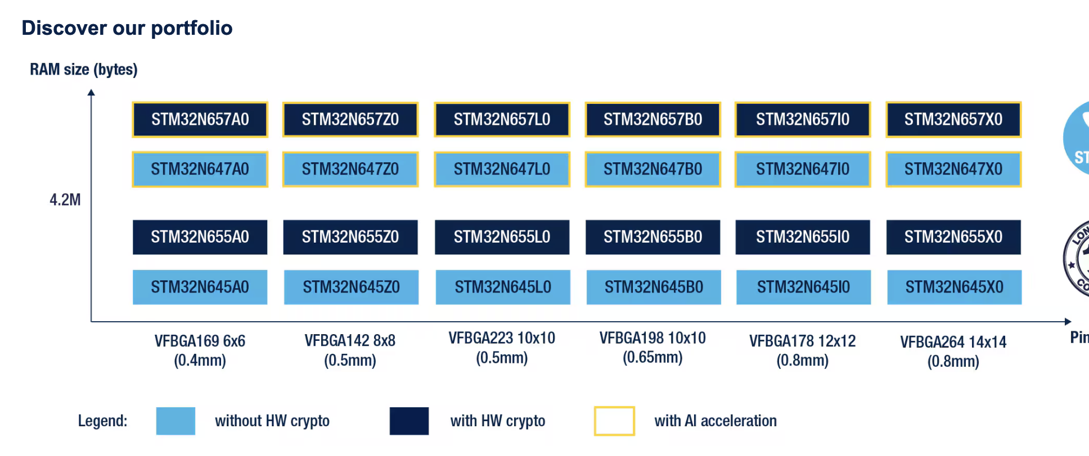
Feature | STM32N657 Series | STM32N647 Series | STM32N655 Series
Primary Functions | Edge AI + Vision processing + sensor orchestration | Edge AI + multi-sensor fusion | Sensor aggregation + secure IoT gateway
Total Pin Count Range | 169 – 264 pins | 169 – 264 pins | 169 – 198 pins
GPIO Availability | ~120–140 GPIO | ~110–130 GPIO | ~100–110 GPIO
Analog / Digital Interfaces | 3× ADC, DAC, digital sensor interfaces | Same as 57series | Same ADC but slightly fewer digital buses
Analog Sensors Supported | MOS gas sensors, EC sensors, load cells, spectroscopy sensors | Same | Same
Digital Sensors Supported | VOC sensors, PM sensors, humidity, pressure, IMU | Same | Same
AI Camera Options | DCMI + MIPI camera interface + ISP | DCMI camera interface | DCMI camera interface
Vision AI Capability | High (image preprocessing + ML inference) | Moderate (camera + ML inference) | Basic camera capture only
Wireless / BLE Support | External modules via SPI/UART (ESP32, BLE modules, WiFi chips) | Same | Same
Number of IoT Devices that can be connected | ~50+ sensors across multiple buses | ~40–45 sensors | ~30–35 sensors
NPU Support | ARM Ethos-U55 (~600 GOPS) | ARM Ethos-U55  (~600 GOPS) | No NPU
AI Model Support | TinyML, CNN inference, anomaly detection, sensor fusion | Same but slightly smaller workloads | AI only via CPU (slow)
NPU Limitations | Models typically <10–15 MB, inference only, not training | Same | No hardware acceleration
Peripheral Interfaces | Up to 6× I²C, 5× SPI, 8× UART, USB HS/FS, Ethernet, Octo-SPI | Same | Slightly fewer interfaces
External Memory Support | HyperRAM, PSRAM, QSPI Flash, Octo-SPI | Same | Same
Display Support | LTDC RGB display + GPU2D | LTDC RGB display | LTDC / SPI display
Touchscreen Support | Yes(external) | Yes(external) | Yes(external)
Non-Touch Display | Yes | Yes | Yes
ADC | Up to 20 channels, 12-bit SAR ADC | Same | Same
DAC | 2 channels | 2 channels | 2 channels
Analog pins | ~20–30 depending on package | ~20–30 | ~20–25
External Flash | Up to 256 MB+ (Octo-SPI) | Same | Same
External PSRAM | Up to 64–128 MB | Same | Same
HyperRAM | Up to 128 MB | Same | Same
SDRAM (via FMC) | Up to 512 MB – 1 GB | Same | Same
eMMC / SD storage | GBs of storage | Same | Same
Typical AI model size supported | 10–50 MB (depending on RAM configuration) | 10–40 MB | <10 MB practical
IDE-
 | Purpose
STM32CubeIDE | main firmware development
STM32CubeMX | configure hardware
STM32Cube.AI | deploy AI models
VS Code | optional development
Keil MDK | professional alternative
6. Hyperspectral Imaging
Hyperspectral Imaging (HSI) is an advanced sensing technique that captures spectral information across multiple wavelengths for each pixel in an image. Unlike conventional RGB imaging, which records only three color bands (Red, Green, Blue), hyperspectral imaging records tens or hundreds of spectral bands, enabling the detection of chemical composition, material properties, and subtle variations that are not visible in standard images.
In the proposed system architecture, hyperspectral sensing is implemented using a dedicated spectral sensor module controlled by the STM32N6 microcontroller, while computationally intensive tasks such as spectral analysis and AI-based classification are executed on an edge AI processor.
Camera options
Fft- camera, how we can do

Limitations of Implementing Hyperspectral Imaging on MCU
- Hyperspectral imaging generates a very large amount of data because it captures multiple spectral bands for every pixel in an image. This creates a three-dimensional dataset known as a spectral cube.However, microcontrollers such as the STM32N6 series have limited on-chip memory.
- Computational Requirements-Hyperspectral processing requires complex algorithms such as:
- spectral calibration
- noise filtering
- dimensionality reduction (PCA)
- machine learning classification
- spectral unmixing
These algorithms require high computational throughput and large matrix operations, which are difficult to execute efficiently on a microcontroller.
- AI Model Complexity-Hyperspectral classification models often use:
- convolutional neural networks (CNNs)
- spectral-spatial models
- deep learning frameworks
Even though STM32N6 includes a TinyML accelerator, it is optimized for small embedded models, not for large spectral-image datasets.
- Data Throughput-High-resolution hyperspectral cameras produce large continuous data streams, requiring high-bandwidth processing and memory access that exceed typical MCU capabilities.
Possible Solution
To overcome these limitations, the system uses a distributed processing architecture where:
- the STM32N6 microcontroller manages sensor acquisition and preprocessing
- a high-performance edge processor performs advanced spectral analysis and AI inference
An edge processor such as NVIDIA Jetson Orin provides significantly higher compute capability for handling hyperspectral data.
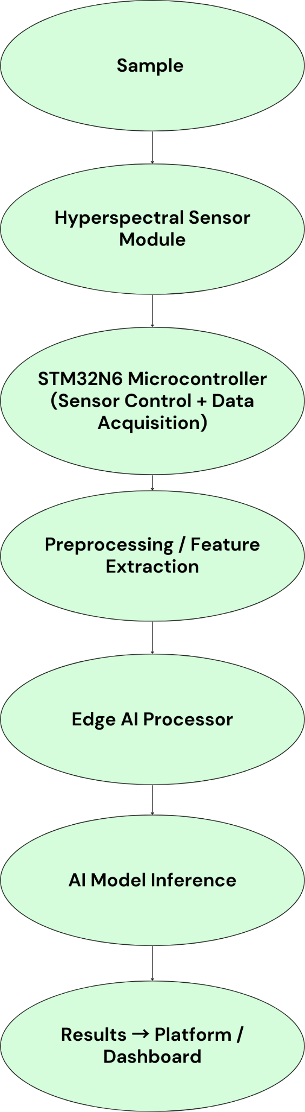

Role of STM32N6 Microcontroller
The STM32N6 performs the following functions:

Sensor Control
- configure spectral sensors
- control integration time
- manage illumination sources (VIS/NIR LEDs)

Data Acquisition
- read spectral data via SPI or I²C
- synchronize sampling cycles
- timestamp measurements

Preprocessing
- dark reference correction
- white reference normalization
- noise filtering
- basic feature extraction

Role of Edge AI processor
Devices such as NVIDIA Jetson Orin provide GPU acceleration capable of running deep learning models locally.
Feature Extraction for Efficient Processing
To reduce data transmission and computational load, the MCU can convert raw spectra into compact feature vectors.
Advantages of Edge AI Hyperspectral Processing
Advantage | Description
Real-time analysis | immediate processing at the device
Reduced bandwidth | raw spectral data does not need cloud upload
Offline operation | system works without internet
Improved accuracy | powerful models can run locally

7.Real Time Fusion Inferencing
Real-Time Fusion Inferencing refers to the integration and simultaneous analysis of data from multiple sensors to produce a unified decision or prediction in real time. In complex sensing systems, individual sensors provide partial information about the environment or sample being analyzed. By combining these data streams, the system can generate more accurate and reliable results.
In the proposed architecture, the STM32N6 microcontroller performs sensor data acquisition, synchronization, preprocessing, and feature extraction, while advanced AI models can run either on the MCU (using the built-in NPU) or on an external edge processor such as NVIDIA Jetson Orin.
This approach enables low-latency decisions while maintaining high computational capability for complex inference tasks.
The real-time fusion architecture consists of multiple sensing channels whose outputs are synchronized and processed before inference.
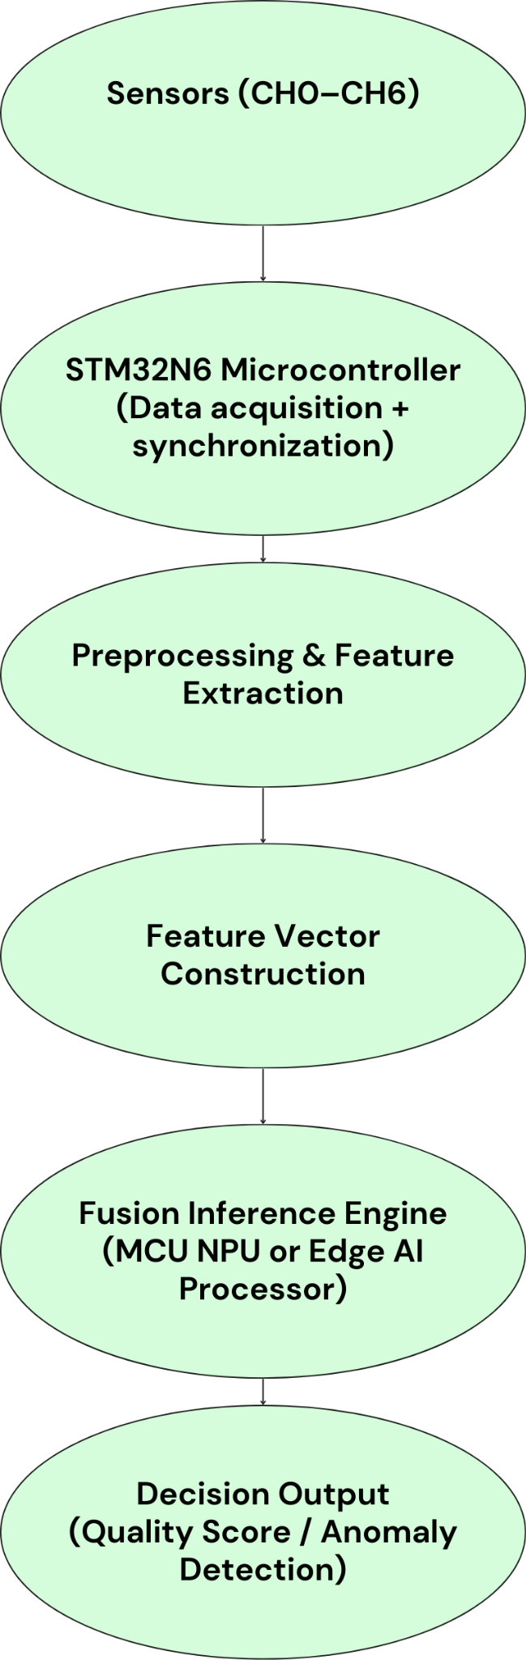

Role of STM32N6 in Fusion Processing
The STM32N6 microcontroller acts as the central coordination unit for sensor fusion.
Key responsibilities include:

Multi-Sensor Data Acquisition
- Collect data from analog and digital sensors
- Support multiple communication interfaces (I²C, SPI, UART, ADC)
- Timestamp sensor readings

Synchronization
Sensor readings must be aligned in time to ensure meaningful fusion.
Preprocessing
Preprocessing ensures sensor data is normalized and comparable.
Feature Extraction
Raw sensor signals are converted into compact features suitable for machine learning models.
Fusion Inference Approaches
Two main inference approaches can be used.

Edge-Level Fusion
The STM32N6 prepares the fused feature vector and sends it to an edge AI processor such as NVIDIA Jetson Orin.
Edge processor tasks:

run deep learning models

perform multimodal fusion

generate predictions

MCU-Level Fusion (TinyML)
The STM32N6 contains an Ethos-U55 Neural Processing Unit, allowing it to run lightweight machine learning models locally.
This allows quick decisions when edge compute resources are unavailable.

Advantages of Real-Time Fusion Inferencing
Advantage | Description
higher accuracy | combines complementary sensors
robustness | reduces false positives
faster decisions | local inference without cloud delay
scalable architecture | supports additional sensing channels
Several case studies of STM32N6-
https://www.st.com/content/st_com/en/st-edge-ai-suite/case-studies.html#page=1

