|  |  |  |  |
| --- | --- | --- | --- |
|  | Bansilal Ramnath Agarwal Charitable Trust's  Vishwakarma Institute of Information Technology  **Department of**  **Artificial Intelligence and Data Science** | | |
| Student Name: Shreyash Sanjay Rahinj | | | |
| Class: SY | Division: A | | Roll No: 271045 |
| Semester: 4th | | Academic Year: 2022-23 | |
| Subject Name & Code: Probability and Statistics | | | |
| Title of Assignment: Assignment 4 | | | |
| Date of Performance: / /2023 | | Date of Submission: / /2023 | |

Aim : To study Normal Distribution and solve the given problem

Problem Statement : Let us assume that the test scores an entrance exam fits a normal distribution where the mean test score is 67, and the standard deviation is 13.7. Calculate the percentage of students scoring 80 or more in the exam? (Normal distribution in R)

Background Information :

Code :

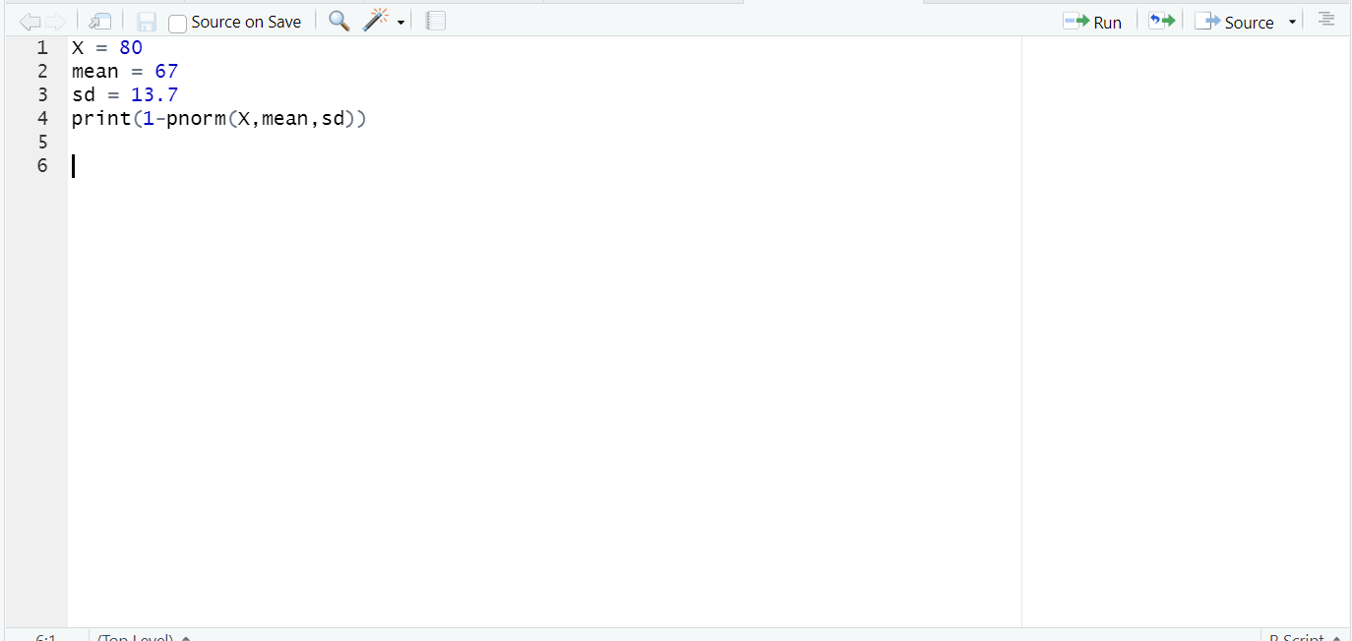

Results and output :

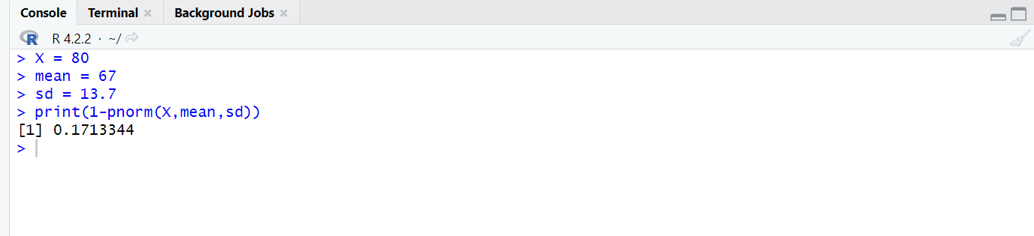

Conclusion :

Hence we have studied and understood the Normal distribution and solved the given problem statement using R-script and its inbuilt functions- pnorm,dnorm,rnorm,qnorm.