



|  |
| --- |
| Experiment No. 9 |
| Program to manipulate arrays using Numpy |
| Date of Performace: 10/04/2024 |
| Date of Submission: 17/04/2024 |





**9AA**

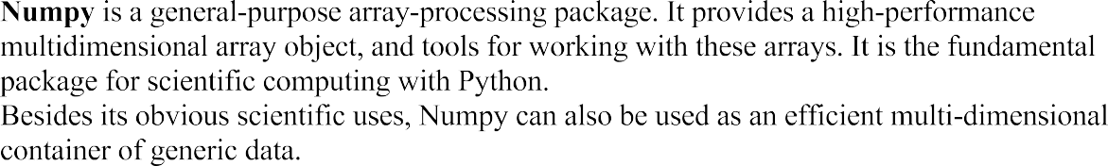

the array.An array class in Numpy is called as ndarray. Elements in Numpy arrays are accessed by using square brackets and can be initialized by using nested Python Lists.











**Code:**

import numpy as np

B=np.array([1,2,3,4,5])

print("The array is",B)

print("The element at index 2 is",B[2])

total=np.sum(B)

print("The sum of all elements in the array is",total)

**Output:**

The array is [1 2 3 4 5]

The element at index 2 is 3

The sum of all elements in the array is 15

**Conclusion:**

NumPy is a fundamental Python library for numerical computing. It provides support for large, multi-dimensional arrays and matrices, along with a collection of mathematical functions to operate on these arrays efficiently. NumPy's main object is the homogeneous multidimensional array. It is a table of elements (usually numbers), all of the same type, indexed by a tuple of non-negative integers. In NumPy, dimensions are called axes. NumPy arrays support advanced indexing techniques like slicing, boolean indexing, integer indexing, etc. NumPy integrates well with other Python libraries like SciPy (for scientific computing), Matplotlib (for data visualization), Pandas (for data manipulation and analysis), and more.