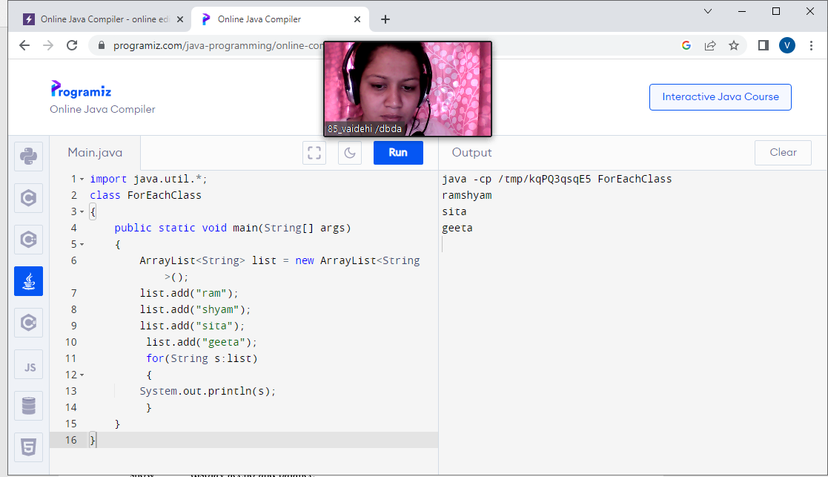

class GrandParent

{

String grandFartherName;

String grandMotherName;

GrandParent()

{

}

GrandParent(String GF , String GM)

{

this.GrandFatherName = GF;

this.GrandMotherName = GM ;

System.out.println("the name of grand Father is : +grandFatherName");

System.out.println("the name of grand Mother is : +grandMotherName");

}

}

class Parent extends GrandParents

{

String fatherName;

String MotherName;

Parents()

{

}

parent (string FN , String MN, String GF, String GM)

{

this(GF , GM);

this.fatherName = FN;

his.MotherName = MM;

System.out.println("the name of Father is : +FatherName");

System.out.println("the name of Mother is : +MotherName");

}

Parent(String grand_father , String grand_mothe)

{

super(grand_father, grand_mother);

}

}

class child extend parent

{

public static void main (string args[])

{

parent obj = new Parent("ram","shyam","seeta",""geeta)

}

}

class Shape

{

void draw()

{

system.out.println("drawing..")

}

class rectangle extends shape

{

void draw()

System.out.println("drawing rectangle")

}

class circle extends Shape

{

void draw()

System.out.println("drawing circle")

}

class traingle extends shape

{

void draw()

System.out.println("drawing triangle")

}

class testpoly

public static void main(String args[])

shape s;

s.draw();

s = new Circle();

s.draw();

s.new traingle();

s.draw();

}

}





