**Practical-4: INDEXING USING Mongodb**

**1. Mongo DB indexing**

a. Create index in Mongo DB

b. Finding the indexes in a collection

c. Drop indexes in a collection

d. Drop all the indexes

**use students**

**db.createCollection("studentgrades")**

**db.studentgrades.insertMany(**

**[**

**{name: "Pradd", subject: "Maths", score: 92},**

**{name: "Krish", subject: "Physics", score: 87},**

**{name: "Harsh", subject: "Maths", score: 99, notes: "Exceptional Performance"},**

**{name: "Aditya", subject: "Literature", score: 78},**

**{name: "Tarak", subject: "History", score: 65, notes: "Adequate"}**

**]**

**)**

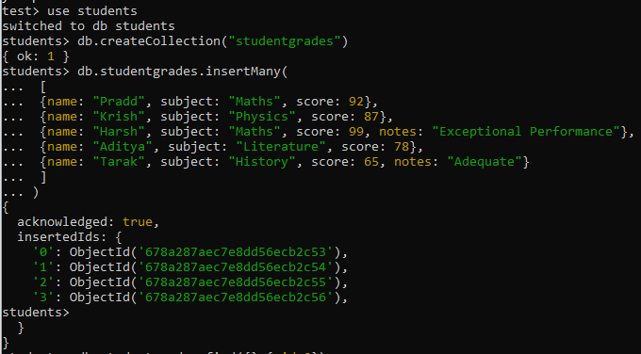

**db.studentgrades.find({},{_id:0})**

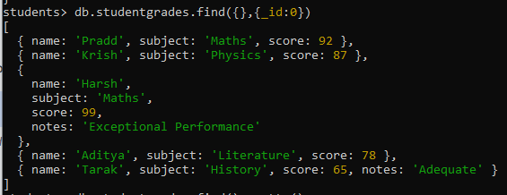

**db.studentgrades.find().pretty()**

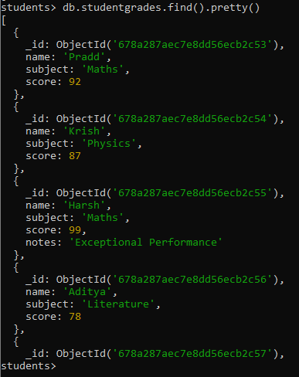

**db.studentgrades.createIndex( {name: 1}, {name: "Students Name Index"} )**

Finding indexes You can find all the available indexes in a MongoDB collection by using the getIndexes method. This will return all the indexes in a specific collection. db..getIndexes() Let’s view all the indexes in the studentgrades collection using the following command:

**db.studentgrades.getIndexes()**

Dropping indexes To delete an index from a collection, use the dropIndex method while specifying the index name to be dropped. db..dropIndex() Let’s remove the user-created index with the index name student name index, as shown below.

**db.studentgrades.dropIndex("Students Name Index")**

You can also use the index field value for removing an index without a defined name: **db.studentgrades.dropIndex({name:1})**

The dropIndexes command can also drop all the indexes excluding the default _id index. **db.studentgrades.dropIndexes()**

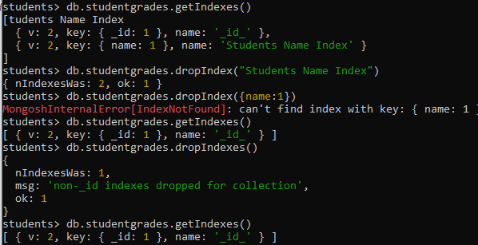

**Types of Indexing**

**use Student**

**switched to db Student**

**db.users.getIndexes()**

**[ { v: 2, key: { _id: 1 }, name:** '_id_' **} ]**

**db.users.createIndex({ "customer_id": 1 })**

**customer_id_1**

**db.users.getIndexes()**

**[**

**{ v: 2, key: { _id: 1 }, name:** '_id_' **},**

**{ v: 2, key: { customer_id: 1 }, name:** 'customer_id_1' **}**

**]**

**db.users.createIndex({"Item":1, "Quantity":-1})**

**Item_1_Quantity_-1**

**db.users.getIndexes()**

**[**

**{ v: 2, key: { _id: 1 }, name:** '_id_' **},**

**{ v: 2, key: { customer_id: 1 }, name:** 'customer_id_1' **},**

**{ v: 2, key: { Item: 1, Quantity: -1 }, name:** 'Item_1_Quantity_-1' **}**

**]**

**db.collection.createIndex({**

**"Category": "text",**

**"Item": "text",**

**"Payment Method": "text",**

**"Location": "text"**

**})**

**Category_text_Item_text_Payment Method_text_Location_text**

**db.collection.find({**

**$text: {**

**$search: "Debit"**

**}**

**})**

**db.collection.find({**

**$text: {**

**$search: "Debit Card"**

**}**

**})**

**db.users.find({**

**$text: {**

**$search: "Debit Card"**

**}**

**})**

[**MongoServerError[IndexNotFound]:**](https://mail.google.com/mail/u/0/?ui=2&ik=262bc0271c&view=lg&permmsgid=msg-a:r2387848324125522571#m_2208512505451122575_) **text index required for $text query**

**db.users.find({**

**$text: {**

**$search: "Debit Card"**

**}**

**})**

[**MongoServerError[IndexNotFound]:**](https://mail.google.com/mail/u/0/?ui=2&ik=262bc0271c&view=lg&permmsgid=msg-a:r2387848324125522571#m_2208512505451122575_) **text index required for $text query**

**db.users.find({**

**$text: { $search: "\"Debit Card\"" }**

**})**

[**MongoServerError[IndexNotFound]:**](https://mail.google.com/mail/u/0/?ui=2&ik=262bc0271c&view=lg&permmsgid=msg-a:r2387848324125522571#m_2208512505451122575_) **text index required for $text query**

**db.users.find({**

**$text: { $search: "Payment Method" }**

**})**

[**MongoServerError[IndexNotFound]:**](https://mail.google.com/mail/u/0/?ui=2&ik=262bc0271c&view=lg&permmsgid=msg-a:r2387848324125522571#m_2208512505451122575_) **text index required for $text query**

**db.users.createIndex({**

**"Category": "text",**

**"Item": "text",**

**"Payment Method": "text",**

**"Location": "text"**

**})**

**Category_text_Item_text_Payment Method_text_Location_text**

**db.users.getIndexes()**

**[**

**{ v: 2, key: { _id: 1 }, name:** '_id_' **},**

**{ v: 2, key: { customer_id: 1 }, name:** 'customer_id_1' **},**

**{ v: 2, key: { Item: 1, Quantity: -1 }, name:** 'Item_1_Quantity_-1' **},**

**{**

**v: 2,**

**key: { _fts:** 'text'**, _ftsx: 1 },**

**name:** 'Category_text_Item_text_Payment Method_text_Location_text'**,**

**weights: { Category: 1, Item: 1, Location: 1,** 'Payment Method'**: 1 },**

**default_language:** 'english'**,**

**language_override:** 'language'**,**

**textIndexVersion: 3**

**}**

**]**

**db.users.find({**

**$text: { $search: "Debit Card" }**

**}).limit(3)**

**{**

**_id: ObjectId(**'678a2534df3c769eedb75b1b'**),**

'Customer ID'**:** 'CUST_0003'**,**

**Category:** 'Gifts'**,**

**Item:** 'Gift Cards'**,**

**Quantity: 2,**

'Price Per Unit'**: 74.57,**

'Total Spent'**: 149.14,**

'Payment Method'**:** 'Debit Card'**,**

**Location:** 'Online'**,**

'Transaction Date'**:** '05-08-2023'

**}**

**{**

**_id: ObjectId(**'678a2534df3c769eedb75aa6'**),**

'Customer ID'**:** 'CUST_0019'**,**

**Category:** 'Gifts'**,**

**Item:** 'Gift Cards'**,**

**Quantity: 2,**

'Price Per Unit'**: 26.93,**

'Total Spent'**: 53.87,**

'Payment Method'**:** 'Credit Card'**,**

**Location:** 'Online'**,**

'Transaction Date'**:** '24-06-2024'

**}**

**{**

**_id: ObjectId(**'678a2534df3c769eedb759fd'**),**

'Customer ID'**:** 'CUST_0137'**,**

**Category:** 'Gifts'**,**

**Item:** 'Gift Cards'**,**

**Quantity: 2,**

'Price Per Unit'**: 67.89,**

'Total Spent'**: 135.77,**

'Payment Method'**:** 'Debit Card'**,**

**Location:** 'Mobile App'**,**

'Transaction Date'**:** '20-05-2024'

**}**

**db.users.createIndex({"Transaction Date":"hashed"})**

**Transaction Date_hashed**

**db.users.getIndexes()**

**[**

**{ v: 2, key: { _id: 1 }, name:** '_id_' **},**

**{ v: 2, key: { customer_id: 1 }, name:** 'customer_id_1' **},**

**{ v: 2, key: { Item: 1, Quantity: -1 }, name:** 'Item_1_Quantity_-1' **},**

**{**

**v: 2,**

**key: { _fts:** 'text'**, _ftsx: 1 },**

**name:** 'Category_text_Item_text_Payment Method_text_Location_text'**,**

**weights: { Category: 1, Item: 1, Location: 1,** 'Payment Method'**: 1 },**

**default_language:** 'english'**,**

**language_override:** 'language'**,**

**textIndexVersion: 3**

**},**

**{**

**v: 2,**

**key: {** 'Transaction Date'**:** 'hashed' **},**

**name:** 'Transaction Date_hashed'

**}**

**]**

**db.users.createIndex({"$**":1})**

**$**_1**

**db.users.getIndexes()**

**[**

**{ v: 2, key: { _id: 1 }, name:** '_id_' **},**

**{ v: 2, key: { customer_id: 1 }, name:** 'customer_id_1' **},**

**{ v: 2, key: { Item: 1, Quantity: -1 }, name:** 'Item_1_Quantity_-1' **},**

**{**

**v: 2,**

**key: { _fts:** 'text'**, _ftsx: 1 },**

**name:** 'Category_text_Item_text_Payment Method_text_Location_text'**,**

**weights: { Category: 1, Item: 1, Location: 1,** 'Payment Method'**: 1 },**

**default_language:** 'english'**,**

**language_override:** 'language'**,**

**textIndexVersion: 3**

**},**

**{**

**v: 2,**

**key: {** 'Transaction Date'**:** 'hashed' **},**

**name:** 'Transaction Date_hashed'

**},**

**{ v: 2, key: {** '$**'**: 1 }, name:** '$**_1' **}**

**]**

**db.users.creteIndex({"Transaction Date":1},{expireAfterSeconds:60})**

[**TypeError:**](https://mail.google.com/mail/u/0/?ui=2&ik=262bc0271c&view=lg&permmsgid=msg-a:r2387848324125522571#m_2208512505451122575_) **db.users.creteIndex is not a function**

**db.users.createIndex({"Transaction Date":1},{expireAfterSeconds:60})**

**Transaction Date_1**

**db.users.getIndexes()**

**[**

**{ v: 2, key: { _id: 1 }, name:** '_id_' **},**

**{ v: 2, key: { customer_id: 1 }, name:** 'customer_id_1' **},**

**{ v: 2, key: { Item: 1, Quantity: -1 }, name:** 'Item_1_Quantity_-1' **},**

**{**

**v: 2,**

**key: { _fts:** 'text'**, _ftsx: 1 },**

**name:** 'Category_text_Item_text_Payment Method_text_Location_text'**,**

**weights: { Category: 1, Item: 1, Location: 1,** 'Payment Method'**: 1 },**

**default_language:** 'english'**,**

**language_override:** 'language'**,**

**textIndexVersion: 3**

**},**

**{**

**v: 2,**

**key: {** 'Transaction Date'**:** 'hashed' **},**

**name:** 'Transaction Date_hashed'

**},**

**{ v: 2, key: {** '$**'**: 1 }, name:** '$**_1' **},**

**{**

**v: 2,**

**key: {** 'Transaction Date'**: 1 },**

**name:** 'Transaction Date_1'**,**

**expireAfterSeconds: 60**

**}**

**]**

**db.users.createIndex({"Payment Method":1},{partialFilterExpression:{"Payment Method":{$eq:"Debit Card"}}})**

**Payment Method_1**

**db.users.find({"Payment Method":"Debit Card"}).limit(3)**

**{**

**_id: ObjectId(**'678a2534df3c769eedb734aa'**),**

'Customer ID'**:** 'CUST_0159'**,**

**Category:** 'Groceries'**,**

**Item:** 'Milk'**,**

**Quantity: 1,**

'Price Per Unit'**: 1.28,**

'Total Spent'**: 1.28,**

'Payment Method'**:** 'Debit Card'**,**

**Location:** 'Mobile App'**,**

'Transaction Date'**:** '13-11-2024'

**}**

**{**

**_id: ObjectId(**'678a2534df3c769eedb734ab'**),**

'Customer ID'**:** 'CUST_0017'**,**

**Category:** 'Friend Activities'**,**

**Item:** 'Dinner with Friends'**,**

**Quantity: 2,**

'Price Per Unit'**: 74.69,**

'Total Spent'**: 149.39,**

'Payment Method'**:** 'Debit Card'**,**

**Location:** 'In-store'**,**

'Transaction Date'**:** '04-05-2023'

**}**

**{**

**_id: ObjectId(**'678a2534df3c769eedb734ae'**),**

'Customer ID'**:** 'CUST_0129'**,**

**Category:** 'Gifts'**,**

**Item:** 'Flowers'**,**

**Quantity: 3,**

'Price Per Unit'**: 43.71,**

'Total Spent'**: 131.12,**

'Payment Method'**:** 'Debit Card'**,**

**Location:** 'In-store'**,**

'Transaction Date'**:** '28-07-2023'

**}**

**db.users.createIndex({"Customer ID":1},{unique:true})**

[**MongoServerError[DuplicateKey]:**](https://mail.google.com/mail/u/0/?ui=2&ik=262bc0271c&view=lg&permmsgid=msg-a:r2387848324125522571#m_2208512505451122575_) **Index build failed: 747a08b2-070c-42f0-b50e-1daa767247d5: Collection Student.users ( 37364d2a-7796-451e-8148-b652dfd21c95 ) :: caused by :: E11000 duplicate key error collection: Student.users index: Customer ID_1 dup key: { Customer ID: "CUST_0001" }**

**db.collection.createIndex({ "Location": 1 }, { sparse: true })**

**Location_1**

**db.collection.find({ "Location": "In-store" }).limit(3)**

**db.collection.find({ "Location": "In-store" }).limit(3)**

**db.users.find({ "Location": "In-store" }).limit(3)**

**{**

**_id: ObjectId(**'678a2534df3c769eedb734ab'**),**

'Customer ID'**:** 'CUST_0017'**,**

**Category:** 'Friend Activities'**,**

**Item:** 'Dinner with Friends'**,**

**Quantity: 2,**

'Price Per Unit'**: 74.69,**

'Total Spent'**: 149.39,**

'Payment Method'**:** 'Debit Card'**,**

**Location:** 'In-store'**,**

'Transaction Date'**:** '04-05-2023'

**}**

**{**

**_id: ObjectId(**'678a2534df3c769eedb734ad'**),**

'Customer ID'**:** 'CUST_0162'**,**

**Category:** 'Fitness'**,**

**Item:** 'Yoga Class'**,**

**Quantity: 5,**

'Price Per Unit'**: 11.24,**

'Total Spent'**: 56.18,**

'Payment Method'**:** 'Cash'**,**

**Location:** 'In-store'**,**

'Transaction Date'**:** '28-01-2024'

**}**

**{**

**_id: ObjectId(**'678a2534df3c769eedb734ae'**),**

'Customer ID'**:** 'CUST_0129'**,**

**Category:** 'Gifts'**,**

**Item:** 'Flowers'**,**

**Quantity: 3,**

'Price Per Unit'**: 43.71,**

'Total Spent'**: 131.12,**

'Payment Method'**:** 'Debit Card'**,**

**Location:** 'In-store'**,**

'Transaction Date'**:** '28-07-2023'

**}**

**db.users.find({ "Location": "Mobile App" }).limit(3)**

**{**

**_id: ObjectId(**'678a2534df3c769eedb734aa'**),**

'Customer ID'**:** 'CUST_0159'**,**

**Category:** 'Groceries'**,**

**Item:** 'Milk'**,**

**Quantity: 1,**

'Price Per Unit'**: 1.28,**

'Total Spent'**: 1.28,**

'Payment Method'**:** 'Debit Card'**,**

**Location:** 'Mobile App'**,**

'Transaction Date'**:** '13-11-2024'

**}**

**{**

**_id: ObjectId(**'678a2534df3c769eedb734ac'**),**

'Customer ID'**:** 'CUST_0094'**,**

**Category:** 'Housing and Utilities'**,**

**Item:** 'Water Bill'**,**

**Quantity: 1,**

'Price Per Unit'**: 76.06,**

'Total Spent'**: 76.06,**

'Payment Method'**:** 'Digital Wallet'**,**

**Location:** 'Mobile App'**,**

'Transaction Date'**:** '16-12-2023'

**}**

**{**

**_id: ObjectId(**'678a2534df3c769eedb734af'**),**

'Customer ID'**:** 'CUST_0071'**,**

**Category:** 'Gifts'**,**

**Item:** 'Flowers'**,**

**Quantity: 2,**

'Price Per Unit'**: 15.87,**

'Total Spent'**: 31.74,**

'Payment Method'**:** 'Digital Wallet'**,**

**Location:** 'Mobile App'**,**

'Transaction Date'**:** '14-07-2024'

**}**

**use students**

**switched to db students**

**db.createCollection("studentgrades")**

**{ ok: 1 }**

**db.studentgrades.insertMany(**

**[**

**{name: "Barry", subject: "Maths", score: 92},**

**{name: "Kent", subject: "Physics", score: 87},**

**{name: "Harry", subject: "Maths", score: 99, notes: "Exceptional Performance"},**

**{name: "Alex", subject: "Literature", score: 78},**

**{name: "Tom", subject: "History", score: 65, notes: "Adequate"}**

**]**

**)**

**{**

**acknowledged: true,**

**insertedIds: {**

'0'**: ObjectId(**'678a329e39591fc12dcbd6a3'**),**

'1'**: ObjectId(**'678a329e39591fc12dcbd6a4'**),**

'2'**: ObjectId(**'678a329e39591fc12dcbd6a5'**),**

'3'**: ObjectId(**'678a329e39591fc12dcbd6a6'**),**

'4'**: ObjectId(**'678a329e39591fc12dcbd6a7'**)**

**}**

**}**

**db.studentgrades.find({},{_id:0})**

**{**

**name:** 'Barry'**,**

**subject:** 'Maths'**,**

**score: 92**

**}**

**{**

**name:** 'Kent'**,**

**subject:** 'Physics'**,**

**score: 87**

**}**

**{**

**name:** 'Harry'**,**

**subject:** 'Maths'**,**

**score: 99,**

**notes:** 'Exceptional Performance'

**}**

**{**

**name:** 'Alex'**,**

**subject:** 'Literature'**,**

**score: 78**

**}**

**{**

**name:** 'Tom'**,**

**subject:** 'History'**,**

**score: 65,**

**notes:** 'Adequate'

**}**

**db.studentgrades.find().pretty()**

**{**

**_id: ObjectId(**'678a329e39591fc12dcbd6a3'**),**

**name:** 'Barry'**,**

**subject:** 'Maths'**,**

**score: 92**

**}**

**{**

**_id: ObjectId(**'678a329e39591fc12dcbd6a4'**),**

**name:** 'Kent'**,**

**subject:** 'Physics'**,**

**score: 87**

**}**

**{**

**_id: ObjectId(**'678a329e39591fc12dcbd6a5'**),**

**name:** 'Harry'**,**

**subject:** 'Maths'**,**

**score: 99,**

**notes:** 'Exceptional Performance'

**}**

**{**

**_id: ObjectId(**'678a329e39591fc12dcbd6a6'**),**

**name:** 'Alex'**,**

**subject:** 'Literature'**,**

**score: 78**

**}**

**{**

**_id: ObjectId(**'678a329e39591fc12dcbd6a7'**),**

**name:** 'Tom'**,**

**subject:** 'History'**,**

**score: 65,**

**notes:** 'Adequate'

**}**

**db.studentgrades.createIndex( {name: 1}, {name: "student name index"} )**

**student name index**

**db.studentgrades.getIndexes()**

**[**

**{ v: 2, key: { _id: 1 }, name:** '_id_' **},**

**{ v: 2, key: { name: 1 }, name:** 'student name index' **}**

**]**

**db.studentgrades.dropIndex("student name index")**

**{ nIndexesWas: 2, ok: 1 }**

**db.studentgrades.dropIndex({name:1})**

[**MongoServerError[IndexNotFound]:**](https://mail.google.com/mail/u/0/?ui=2&ik=262bc0271c&view=lg&permmsgid=msg-a:r2387848324125522571#m_2208512505451122575_) **can't find index with key: { name: 1 }**

**students**