**Practical 6 : Replication**

Step1: Make one mane folder in windows C and inside that folder make 3 folders name: primary, secondary, secondary1.

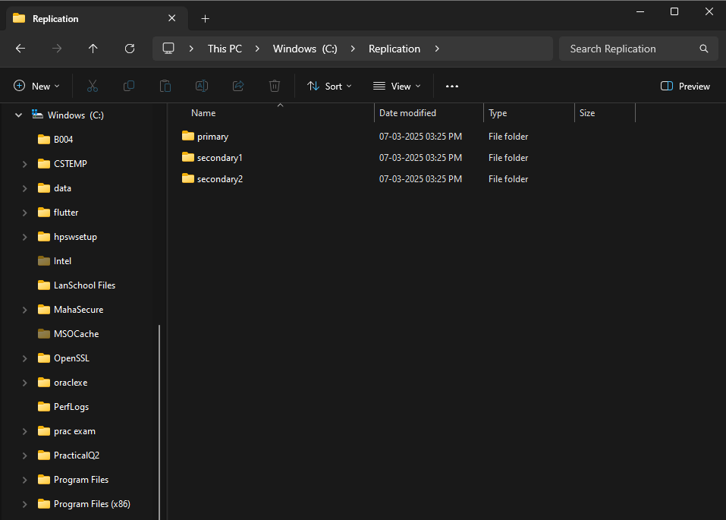

Step2: Open cmd different for each that is total 3.

1. For Primary

mongod --port=2717 --dbpath="C:\Replication\primary" --replSet="test-replica-set"

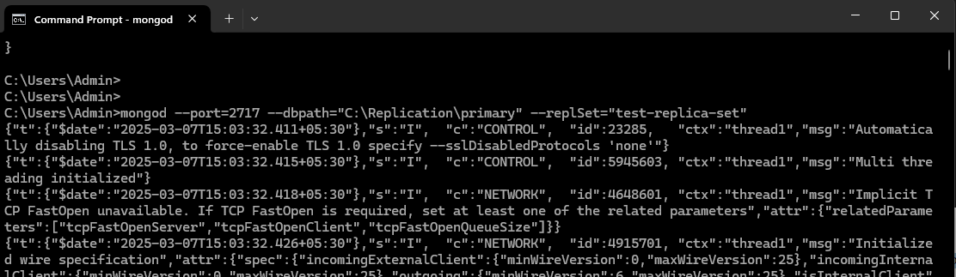

1. For Secondary

mongod --port=2727 --dbpath="C:\Replication\secondary" --replSet="test-replica-set"

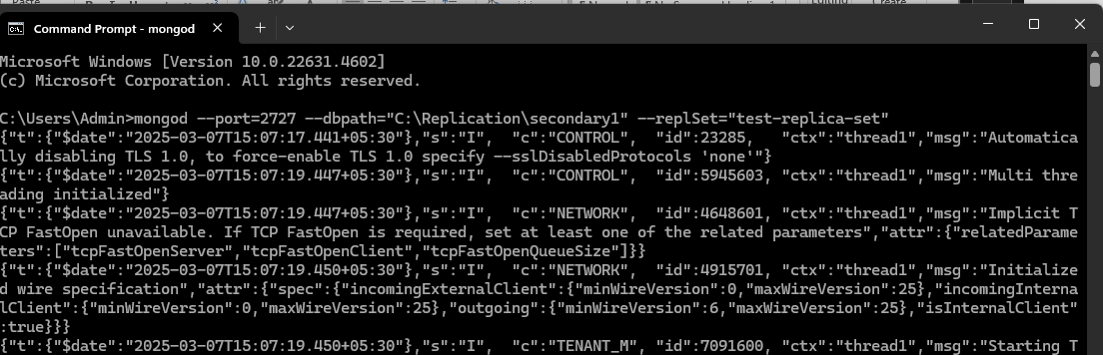

1. For Secondary1

mongod --port=2727 --dbpath="C:\Replication\secondary1" --replSet="test-replica-set"

Step 3:

Open Windows Power shell 1st window

mongosh --host="localhost2717"

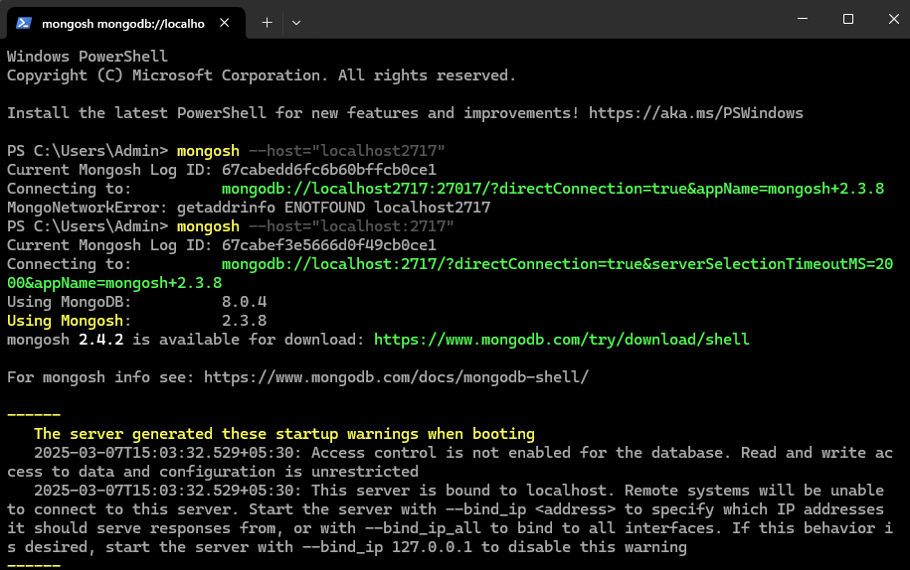

rs.initiate()

rs.add({host:"localhost:2727"})

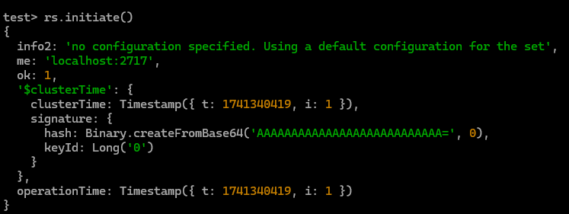

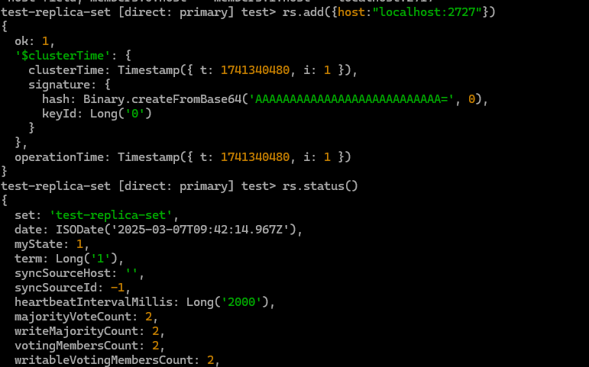

Step 3:

To check if both the ports are available

rs.status()

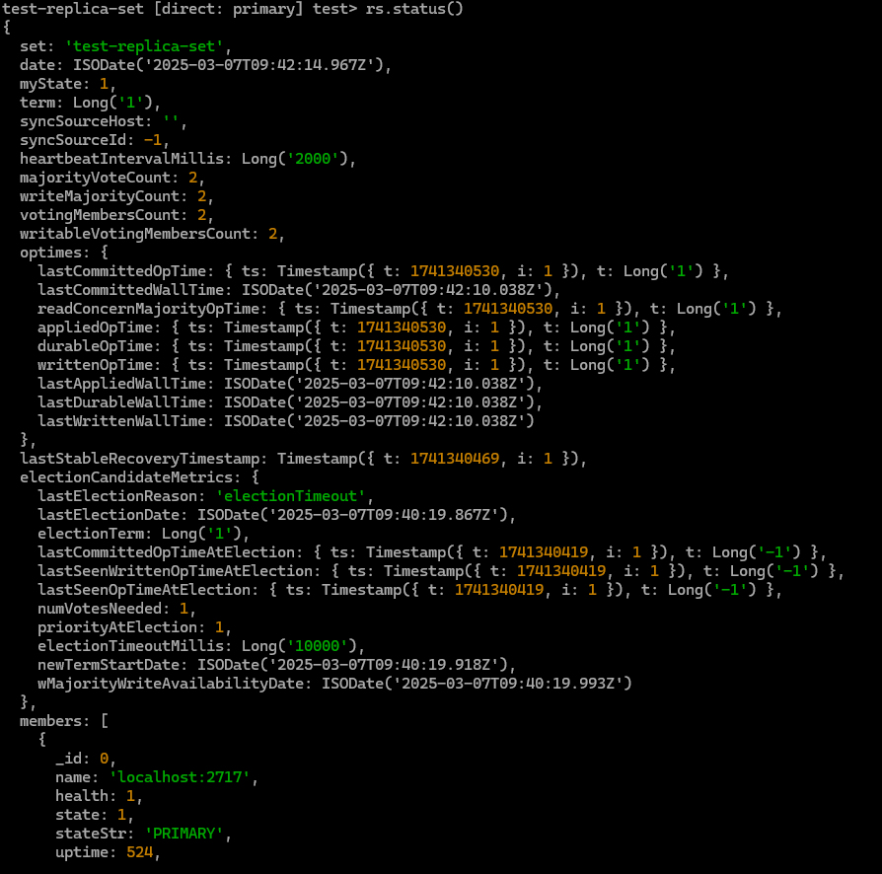

Creating instance for secondary1 and secondary2

Now open another power shell window

mongosh --host="localhost:2727"

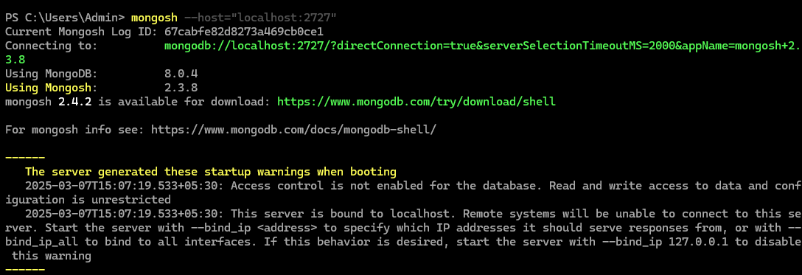

Open the 3rd powershell window

mongosh --host="localhost:2737"

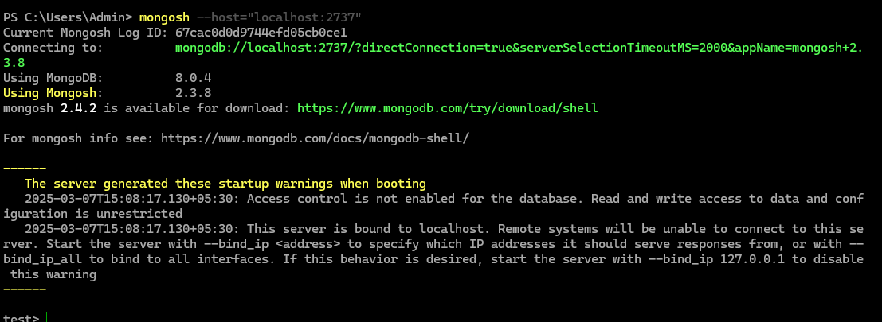

First we see all the servers have same database using **show dbs** command

Creating database Practical and performing CRUD operations

Insertion of data

Now go to the power shell of primary

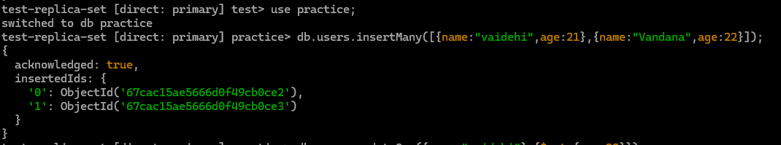

Here we are creating a database in primary

Now Checking if the file is replicated in secondary server

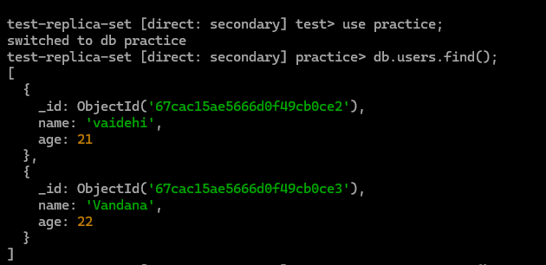

Now Updating the data in the primary

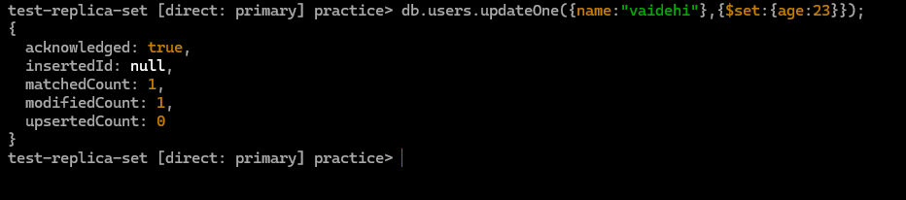

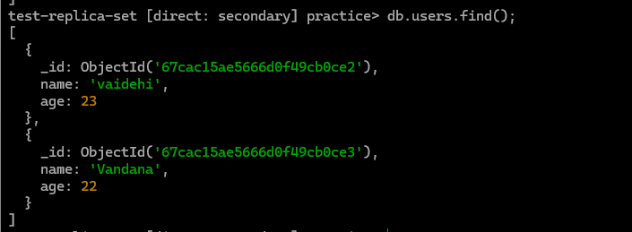

Deleting Data



