1. **3 files with different delimiters**

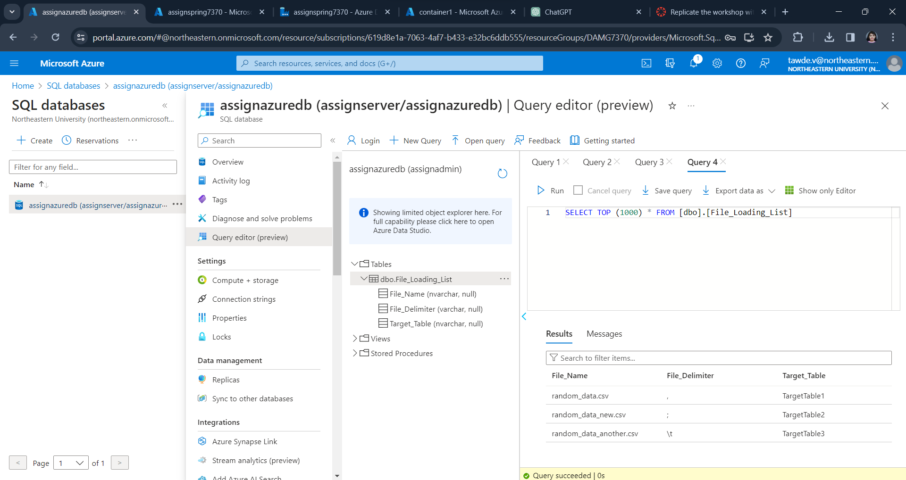

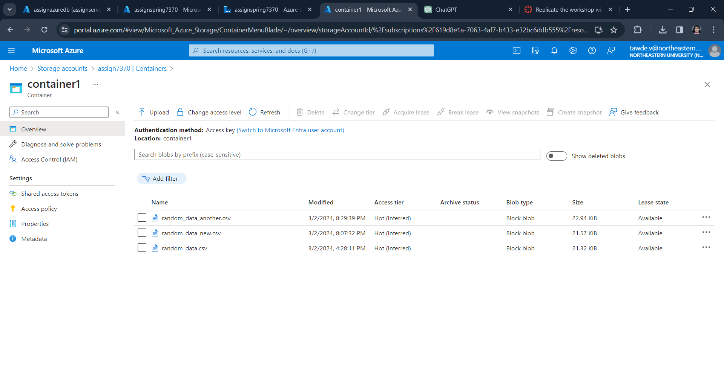

1. **Screenshot of table File_Loading_List**



1. **Screenshot of 3 files loaded to ADLS2**



1. **Screenshot of Adf Pipeline successfull run**

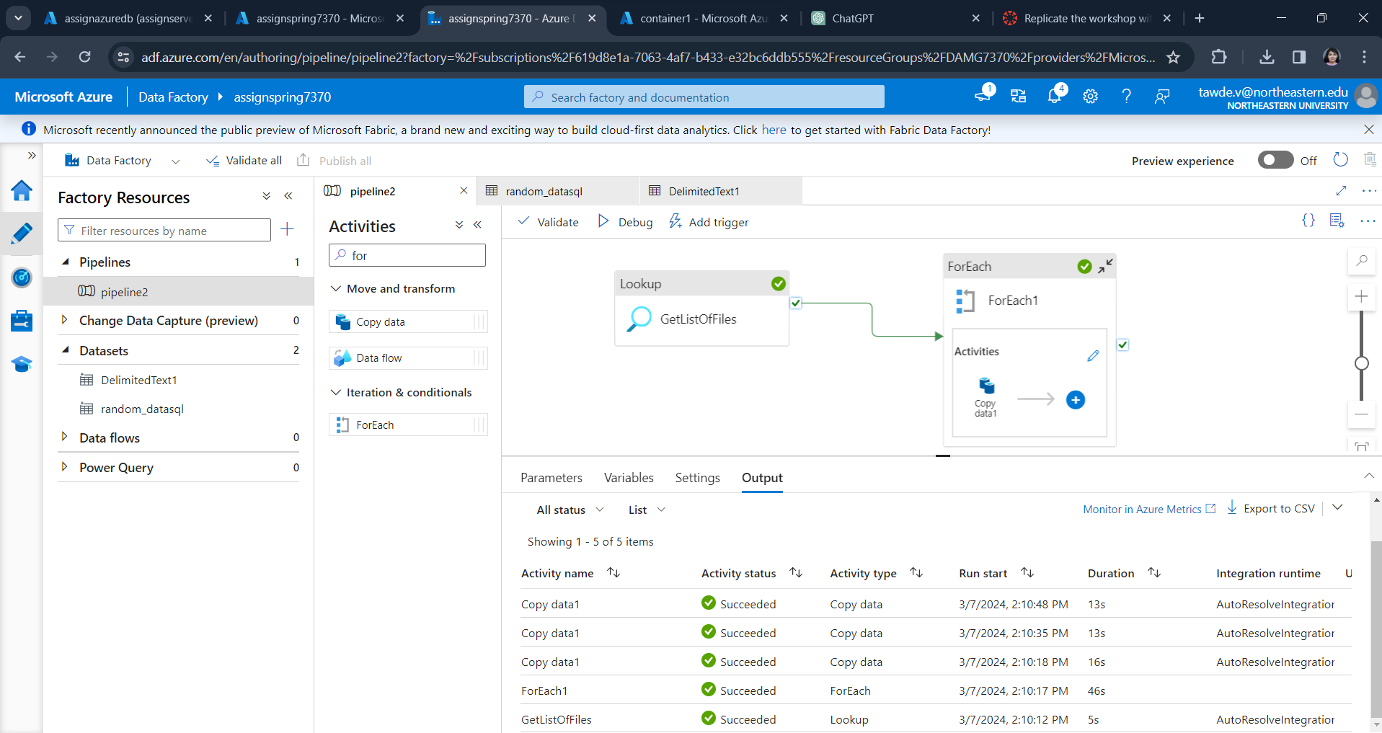

1. **Screenshot of configuration of Lookup Activity**

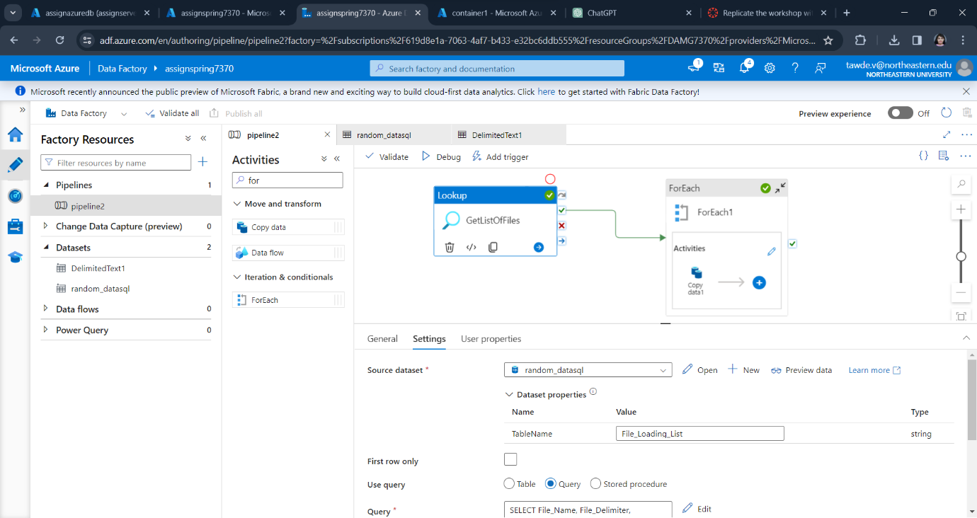

1. **Screenshot of configuration of Copy Activity**

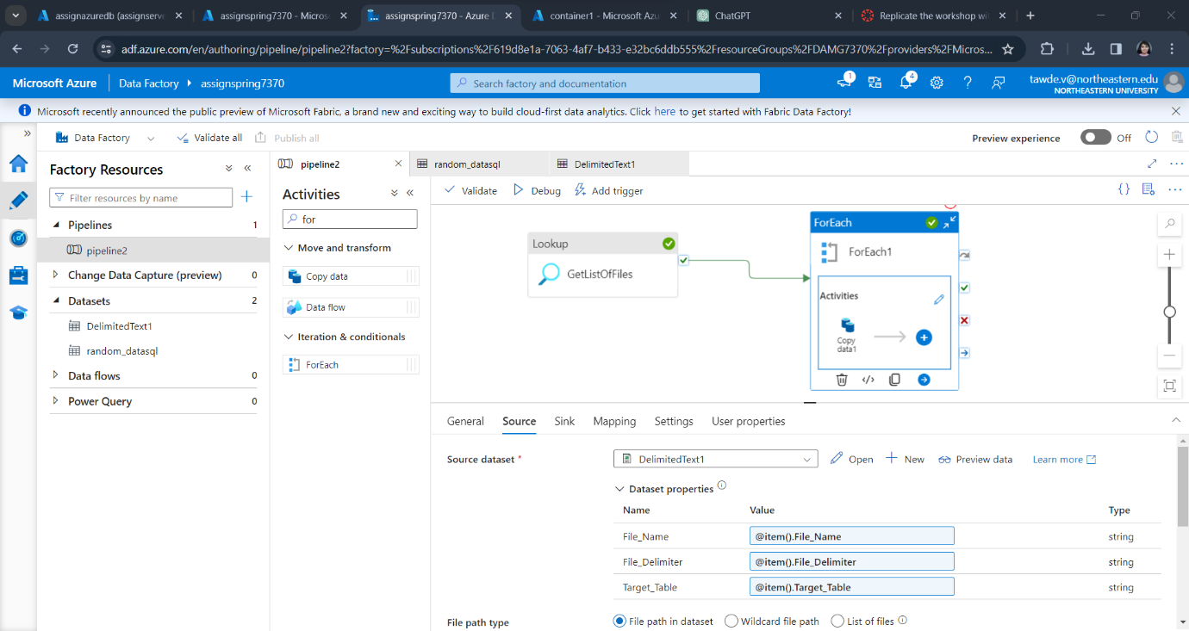

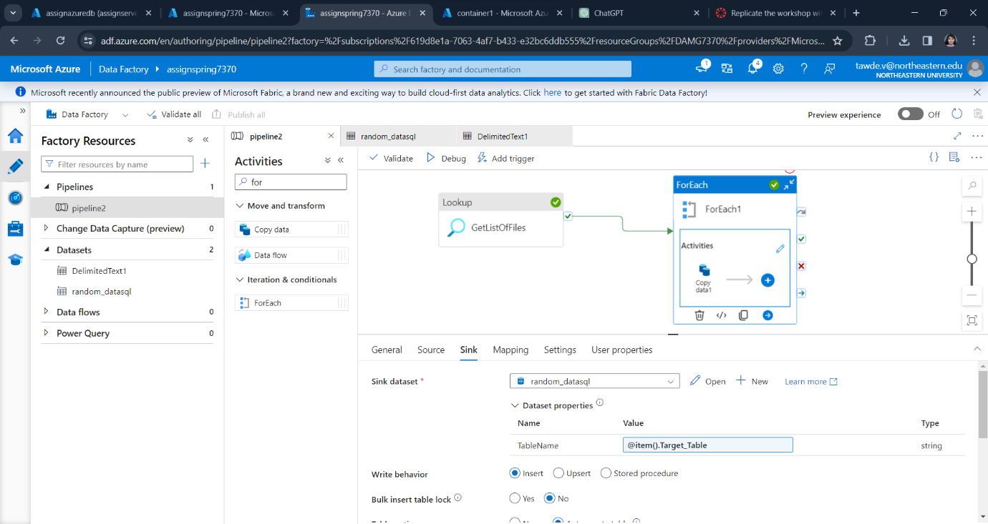

1. **Output Screenshot of Target tables**

