# Neural Networks: Core Concepts and Applications

## Core Concepts of Neural Networks

Neural networks are foundational to machine learning, emulating the human brain’s structure to process data. At their core are perceptrons, the building blocks that classify data into two classes. Activation functions introduce non-linearity, crucial for capturing complex patterns, while loss functions measure prediction accuracy, guiding model optimization through backpropagation, which adjusts weights to minimize errors.

**Key Concepts:** - **Perceptrons:** Basic units for binary classification. - **Activation Functions:** Introduce non-linearity for complex pattern recognition. - **Loss Functions:** Measure prediction errors, essential for optimization. - **Backpropagation:** Adjusts weights using gradient descent for accuracy improvement.

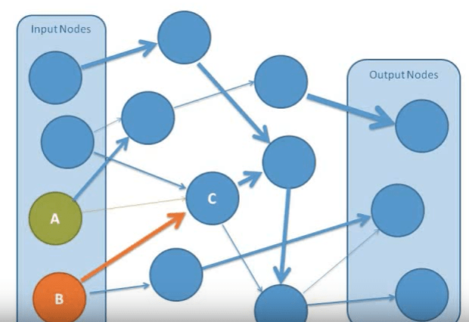

neural_network_concepts

## Neural Network Architectures

Architectures are tailored for specific tasks: - **Feedforward Networks:** Process data in one direction for simple tasks. - **CNNs:** Excel in image processing with convolutional layers. - **RNNs/LSTMs:** Handle sequential data, like text or speech. - **Transformers:** Revolutionize NLP with attention mechanisms.

**Key Architectures:** - **CNNs:** Used in image recognition. - **RNNs/LSTMs:** Ideal for sequential data. - **Transformers:** Advanced NLP applications.

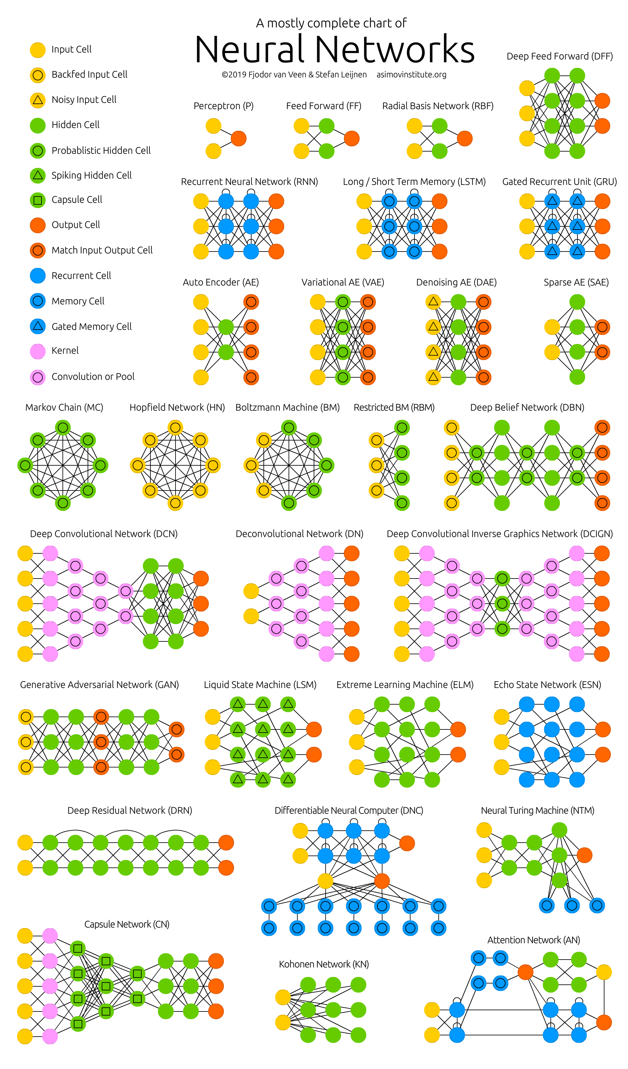

neural_network_architectures

## Transfer Learning and Fine-Tuning

Transfer learning leverages pre-trained models for efficiency, reducing training time and data needs. Fine-tuning adapts models to specific tasks, balancing performance and resource use.

**Considerations:** - **When to Use:** Saves time and data. - **Trade-offs:** Balance between performance and overfitting.

## Metrics and Pitfalls

Evaluating neural networks involves metrics like accuracy and inference latency. Challenges include overfitting, interpretability issues, and data biases.

**Key Metrics:** - **Accuracy:** Measures prediction correctness. - **Latency:** Indicates inference speed. - **GPU Hours:** Reflects computational effort.

**Common Pitfalls:** - **Overfitting:** Models perform well on training data but poorly on new data. - **Interpretability:** Complex models can be difficult to interpret. - **Data Biases:** Models may reflect training data biases.



metrics_pitfalls

## Applications of Neural Networks

Neural networks drive advancements in: - **Medical Imaging:** Enhancing diagnosis accuracy. - **NLP:** Revolutionizing text processing. - **Autonomous Vehicles:** Improving safety and navigation. - **Fraud Detection:** Identifying anomalies in transactions. - **Recommendation Systems:** Personalizing user experiences. - **Data Augmentation:** Enhancing datasets for better model training.

**Real-World Examples:** - **Medical Imaging:** Detecting diseases like cancer more accurately. - **Autonomous Vehicles:** Processing sensory data for real-time decisions. - **Fraud Detection:** Identifying fraudulent transactions efficiently.

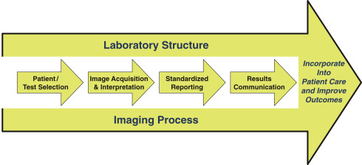

medical_imaging_process_flow

## Reflection Questions

* How might neural networks address challenges in your industry?
* What data challenges might your organization face?

## Further Reading

1. [8 Key Concepts In Neural Networks Explained](https://arunangshudas.com/blog/8-key-concepts-in-neural-networks-explained/)
2. [Deep Learning in a Nutshell: Core Concepts](https://developer.nvidia.com/blog/deep-learning-nutshell-core-concepts/)
3. [Loss Functions and Their Use In Neural Networks](https://towardsdatascience.com/loss-functions-and-their-use-in-neural-networks-a470e703f1e9/)

https://medium.com/accredian