**NAME: KAVA VAIDIK**

**ASSIGNMENT: MODULE (1) SE – OVERVIEW OF IT INDUSTRY**

**INSTITUTE: TOPS TECHNOLOGIES**

**QUE. 1: What is software? What is software engineering**

* Software is a generic term used to refer to applications, scripts and programs that run on a device. It can be thought of as the variable part of computer, while hardware is the invariable part. The two main categories of software are application software and system software.
* Software engineering is the branch of computer science that deals with the design, development, testing and maintenance of software applications. Software engineers apply engineering principles and knowledge of programming languages to build software solutions for end users.

**QUE. 2: Explain types of software**

1. *Application software:*

Application software is a type of computer program that performs a specific personal educational, and business function

1. *System software:*

System software is a type of computer program that is designed to run a computer’s hardware and application programs.

1. *Driver software*

A driver is a software component that lets the operating system and a device communicate.

1. *Programming software*

Programing software is a tool for creating computer code that allows computer software to operate.

**QUE. 3: What is SDLC? Explain each phase of SDLC**

* The SDLC is the cost-effective and time-efficient process that development terms use to design and build high-quality software.

1. Planning:

* Objective: Define the task scope, goals and feasibility.
* Activities: identify resources, set up mission schedules, estimate costs and expand a venture plan.
* Outcome: project constitution, feasibility look at and mission plan.

1. Requirements analysis:

* Objective: Gather and examine commercial enterprise requirement.
* Activities: conduct stakeholder interviews, surveys, and record analysis to collect requirements. Create requirement spects.
* Outcome: requirement’s specification record, use case diagram, and consumer stories.

1. Design:

* Objective: define the software program architecture and layout
* Activities: create device architecture, statistics models, interface designs and distinct layout spacifications.
* Outcome: system layout record, architecture layout, and database scheme

1. Implementation(coding):

* Objective: transform design files into functional software program.
* Activities: write code, carry out unit checking out, and integrate specific modules.
* Outcome: source code, unit check reviews, and software builds.

1. Testing:

* Objective: ensure the software is disorder-free and meets the specified requirement
* Activities: execute diverce testing sorts, such as unit testing, integration testing, machine testing, and person acceptance checking out (UAT).
* Outcome: test plans, check instances, computer virus reports and take a look at summary report.

1. Deployment:

* Objective: deploy the software program to a production environment
* Activities: install and configure the software program, perform very last trying out and ensure the gadget is prepared for use.
* Outcome: deployed software program, installation courses and deployment reviews.

1. Maintenance:

* Objective: provide on going guide and improvements.
* Activities: monitor the gadget for troubles, perform trojan horse fixes, and enforce improvements based totally on user remarks.
* Outcome: updated software program versions, maintenance review, and enhancement files.

**QUE. 4: What is DFD? Create a DFD diagram on Flipkart**

* A data flow diagram (DFD) is a graphical or visual representation using a standardized set of symbols and notations to describe a business’s operations through data movement
* A data flow diagram is a way of reprenting a flow of data through a process or a system. The DFD also provides information about the outputs and inputs of each entity and the process itself.

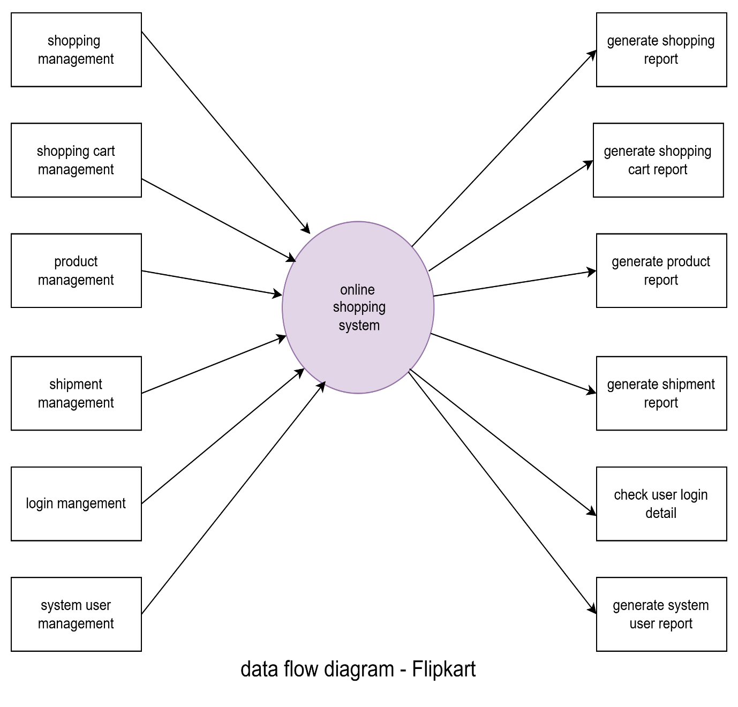

**QUE. 5: What is flow chart? Create a flowchart to make addition of two numbers**

* A flowchart is a diagram that depicts a process, system od computer algorithm. They are widely used in multiple fields to document, study, plans, improve and communicate often complex processes in clear, easy-to-understand diagrams.
* Flowchart of additions of two numbers.

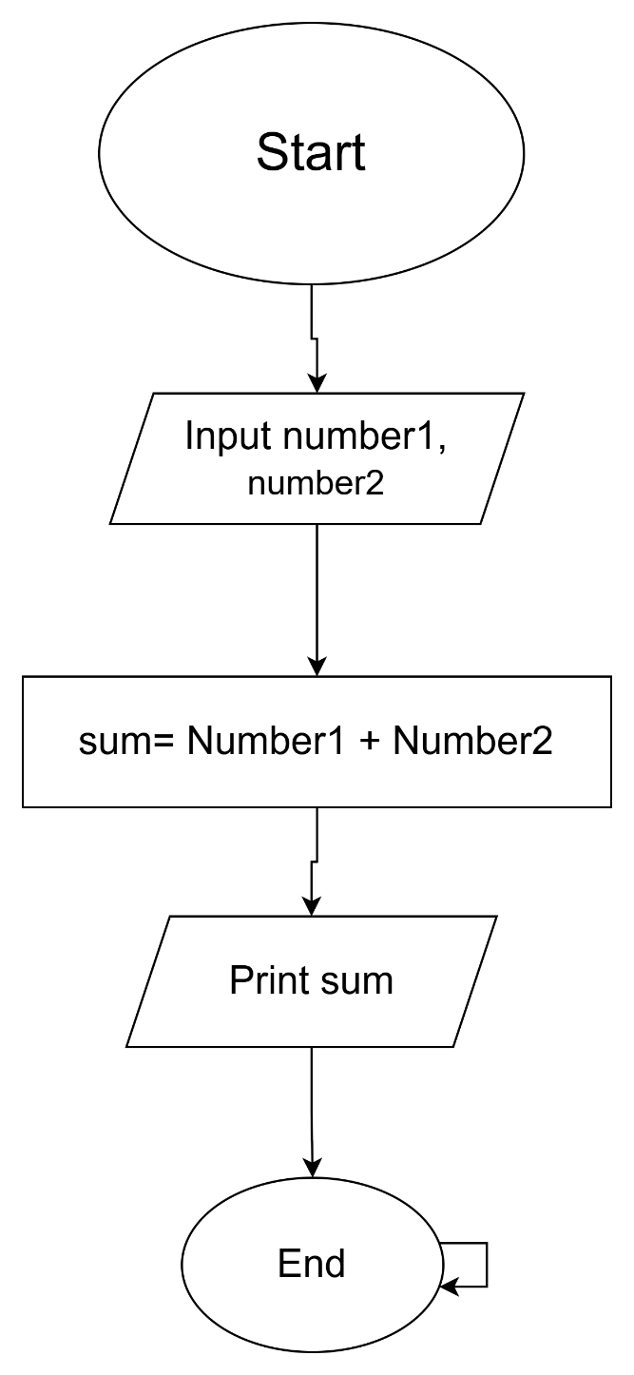

**QUE. 6: What is use case diagram? Create a use case on bill payment on paytm**

Use-case diagram describe the high-level functions and scope of a system. These diagrams also identify the interactions between the system and its actors. The use-cases and actors in use-case diagram describe what the system does and how the actors use it, but not how the system operates internally. 