1. Introduction
1.1 Problem Statement
In the era of digitalization, consumers prefer to purchase goods online rather than through traditional retail channels. However, many small-scale businesses and eco-friendly product sellers lack a unified and user-friendly digital platform to showcase their products effectively. The main problem is the absence of a system that allows users to browse available products, add them to a shopping cart, and proceed to checkout seamlessly while maintaining proper database connectivity and product management. This project aims to design and implement a database-driven e-commerce web application that provides an intuitive user interface for customers and ensures efficient backend data handling through MongoDB.
1.2 Objective of the Project
The main objectives of the project are as follows:
- To design and develop a full-stack web-based e-commerce system using Node.js, Express, MongoDB, and JavaScript.[1][2]
- To store and retrieve product information dynamically from a database.
- To enable users to browse products, add them to a cart, and manage their selections.
- To implement a checkout feature for entering user details and confirming orders.
- To ensure a responsive, clean, and interactive frontend interface.
- To demonstrate database connectivity, CRUD operations, and real-time data handling in a practical DBMS-based application.[1]
1.3 Scope of the Project
The scope of this project includes the development of a mini e-commerce platform that connects the frontend interface with a backend database.
It focuses on:
- Building a user-friendly interface to display and organize products.
- Establishing data communication between the frontend (HTML, CSS, JS) and backend (Node.js, Express).[2][3]
- Using MongoDB for product storage and retrieval, ensuring scalability and efficiency.
- Implementing essential features like product listing, cart management, and checkout.
- Providing a foundation for future enhancements such as payment integration, order history, and admin dashboards.
This project demonstrates the integration of web technologies with database systems to create a functional, real-world online shopping application.

2. Methodology
The methodology followed in the development of this project is structured in a systematic manner, involving several key stages from problem identification to system implementation and testing. The development process integrates both frontend and backend technologies, ensuring efficient database connectivity and user interaction.
2.1 Steps Involved
- Problem Identification
The growing need for an online platform where users can browse, compare, and purchase products conveniently was identified as the central problem.
- System Design and Planning
The project was planned to use a modular architecture — separating the frontend (UI), backend (server logic), and database (MongoDB).[1]
The schema design focused on storing key product attributes such as title, price, category, image URL, and description.
- Frontend Development
The user interface was created using HTML, CSS, and JavaScript.[3]
The frontend allows users to:
  - View dynamically loaded products,
  - Add items to a cart, and
  - Proceed to checkout.
- Backend Development
The backend was built using Node.js and Express.js.[2]
APIs were created to:
  - Retrieve product listings from MongoDB,
  - Manage data operations (CRUD), and
  - Connect the user interface with the database.
- Database Design
MongoDB was used to store product data in collections. Each product document contains attributes like title, category, image URL, price, and stock quantity.
- Execution Flow
When the user loads the page:
  - The system fetches product data from the backend API.
  - Products are displayed dynamically.
  - The user can add items to the cart (saved in LocalStorage).
  - The cart page summarizes all selected items and total cost.

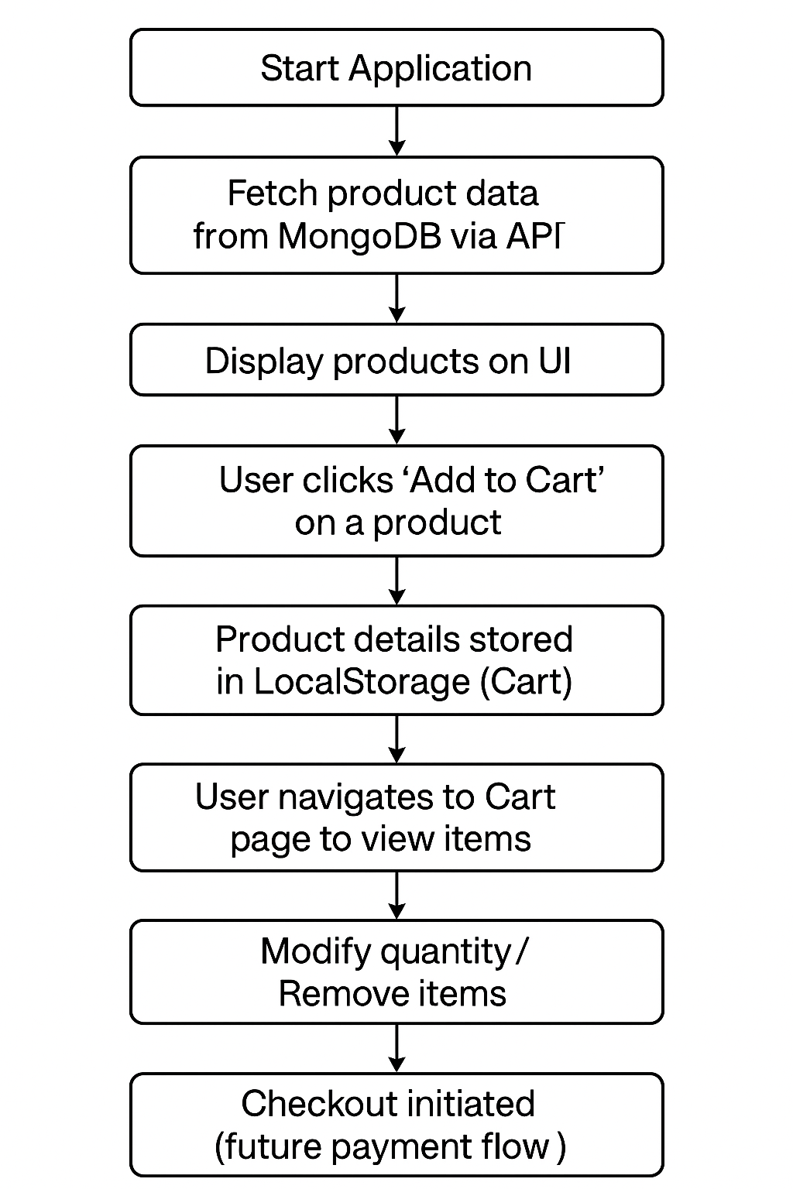
3. Flowchart
4. Conclusion and Future Scope
6.1 Conclusion
The project “E-Commerce Product Store using Node.js and MongoDB” successfully demonstrates the integration of database management with full-stack web development.
It provides a complete solution where users can view products, add them to a cart, and proceed through a checkout process.
By combining technologies like Node.js, Express, MongoDB, and Vanilla JavaScript, the system offers dynamic data handling and an interactive shopping experience.
6.2 Future Scope
In the future, this project can be extended by integrating:
- A secure payment gateway (Razor pay/Stripe),
- User authentication for personalized experiences,
- An admin panel for managing inventory and orders, and
- Cloud deployment for online accessibility.
This project bridges theoretical DBMS concepts with practical implementation, showcasing how database-backed systems can power efficient and user-friendly web applications.

References
- MongoDB Documentation, “CRUD Operations — MongoDB Manual”, MongoDB Inc., 2025. [Online]. Available: https://www.mongodb.com/docs/manual/crud/
- Express.js Foundation, “Express — Node.js web application framework”, 2025. [Online]. Available: https://expressjs.com/
- W3Schools, “HTML, CSS, and JavaScript Tutorials”, 2025. [Online]. Available: https://www.w3schools.com/

