|  |  |
| --- | --- |
| ***Ex:No : 11.a*** | ***Nodejs.FileOperations*** |
| ***Date :*** |

***Aim:***

Nodejs program for All File-Operations.

***Program:***

***allfiles.js***

var http = require('http');

var fs=require('fs');

http.createServer(function (req, res) {

fs.readFile('sona.txt', function(err, data) {

res.writeHead(200, {'Content-Type': 'text/html'});

// res.write("<h1>"+data+"</h1>");

res.end("<h1>"+data+"</h1>");

});

}).listen(8081);

fs.appendFile('sona.txt', 'All is WELL !', function (err) {

if (err) throwerr;

console.log('Saved!');

});

fs.writeFile('university.txt', 'SCT has attained the status of University', function (err) {

if (err) throwerr;

console.log('Replaced!');

});

fs.unlink('university.txt', function (err) {

if (err) throwerr;

console.log('File deleted!');

});

console.log("Going to create directory /tmp/test");

fs.mkdir('/test',function(err) {

if (err) {

returnconsole.error(err);

}

console.log("Directory created successfully!");

});

// readfile in a directory

console.log("Going to read directory /tmp");

fs.readdir("./",function(err, files) {

if (err) {

returnconsole.error(err);

}

files.forEach(function (file) {

console.log(file );

});

});

***Output:***

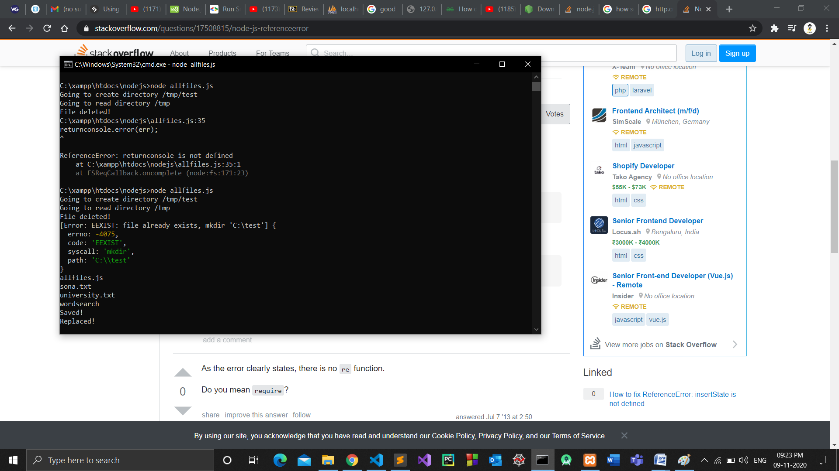

|  |  |
| --- | --- |
| ***Ex:No : 11.b*** | ***Nodejs.VisitorsCount*** |
| ***Date :*** |

***Aim:***

Nodejs program for tracking no of Visitors.

***Program:***

***client.html***

<!DOCTYPEhtml>

<html>

<head>

<meta charset="ISO-8859-1">

<title>Welcome to Dictionary Search Page</title>

</head>

<body>

<h1> Enter the word </h1>

<form method="get"action="http://127.0.0.1:1234/process_get">

<input type="text"name="name"/>

<input type="submit"/>

</form>

</body>

</html>

***testing.js***

var express=require('express');

var mysql=require('mysql');

var con=mysql.createConnection({

host: "localhost",

user: "root",

password: "",

database: "test"

});

con.connect(function(err){

if(err) throwerr;

console.log("connection established");

});

var app=express();

app.get('/client.html', function (request, response) {

response.sendFile(__dirname+"/"+"client.html");

})

app.get('/process_get', function (request, res) {

var name=request.query.name;

console.log("Welcome to Node JS program "+name);

con.query("SELECT * FROM dictionary where word=\'"+name+"\'", function (err, result, fields) {

if (err) throwerr;

console.log(result);

console.log(result.length)

if(result.length==1)

{

var Data=JSON.stringify(result);

console.log(Data);

var out=JSON.parse(Data);

console.log(out[0].meaning+out.length);

res.end("<h1> Meaning of the word "+out[0].word+" is "+out[0].meaning+"</h1>");

}

else

{

res.end("<h1> Meaning of the word "+name+" Not Found</h1>");

}

});

});

var server=app.listen(1234, function () {

console.log("Example app listening at http://127.0.0.1:1234");

});

***Output:***

