|  |  |
| --- | --- |
| ***Ex:No : 3*** | ***XML*** |
| ***Date :*** |

***Aim:***

XML DTD and Schema for describing the structure of news article file.

***Program:***

***newspaper.xml***

<?xml version="1.0" encoding="UTF-8"?>

<!DOCTYPE newspaper SYSTEM "newspaperdtd.dtd">

<newspaper name="The Hindu">

<article type="politics">

<title>GO BACK MODI</title>

<author> RJB </author>

<date> 1/11/2020 </date>

<summary> Central Government is asking everyone to live with virus </summary>

</article>

<article type="sports">

<title>WORLD CUP</title>

<author>RJ</author>

<date> 1/11/2020</date>

<summary>Next T20 host in INDIA</summary>

</article>

</newspaper>

***newnewspaperschema.xml***

<?xml version="1.0" encoding="UTF-8"?>

<tns:globalnews name="" xmlns:tns="http://www.example.org/newspaperSchema"

xmlns:xsi="http://www.w3.org/2001/XMLSchema-instance"

xsi:schemaLocation="http://www.example.org/newspaperSchema newspaperSchema.xsd ">

<tns:article type="politics">

<tns:title>GO BACK MODI</tns:title>

<tns:author>RJB</tns:author>

<tns:date>1/11/2020</tns:date>

<tns:summary> Central Government is asking everyone to live with virus

</tns:summary>

</tns:article>

<tns:article type="sports">

<tns:title>WORLD CUP</tns:title>

<tns:author>RJ</tns:author>

<tns:date>1/11/2020</tns:date>

<tns:summary>Next T20 host in INDIA</tns:summary>

</tns:article>

</tns:globalnews>

***Output:***

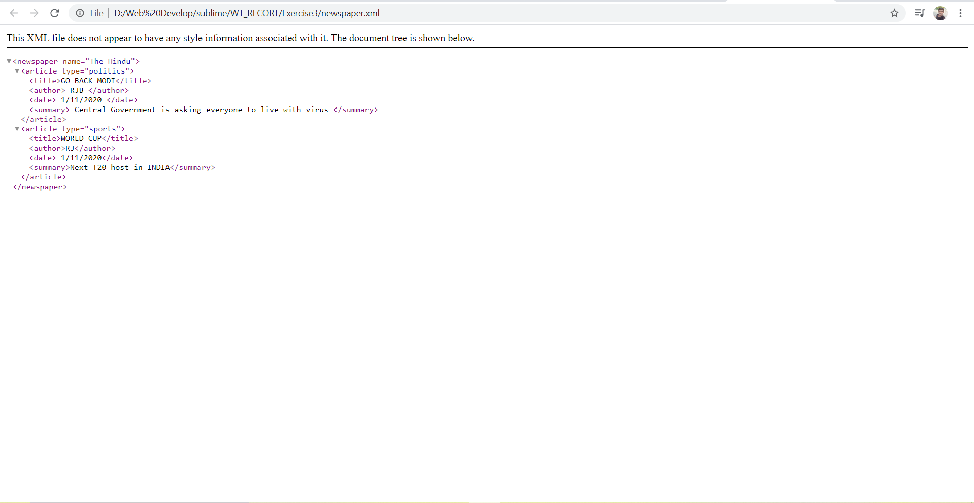

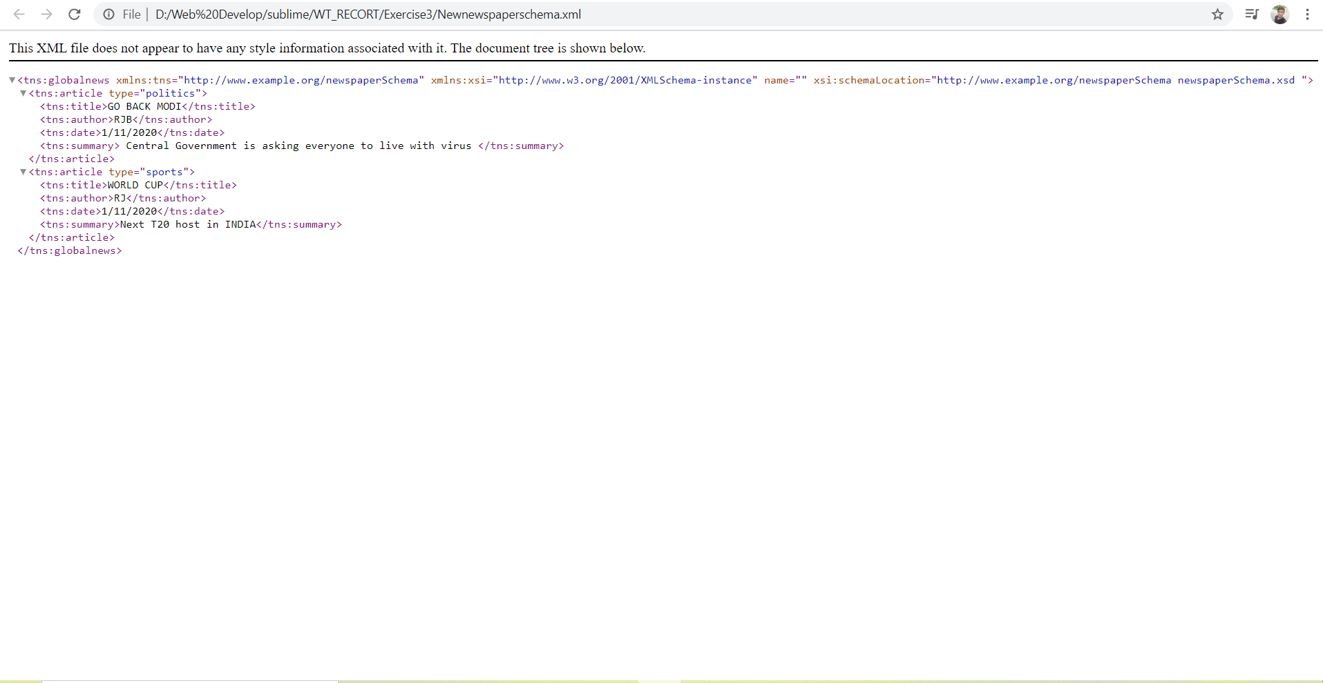

RESULT:

Thus the structure of news article file was created using xml successfully.