|  |  |
| --- | --- |
| ***Ex:No : 4*** | ***XSL file for the following XML file to render it as HTML table.*** |
| ***Date :*** |

***Aim:***

XSL file for the following XML file to render it as HTML table.

***Program:***

***game.xml***

<?xml version="1.0" encoding="UTF-8"?>

<?xml-stylesheet type="text/xml" href="gamexsl.xsl" version="1.0"?>

<sports>

<game id = "500">

<name>Cricket</name>

<paragraph>

Cricket is like religion in INDIA

</paragraph>

<playingcountry>200</playingcountry>

</game>

<game id = "501">

<name>Baseball</name>

<paragraph>

Popular in America.

</paragraph>

<playingcountry>183</playingcountry>

</game>

<game id = "502">

<name>Soccer (Football)</name>

<paragraph>

Popular sport in the world.

</paragraph>

<playingcountry>264 </playingcountry>

</game>

</sports>

***gamexsl.xsl***

<?xmlversion="1.0"encoding="UTF-8"?>

<xsl:stylesheet version="1.0"xmlns:xsl="http://www.w3.org/1999/XSL/Transform">

<xsl:template match="/">

<!-- TODO: Auto-generated template -->

<html>

<body>

<style>

table, th, td {

border: 1px solid black;

}

th,td{padding:10px; } th{background-color:#000;color:#fff; }

table{margin-left:auto;margin-right:auto;margin-top:100px; }</style>

<h1style="text-align:center;">Web Technology Lab Exercise 4</h1>

<h3style="text-align:center;">To write a XSL file for the following XML file to render it as HTML table</h3>

<table>

<tr>

<th>GAME ID</th>

<th>NAME</th>

<th>POPULARITY</th>

<th>PLAYING COUNTRIES</th>

</tr>

<xsl:for-each select="sports/game">

<tr>

<td><xsl:value-of select="@id"/></td>

<td><xsl:value-of select="name"/></td>

<td><xsl:value-of select="paragraph"/></td>

<td><xsl:value-of select="playingcountry"/></td>

</tr>

</xsl:for-each>

</table>

<xsl:variable name="total"select="sum(//playingcountry)"></xsl:variable>

<h1style="margin-left:62%;">TOTAL: <xsl:value-of select="$total"/></h1>

</body>

</html>

</xsl:template>

</xsl:stylesheet>

***Output:***

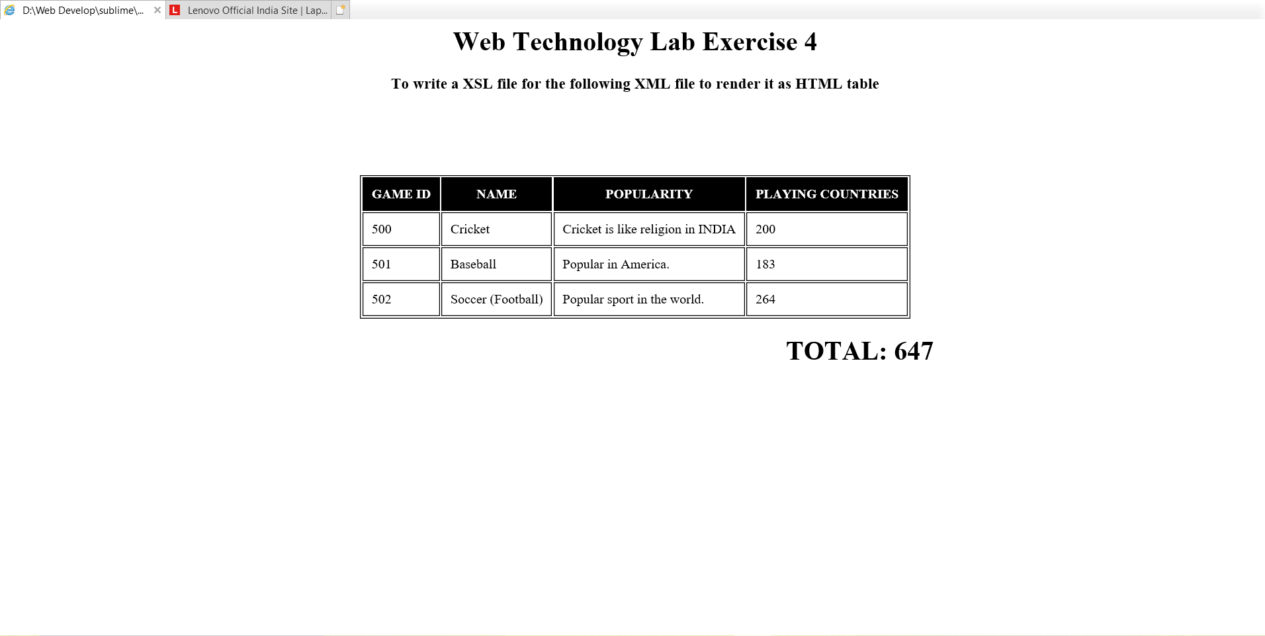

RESULT:

Thus the HTML table was created using xml successfully.