Created **Resource** **Group** with name **VaijayanthiRG**.

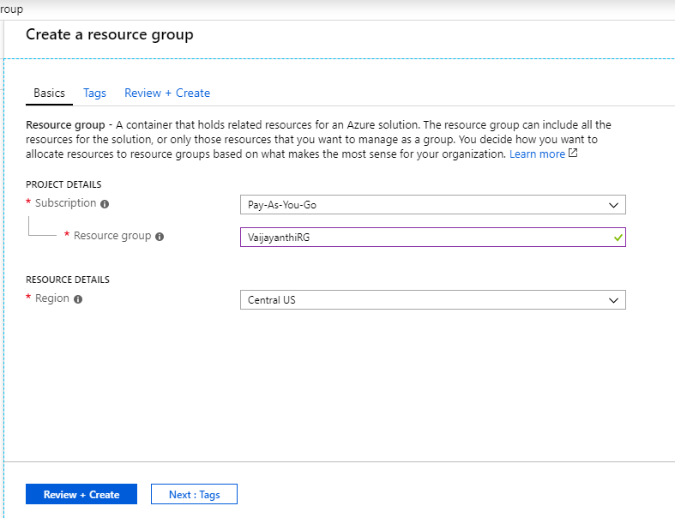

Created **Vnet** with name **LenoraVnet**:

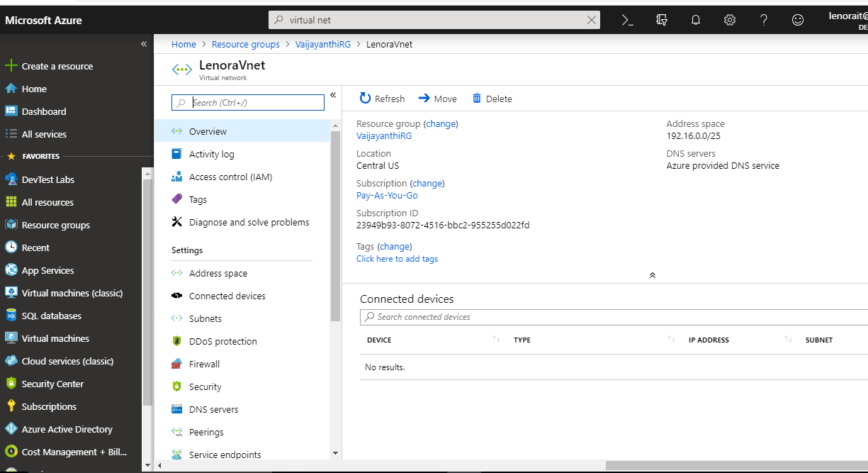

Created **Subnet** with name “**frontendsubnet**” and “**backendsubnet**”.

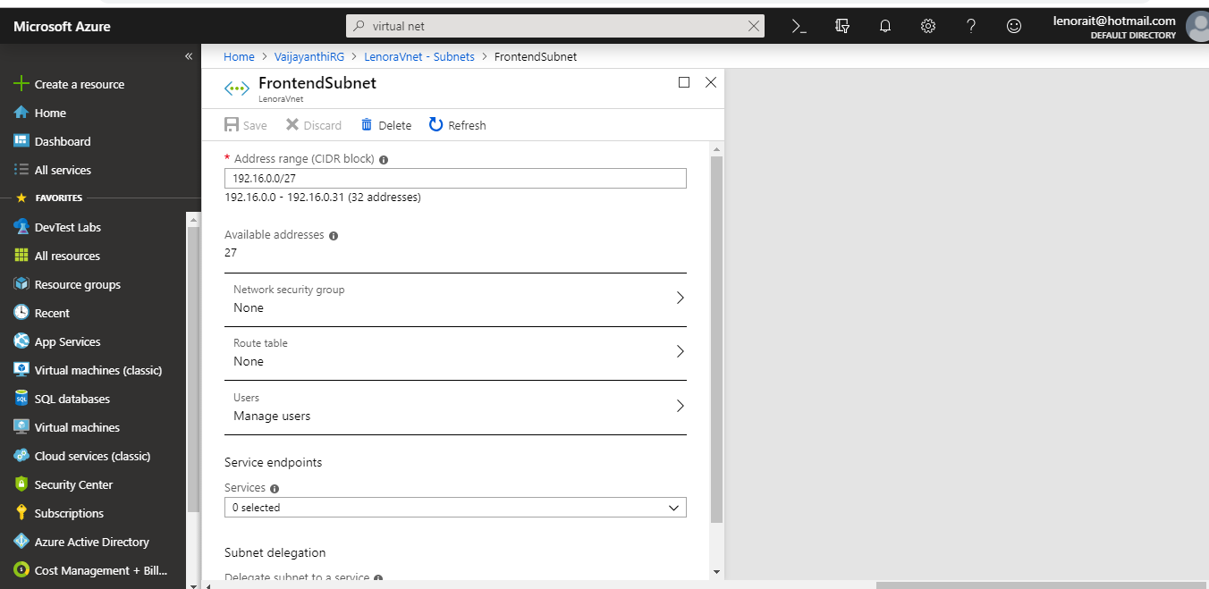

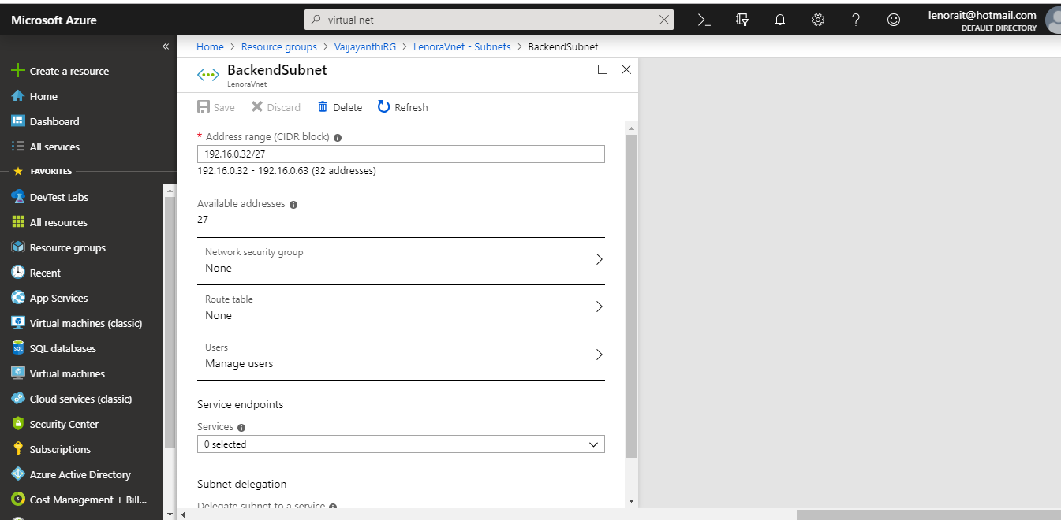

Created Inbound Security Rules for Frontend:

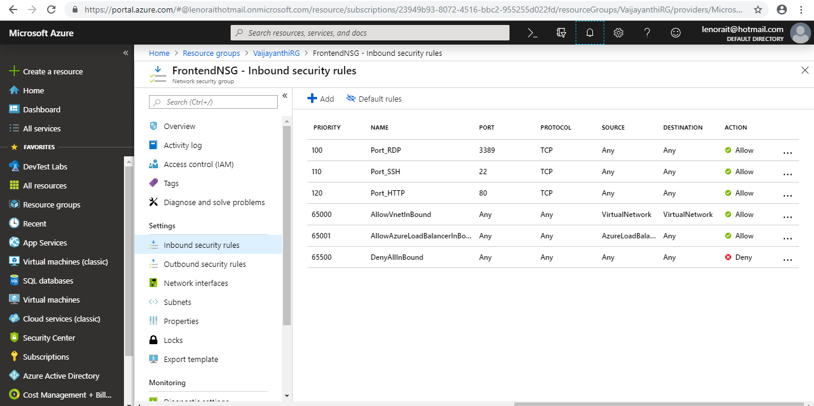

Created Inbound Security Rules for Backend:

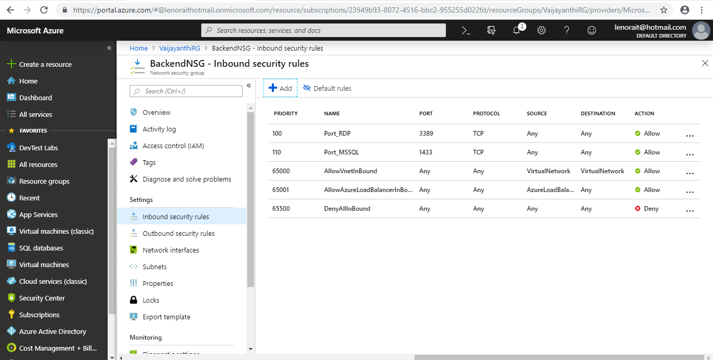

Created Outbound Security Rules to Backend:

